CS 255 System Design Document

Ashley Grevelink
October 18, 2026
Project Two

UML Diagrams

UML Use Case Diagram

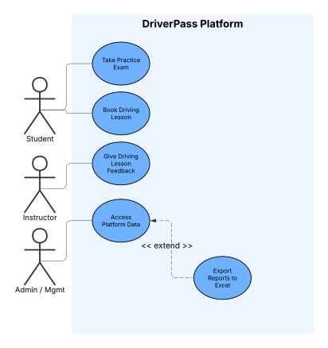

UML Activity Diagrams

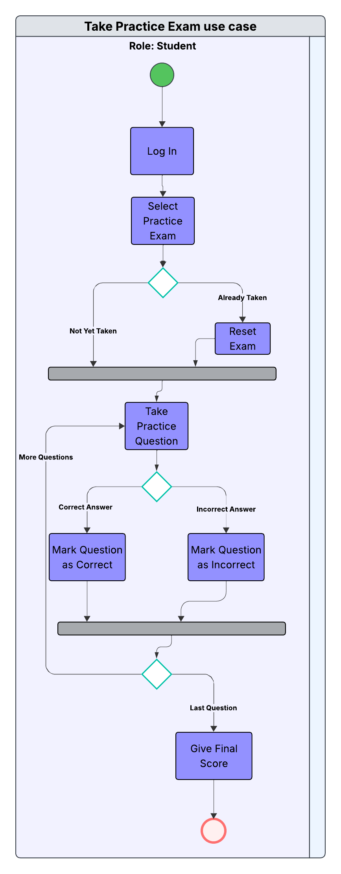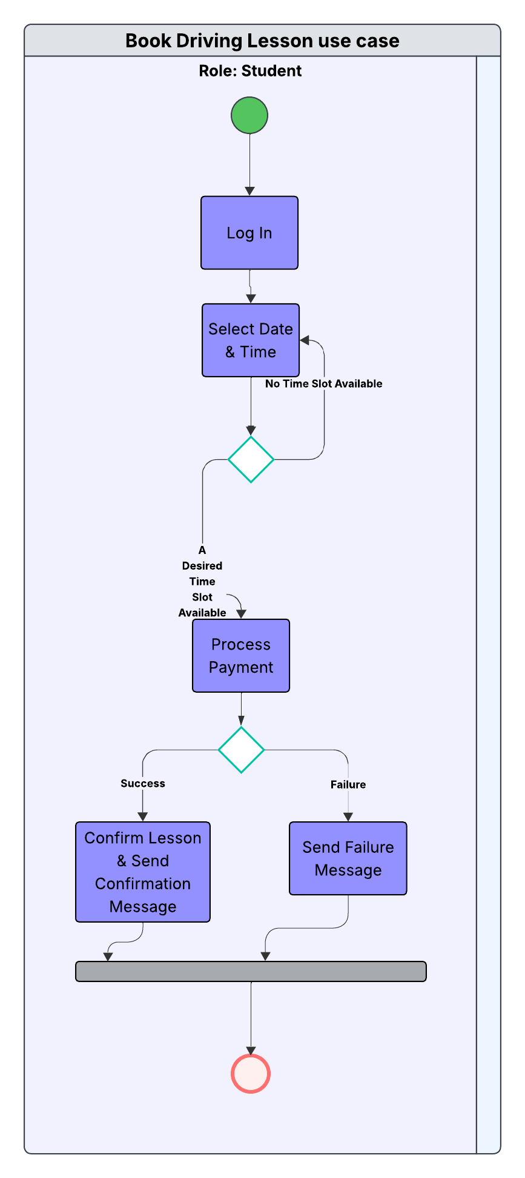

UML Sequence Diagram

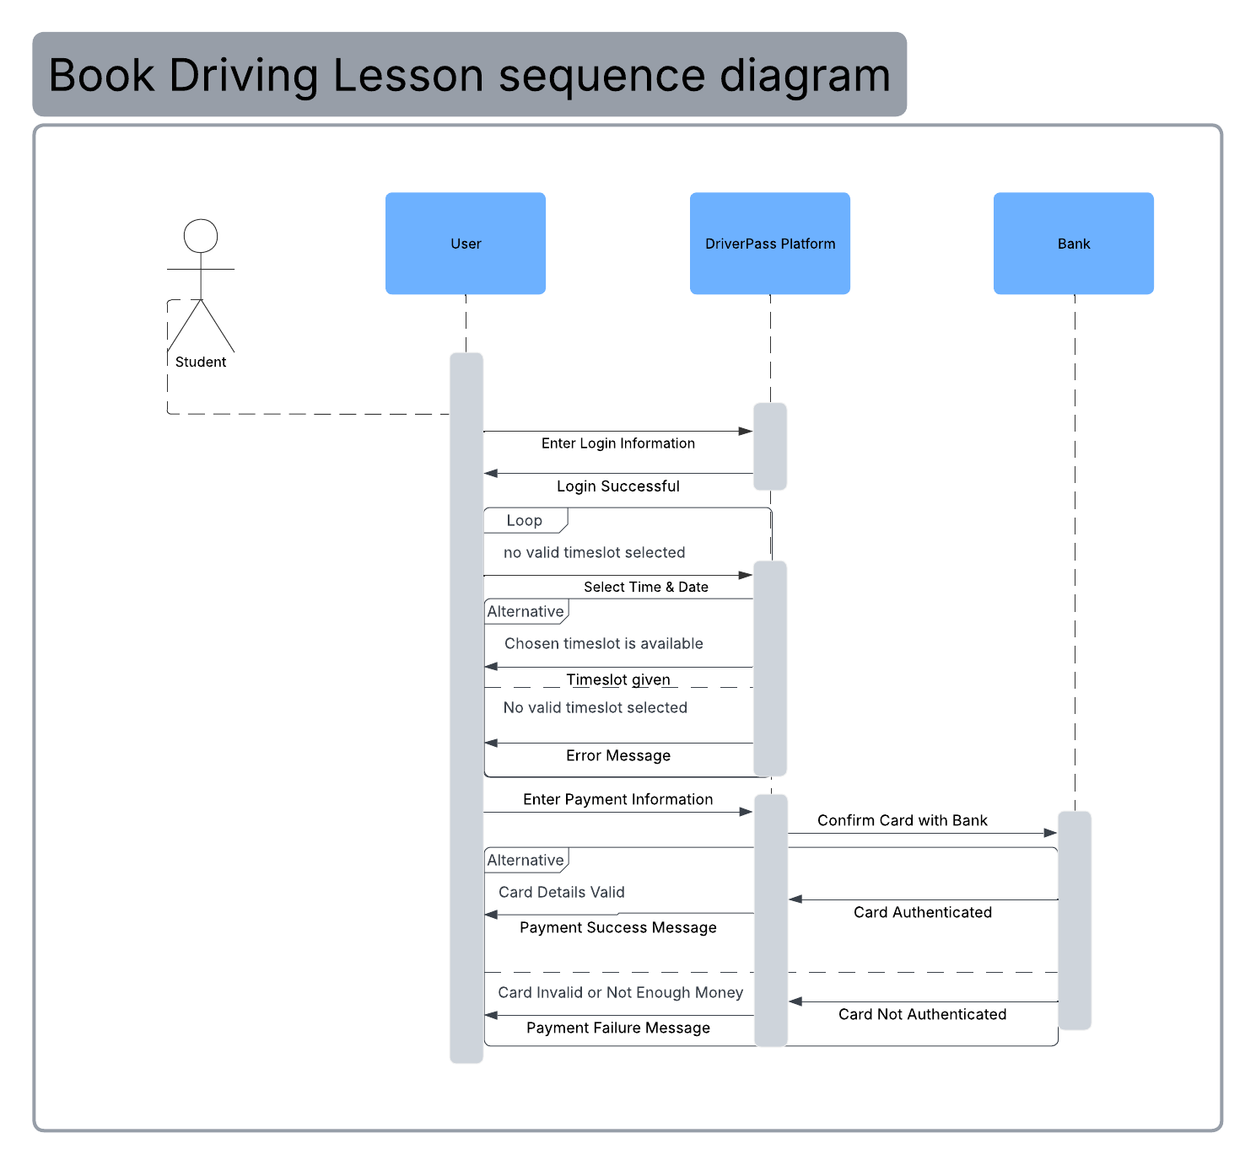

UML Class Diagram

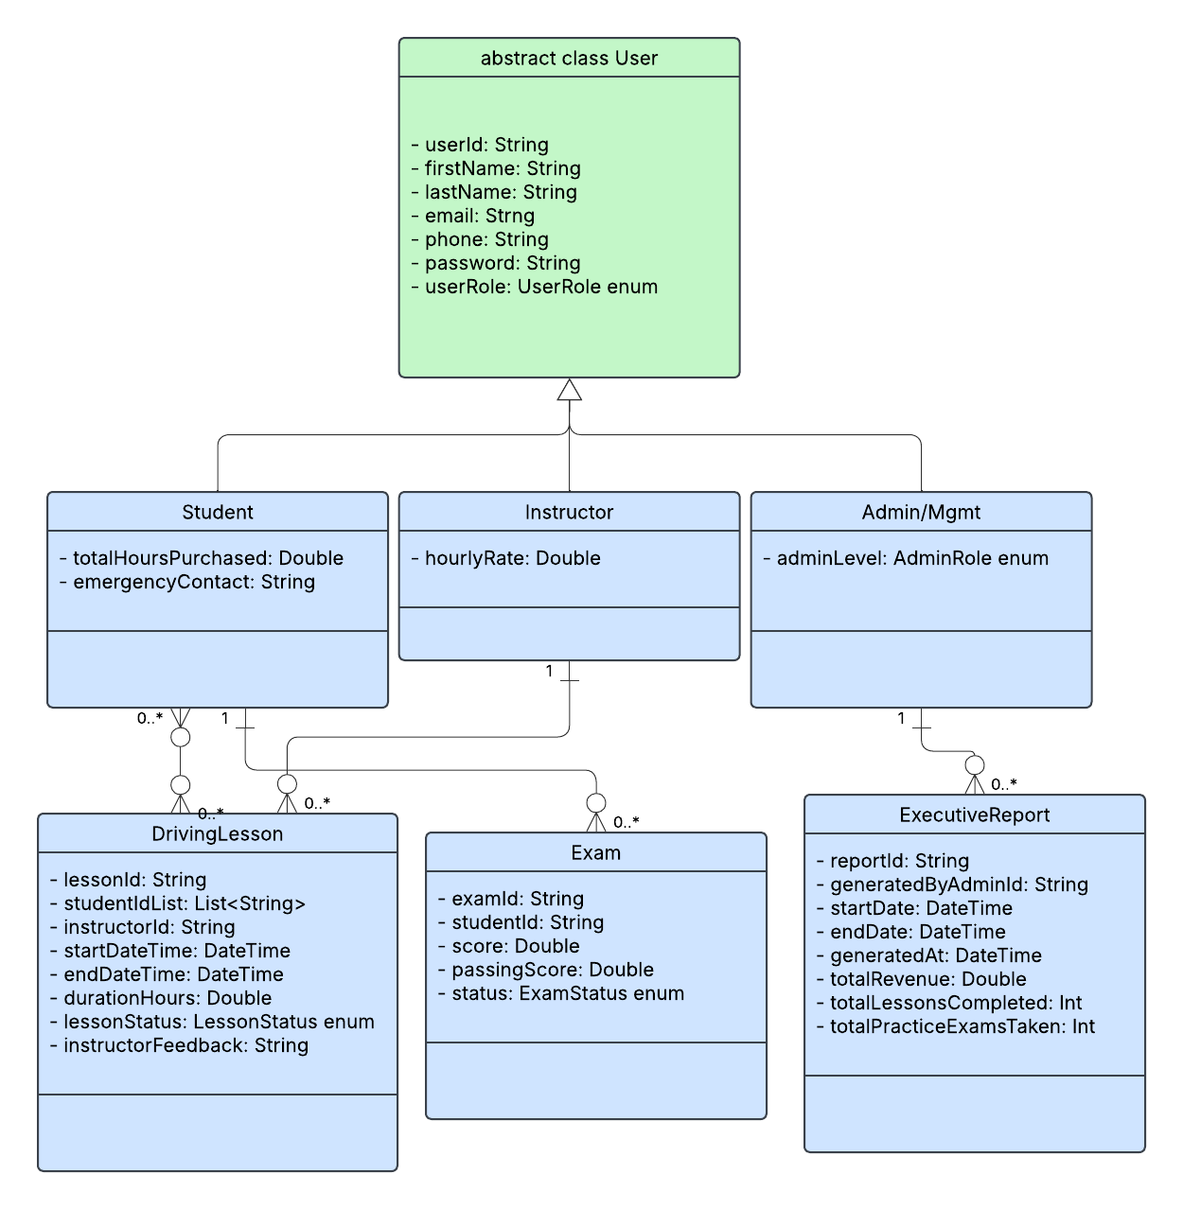

Technical Requirements
Required hardware includes students, instructors, and administrators devices. They need to have standard smartphones, tablets, or laptops/desktops. The required software on these hardware devices would be modern web browsers, either the desktop or mobile version. There are no required tools and the DriverPass platform works entirely in browser. Required infrastructure would be an internet router that connects to a device either over WiFi or by Ethernet cable.

