**Website Content Pages**

**HP Inc.**

* **Image Classifier App**
* **Document Scanner**

**BLK J**

**National Team**

**Imperial College London**

* **C Project Extension – Capacitive Control Speaker**
* **Parkour Soc**

**Google Get Ahead Program**

**Raffles Institution / RGS**

**Dog Pictures + SPCA**

**Good Movies/TV Shows to watch + autographs**

**Internship at HP Inc.**

**July 2018 – August 2018**

I recently completed a two-month internship at HP Inc. Singapore. I was with the Home Printing Solutions R&D team, which controls worldwide R&D for HP printers. During my time there, I worked on two software projects – an Image Recognition Android App, and a Document Scanner.

On top of working on my projects, I also got involved in the organizing and running of HP PrintHack Asia 2018. This hackathon brought people from various departments in HP together to work on solving printing problems faced by HP consumers in China. This experience…

Also, I got the chance to tour some of HP’s ~~leading tech offices,~~ namely the HP Graphics Solutions Centre of Excellence, HP Indigo Press facility, and the SMARC office. They gave me a glimpse into how tech is rapidly evolving and how HP fnadjskfjnqeoi

What this internship really taught me was how to teach myself. Prior to this internship, I did not know anything about machine learning, image processing or android app development. However, throughout this internship, I had to pick up these skills on my own, by watching tutorials on YouTube or by vehemently using Stack Overflow to diagnose any problems I run into. In addition, I also found time to pick up some web development skills (which is how I made this website).

I aim to ….

**Image Classifier Android App**

**2018**

For my internship project, I was tasked to build an image classification android app. I had no prior knowledge about image recognition, machine learning or how to build an android app, so I searched the web on what would be the best way to build my image classifier.

I settled on using Google’s TensorFlow machine learning framework, as it had some pretty comprehensive documentation. I followed the [TensorFlow For Poets](https://codelabs.developers.google.com/codelabs/tensorflow-for-poets/#0) tutorial, using my own dataset of images. My dataset was collated by mass downloading relevant images from Google Image Search using a python script.

Once I trained the TensorFlow model, I proceeded to write a python script to test its accuracy. I collated a folder of test images, and my script would go through each of the pictures in the folder, classify it and compare the results with the actual label. It would then calculate the accuracy for each label, as well as the overall accuracy.

With my trained TensorFlow model, I optimized it for mobile use and then integrated it into my simple mobile application. It being my first time using Android Studio to make an android app, I struggled at first, trying to get the hang of how to create new Activities, edit Manifests and such. I eventually made a simple UI, where users could either take a new picture using the phone camera or select an image from the gallery. Once selected, the app would use the trained TensorFlow model to classify the image and display the results on the page.

It was quite tough figuring out how to invoke the trained TensorFlow model from my Java program. I initially tried adapting the TensorFlow demo app on GitHub, but I soon realised that there were too many unnecessary files in that project. So instead I started a new project, wrote out the app framework, and then cloned TensorFlowImageClassifier.java and ImagePreprocessor.java to my project files. I then used the methods in those classes to invoke my classifier model.

Here is a demo of my app:

**Further Improvements**

As I just wanted to show a proof of concept, I only trained my TensorFlow model till it had an accuracy of about 87%. Further refinement to the training could be done by:

* Increasing the number of training steps
* Changing learning_rate from 0.01 to 0.005
* Using a larger dataset (I currently only have about 200 images per category)
* Distorting the images by passing –random_crop, --random_scale, --random_brightness to the training script

**Document Scanner**

**2018**

As I had completed my main project and still had one month left of my internship, they assigned me another project to do. I was tasked to design a smart document scanner, which automatically crops and rotates scanned images from a printer scanner.

There are two parts to the solution I came up with. The first script takes scanned images from a folder, crops them and saves them to a ‘croppedimages’ folder. The next script takes these images, uses a TensorFlow classifier to identify the angle of rotation, rotates them accordingly, and saves them to a ‘results’ folder.

**BLK J Internship**

**January 2017 – March 2017**

I've had experience interning for 3 months at a marketing company DDB, as an accounts executive intern. During this internship, I worked with a team to manage client accounts and projects, and assisted with the formulation of marketing strategies. This internship helped develop my communication and presentation skills, each being essential for swift and effective completion of projects.

**Gymnastics**

Gymnastics has been an integral part of my life for almost a whole decade, and it has been a very memorable chapter indeed. Unlike most, I started gymnastics pretty late. I was eight when I decided to join recreational gymnastics classes, training twice a week. Starting off at level 2, I slowly built up my skills and eventually had the chance to train with the National Team.  
  
Throughout my gymnastics career, I was privileged to have many opportunities to represent Singapore, which I would not have been able to do so without the guidance of our coaches and support from my family, Singapore Gymnastics, and the SNOC.

Here are some competitions I took part in:

* 2014, Doha: 7th FIG Gymnastics World Challenge Cup
* 2014, Glasgow: Commonwealth Games
* 2015, Singapore: 28th Southeast Asian Games
* 2015, Glasgow: World Artistic Gymnastics Championships

**Doha World Cup 2014**

Uneven Bars final – 7th

Balance Beam final – 7th

This was my first overseas competition competing in the senior category. Going in, I did not have much expectations in terms of medal placing. I just wanted to do my best, and get the best score that I could. Which is what I did, and I managed to obtain my personal best score of 14.150 on the balance beam, as well as qualify for event finals for both bars and beam!

As this was my first competition on the world stage, I managed to see many of my sporting idols competing in real life. I vividly recall having goose bumps while watching Larisa Iordache perform her routine on the floor exercise. Coming back from that competition, I was really inspired to work harder.

* Link newspaper article

**CWG 2014**

Team – 6th

This was the competition

**SEA Games 2015**

Team – Silver

Uneven Bars final – 4th

Balance Beam final – 8th

**World Champs 2015**

**Google Get Ahead Program**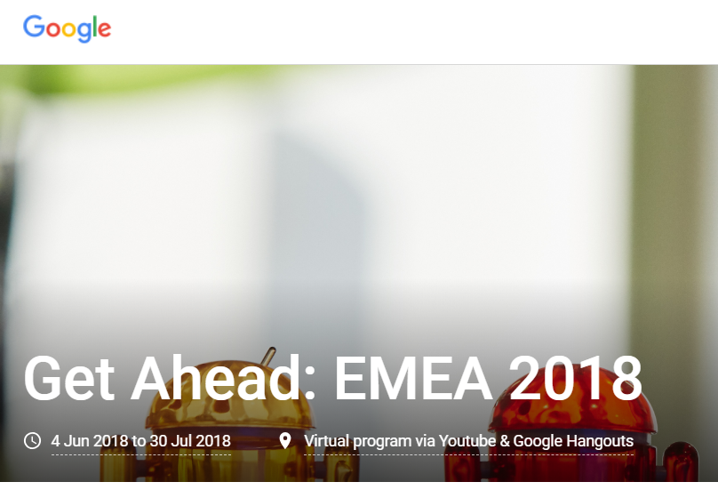

Get Ahead is a self-study program for students interested in developing their technical skill set and knowing more about future employment opportunities at Google. This program includes interactive Google Hangouts, YouTube Live events, as well as weekly newsletters with suggested material to complete each week.

I was invited to participate in the 6-week program, where I solved the problems posed to us each week and even took part in the Codejam Kickstart competition (where I placed 32nd out of the 87 people around the world who took part). Here are my implementations of the problems posed to us: GITHUB link <https://github.com/ashlylau/google-challenges-practice>

**Imperial College London**

**Computing – Artificial Intelligence (MEng)**

**2017 - 2021**

I am currently starting my second year of studying Computing at Imperial College London. Looking back at my first year, I realise that I’ve come a long way since then.

**First Year**

First year courses: Logic, Discrete Structures, Mathematical Methods, Hardware, Graphs and Algorithms, Architecture, Reasoning about Programs, Databases, Programming (Java, C, Haskell)  
Year 1 Overall Grade: A

I entered university with no prior programming experience at all, unlike most of my course mates who’ve all had at least 2 years of experience. So, my initial learning curve was extremely steep (I didn’t even know how to use the command line!!) and at many times I wanted to give up. But I stuck with the course, and tried my best to catch up with the rest of the class. Gradually, I started to understand more and more of what the lecturers were saying, and I fasfjdfolkm

For our last term, we had to complete a group project in C. Here

**Second Year**

Parkour soc – Events officer

Singsoc – OGL for Sojourn Camp, Acad Rep for Computing/Math, ME 2018

**C Project Extension**

**2018**

In our last term of school, we were tasked to do a group project using C, the language we were learning at the time. We had to implement an ARM emulator, an ARM assembler and an ARM assembly program that flashed an LED on a Raspberry Pi. This group project allowed me to learn how to work on code as a group, and how to manage forks/branches using Git.

For the extension of our project, we had an idea to use a Pi Cap hat for the Raspberry Pi and conductive paint to create a proximity sensitive audio controller. By just waving your hand close to the audio box, one can control playback of a playlist of songs. Here is a demo of our final product:

**Tertiary Education**

* RI – grades, subjects
* RGS – grades, subjects, projects
* Gymnastics training & balancing school work

**Dog Pictures**

Hi, here are some pictures of my dog. He’s slightly derpy.

Here are also some good doggos and cats that I met during my volunteering stint at SPCA.

**Some good TV shows and movies to watch**

I watch lots of tv shows and movies (I don’t even know how I find the time??). But here’s a list of my favourite shows:

* Westworld HBO
* Game of Thrones (everything after S3 is amazing)
* Grey’s Anatomy
* Brooklyn Nine-Nine!!
* Oceans 8
* Crazy Rich Asians
* Ladybird
* Pitch Perfect
* The Force Awakens
* The Last Jedi

If you have any good movie/tv series suggestions, please leave them here!

Also what about some song suggestions while you’re at it:

And some book recommendations:

* Autograph collection

**Cool stuff I’ve done**

Photo gallery (with captions) (3-2-1 responsive gallery)

* Concerts
* Red carpet events
* Photos w ppl
* James corden