|  |  |  |
| --- | --- | --- |
| ECE 403 | June 23, 2020 | Ashlynn Steeves |
| Assignment 4 |  | V00850631 |

All MATLAB code used to generate answers for this assignment can be found at <https://github.com/ashlynns/ECE403/tree/master/A4>

**Q1.12**

*(a) Apply least-squares linear regression to the data to generate a prediction model*

X = [-2.1 -2 -1.1 -1 -0.9 -0.2 -0.1 0 0.1 0.9 1 1.1 1.9 2 2.1 3];

y = [1 2 1 2 3 1 2 3 4 2 3 4 3 4 5 5]';

X = [X ; ones(1, length(X))];

w = pinv(X')*y;

*(b) In a single figure, plot the sixteen data samples and the optimized model as a straight line in the x-y space.*

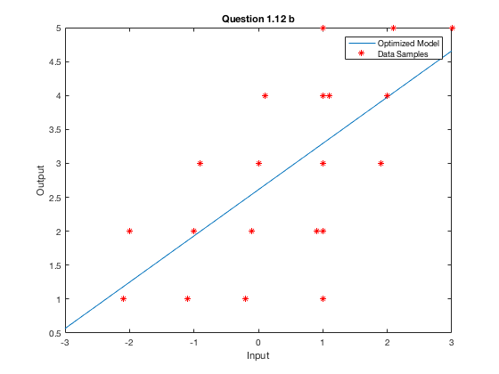

*(c) Use the model obtained to predict the output for input x = 1.5.*

Using the model to predict the output for input x=1.5 returns a y value of y = 3.634.

Q2.1

*(a) Follow the above discussion to define a softmax cost function in terms of wˆ and z_p defined in (P2.7). Hint: Eq. (1.49) of the Notes provides a counterpart of the cost function in the original input space.*

(b) Derive a formula for the gradient of

(c) Write a MATLAB function for and

function [E_lr_out] = E_lr(w)

X = [-1 0 2 0 1 2 ; -1 1 0 -2 0 -1];

y = [1 1 1 -1 -1 -1]';

z = zeros(5, length(X));

for i = 1:length(X)

x1 = X(1,i);

x2 = X(2,i);

z(1,i) = x1;

z(2,i) = x2;

z(3,i) = x1^2;

z(4,i) = x1*x2;

z(5,i) = x2^2;

end

w_padded = repmat(w,1,length(X))

zdw = dot(z, w_padded, 1)

exp_val = exp((-y)'.*zdw)

sum_val = sum(log(1+exp_val))

E_lr_out = sum_val/length(X)

end

function [E_lr_grad_out] = E_lr_grad(w)

X = [-1 0 2 0 1 2 ; -1 1 0 -2 0 -1];

y = [1 1 1 -1 -1 -1]';

u = 0.03;

z = zeros(5, length(X));

for i = 1:length(X)

x1 = X(1,i);

x2 = X(2,i);

z(1,i) = x1;

z(2,i) = x2;

z(3,i) = x1^2;

z(4,i) = x1*x2;

z(5,i) = x2^2;

end

w_padded = repmat(w,1,length(X));

zdw = dot(z, w_padded, 1);

exp_val = exp((y)'.*zdw);

denom = 1+exp_val; % Denominator of sum term

num = y'.*z; % Numerator of sum term

sum_val = sum(num./denom, 2);

norm = sum_val./-(length(X)); % Sum term normalized by -P

uw = u*w; % Addition term

E_lr_grad_out = norm+uw;

end

Q2.2

*(a) Apply the basic GD to minimize ELR with input* ***w**** 0, u  0.03, and   10^-6. Report the numerical result of the minimizer* ***w*** *obtained. Use the optimized model to classify new input samples.*

x_tr_1 is classified as -1

x_tr_1 is classified as 1

*(a) Apply momentum-accelerated GD to minimize ELR with input* ***w**** 0, u  0.03, and   10^-6. Report the numerical result of the minimizer* ***w*** *obtained. Use the optimized model to classify new input samples.*

Running the provided gd_momentum script under these conditions was not yielding results in a reasonable amount of time (i.e. was not converging). I have tried running it with different conditions such as a smaller epsilon and smaller beta value and was able to run the scrip efficiently using e = 10^-6 and b = 0.75. Which yields the results below (same as a).

x_tr_1 is classified as -1

x_tr_1 is classified as 1