ECE 403 – Pre Lab 3

Ashlynn Steeves

V00850631

1. *For the normalized data set, what are the values of mean and variance for each feature?*

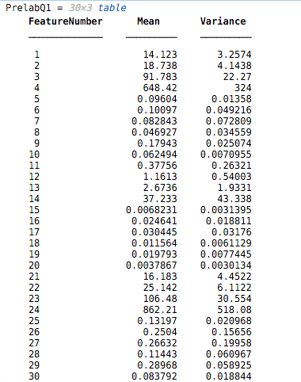

1. *How many samples in the train and test data? How many features in each data sample?*

The training dataset and the testing dataset have 285 and 284 samples respectively. Each sample is composed of 30 features as well as label to indicate the present diagnosis of the patient.

1. *What is the regularization term of the softmax cost function?*

The regularization term of the softmax function is an additional term that ensures that the magnitude of $\hat{w}$ stays within a reasonable range to avoid overfitting the data. The regularization term is defined as:

$$\frac{μ}{2}{\left\|\hat{w}\right\|}_{2}^{2}$$