ECE 579A

Presentation, Monday June 8th 2020

**Question – Does local air quality have an impact on a population’s susceptibility to COVID-19?**

Started by looking at Australia since:

* They were heavily impacted by wildfires in early 2020
* Focusing specifically Australia reduces the need to account for different confounding variables

|  |  |
| --- | --- |
| Macintosh HD:Users:Ashlynn:Desktop:Screen Shot 2020-06-08 at 1.07.50 AM.png | Macintosh HD:Users:Ashlynn:Desktop:Screen Shot 2020-06-08 at 1.06.53 AM.png |
| Macintosh HD:Users:Ashlynn:Desktop:Screen Shot 2020-06-08 at 1.07.06 AM.png | Macintosh HD:Users:Ashlynn:Desktop:Screen Shot 2020-06-08 at 1.07.22 AM.png |

**Summary Statistics:**

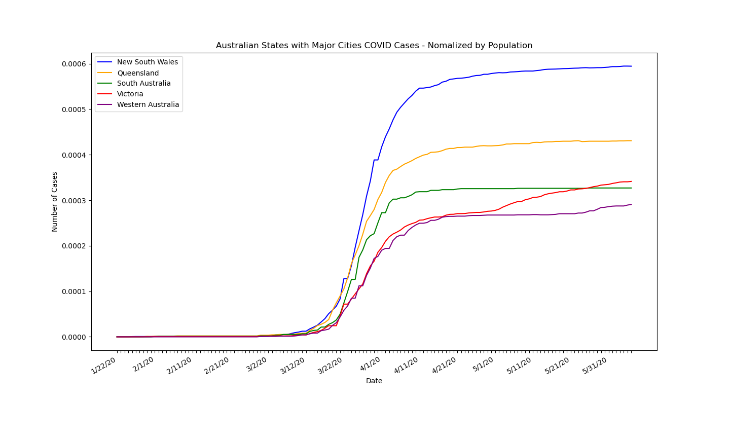

|  |  |  |
| --- | --- | --- |
| **City** | **State** | **Population\*** |
| Sydney | New South Wales | 5,230,330 |
| Melbourne | Victoria | 4,936,349 |
| Brisbane | Queensland | 2,462,637 |
| Perth | Western Australia | 2,059,484 |
| Adelaide | South Australia | 1,345,777 |

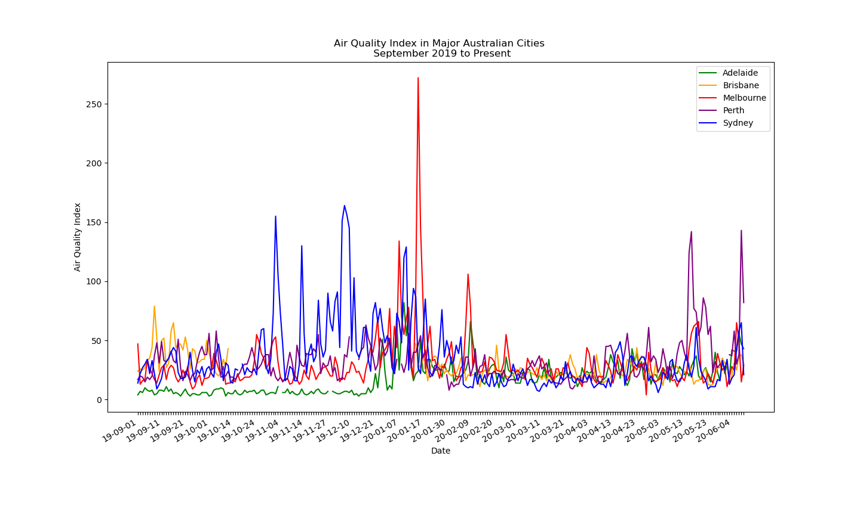

|  |  |  |  |  |
| --- | --- | --- | --- | --- |
| **Air Quality Index** | | | | |
| **0 -50** | **51 -100** | **101-150** | **151-200** | **201-250** |
| Good | Moderate | Unhealthy for Sensitive Groups | Unhealthy | Very Unhealthy |

**Next Steps:**

* Averaging of air quality data across a city
* Higher Resolution Datasets?
  + NSW has publicly released high res COVID data

**Questions:**

* Expand scope to include other cities
  + If so, what cities?

**\*** <https://www.abs.gov.au/AUSSTATS/abs@.nsf/Lookup/3218.0Main+Features12017-18?OpenDocument>