**Normalization process**

Want to normalize all features to a [-1,1] range. The most appropriate method to use will depend on the features distribution pre-normalization.

**Good days - PRE**

Min = 0.1004

Max = 0.9986

NNZ = 832

Norm Fcn = 2x^3-1

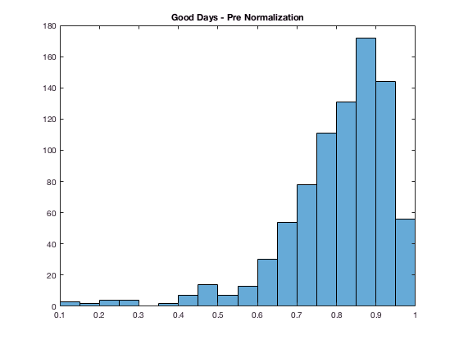

**Moderate Days**

Min = 0.0014

Max = 0.7120

NNZ = 832

Want to spread values between 0.05 and 0.3 over a large range, ideally centered around 0. Norm Fcn = tanh(7(x-0.2))

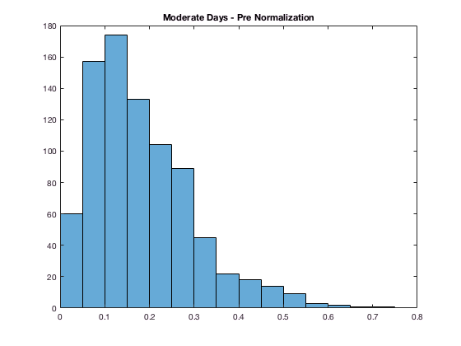

**Unhealthy for Sensitive Groups**

Min = 0

Max = 0.2822

NNZ = 756

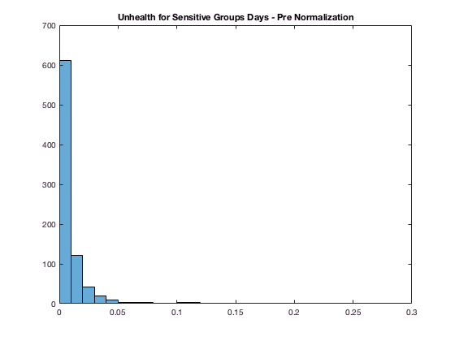

**Unhealthy Days**

Min = 0

Max = 0.3305

NNZ = 351

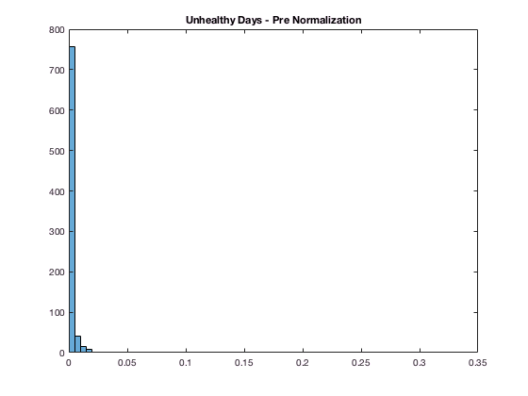

**Very Unhealthy Days**

Min = 0

Max = 0.0256

NNZ = 79

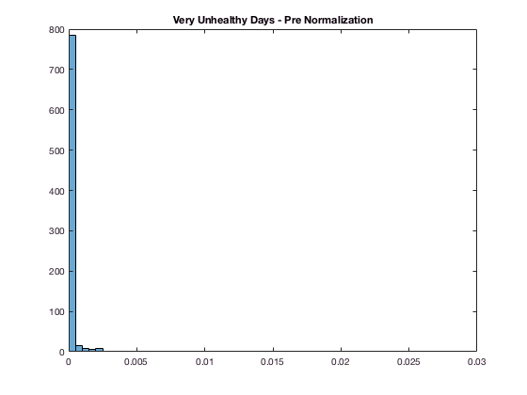

**Hazardous Days**

Min = 0

Max = 0.0310

NNZ = 34

