Dashboard and relevant results Screenshots
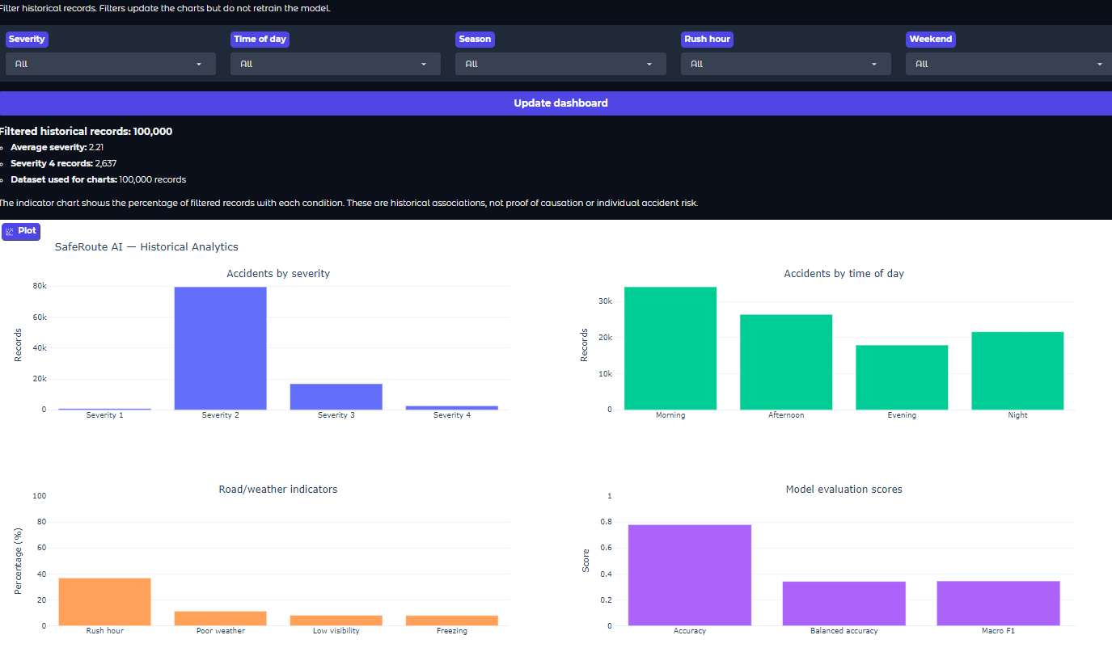
Fig: Dashboard developed for analysis

Fig: Interactive Filters

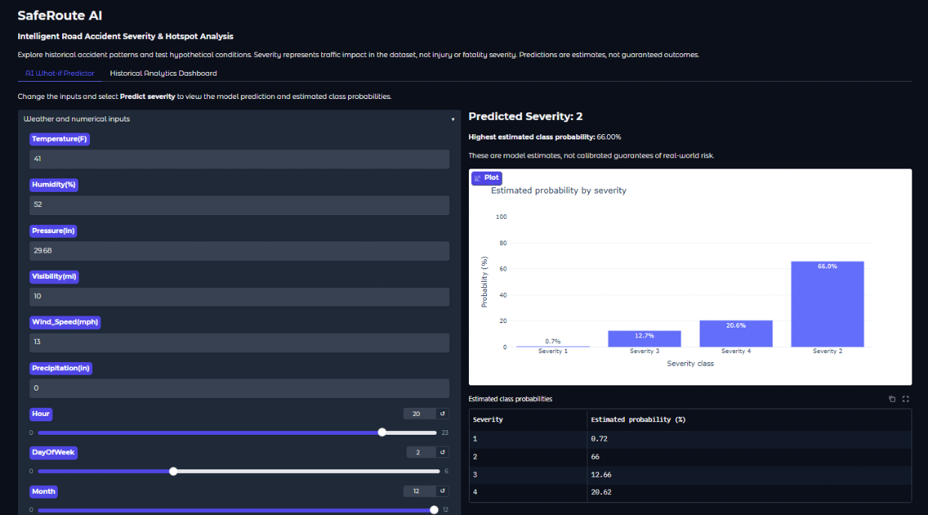
Fig: AI What-If Predictor
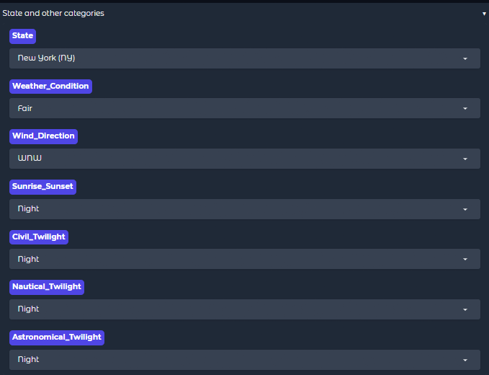
Fig: AI What-If Predictor state filters
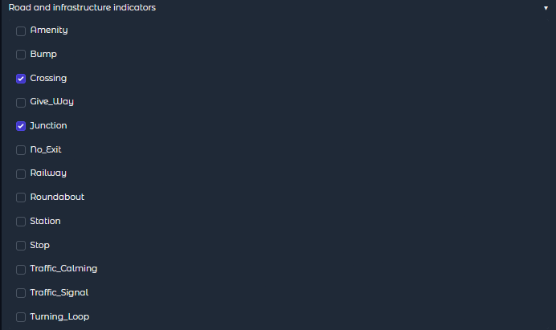
Fig: AI What-If Predictor road and infrastructure filters
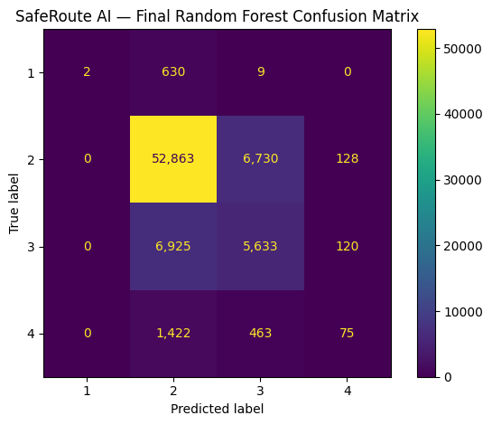
Fig: Final Confusion Matrix
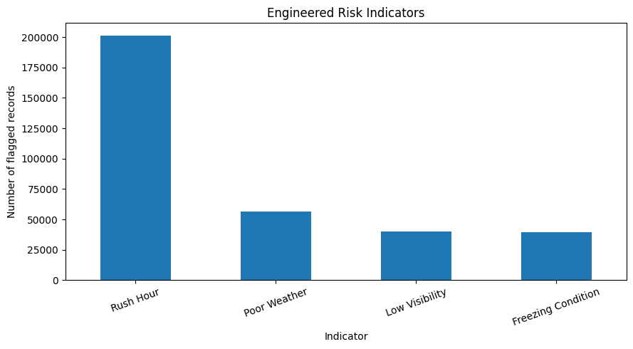
Fig : Engineered risk factors
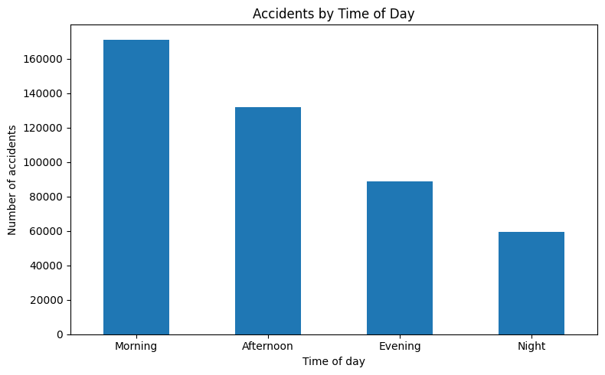
Fig:Accidents by time of Day
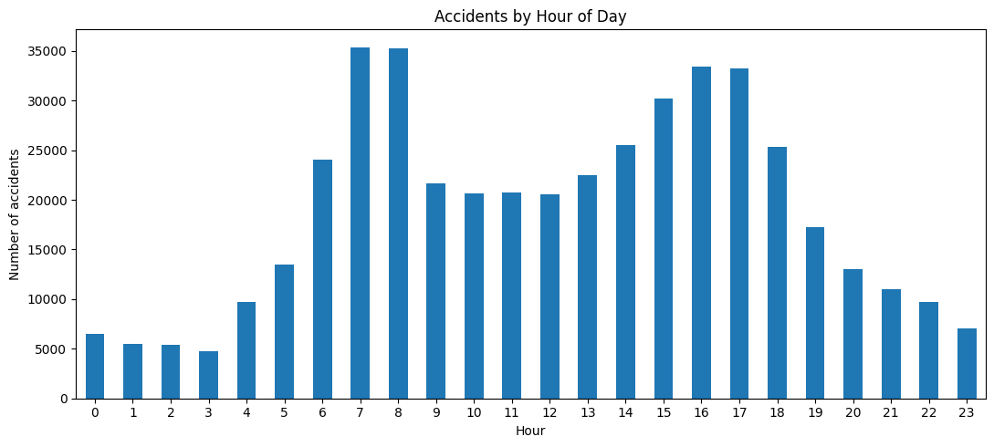
Fig : Accidents by hours of day
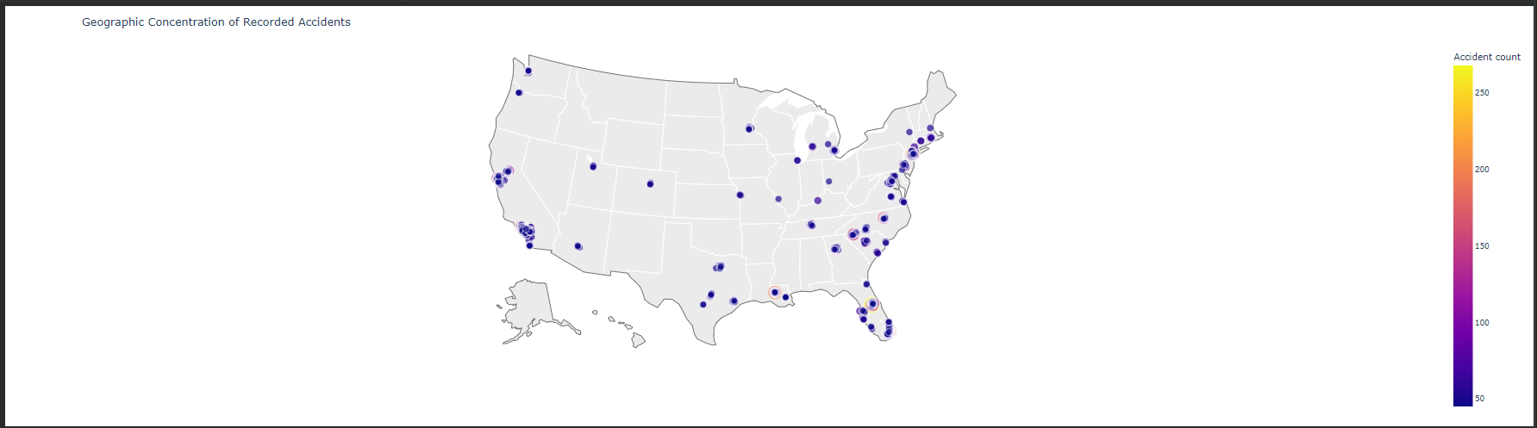
Fig : Geographic accident concentration map

