FEASIBILITY EVIDENCE
SafeRoute AI – Intelligent Road Accident Severity & Hotspot Analysis
Purpose: This document provides preliminary evidence that the proposed SafeRoute AI system is technically feasible. Insert screenshots or outputs from the project notebook where indicated.
1. DATASET LOADING
The project successfully loads a 500,000-record sample of the US Accidents (March 23) dataset containing 46 columns.
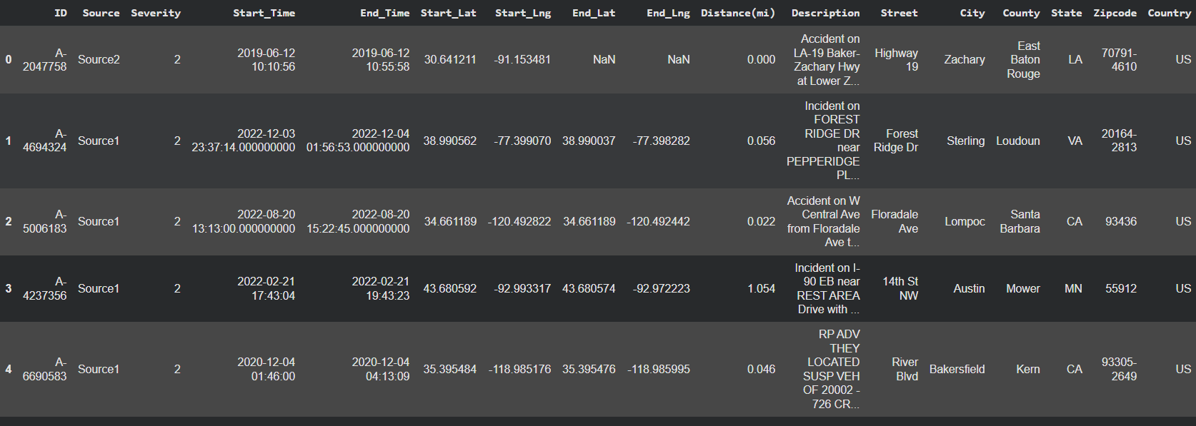

2. DATASET EXPLORATION & READINESS
Initial exploration was conducted to assess the structure, completeness and class distribution before modelling.
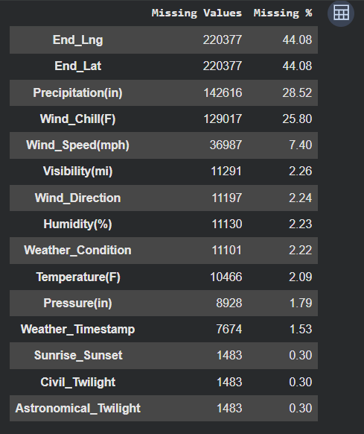
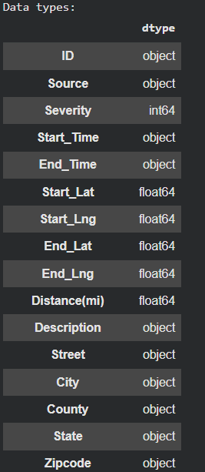

3. FEATURE ENGINEERING & PREPROCESSING
The preprocessing pipeline prepares numerical, categorical and boolean features for machine learning.
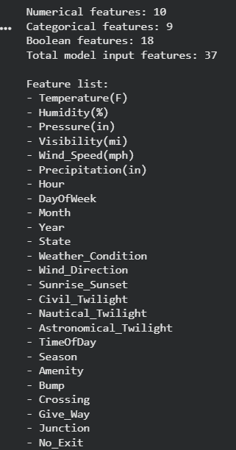
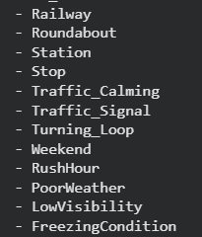
4. TRAIN/VALIDATION/TEST SPLIT
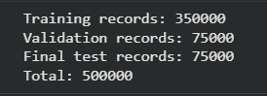
Training: 70%
Validation: 15%
Testing: 15%
A stratified split was used so the class distribution is maintained across the datasets.
5. BASELINE MODEL
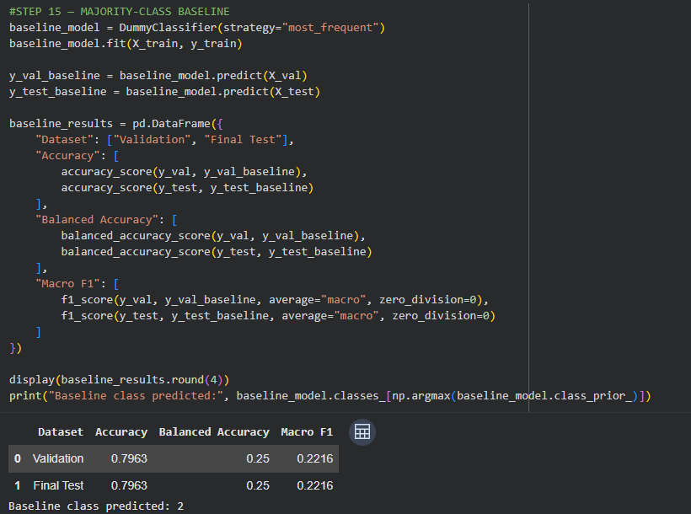-
A Random Forest classifier was established as the baseline AI model for four-class traffic-impact severity classification.

6. CLASS IMBALANCE EXPERIMENT
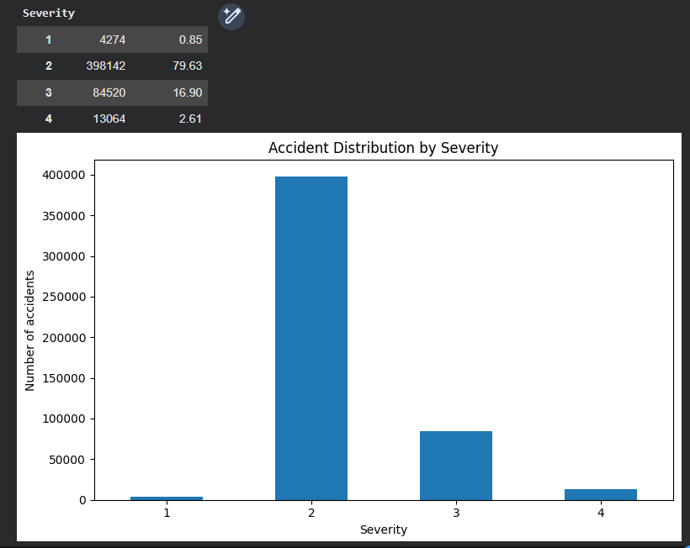
Multiple class-weight strategies were tested because Severity 2 represents the majority of observations. The experiments demonstrate the trade-off between overall accuracy and minority-class recognition.
7. MODEL EVALUATION
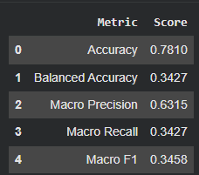
The model was evaluated using multiple metrics rather than accuracy alone because of the imbalanced severity distribution.

8. SAMPLE AI PREDICTION
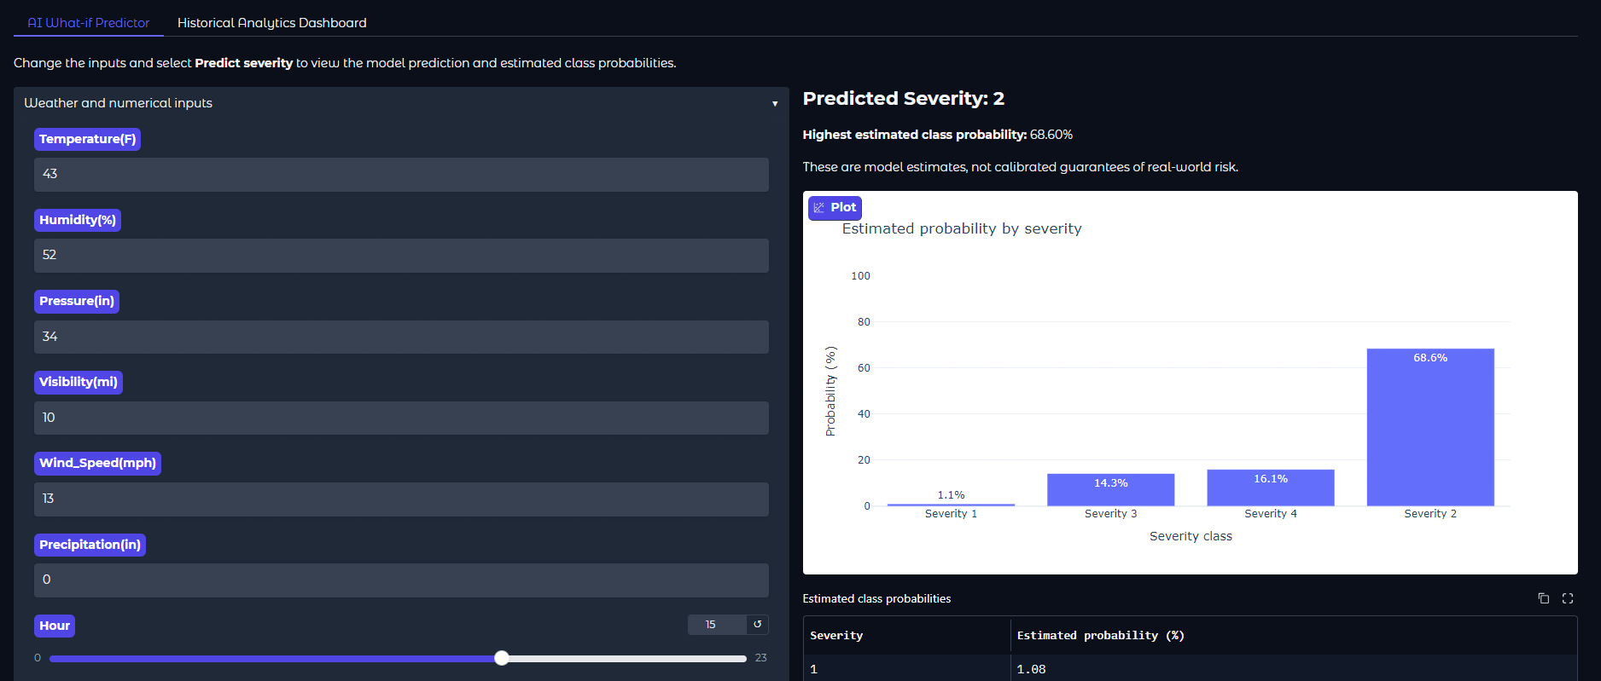
Prediction probabilities indicate the model's output distribution and are not guaranteed outcomes.
9. FEATURE IMPORTANCE
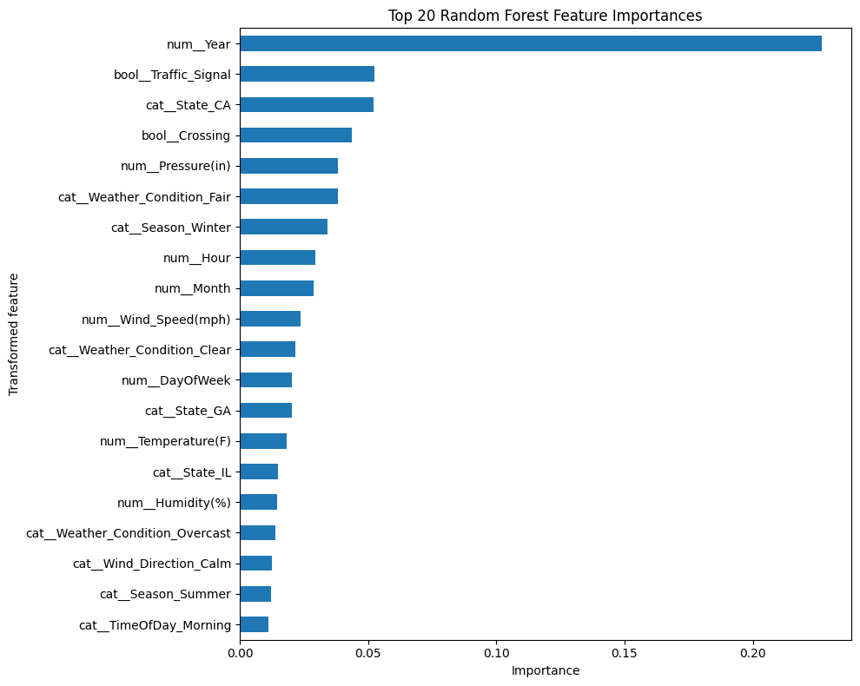
Feature importance provides an initial indication of which input variables contribute most to model predictions.
10. GEOGRAPHIC ACCIDENT CONCENTRATION MAP
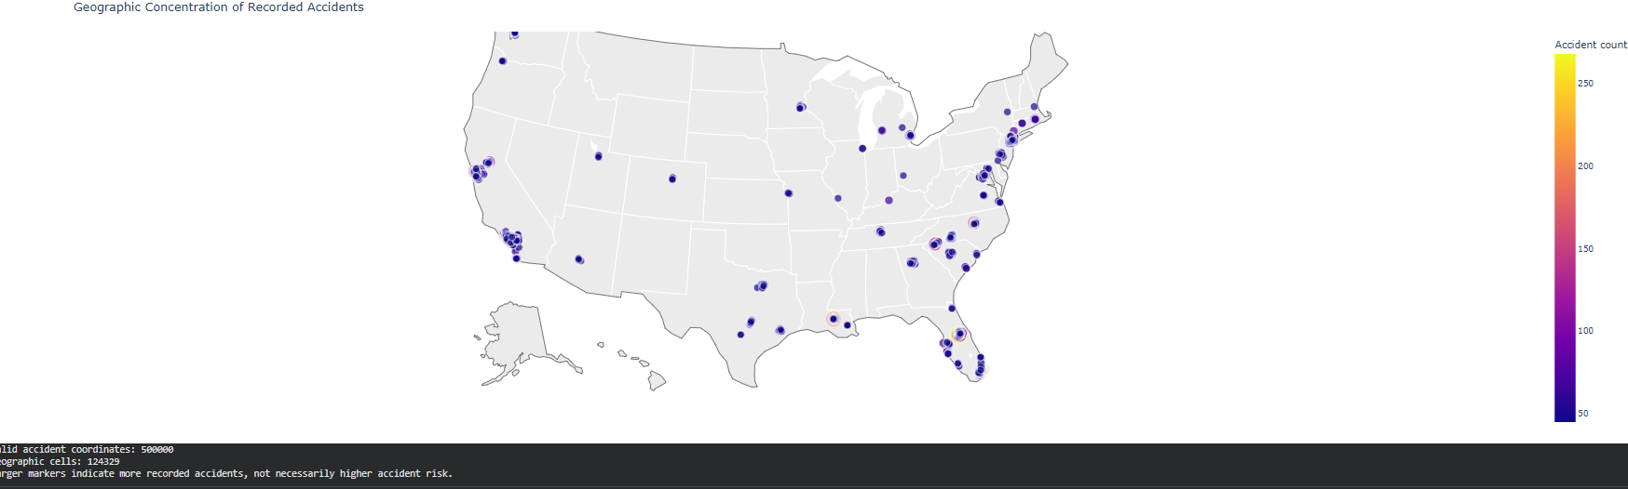
The geography visualisation employs the coordinates of the accident starting point, verifies the coordinate values, sorts the locations based on their latitude and longitude into approximate grid cells and counts the records in each cell.
The visualisation is based on the identification of concentration of recorded accidents and is not a representation of the verified rate of risks. The factors necessary for calculating the risk per vehicle or trip are not taken into account.
11. INTERACTIVE DASHBOARD
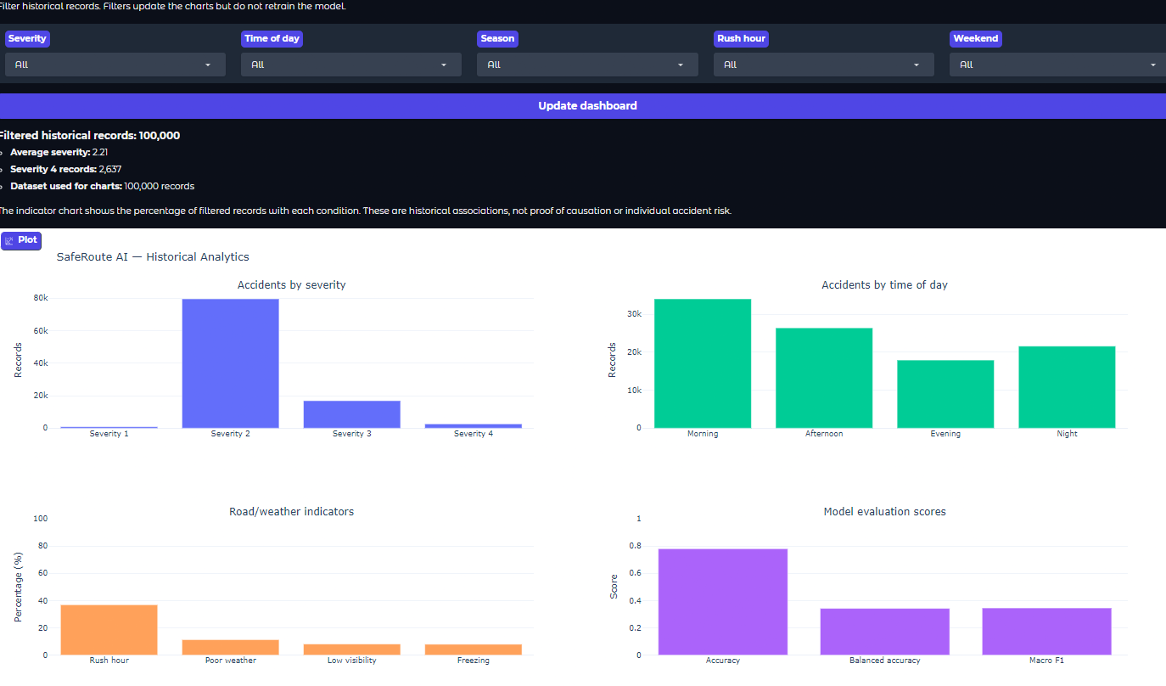
A preliminary interactive dashboard was developed using Plotly and ipywidgets for historical accident analysis.
12. FEASIBILITY SUMMARY
It is clear from the implementation that data loading and processing, feature engineering, and training & evaluating a Random Forest algorithm can be done. Class imbalance techniques have been compared in order to assess the effect they have on classification results. In addition, the implementation creates prediction probabilities, feature importance values, confusion matrices, and geospatial visualizations of accident concentration. Also, the project involves an interactive Gradio web app with What-if Scenario Predictor component that lets users change the available input parameters and see the predicted traffic impact severity level along with probabilities for each of the four severity levels. Besides, the application offers an interactive analytics dashboard for visual analysis of historical accidents, severity distribution, time of day trends, roads and weather conditions and model evaluation results. The provided implementations confirm the technical feasibility of the system, although the issues of prediction accuracy, class imbalance and historical accidents data limitations should be taken into account.
13. LIMITATIONS OF PRELIMINARY EVIDENCE
The current implementation provides the basic features of the SafeRoute AI such as data preparation, Random Forest classification, model evaluation, geographic accident concentration visualization, and an interactive web application. But there are still some shortcomings.
Scope of the prototype: SafeRoute AI is an academic prototype, and therefore its validation as a road safety system for production use is not carried out yet.
Model prediction accuracy: There is an extreme class imbalance in the used dataset for Severity 1 and Severity 4 classes.
Uncertainty of predictions: The What-if predictor shows the probability estimates of class belonging, but those cannot be considered as reliable or calibrated probabilities of real cases.
Geography-based analysis: The geography map visualizes the zones of accident concentrations, but this does not mean that it measures road risk since traffic volume and road user exposure are not considered.
Data Coverage: The project works with a sample dataset of size 500,000 records of US Accidents dataset instead of full data set. Results may not be representative of all accident records and current road conditions.
Reproducibility: The project is dependent on appropriate data path, dependencies, and feature engineering. The temporary link for the Gradio application can also become unavailable once the notebook session ends.
Generalizability: Patterns learned from US accident data can not be generalized to other countries/locations/time periods.
These should be kept in mind while interpreting the model results and using the application.
CLASS-WEIGHT EXPERIMENT RESULTS
Model configuration | Accuracy | Balanced accuracy | Macro F1 | Severity 4 recall
No Weight | 79.67% | 25.08% | 22.34% | 0.00%
Balanced | 51.59% | 58.28% | 32.51% | 27.30%
Balanced Subsample | 51.91% | 58.34% | 32.62% | 26.79%
Custom 1 | 79.95% | 29.00% | 29.24% | 0.05%
Custom 2 | 79.94% | 29.19% | 29.61% | 0.71%
Custom 3 | 78.13% | 33.60% | 33.57% | 1.94%
Custom 4 | 78.21% | 33.75% | 34.65% | 5.00%
Custom 4 configuration was able to score the highest Macro F1-score (34.65%) along with the highest Macro F1-score related performance balance among the seven tested configurations. The balanced accuracy of Custom 4 was 33.75% and it had 5.00% Severity 4 recall.
The Balanced and Balanced Subsample configurations had significantly better balanced accuracy and Severity 4 recall, yet their overall accuracy was lower. Compared to this, the No Weight configuration achieved an accuracy of 79.67%, but did not recognise any Severity 4 cases.
This proves the relationship between the overall accuracy and the minority class recognition. There is no one configuration that does well in all the measures, hence the model selection must depend on the goals of the evaluation process.

