Content Ranking Agent (CARS)

Methodology Overview

POC | Trading Cards and Preloved Fashion | US Market

01 | What CARS Does

CARS sits between the Intent Agent and FRAME. It takes all available marketing creatives and ranks them by how relevant they are to what each user is currently trying to do. The output is a prioritised list that FRAME uses to assemble the final email.

The pipeline flow is straightforward: the Intent Agent tells us what the user wants, CARS ranks creatives against those intents, and FRAME assembles the final email from the top-ranked content.

If the Intent Agent tells us a user is “chasing Haaland rookie cards” with high confidence, CARS scores every available banner, carousel, and promo tile against that intent. FRAME then gets a ranked list so it can assemble an email that actually makes sense for that user — not just a generic Trading Cards message.

02 | Pipeline Architecture

CARS has two layers: a batch layer that runs daily to prepare creative embeddings, and a runtime layer that scores and ranks for each user at send time.

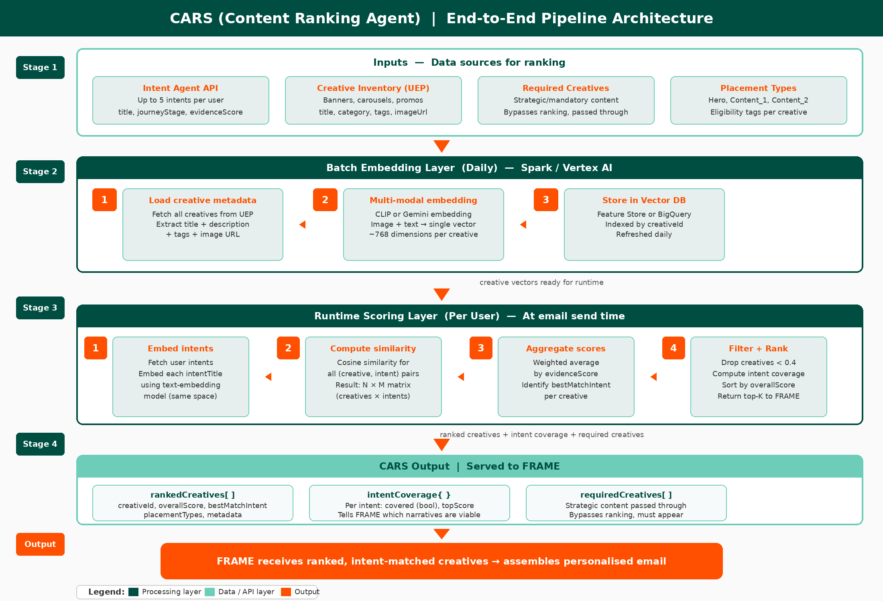

03 | The Approach

We use embedding-based semantic matching. Each creative gets converted into a vector that captures its meaning (from both image and text). Each intent also becomes a vector. We then measure how close they are in vector space — closer means more relevant.

Step 1 — Embed creatives (batch, daily)
Each creative is embedded using a multi-modal model (CLIP or Gemini) that jointly encodes the image and text metadata. This runs once per day as a batch job.

Step 2 — Embed intents (runtime, per user)
When a user is about to receive an email, we fetch their intents and embed each intent title into the same vector space.

Step 3 — Compute similarity
We calculate cosine similarity between every creative and every intent. For a user with 3 intents and 500 creatives, this produces a 500 x 3 matrix of scores.

Step 4 — Aggregate to single score
We collapse the matrix to one score per creative using a weighted average, where the weights are the evidence scores from the Intent Agent. A creative matching a strong intent scores higher than one matching a weak intent.

Step 5 — Filter and rank
We drop creatives below the threshold, sort by overall score, and pass the ranked list to FRAME.

Why this approach? No LLM at runtime — it’s fast, predictable, and cheap. Multi-modal embeddings capture visual signals that text alone would miss. And weighting by intent strength means we prioritise creatives that match strong signals, not just any intent.

04 | Scoring Logic

Overall score per creative:

overallScore = Σ (matchScore_i × evidenceScore_i) / Σ evidenceScore_i

In plain terms: we take each intent’s match score, weight it by how confident we are in that intent, and compute the weighted average. A creative that matches a strong intent well will outscore one that matches a weak intent perfectly.

Thresholds:

Threshold | Value | What happens
Creative threshold | 0.4 | Creatives below this are filtered out entirely
Intent coverage threshold | 0.5 | If no creative scores above this for an intent, we mark that intent as "not covered"

Intent coverage tells FRAME which intents have viable creative matches and which don’t. If intent #2 has no good matches, FRAME shouldn’t try to build a narrative around it.

05 | Inputs and Outputs

What CARS receives from the Intent Agent:

{
"userId": "u_123",
"intents": [
{ "rank": 1, "intentTitle": "chasing Haaland rookie cards",
"journeyStage": "ready_to_buy", "evidenceScore": 0.82 },
{ "rank": 2, "intentTitle": "hunting vintage denim",
"journeyStage": "browsing", "evidenceScore": 0.44 }
]
}

What CARS receives from the Creative Inventory (UEP):

{
"creativeId": "cr_001",
"title": "Haaland Rookie Cards — Top Picks",
"category": "Trading Cards",
"tags": ["football", "rookie"],
"imageUrl": "https://...",
"placementTypes": ["hero", "content"],
"isRequired": false
}

What CARS sends to FRAME:

{
"userId": "u_123",
"rankedCreatives": [
{ "rank": 1, "creativeId": "cr_001", "overallScore": 0.78,
"bestMatchIntent": { "intentRank": 1, "matchScore": 0.85 },
"placementTypes": ["hero", "content"] }
],
"intentCoverage": {
"1": { "covered": true, "topScore": 0.85 },
"2": { "covered": false, "topScore": 0.31 }
},
"requiredCreatives": [ ... ]
}

Field | What it tells FRAME
overallScore | Single number to rank by (weighted avg across intents)
bestMatchIntent | Which intent this creative best serves — useful for narrative
intentCoverage | Which intents have viable matches and which don’t
requiredCreatives | Strategic creatives that must appear regardless of score

06 | What We’re Assuming

These are the assumptions baked into this design. If any turn out to be wrong, we’ll need to revisit.

# | Assumption | If wrong...
1 | Images are available for most creatives | Fall back to text-only embedding (lower quality)
2 | Creative metadata has title, category, tags at minimum | May need LLM enrichment (adds cost)
3 | One email per user (blending multiple intents) | Output schema changes significantly
4 | Creatives tagged with placement types (Hero, Content) | CARS returns flat list, FRAME infers placement
5 | ~1,000 creatives in inventory | If 10K+, we need approximate nearest neighbour
6 | No historical CTR data for POC | Pure semantic ranking, no engagement signal

07 | Boundaries

To keep responsibilities clear, here’s what CARS explicitly does not do:

Not CARS’ job | Who owns it
Assigning creatives to placements (Hero, Content) | FRAME
Making sure the email tells a coherent story | FRAME
Applying fatigue rules | TBD — likely upstream or FRAME
Final send/no-send decision | GOAT / Orchestrator

08 | Open Questions

These are blocking questions. We cannot finalise the design until we get answers.

# | Question | What it unlocks
1 | Is it one email per user (multi-intent) or one email per intent? | Output schema and scoring aggregation logic
2 | Are creatives already tagged with placement types? | Whether CARS filters by placement or returns flat list
3 | What creative metadata is actually available? Are images available? | Embedding approach — multi-modal vs text-only

