The Cubs have depth in every position across the field with the addition of Alex Bregman this offseason and the emergence of potential superstar Pete Crow-Armstrong, helping drive attendance back toward pre-pandemic levels. With a lineup of veteran position players like Dansby Swanson and Alex Bregman under long-term contracts, the Cubs are projected to compete for the NL Central in 2026. However, entering the 2027 season, much of the Cubs’ pitching roster is scheduled to enter free agency, with only Caleb Thielbar and Phil Maton under locked-down contracts (“Chicago”).
As the league has graduated from reliance on a single star pitcher toward deeper rotations, organizations need more arms to sustain them through the 162-game gauntlet. Pitchers carry the highest injury risk, and this vulnerability was manifested in the Cubs’ 2025 NLDS loss, when bullpen fatigue became an obvious setback. With the average age of the Cubs’ 2026 pitching rotation at 29.8, adding a younger starter who could complement Edward Cabrera is essential to sustaining postseason success through October (“Chicago”). Jesús Luzardo presents a solution to this rotation longevity issue.
The Cubs almost acquired Luzardo after the 2025 season but declined due to his medical history. However, Luzardo delivered a strong 2025 season with the Phillies, finishing seventh in the race for the NL Cy Young Award at age 28 (Rosenthal). He remains on the left side of the pitcher aging curve, meaning the Cubs could capitalize on his projected peak seasons that occur between ages 28 and 30 (Petti). Among starters under 30 in the 2027 free-agent class, including Kris Bubic, Dustin May, Trevor Rogers, and Michael Soroka, Luzardo leads the group with 11.4 WAR, 121 career starts, and a 26.7% strikeout rate (“Justin”).
The accompanying visualizations reinforce this point. The scatterplot in Figure 1 compares 2026 Cubs starters (red) to other under-30 free-agent pitchers in the 2027 class. The plot shows that Cubs pitchers have higher salaries as age increases, and Luzardo’s projected salary places him below the Cubs’ starters at a younger age. This favors Luzardo because he is younger than the rotation average and cheaper than current starters.
The Figure 2 bar chart also highlights Luzardo’s appeal. Assuming the average market valuation of $8 million per WAR, the chart sorts pitchers by surplus value. Luzardo shows one of the largest gaps between WAR (blue) and salary (red), demonstrating that he is undervalued. While some pitchers in the class are cheaper, they offer considerably lower performance, and higher-priced alternatives fail to pull their weight in WAR.
Given his performance outlook and injury risk, including prior back and elbow issues, I recommend offering Luzardo a two-year, $24 million contract. This allows the Cubs to capture his prime years while limiting potential medical problems, providing rotation stability through the 2027 pennant race. Luzardo would earn more than his current salary and have the option to re-enter free agency at 30 with higher market value. Overall, Luzardo represents an opportunity that meets the Cubs’ competitive and financial standards.

Starting Pitcher Aging Curve:
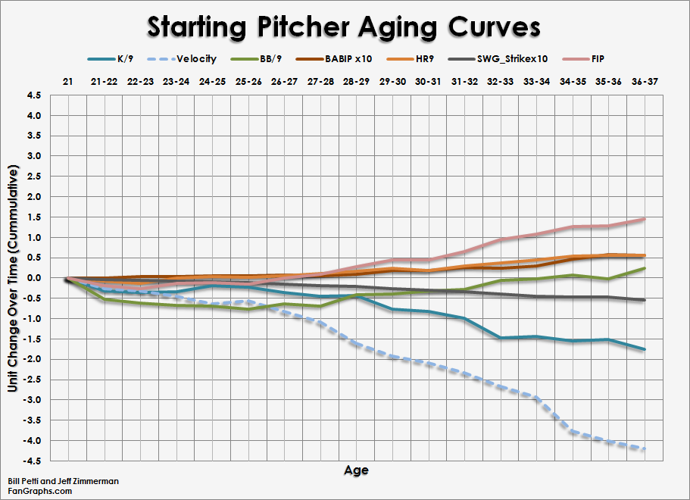
Figure 1:
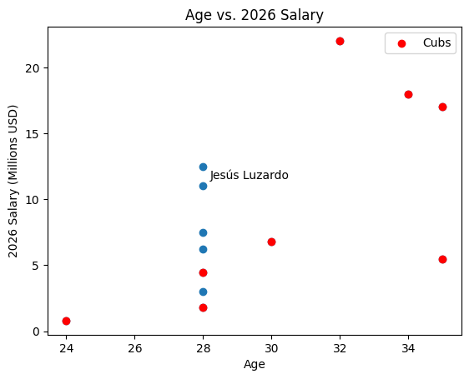

Figure 2:
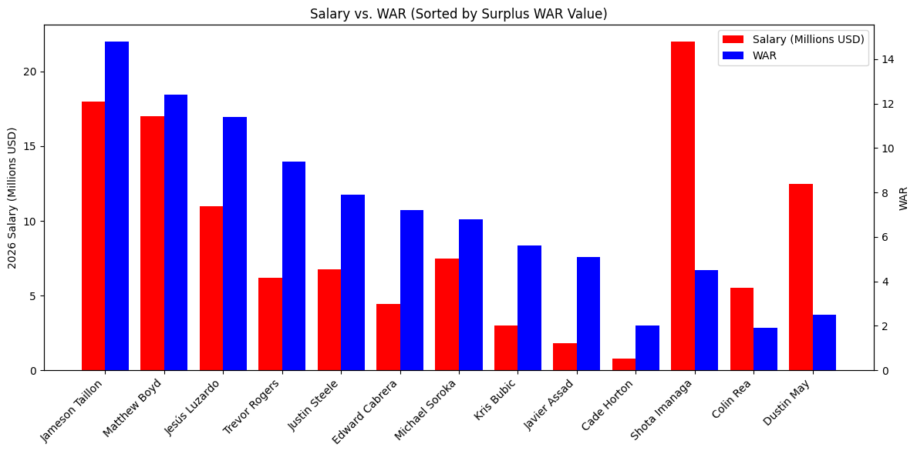
Works Cited
“Chicago Cubs Salaries and Contracts.” Baseball Reference, Sports Reference LLC, www.baseball-reference.com/teams/CHC/chicago-cubs-salaries-and-contracts.shtml. Accessed 31 Jan. 2026.
“Justin Steele vs. Javier Assad vs. Matthew Boyd vs. Cade Horton vs. Shota Imanaga vs. Michael Soroka: Head-to-Head Stats Comparison.” Stathead Baseball, Sports Reference LLC, www.sports-reference.com/stathead/baseball/versus-finder.fcgi?request=1&player_id1=steele000jus&player_id2=assad-000jav&player_id3=boyd--000mat&player_id4=horton000cad&player_id5=imanag000sho&player_id6=soroka000mic. Accessed 31 Jan. 2026.
Petti, Bill. “Pitcher Aging Curves: Starters and Relievers.” FanGraphs Baseball, 2 May 2012, blogs.fangraphs.com/pitcher-aging-curves-starters-and-relievers/. Accessed 31 Jan. 2026.
Rosenthal, Ken. “Cubs Had Offseason Trade Ready for Jesús Luzardo, but Backed out Due to Medical Concerns: Sources.” The Athletic, 25 Apr. 2025, www.nytimes.com/athletic/6310063/2025/04/25/jesus-luzardo-phillies-cubs-marlins-trade-medical/. Accessed 31 Jan. 2026.

