MEMORANDUM
Date: 18 February 2026
To: Gates Foundation
From: Ashley Marietta Technologies (AMT)
Subject: Misdiagnosed Pneumonia Cases: Optimizing Model Accuracy

Executive Summary
To combat misdiagnosed pneumonia in children in Nigeria, Ashley Marietta Technologies (AMT) created a Convolutional Neural Network (CNN) using training data from 2,900 children’s X-rays and validated it on 200 held-out images to identify the parameters that maximize the Area Under the Curve (AUC) value. The best model resulted in an AUC of .9918 and 96% accuracy. AMT suggests process-augmentation deployment of their model, utilizing the Gates Foundation’s generous funding to decrease misdiagnosed pneumonia cases that cost Nigerians $70,264,824.55 annually and save lives, as 19% of children die each year from pneumonia in Nigeria (“Nigeria”).

Background and Description of Analysis
Pneumonia is the world’s leading cause of death for children aged five or under, particularly in Sub-Saharan Africa, where 60% of pneumonia deaths occur. Misdiagnosis is a major problem, with 8.3% of children who manifest World Health Organization (WHO) pneumonia criteria lacking a diagnosis and risking severe health consequences (Graham et al.). The limited availability of X-ray machines and inadequate radiologist training lead to incorrect diagnoses. To address the problem, AMT has begun using Convolutional Neural Networks (CNNs) to detect pneumonia in patients’ X-rays through process augmentation that serves as a second opinion for clinicians. CNNs use the powerful concepts of convolution, pooling, and dropout across multiple layers to learn complex patterns from images, meaning they can classify images based on visual patterns like edges and textures. Utilizing the “Individual Assignment” notebook linked in the appendix, AMT built a model with a parameterized architecture and optimized weights learned through backpropagation with gradient descent to make the CNN more efficient for quicker and more accurate diagnoses for patients in Nigeria.

Key Factors for Accurate Detection
The parameters that output the model with the highest AUC of .9918 are shown below in Key Model Parameters (Figure 1). A higher dropout value increased the ratio of randomly deactivated neurons to limit overfitting. A parameterized model was used to allow for systematic hyperparameter tuning to support the goal of efficiency. AMT also found that using more epochs, which occur when the network has made one complete pass through the training set, and filters, which extract features to create a feature map, allowed the model to detect more patterns and, thus, improve accuracy. Here, utilizing multiple layers allowed the CNN to learn many levels of features because filters in different layers extract different patterns. Using a smaller batch size, which controls the quantity of instances seen in a batch before each update, helped generalize the data to avoid overfitting, and a smaller kernel size also allowed for a deeper architecture to learn more complex features.

Key Model Parameters (Figure 1)
Convolutional Layers | Filters | Kernel Size | Dropout Value | Max Pooling Layers | Classes | Batch Size | Learning Rate | Epochs
3 | 256 | 3x3 | .3 | 2 | 2 | 32 | .0001 | 32

The .9918 AUC metric shown below in Model Outputs (Figure 2) demonstrated that the model is nearly perfect at ordering data points as either pneumonia or not pneumonia and misses fewer than 5% of true pneumonia patients. AMT submitted predictions to Kaggle, resulting in a .99620 Kaggle score, above the required .995 target for effective deployment of the model. The external Kaggle validation confirmed the CNN’s ability to generalize beyond the training data.

Model Outputs (Figure 2)
Accuracy | Precision Negative | Precision Positive | Recall Negative | Recall Positive | AUC
96 | 95.85 | 96.15 | 96.18 | 95.82 | 99.18

The benefits of deploying this model are minimal cost per scan, increased consistency from solely human interpretation, and reduced radiologist workload. However, model monitoring and staff training entail some initial setup costs and minor inaccuracies. For example, as shown by the Confusion Matrix (Figure 4), the model still misidentifies 23 out of 575 cases, and 12 children with pneumonia are classified as healthy. Applied to the 89,299,335 children aged zero to 14 in Nigeria, false negative cases from relying solely on the CNN model result in a total cost of $69,633,746.15 in ICU admissions (shown in Cost-Benefit Analysis (Figure 3)) if each child stays one day (“Population”; “Healthcare”). This assumes the patient can be admitted, given that there is a ratio of .19 beds per 100,000 Nigerians (Tobi and Ogunbiyi). However, when compared to the current 85% accuracy of radiologists throughout disparate regions, this technology would correct 9,822,926 diagnoses, saving thousands of lives and dollars. This is why AMT recommends implementation via augmentation in addition to a clinician’s opinion to decrease the number of missed cases that lead to hospitalization and, 19% of the time, death (“Nigeria”).

Cost-Benefit Analysis (Figure 3)

Conclusion
Because there is higher variance in children’s X-rays than adults’ scans, AMT suggests first implementing the model as an augmentation to clinicians. Though models with AUC values above 99% are considered useful decision aids in countries with developed healthcare systems, the problem of misdiagnosis is rampant enough in developing countries like Nigeria to recommend starting with process augmentation. AMT suggests that the Gates Foundation deploy this CNN model in Nigeria immediately to improve diagnostic abilities and decrease clinician workload, decreasing the $70,264,824.55 currently spent on false positives and negatives. Though the costs of setup and training exist, the benefit of higher accuracy means more correctly classified X-ray images and, thus, more patients’ lives saved. If not, the lives of nearly 17 million Nigerian children are at stake.
Appendix
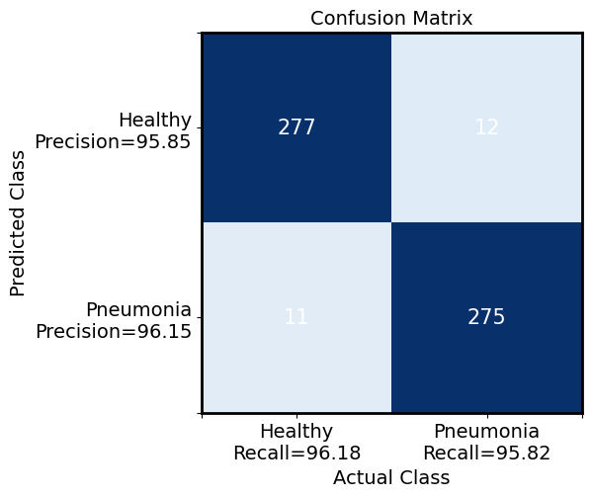
Confusion Matrix (Figure 4)
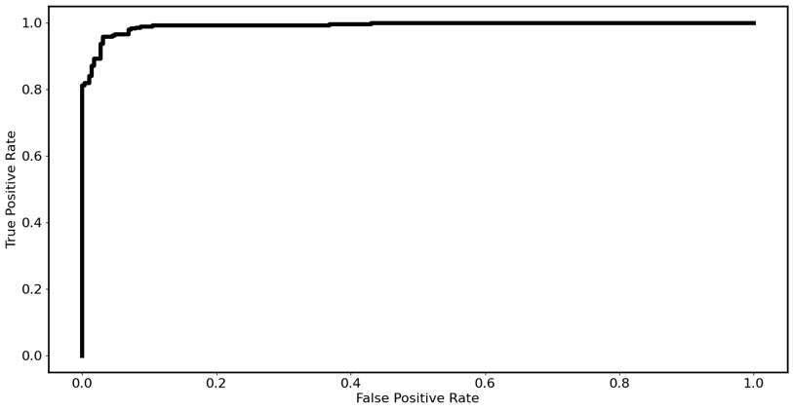
ROC Curve (Figure 5)
Model Summary (Figure 6)
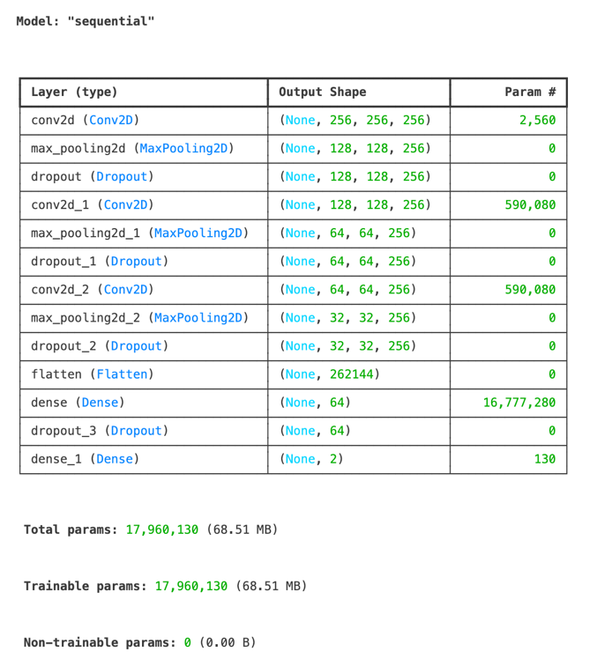
Sources
Graham, Hamish, et al. “Diagnosis of Pneumonia and Malaria in Nigerian Hospitals: A Prospective Cohort Study.” Pediatric Pulmonology, vol. 55, suppl. 1, 2020, pp. 37-50, https://pubmed.ncbi.nlm.nih.gov/32074408/. Accessed 16 Feb. 2026.
“Healthcare Costs in Nigeria (2025): What’s Rising and How to Save.” CIMPLE Healthcare, 29 Aug. 2025, www.cimplehealthcare.com/post/healthcare-costs-in-nigeria-2025-what-s-rising-and-how-to-save. Accessed 17 Feb. 2026.
“Nigeria Contributes Highest Number to Global Pneumonia Child Deaths.” UNICEF, 12 Nov. 2019, www.unicef.org/nigeria/press-releases/nigeria-contributes-highest-number-global-pneumonia-child-deaths. Accessed 16 Feb. 2026.
“Population Ages 0-14, Total - Nigeria.” World Bank Open Data, 2026, data.worldbank.org/indicator/SP.POP.0014.TO?locations=NG. Accessed 18 Feb. 2026.
Tobi, Kingsley Ufuoma, and Obashina A. Ogunbiyi. “Critical Care in Sub-Saharan Africa, Where Are We? A Review.” Journal of the West African College of Surgeons, vol. 14, ed. 1, 14 Dec. 2023, pp. 1-4, https://pmc.ncbi.nlm.nih.gov/articles/PMC10936891/. Accessed 17 Feb. 2026.

