Ashley Marietta
Professor Barron
Sports Analytics
26 February 2026
MLB All-Stars: A Groundout for Game Attendance
Introduction
Professional sports teams have two goals in business: to make money and to win championships. While these two may seem to be antithetical, a recent Major League Baseball (MLB) trend may disprove the idea that revenue and win maximization are separate entities. The league has entered an era where star players seem to drive fans to games and teams to postseason competitions. This project analyzes whether superstar players increase MLB game-level attendance beyond what can be explained by team performance and market size to combat the problem of league disparity.
In baseball, fewer competitive balance checks exist than in other leagues, such as salary caps. Thus, a larger disparity between small-market and large-market teams manifests itself, with clubs like the Yankees and Dodgers owning an uneven portion of market share. With higher payrolls, these teams can afford expensive names like Aaron Judge and Shohei Ohtani and see higher fan turnout. However, are these phenomena correlated? The potential connection between star players and game attendance numbers could be a marketing strategy for small-market teams because, by buying a name-brand cornerstone on which to build their organization, teams with less capital could still drive fans to games to see their one all-star. Therefore, a few supplementary questions arise. Do star players have a valuable return on investment (ROI) in the MLB in terms of attendance? Should teams invest in one all-star instead of distributing their payroll more evenly? The proposed solution is to model the dependent variable of game attendance based on winning percentage, number of star players per team, and market size via city population using linear regression, LASSO, decision tree, hierarchical clustering, and XGBoost with SHapley Additive exPlanations (SHAP) models, outputting a statistical analysis with documented results for teams to consider.
Related Work
A study was conducted by Dominic H. Rivers and Timothy D. DeSchriver in 2002 to examine the relationship between top-tier players and payroll distribution and attendance in Major League Baseball. They found that an all-star has a trivial influence on attendance if he does not improve on-field success. While they also discovered that the relationship between payroll and attendance is positive, the researchers recommended that MLB teams distribute their payroll evenly across the roster if they wanted to maximize attendance. I hoped to update their research, given that the top-paid athlete Shohei Ohtani now earns $70 million annually, compared to the $20 million that Alex Rodriguez signed for in 2001 (Rivers and DeSchriver). The disparity between elite and average MLB athletes’ salaries has also increased over the last 20 years; for example, Kyle Tucker will earn $55 million in the 2026 season, compared to the $5.5 million made by Miguel Rojas, even though they are both infielders on the Los Angeles Dodgers (“Los”). I additionally defined a star player differently from the authors in the prior paper because Wins Above Replacement (WAR), which measures the number of wins an athlete adds above a replacement-level player, was not a widely used sabermetric statistic at the time of their research. The authors instead used a value system that awarded players points for winning awards or making the All-Star Game, which can be skewed because there must be at least one competitor from each team in the All-Star Game (Rivers and DeSchriver). WAR is a more objective metric than accolades, thus making my measure less biased.
Methodology
To answer the key questions, game-level attendance, individual and team performance, and market size data were compiled. For game-specific attendance data, Baseball Reference hosted tables for each park, both in totals and averages. ESPN provided in-depth athlete data for each season, starting in 2023 and continuing through the 2025 season, to have sufficient data points. Finally, Clem’s Baseball Blog contained United States metropolitan area population estimates, citing the U.S. Census Bureau and The World Almanac and Book of Facts. The final dataset contained a row for each of the 30 teams for 2023, 2024, and 2025 (90 total), along with the number of all-star players, defined as having a WAR greater than or equal to five, extrapolated from these data sources.
The variables of payroll, winning percentage, stars per team, and city population were chosen for their implied impact on driving fans to the ballpark. For example, large-market teams that can afford higher-salaried players and more marketing campaigns were predicted to have higher attendance. Additionally, teams that win more were forecasted to draw more fans to games. Cities with greater populations were also anticipated to bring in more supporters, except for cities like New York, Los Angeles, and Chicago that have two teams in the area. Finally, when a team had more all-stars, it was predicted to have a higher game-level attendance because athlete popularity, especially driven by social media advertising, could influence even non-avid baseball followers to head to the ballpark. For each model, game attendance was the dependent variable, with winning percentage (w_l), stars per team (stars_per_team), payroll, and city population as explanatory variables. Several models were run, including linear regression, LASSO, decision tree, hierarchical clustering, and XGBoost with SHAP values models using R.
Discussion
The linear regression found that payroll and winning percentage were the only statistically significant variables at the 95% confidence interval, with p-values of 0.00000000000000732 and 0.00431, respectively. When payroll increased by $10,000,000, attendance climbed by 1,680 fans, and, when a team’s winning percentage grew by 5%, attendance rose by 1,214, holding all other variables constant. Stars per team showed the least amount of impact with a p-value of 0.97871. The adjusted R-squared value was .7012, meaning that the model predicted roughly 70% of the change in attendance variation. In both the linear regression and LASSO models, population showed a negative effect, meaning that an increase in population led to a decrease in attendance. This could be caused by the fact that larger cities like New York, Los Angeles, and Chicago have two teams or that fans in larger metropolitan areas are less interested in attending games, perhaps because multi-team markets split demand. Because there were only four independent variables in the dataset, the LASSO model results were trivial because all variables remained in the model. Once again, payroll showed the largest impact, followed by winning percentage, population, and stars per team, ceteris paribus.
In the decision tree model (Figure 1), payroll displayed its prominence because decision trees split on their most prominent node. When the payroll was under $142,000,000, the next split occurred at a winning percentage below or above 53%, demonstrating that small-market teams below a $142,000,000 payroll often had lower winning percentages than the 57% winning percentage for teams above that threshold. Even in the cluster analysis (Figure 2), the model grouped teams with similar payrolls and winning percentages, with large-market, successful teams like the New York Yankees and Los Angeles Dodgers being in the purple cluster and teams like the 2025 Colorado Rockies, who had zero all-stars and one of the worst records in baseball history, in their own separate green attendance category. The number of all-stars did not appear to impact the clusters at all, with teams like the 2023 San Diego Padres and 2023 Atlanta Braves existing in the same light blue cluster despite having three and four all-star players, respectively. They appeared to be more based on payroll, manifested by the 80% similarity in the budgets for the two teams in the light blue cluster. Finally, SHapley Additive exPlanations (SHAP) values were created from an XGBoost model. The SHAP values (Figure 3) shared the same conclusion as the other models: payroll and win-loss percentages had a much greater influence than the number of stars per team in driving attendance.
Figure 1 – Decision Tree Model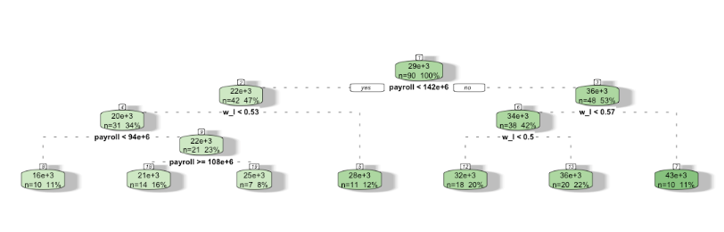
Figure 2 – Cluster Analysis
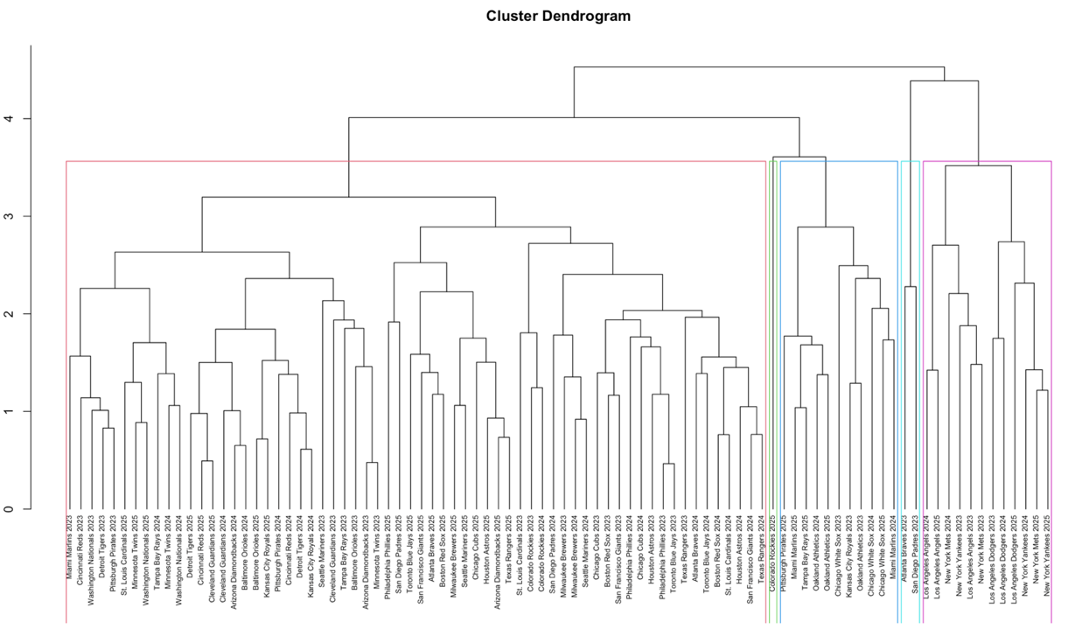
Figure 3 – SHAP Values
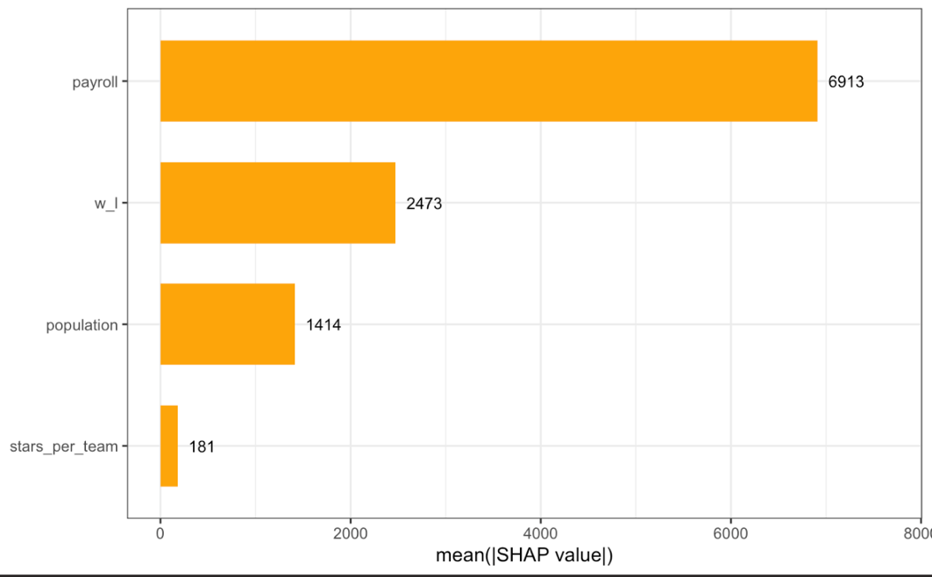
ChatGPT helped complete the datasets in Excel, such as aggregating the WAR data from multiple sources to include team names. I reviewed its work by cross-referencing between my sources to ensure the information seemed logical. I also used it to help lay out the coding steps to get my project off the ground, serving as an outline for where I started and where I needed to be by the project deadline.
This analysis implied that teams should use their payroll to have the best winning percentage, not one all-star, likely meaning spreading their funding for a more balanced lineup. Small-market teams thus have two options for attendance strategies. First, they could incorporate more rebuilding years where they take a hit on attendance for a few seasons to save for a year to push for the pennant, making their ticket money back in one season; the other option is to keep their win-loss record as consistent as possible, never fully optimizing their attendance but keeping fans steadily engaged. Large-market teams did have an advantage created by payroll, but their disparity was not caused by big-name athletes. While top-tier players may have influenced other variables like winning percentage, as demonstrated in Figure 4, they did not directly affect game-level attendance as originally predicted. Generally, attendance and all-stars were positively correlated (shown in Figure 5), but, as evidenced in this paper, this relationship held less prominence when payroll and winning percentage were controlled. Thus, all-stars were a groundout for predicting attendance, not a strikeout nor a home run.
Figure 4 – Star Players vs. Winning Percentage Scatter Plot
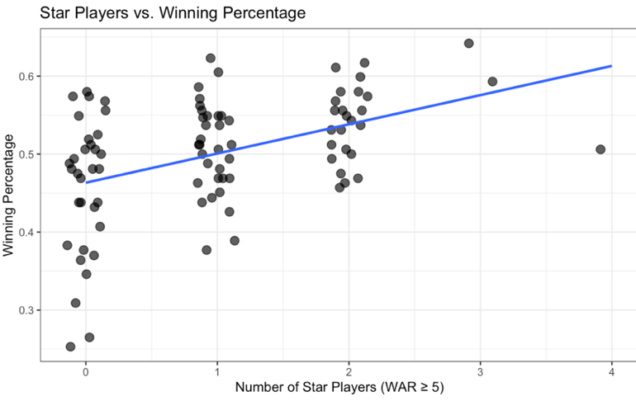
Figure 5 – Star Players vs. Attendance Scatter Plot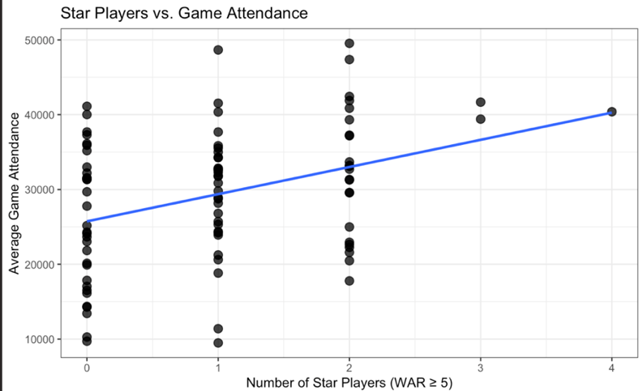
Conclusion and Future Work
Attendance is most strongly associated with payroll, moderately with winning percentage, and minimally with population and all-star concentration. Win and revenue maximization remain distinctive goals that can both be impacted by successful team performance, given that teams that spend more on their rosters generally win more. All-stars create a return on investment in their contribution to winning percentage but not in a direct attendance boost. To maximize winning percentage, which had more impact on attendance than did all-star players, teams should spread their payroll across the roster, as noted by the findings of Rivers and DeSchriver in 2002.
With more time, I would include data from the past 10 seasons, dropping the 2020 and 2021 seasons that were skewed by the global pandemic, to potentially improve the R-squared value of the linear regression model. Given the small sample size of 90, my model risks overfitting, so a more robust dataset could improve data quality. I would also focus my analysis on small-market teams like the Kansas City Royals and the Tampa Bay Rays. For teams like the Philadelphia Phillies, the marginal addition of one star player may not impact attendance, given that they had three in the 2025 season. However, for smaller clubs, having one athlete to serve as the face of the franchise could change their marketing strategies and how they appeal to their supporters and their cities. I would split at the average payroll of $161,385,931.60 and evaluate only teams under that metric. With a more focused unit of analysis, I could better study whether acquiring a single star player could be a strategy for small-market teams to expand attendance revenue and close the wide payroll gap. Finally, I would analyze the stadium type for each team, considering that the Tampa Bay Rays play in a small dome compared to the massive Dodger Stadium; I could calculate attendance based on percent capacity filled instead of raw numbers. However, ultimately, championship teams have all-stars, but attendance maximization occurs through balanced rosters and consistent wins.
Works Cited
“2025 Major League Baseball Attendance & Team Age.” Baseball Reference, 2026, www.baseball-reference.com/leagues/majors/2025-misc.shtml. Accessed 31 Jan. 2026.
Clem, Andrew G. “Baseball Cities.” Clem’s Baseball Blog, www.andrewclem.com/Baseball/Baseball_cities.html. Accessed 4 Feb. 2026.
“Los Angeles Dodgers Salaries and Contracts.” Baseball Reference, 2026, www.baseball-reference.com/teams/LAD/los-angeles-dodgers-salaries-and-contracts.shtml. Accessed 9 Feb. 2026.
“MLB Wins Above Replacement.” ESPN, ESPN Internet Ventures, www.espn.com/mlb/war/leaders/_/type/seasonal/year/2025. Accessed 2 Feb. 2026.
Rivers, Dominic H., and Timothy D. DeSchriver. “Star Players, Payroll Distribution, and Major League Baseball Attendance.” Sport Marketing Quarterly, vol. 11, issue 3, 2002, pp. 164-173. https://doi.org/10.1177/106169340201100304. Accessed 9 Feb. 2026.
Snyder, Matt. “Average MLB Salary Hits Record in 2025, but Increases Shrink Again as CBA Battle Looms.” CBS Sports, CBS Interactive Inc., 3 Feb. 2026, www.cbssports.com/mlb/news/mlb-salary-record-payroll-2025/. Accessed 10 Feb. 2026.
“War Leaderboards.” FanGraphs Baseball, www.fangraphs.com/leaders/war. Accessed 3 Feb. 2026.

