Ashley Marietta
Professor Barron
Human Performance Analytics
01 April 2026
Assignment Two
- Define the problem you are trying to solve and state a clear objective.
  - Especially with an increase in long-distance trips due to conference realignment, student-athletes must travel frequently for competitions, heightening the risk of travel fatigue. The objective is to identify and quantify the significant factors contributing to travel stress among college softball student-athletes at the University of Notre Dame. By analyzing force plate jump data in relation to travel schedules, this analysis hopes to identify stress-inducing variables and implement strategies to help athletes perform at their peak.
- Describe the perfect world model -- what would the ideal solution look like if you had no constraints?
  - A perfect model would reveal the worst scenario that causes peak travel stress so that those factors could be avoided at all costs by the program. The Notre Dame Athletics department could fund travel in a way to minimize those factors so that their athletes are the most rested and confident heading into away competitions.
- Identify the factors you believe play a role in the problem and explain why each one matters.
  - From personal experience, I expect time zones crossed to play a large factor because adjusting one’s body clock for multiple hours behind or ahead can impact mealtimes, bedtimes, and peak energy times. I also anticipate distance from home to play a key role in determining fatigue and force plate performance. While these are not directly controllable by the Notre Dame Athletics department, they could lead to altered travel schedules, such as a flight one day earlier before competition or the placement of a long-distance series at the beginning of the season instead of mid-season.
- Sketch a diagram of your mental model showing how the factors relate to each other and to the outcome.
  - 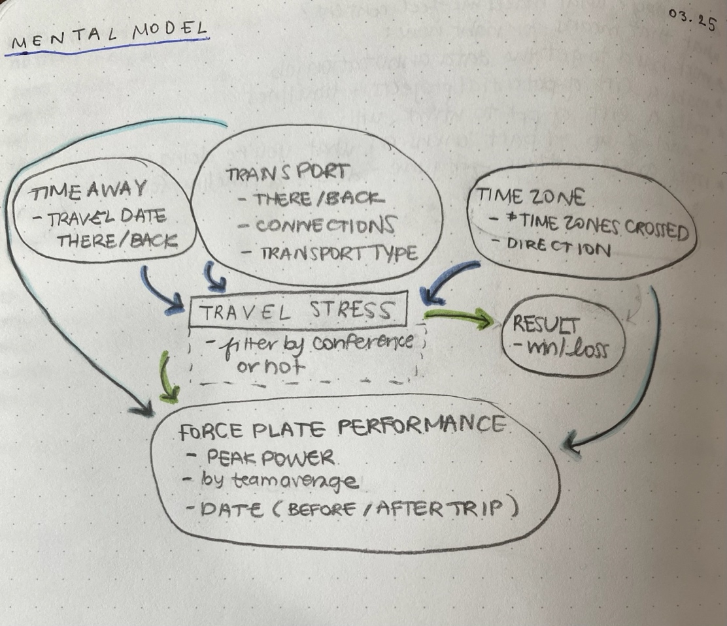
- Identify data sources for each factor -- name specific datasets, APIs, or R packages you plan to use.
  - I plan to use internal force plate data from my internship at Notre Dame Athletics, as well as publicly available schedule data from the Notre Dame Athletics website. I will use my personal travel itinerary from each trip to fill in flight and schedule data, and I will use a document provided by Notre Dame Athletics from the Grow Irish data project to calculate the travel stress functions.
- Convert to specific variables and update your diagram to show where each variable connects to the factors.
  - 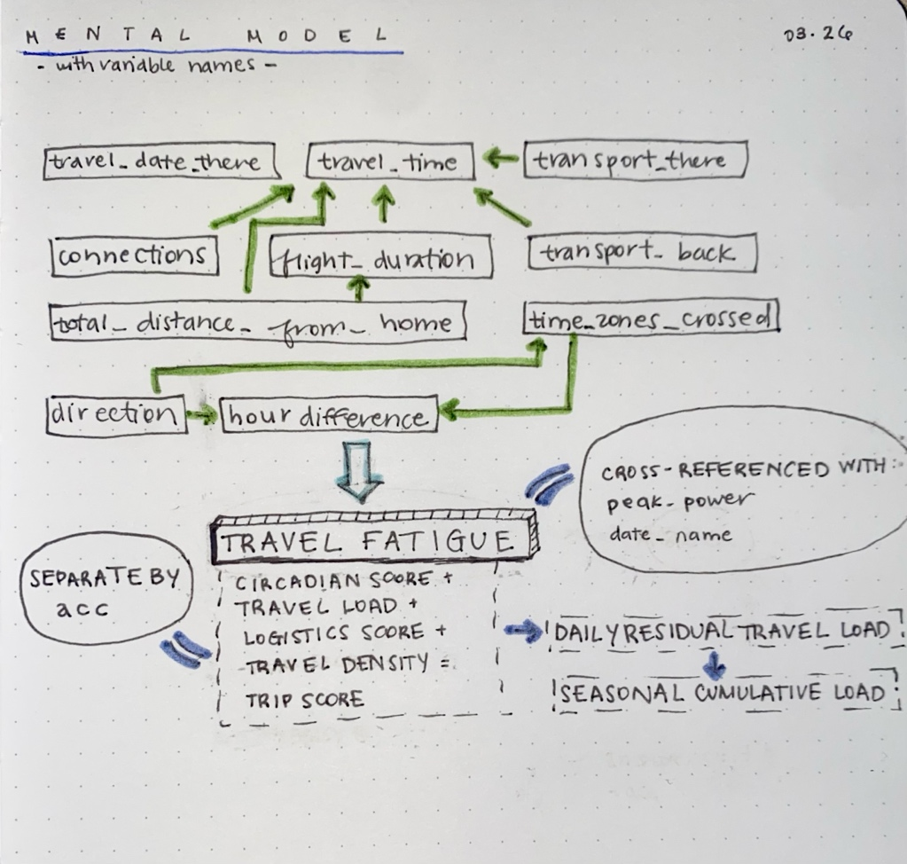
  - Variables – travel_date_there and travel_date_back will provide the trip duration and the framework for when athletes begin/end experiencing travel fatigue. travel_time is the total number of minutes spent in transit (flying or driving), and it is influenced by connections (including a charter bus to flight connection), flight_duration (minutes allotted by the airline for the flight), total_distance_from_home (calculated in miles from the center of campus to the town of play), transport_there (the type of transport taken to reach the destination), and transport_back (the type of transport used to return from the destination). In theory, if an athlete must endure more connections and miles, they are spending less time acclimating to their new competitive environment. Direction (east or west), hour_difference (from EST), and time_zones_crossed (from EST) will also be considered in determining travel fatigue. Any deviation from an athlete’s normal patterns, even one hour off their native time zone, can impact their energy and mood, which impacts performance.
  - Cross-references – I will utilize peak_power (measure of force applied by the athlete into the force plate) and date_name (date of force plate jump) to track athletes’ physical fatigue manifested in performance to compare it to the calculated Seasonal Cumulative Load. While I cannot guarantee that jumps will correlate to travel fatigue because they could be influenced by other factors like academic stress, practice soreness, or failure to give maximum effort, I expect to see that longer trips will correlate to lower peak power.
  - Outputs – I will utilize Trip Score (a combination of Circadian Score, Travel Load, Logistics Score, and Travel Density) to calculate Daily Residual Travel Load (RTL) (fatigue score beginning on first day home after travel) and Seasonal Cumulative Load (CRTL) (cumulative sum of RTL across the season).
    - Later, I hope to apply travel fatigue to focus on ACC competitions (games that matter more than pre-season competitions).
- Write out the formula for your model, progressing from abstract factors to concrete variables, with noise.
  - P(travel fatigue) = f(circadian score, travel load, logistics score, travel density, noise)
  - I do not include jump data here because I want to use that data to compare with the calculated trip scores. I do not want to risk force plate data overriding the other variables in the model because Notre Dame Athletics gave me those specific formulas for travel stress to use.

