Ashley Marietta
Professor Barron
Human Performance Analytics
28 April 2026
The Impact of Travel Fatigue on College Athlete Performance
Introduction
With the increase in long-distance travel due to conference realignment, student-athletes must travel frequently for competitions, heightening the risk of travel fatigue. The problem is critical to the University of Notre Dame Athletics Department because of how many minute factors impact peak performance; for example, crossing time zones means adjusting one’s body clock and altering mealtimes, bedtimes, and peak energy times. For athletes’ health, safety, and longevity, minimizing fatigue becomes a fundamental priority. The objective is to cluster softball student-athletes at the University of Notre Dame based on how their force plate jump performance responds to shared team travel stress. Then, cluster assignment will be predicted from personal response features. By cross-referencing force plate jump data with travel schedules, this project hopes to identify the impact of stress on each player, grouping them into one of five groups based on stress response. This can be passed on to coaches and directors to implement strategies to help athletes perform at their peak and to empower administrators to minimize controllable factors, like means of transportation, that affect player longevity.
This analysis uses internal force plate data from Notre Dame Athletics, as well as publicly available schedule data from the Notre Dame Athletics website. The official travel itinerary from each softball trip is utilized to fill in flight and schedule data, along with a document provided by Notre Dame Athletics to calculate travel stress functions, eliminating the need for assumptions about event times. The outputs include two baseline random forest models; two XGBoost models; a feature significance plot for the best-performing model; visualizations showing the relationships between key variables; and this report summarizing the methods.
Related Work
Recent research on the subject, especially prominent in the new era of conference realignment, included a study by Dr. River Mackenzie VanZant on the University of Georgia NCAA women’s basketball team for the 2023-2024 season. It analyzed subjective sleep, mood, and recovery scores, as well as countermovement jump metrics, and showed that travel negatively impacted sleep quality, mood, and physical readiness; however, it had no significant effects on countermovement jumps (VanZant 82-83). Additionally, in 2024, a paper titled “The Negative Effects of Travel on Student Athletes Through Sleep and Circadian Disruption” was published in the Journal of Biological Rhythms by 25 authors across many elite institutions, confirming that travel caused desynchrony among natural rhythms that contributed to worsened performance (Heller et al.).
The research in this study differed in season length and sport specificity. The NCAA Division I women’s basketball regular season spans from early November until mid-March, while the NCAA Division I softball season lasts from the first week of February until the last weekend of April. The number of games played varies substantially, with women’s basketball teams competing in 31 regular-season games and softball teams playing in 56 games in a much shorter time span (Norlander).
Data Description
The main dataset contained travel metrics that were transformed into stress functions. To build the function for Circadian Load, time zones crossed and direction (east or west) were summed, with further distances yielding higher ordinal numbers and eastward travel weighted more heavily. Travel Load equaled the total distance from home plus the travel time in minutes, accounting for both flight and drive times. The Logistics Score measured transit type, with commercial flights equaling a score of four and home games equaling zero, and trip length. Density Score summed the return time to campus, with later times earning higher numbers, and the turnaround time in days before the next trip. Finally, Trip Score, a combination of Circadian Score, Travel Load, Logistics Score, and Density Score, was used to calculate Daily Residual Travel Load (RTL), which was the fatigue score beginning on the first day home after travel, and Seasonal Cumulative Load (CRTL), which equaled the cumulative sum of RTL across the season (see Figure 1). If an athlete must endure more connections and miles, they spend less time acclimating to their new competitive environment, and any deviation from their normal patterns, even one hour off their native time zone, can impact their energy, mood, and, ultimately, performance.
The jump performance dataset incorporated four main variables: athlete ID, z-score of peak power, peak power, and date. Peak power (measure of force applied by the athlete into the force plate) and date (date of force plate jump) tracked physical fatigue by day, sorted by athlete ID (each player’s unique identifier number). However, because peak power varied drastically by body weight and position, z-score of peak power provided a better baseline by capturing variation relative to each athlete’s average. Because there were only 21 members on the softball team, the sample size was small but could provide a signal for further data exploration. There were a total of 623 pre-season jumps from August 1, 2025, until February 4, 2026, (Figure 2) and 328 in-season jumps from February 5, 2026, until April 18, 2026, recorded (Figure 3).
Although jump performance was influenced by multiple factors, such as academic stress, practice load, or effort level, it was expected that longer and more demanding trips would generally correspond to lower (more negative) z-scores. A key derived variable measured days since travel, which set a boundary for keeping jumps only within zero to seven days after travel for modeling. Additional derived variables included flags for jumps below baseline z-score peak power, z-scores below -0.5, and negative z-scores; categorical buckets for ranges of days post-travel; and indicators for high RTL, CRTL, and Trip Score values. A key challenge was whether to include RTL and CRTL. Because CRTL monotonically increased, the CRTL values were always much larger than other values in the training set. Also, RTL and CRTL were closely correlated, so including both could introduce multicollinearity and reduce model reliability.
Methods
The data split was made on an athlete level because the season was too short for a meaningful temporal split. Leave-one-out cross-validation was used to prevent the model from memorizing patterns specific to athletes seen during training. The models were built using only jumps recorded during the season, looking into each individual’s z-score peak power. All jumps from the first workout in August until the first travel day in February were extracted to create a baseline for peak power from which the z-score would vary during the season. Athlete instances were created from only spring data, and players were clustered into five groups based on response variation from the fall baseline. Clusters were based on athlete-level data, such as their lowest z-score and percentage of days with low jump z-scores, not team-level variables, like turnaround time, that were constant across individuals. These clusters represented varying levels of fatigue sensitivity: highly-sensitive, sensitive, moderate-response, resilient, and highly-resilient. The highly-sensitive bucket held those who were most likely to suffer travel fatigue, and the highly-resilient group incorporated players who showed minimal fatigue as the season progressed.
After forming cluster groups, the models predicted which bucket each of the 21 athletes would be classified into. First, two random forest models were used: one including RTL and CRTL and one without these values. For predicting z-scores, random forests captured nonlinear relationships without extensive tuning. A total of 300 estimators were used with a maximum depth of five to balance predictive performance and computational efficiency, while a minimum leaf size of two prevented overly specific splits. The XGBoost models improved upon random forests by iteratively focusing on athletes that the random forest predicted poorly, learning from residual errors and incorporating regularization. These models ran 200 estimators with a maximum depth of three to balance complexity and generalization. A learning rate of 0.05 allowed for gradual learning across many trees, while a subsample value of 0.8 introduced randomness to help lessen overfitting.
Results
For the random forest model with RTL and CRTL, the RMSE was 1.4778 with an MAE of 1.0384 and R-squared of 0.0487; the values were 1.4778, 1.0385, and 0.0487 for the model without RTL and CRTL. Because the models had nearly identical outputs, RTL and CRTL may contribute only trivial predictive power. Similarly, for the XGBoost models, the model with RTL and CRTL outputted an RMSE of 1.4767, MAE of 1.0372, and R-squared of 0.0500, while the model without RTL and CRTL had values of 1.4768, 1.0369, and 0.0499, respectively (Figure 4). The combination of these metrics provided a comprehensive view that balanced accuracy and outlier variance. These values all indicated weak predictive performance, which was a key issue in the analysis. However, given the small sample size at the athlete level, the models were better suited to signal coaches and administrators toward capabilities with a larger sample size. Because the XGBoost with RTL and CRTL model yielded the best summary statistics, it was employed to create feature importance plots.
As shown by Figure 5, the most important predictor for the z-score of peak power with an importance of .22 was whether the team took a commercial flight home, followed by the Trip Score with an importance of .15. The binary variable of commercial return flight likely had the most predictive power because trips with a commercial flight back also involved a bus from Chicago to campus, often resulting in a much later return time. Multiple components compiled into commercial flights for Notre Dame student-athletes because of the lack of a major commercial airport near campus. The least predictive variables included whether a commercial flight was taken to the away series and the individual travel functions, like the Logistics Score and Travel Load Score. The low scores for these travel functions may have resulted because they were included in the overall Trip Score.
For the remaining seven games in the season, a prediction model was built to determine each individual’s expected z-score and to flag if the coaching staff should monitor an athlete more closely. It also showed the CRTL as it accumulates through the rest of the season, providing context for the predicted jump z-scores.
Actions
Stakeholders include administrators in the Notre Dame Athletics Department, especially Research and Innovation Associate Jono Lever and Associate Athletics Director John Wagle, and coaches. From this information, coaches can form training plans based on the habits of highly-resilient players; for example, these fatigue-resistant athletes could share their sleep or nutrition habits with teammates who are more sensitive to travel effects. This analysis also suggests that administrators should adjust travel budgets to allow for charter flights home from tournaments, even if it means flying commercially to more competition sites (Figure 6). They also can put less emphasis on the number of time zones crossed, the direction of travel, the distance in miles from home, and the duration of travel, as these components make up the Circadian Score and Travel Load Score. If resistance persists when presenting these ideas, this research can be supported by pointing to the extreme gap between the importance of the top-tier features, like a commercial flight home or the total trip score, in comparison to factors with zero importance, like Circadian Score and Travel Load Score. This is consistent with the idea that, when athletes have more demanding travel back to campus, they go into their next week fatigued, starting the next training block at a disadvantage. Because travel trips are often on a short time span for softball, athletes’ bodies may not fully adjust to new time zones, rendering time zone less useful in predicting long-term player fatigue.
This analysis can also be extended to the remainder of the current season. As illustrated in Figure 7, a prediction can be generated for the team’s next home game on April 22 against Northwestern, using data available as of April 21. If the team were to complete a jump assessment on that date, the two fatigue-sensitive groups would likely underperform due to limited recovery time following an away weekend series at Syracuse University and a home game on Tuesday, April 21.
Conclusion and Future Work
In summary, softball student-athletes face a 56-game schedule that accumulates physical strain over time, particularly as travel demands increase throughout the season. Using variance from players’ pre-season baseline peak power z-scores from force plate jumps, this analysis found that only five athletes fall into the highly-resilient group. This suggests that most athletes experience some element of performance decline under travel stress, indicating that current training plans may not serve all players. Equally helpful, identifying highly-resilient athletes provides coaches with clear prototypes of whose habits can be studied to improve overall team performance.
Across all models, the most important predictor of variance in z-score peak power was whether the team took a commercial or charter flight back to campus. This highlights that the structure and timing of return travel, often involving late arrivals and bus rides from Chicago, may play a larger role in short-term fatigue than broader cumulative metrics. Variables such as RTL and CRTL did not meaningfully improve model performance, suggesting that accumulated load may be less informative than immediate recovery conditions post-travel. From an administrative perspective, this presents a practical opportunity to reevaluate travel logistics, such as prioritizing charter flights for return trips, even if it requires trade-offs on the opening leg of a trip.
However, these results should be interpreted with prudence due to the small sample size and inherent variability in athlete performance data. The models in this analysis are better for identifying directional patterns than for producing accurate predictions. A key area for future work would be shifting focus away from team-level metrics like RTL and CRTL toward more athlete-specific models that better capture differences in fatigue response. With more time and data, the analysis could also emphasize ACC competition travel, which carries more importance than pre-season games.
Additionally, incorporating variables that account for external stressors, such as academic workload and opponent strength, would provide a more complete picture of performance variation. Introducing an injury flag would also help control for athletes who may be classified as fatigue-sensitive due to physical pain rather than travel effects. Finally, this framework could be extended to other sports with similar or more demanding travel schedules, particularly baseball, where a larger sample size may offer more robust analytical opportunities. Overall, while predictive performance remains limited, this study establishes a foundation for recognizing how travel logistics impact athlete performance and highlights the importance of recovery-focused decision-making in athletics administration.
Works Cited
Heller, et al. "The Negative Effects of Travel on Student Athletes Through Sleep and Circadian Disruption." Journal of Biological Rhythms, vol. 39, iss. 1, Feb. 2024, pp. 5-19. https://journals.sagepub.com/doi/epub/10.1177/07487304231207330. Accessed 2 Apr. 2026.
Norlander, Matt. “NCAA Votes to Increase College Basketball Schedules to 32-Game Season Beginning in 2026-27.” CBS Sports, CBS Interactive Inc., 25 June 2025, www.cbssports.com/college-basketball/news/ncaa-set-to-allow-college-basketball-schedules-increase-to-32-game-season-beginning-in-2026-27/. Accessed 9 Apr. 2026.
VanZant, River Mackenzie. Effect of Travel Stress and Physiological Training Load on In-Game Performance, Recovery, and Subjective Sleep Quality in NCAA DI Women’s Basketball Athletes. 2024. University of Georgia, PhD dissertation. https://openscholar.uga.edu/record/1923/files/VanZantRiverPHD.pdf. Accessed 2 Apr. 2026.

Appendix
Figure 1 – Original Dataframe with Travel Metrics

Figure 2 – Pre-Season Baseline Data
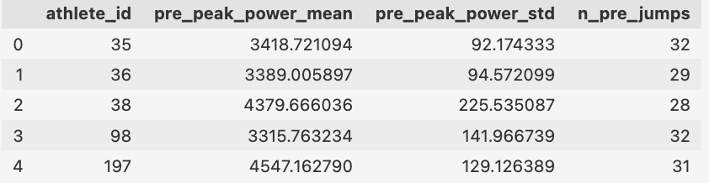
Figure 3 – Spring Testing Dataframe with Derived Variables
Figure 4 – Model Outputs
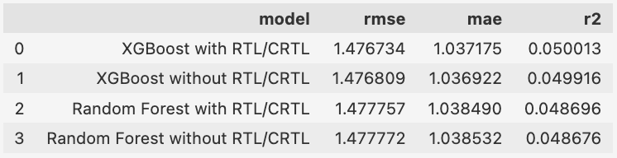
Figure 5 – Feature Importance Values
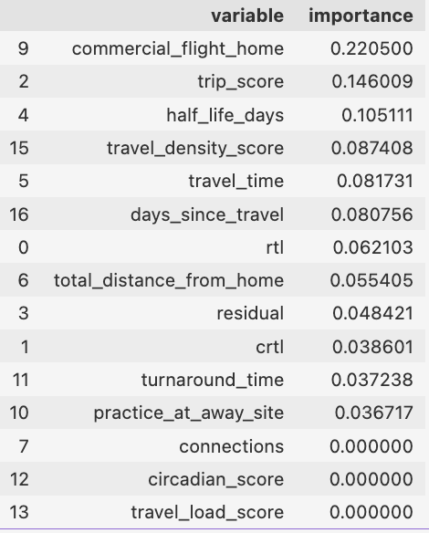

Figure 6 - Feature Importance Plot
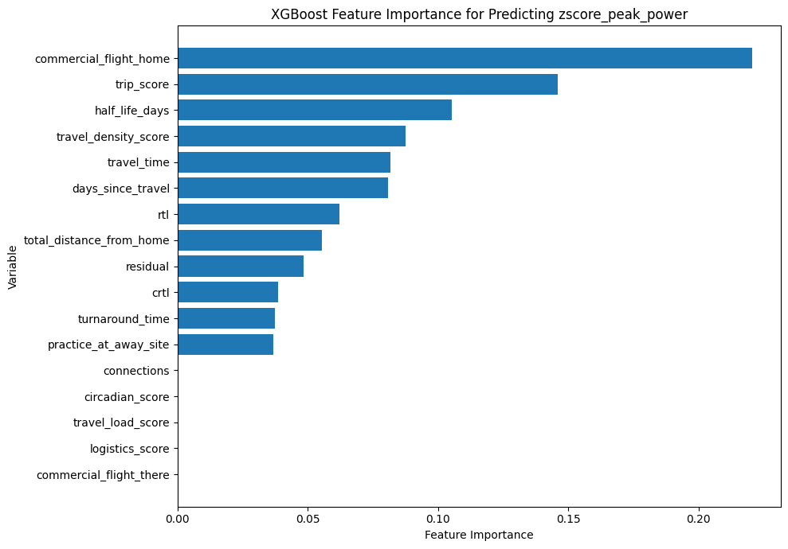
Figure 7 – Future Prediction Model Z-Score Visualization
