Ashley Marietta
Professor Barron
Human Performance Analytics
15 April 2026
Assignment One
Visualizations
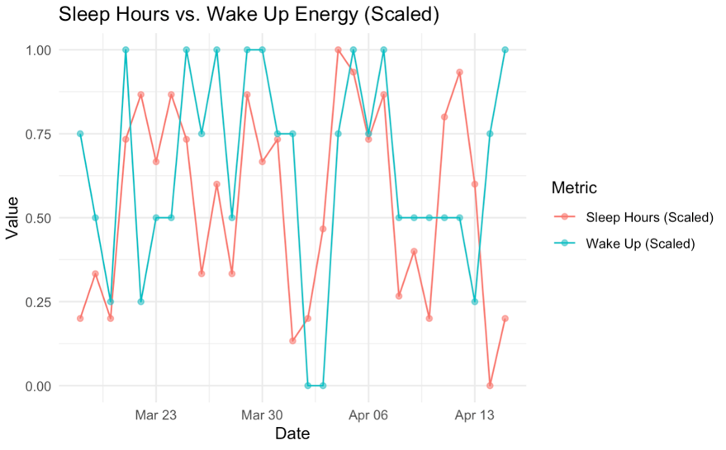
Figure 1
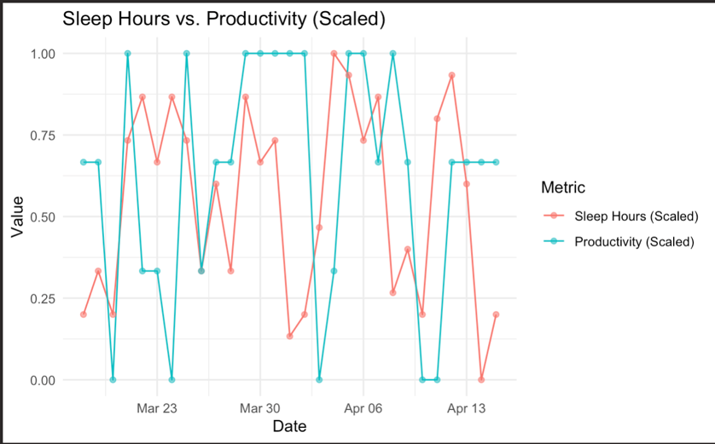
Figure 2
Findings
The first relationship visualized was between sleep hours and wake up (morning alertness) in Figure 1. I found that the scaled number of sleep hours and the energy I felt upon waking followed a very similar pattern. For the most part, when I slept more hours, I woke up feeling more refreshed. This made complete sense, as I recognize that I require a certain threshold of sleep to feel rejuvenated. I have always prioritized sleep, so, when I did not get enough time to rest, I clearly noticed that impact. In the tracking period, I felt particularly tired the weekend before Easter (around April 3rd) because I played several night games that week, meaning I slept less than normal. This corresponded with a dip in morning energy, shown in the graph.
The second relationship depicted in Figure 2 was between sleep hours and productivity. While not as obviously related as morning alertness and time in bed, my productivity roughly correlated with the amount of time spent sleeping. This made sense, given that I felt more grounded and ready to work when I gave myself ample time to recover. There were a few notable exceptions, such as on March 18th, when my productivity was high but sleep hours were low. However, my sister was visiting me that day, so I was excited to work with her at a coffee shop, boosting my productivity despite lacking sleep.
Events and Circumstances
During the tracking period, I frequently traveled for softball games and consistently had later bedtimes because of night games. Even if a game finished at a reasonable hour, such as 8:00 p.m., I still had to come home, lay out my things for the next day, and wind down before going to sleep. In my normal routine, I shut down everything at 8:45 p.m. to fall asleep around 9:30 p.m. However, when traveling or playing late, this routine was often interrupted, meaning that I slept much less than my nine-hour goal. To keep my circadian rhythm on track, I consistently woke up at the same time each day (6:15 a.m. before April 5th and 6:30 a.m. after that date), except on Sundays when I allowed myself to sleep in. I shifted the wakeup time back 15 minutes halfway through tracking to see if the extra sleep time would benefit my overall health and well-being, since I had been frequently waking up tired.
During this time, I also started drinking caffeine regularly. Before the week of March 30th, I consumed caffeine roughly three times per week, trying to moderate my intake to upregulate its performance benefits. However, during the first week of April, I decided that the positive effects of daily caffeine on my school productivity made it worth the potential downregulation of its long-term impact. I received a boost in productivity after making that switch and plan to continue consuming caffeine regularly.
Expected Patterns
I expected to find a positive correlation between sleep hours and productivity and between caffeine consumption and productivity. I also expected days where I woke up feeling tired to be correlated with caffeine consumption, as I would have been more inclined to have caffeine if I did not feel rested. Finally, I expected a relationship between sleep hours and energy upon waking to be a curve, with the best energy occurring when I slept around nine hours. I predicted this because sleeping too much could negatively impact my performance as much as not sleeping enough sometimes, and I tend to feel best with around nine to nine and a half hours of rest.
Surprises
I did not expect to have a disproportionate relationship between caffeine intake and wake up. However, I now recognize that I consumed caffeine after deciding how I felt that day, so it could not have improved the metric at the time it was recorded. Also, because I increased my caffeine intake partway through the collection, that changed how I expected that variable to impact the data.
I would have loved to add a third variable that indicated when I finished physical activity for the day. I feel best when I shut down activity before 5:00 p.m., other than a brief post-dinner walk. However, when I have vigorous activity later in the evening, I struggle to fall asleep and feel tired during the workout. I perform best physically in the morning and sleep best when I have time to wind down in the evening. I think this most impacted whether I ate later in the evening (any time after 6:30 p.m.), which also usually made it harder for me to fall asleep.
Appendix
