
Ruya
Remass
Ghaida
Eshraq Zakri
Gene & Pathways affected by TDP-43 Knockout in Chromosome 17
Kaust Bioinformatics

2026

Data Preparation
- Proper data preparation is essential for reliable results.
Step 1: preparing the project working directory
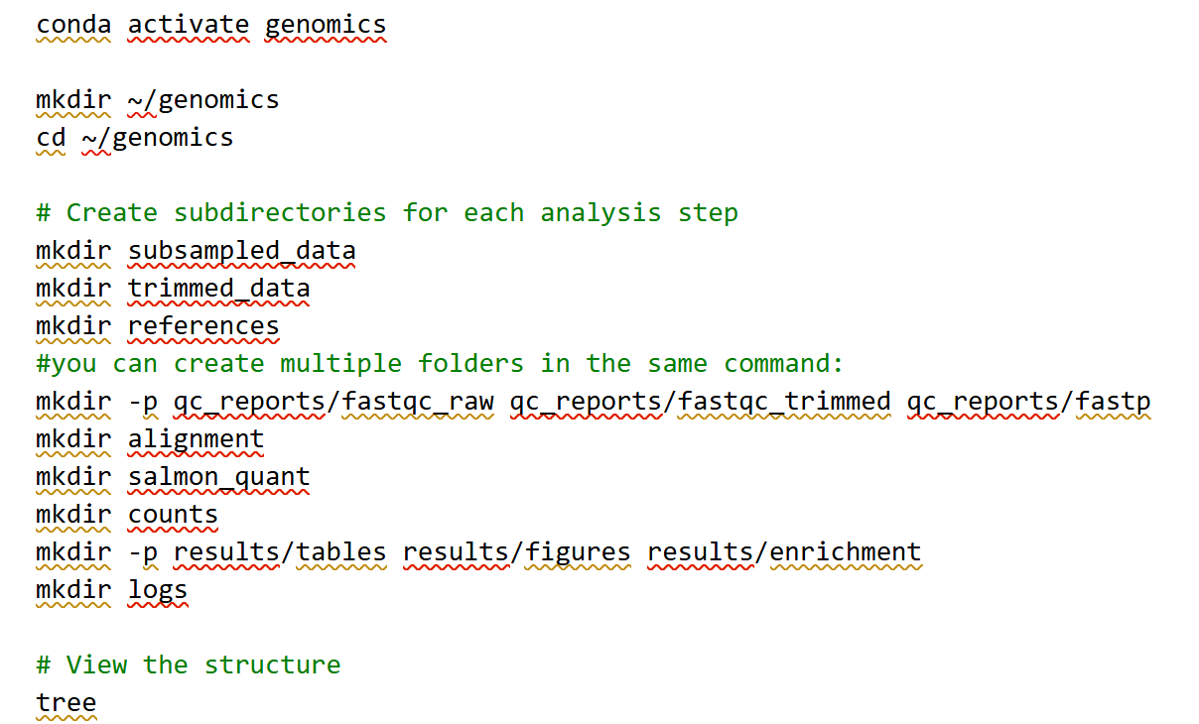
Step 2: Downloading the data
For our analysis, we anchored the workflow to a well-defined reference framework:
- The GRCh38 genome assembly
- Ensembl Release 115
- Chromosome 17
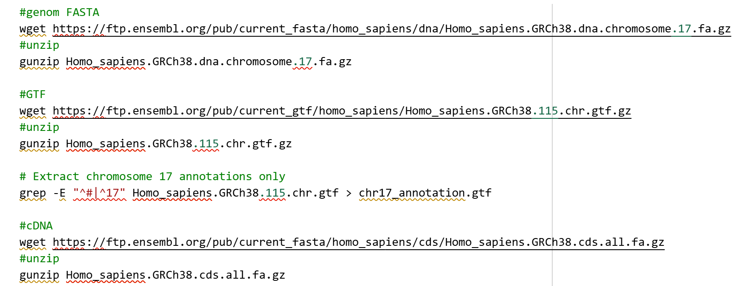
Step 3: Downloading the raw data
These raw reads represent the direct output of the sequencing instrument before any filtering or processing. At this stage, the data still includes sequencing noise, adapters, and potential technical artifacts — all of which will be addressed during quality control and trimming.
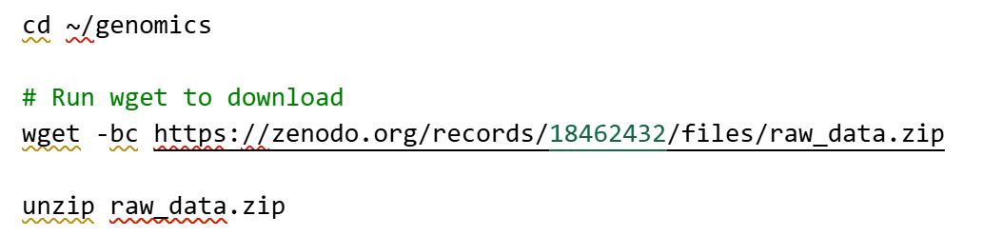
- Data Exploration & Statistics
Step 1: Exploration
As we explored Chromosome 17, we began by taking a closer look at the reference files we downloaded from Ensembl.
We counted the
- Genes: 3780
- Transcripts: 25996
- Total bases: 83257441
- Transcript nucleotide lengths: 351250713
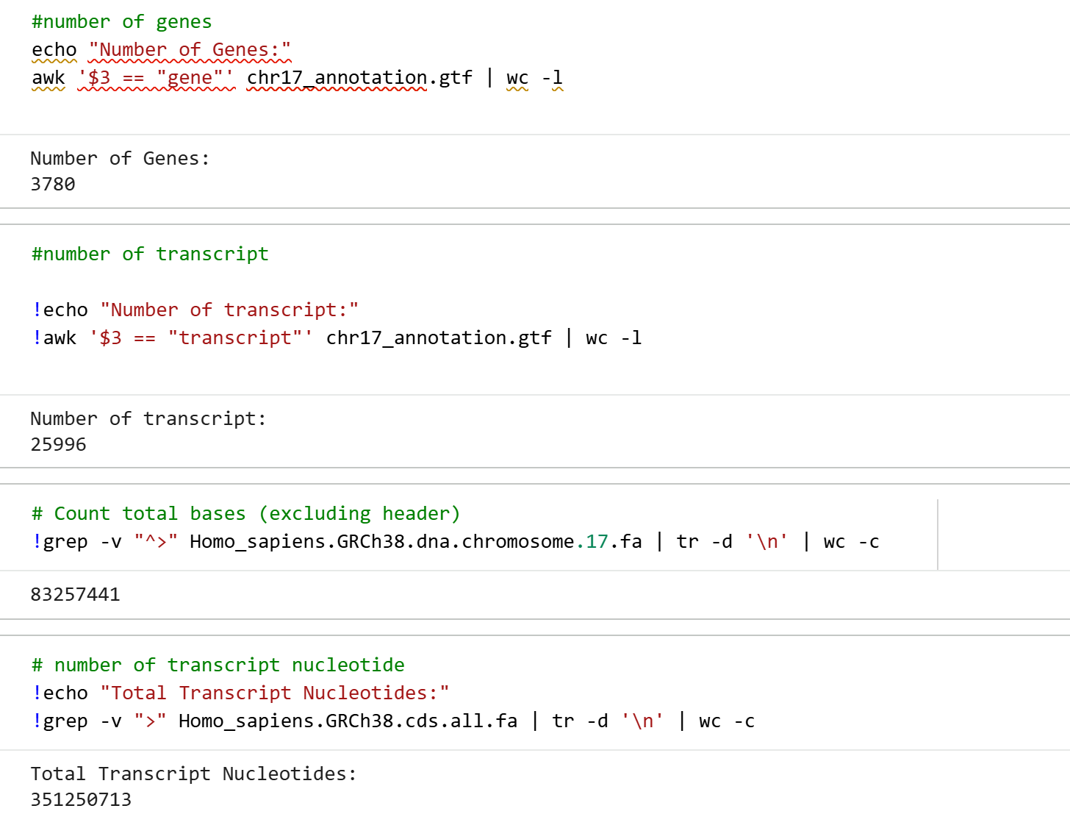
Step 2: Statistics
We extracted key QC metrics:
- Total reads: 12219948
- GC content: 45.13%
- quality scores: Average Phred quality: 6.9239

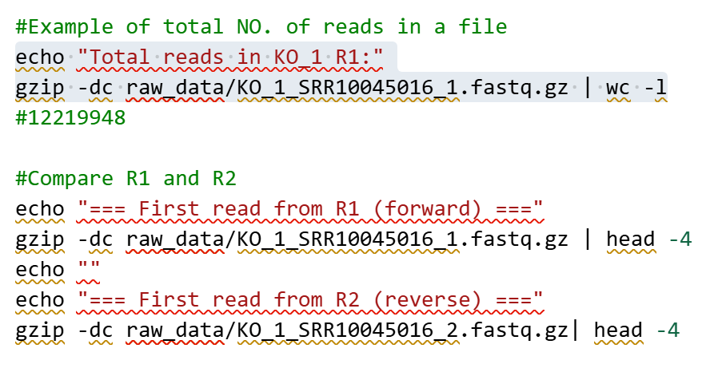

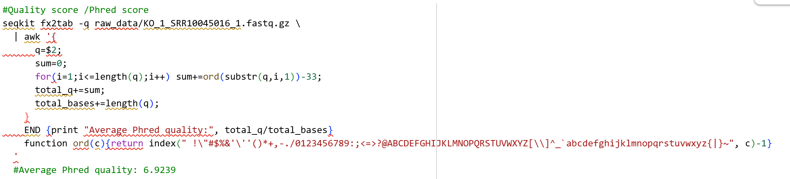
- Quality Control
We applied a streamlined quality-control workflow to ensure clean, reliable RNA-seq reads before quantification.
Step 1: Quality Asessment
Assess initial read quality.
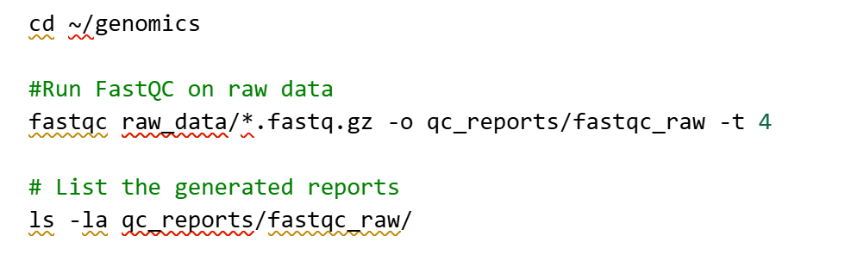
Step 2: Trimming & Filtering
Remove adapters and low-quality bases.

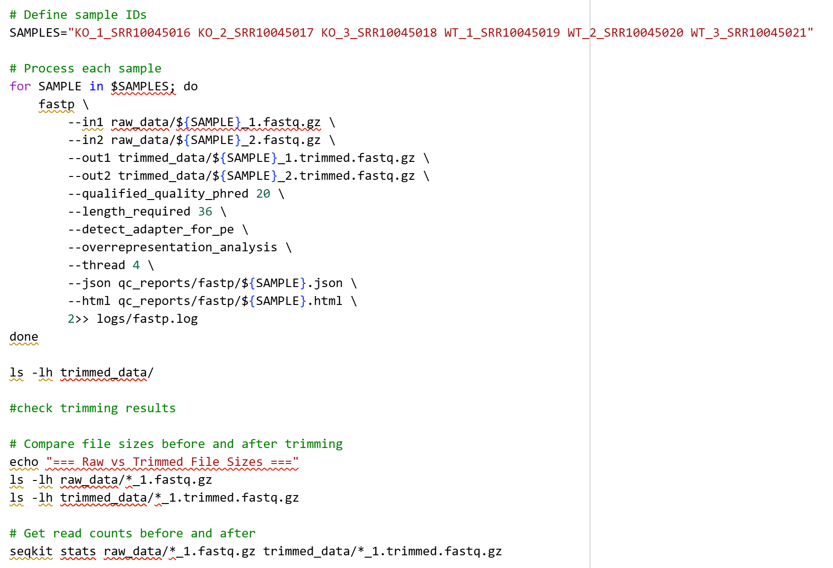
Step 3: Post-Trimming Quality Check
Confirm trimming improved quality.
Step 4: Aggregation of QC Reports
Combine all FastQC + fastp reports into one summary.
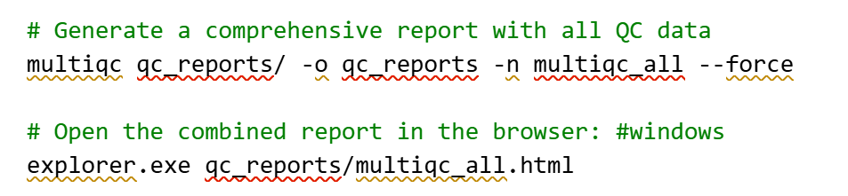

- Genome alignment
In this analysis, we quantified transcript and gene expression using Salmon, which performs lightweight, alignment-free (pseudo-alignment) directly on raw FASTQ files.
Step 1: Build Salmon transcript index

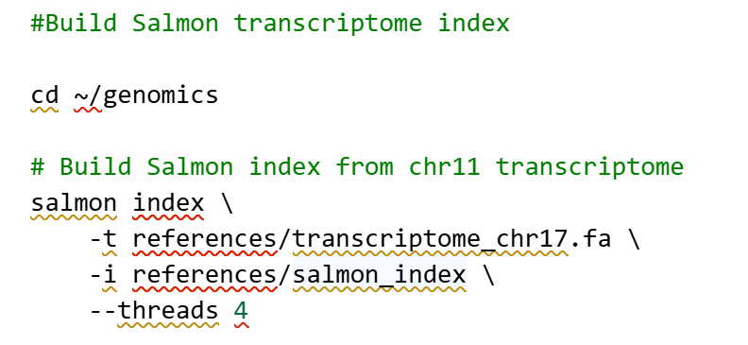
Step 2: Quantify all samples with Salmon
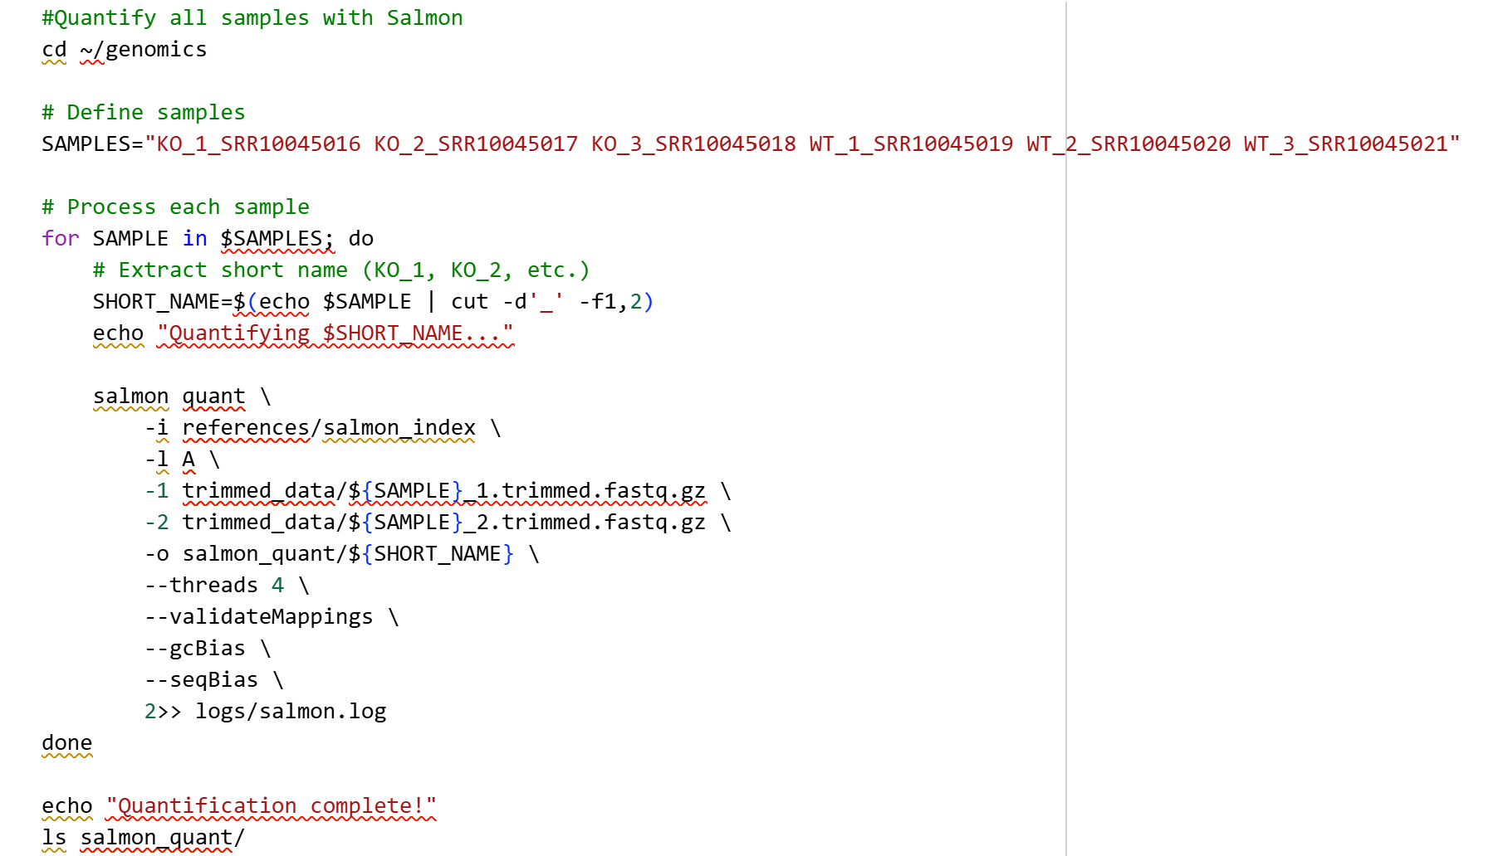
Step 3: Explore Salmon output

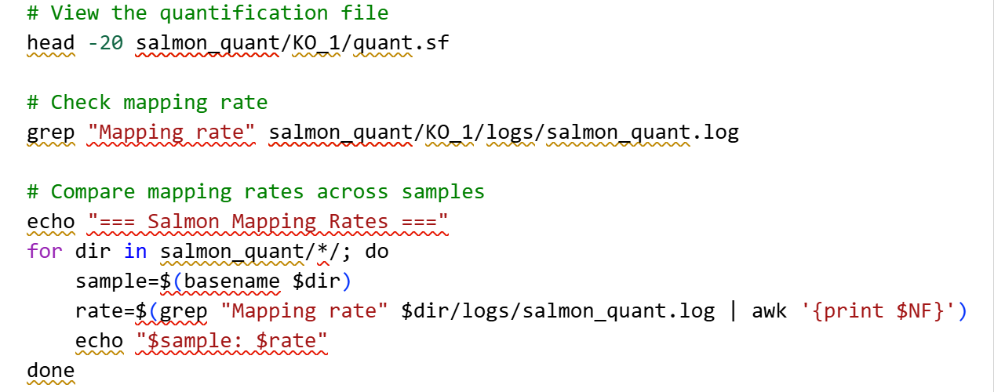
Mapping rate is 95%
Step 4: Aggregate to Gene Level with tximport & Run
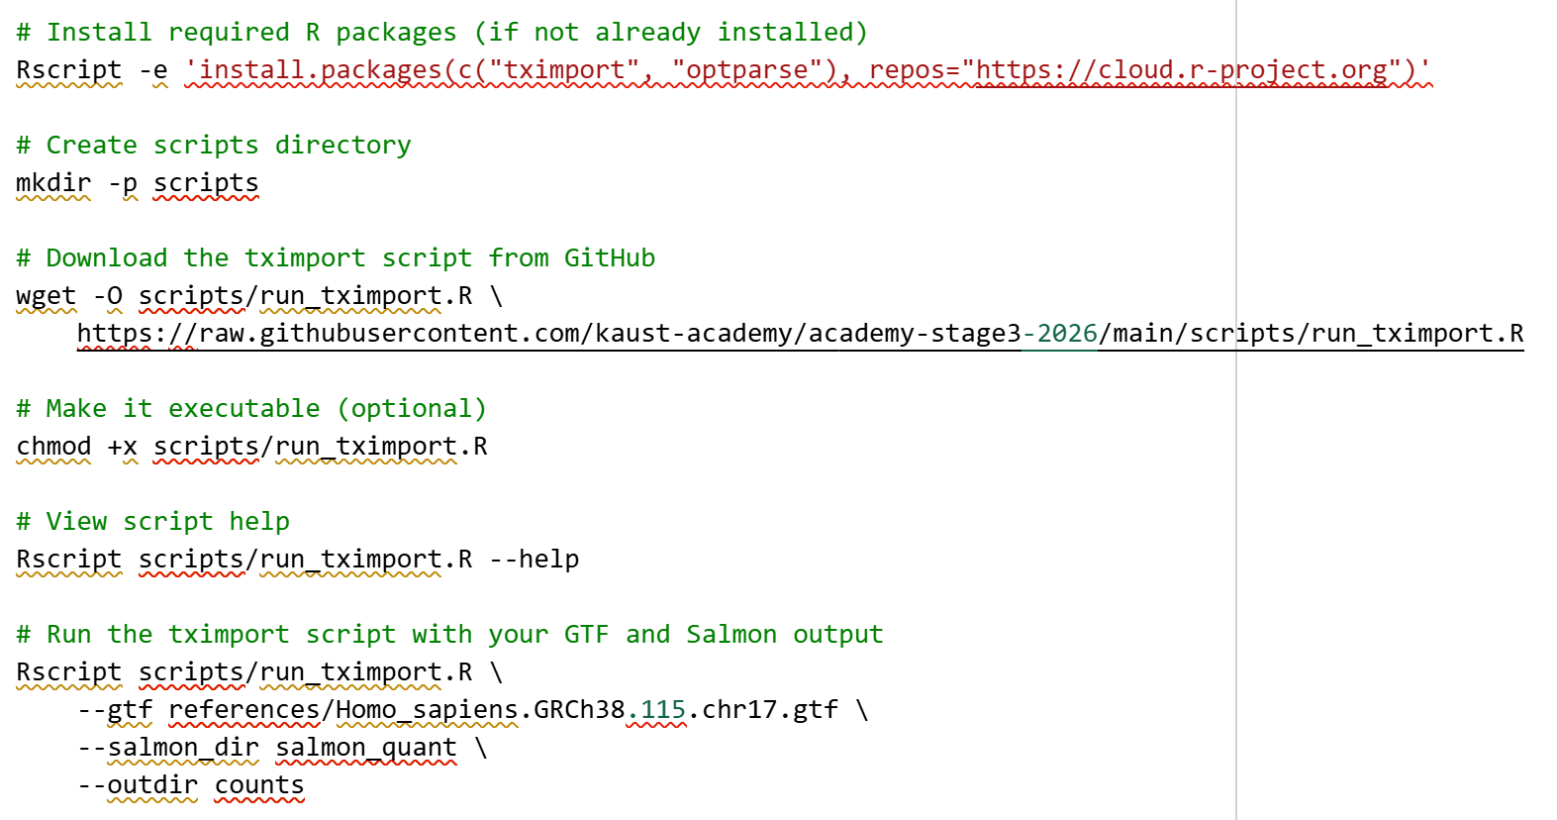
Run tximport
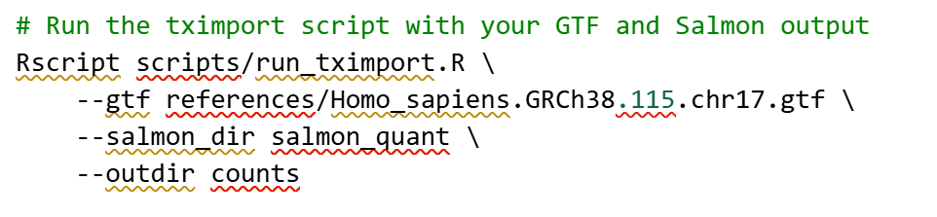
Step 5: Explore the expression matrix
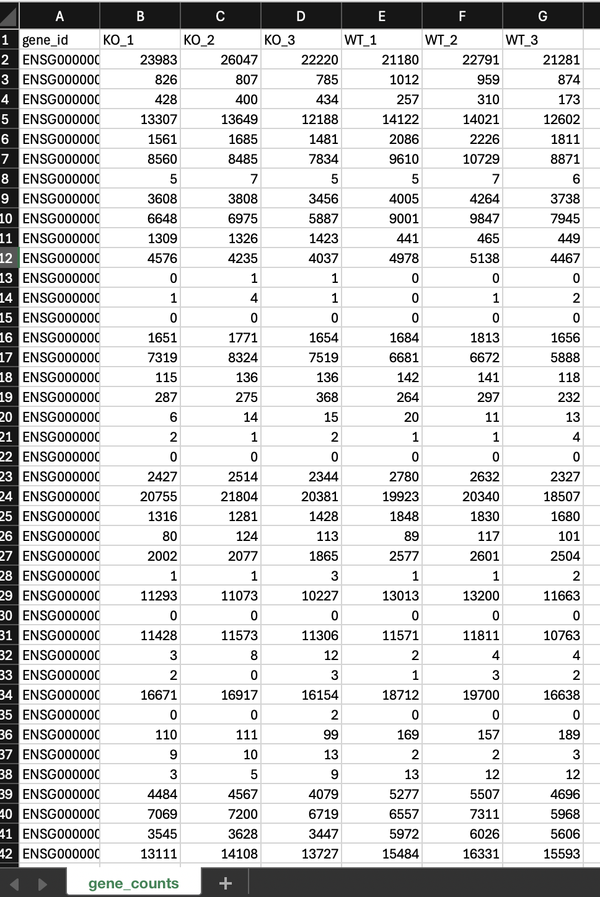

Data Analysis
- Deferential expression
we ran the analysis in Jupyter Notebook
DESeq2 all results
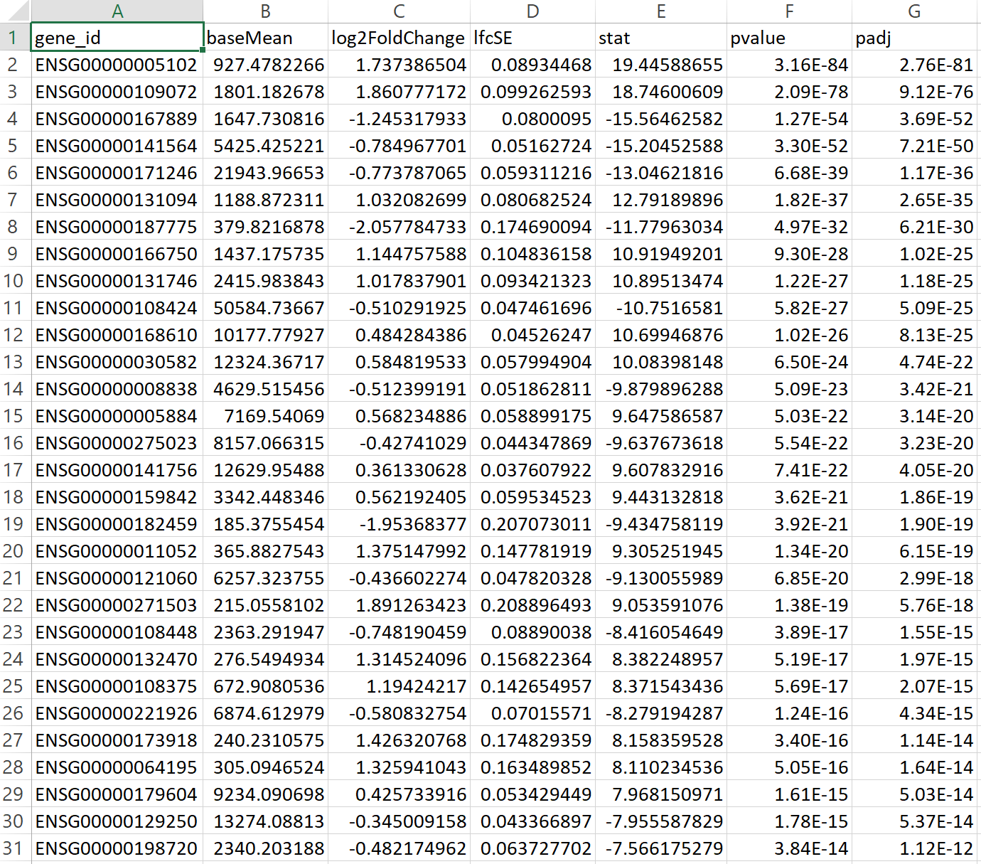

The Excel results show a mix of strongly up- and down-regulated genes in the KO condition: genes with positive log2FC values, such as ENSG00000005102 and ENSG00000197081, are upregulated in KO and may normally be suppressed by TDP-43, while genes with negative log2FC values, such as ENSG00000167489 and ENSG00000131788, are downregulated and likely depend on TDP-43 for proper expression or stability. Most listed genes have extremely small adjusted p-values and many exceed log2FC > 1, indicating highly significant and biologically meaningful expression changes.

DESeq2 significant genes
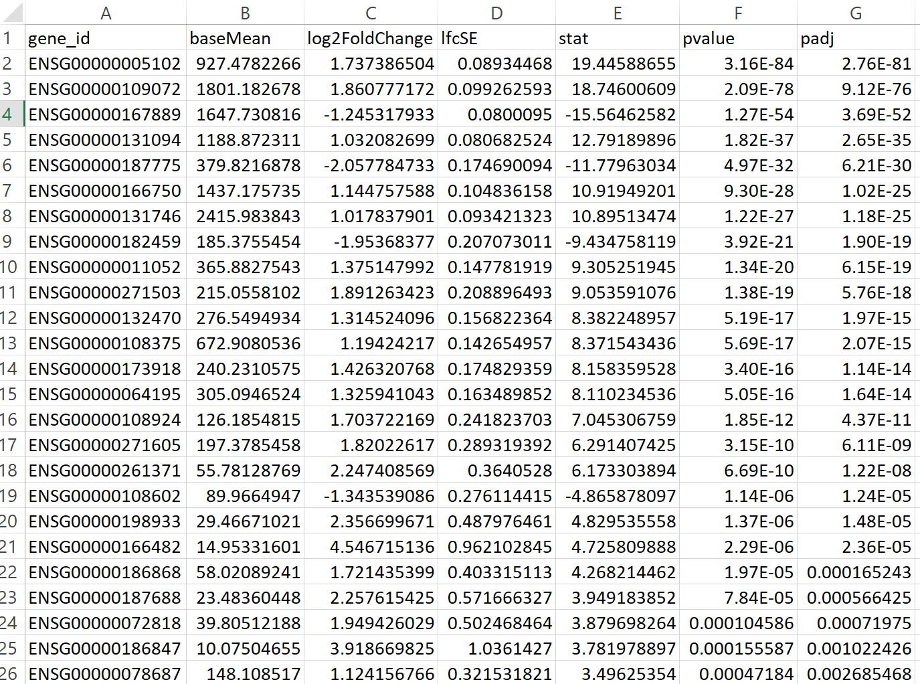
- Visualization & QC Plots

Library size bar chart
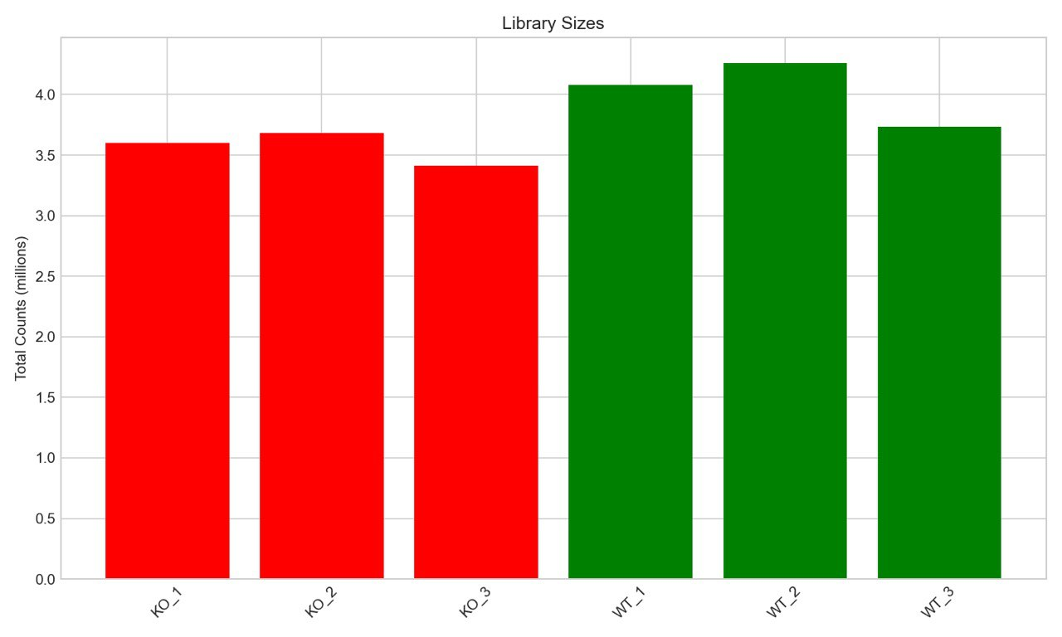
KO and WT samples have very similar total read counts (around ~4 million each), showing balanced sequencing depth across all samples.

DE Volcano Plot
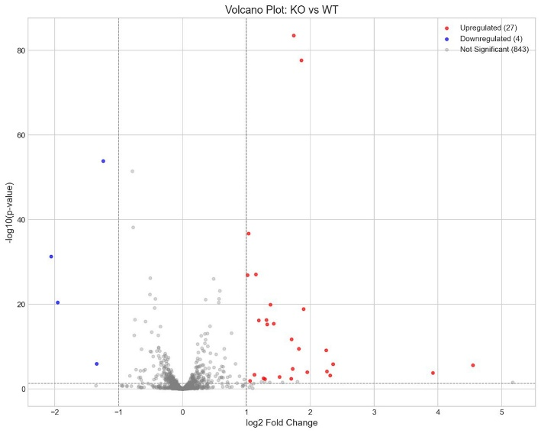
The volcano plot shows that 27 genes are significantly upregulated in KO, 4 are downregulated, and the rest are not significantly changed. KO has many more genes increasing in expression than decreasing.

Hierarchical Clustering and Heatmap Analysis
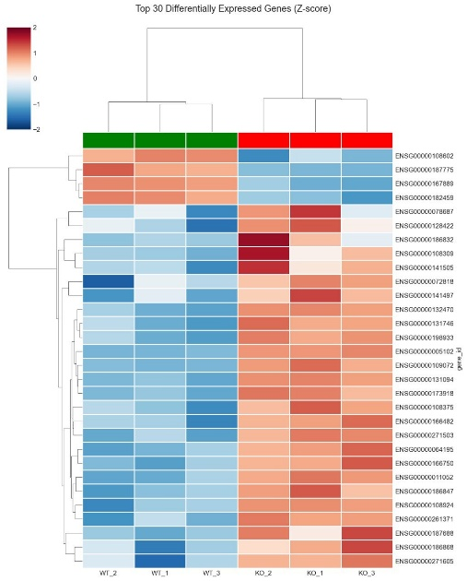
The heatmap shows the top 30 differentially expressed genes clearly separating WT and KO samples, with KO samples clustering together and showing distinct expression patterns compared to WT.

Count distribution Violin plot

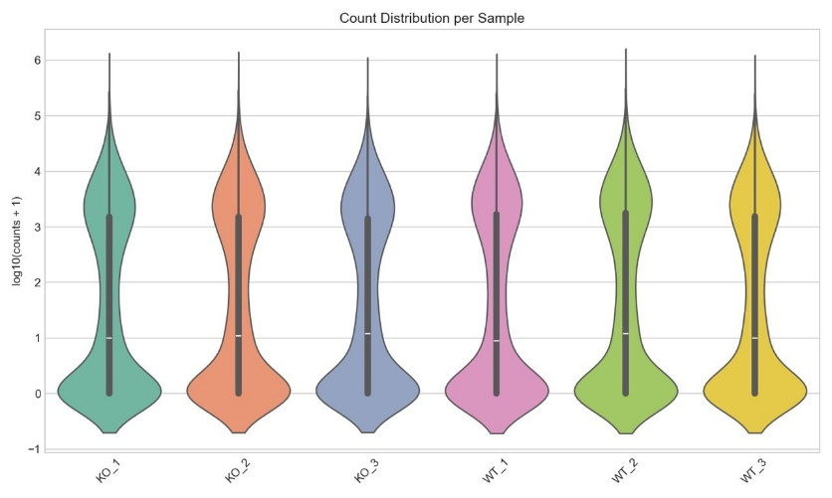
All samples show very similar count distributions, meaning KO and WT have comparable overall expression profiles with no major outliers

PCA Analysis
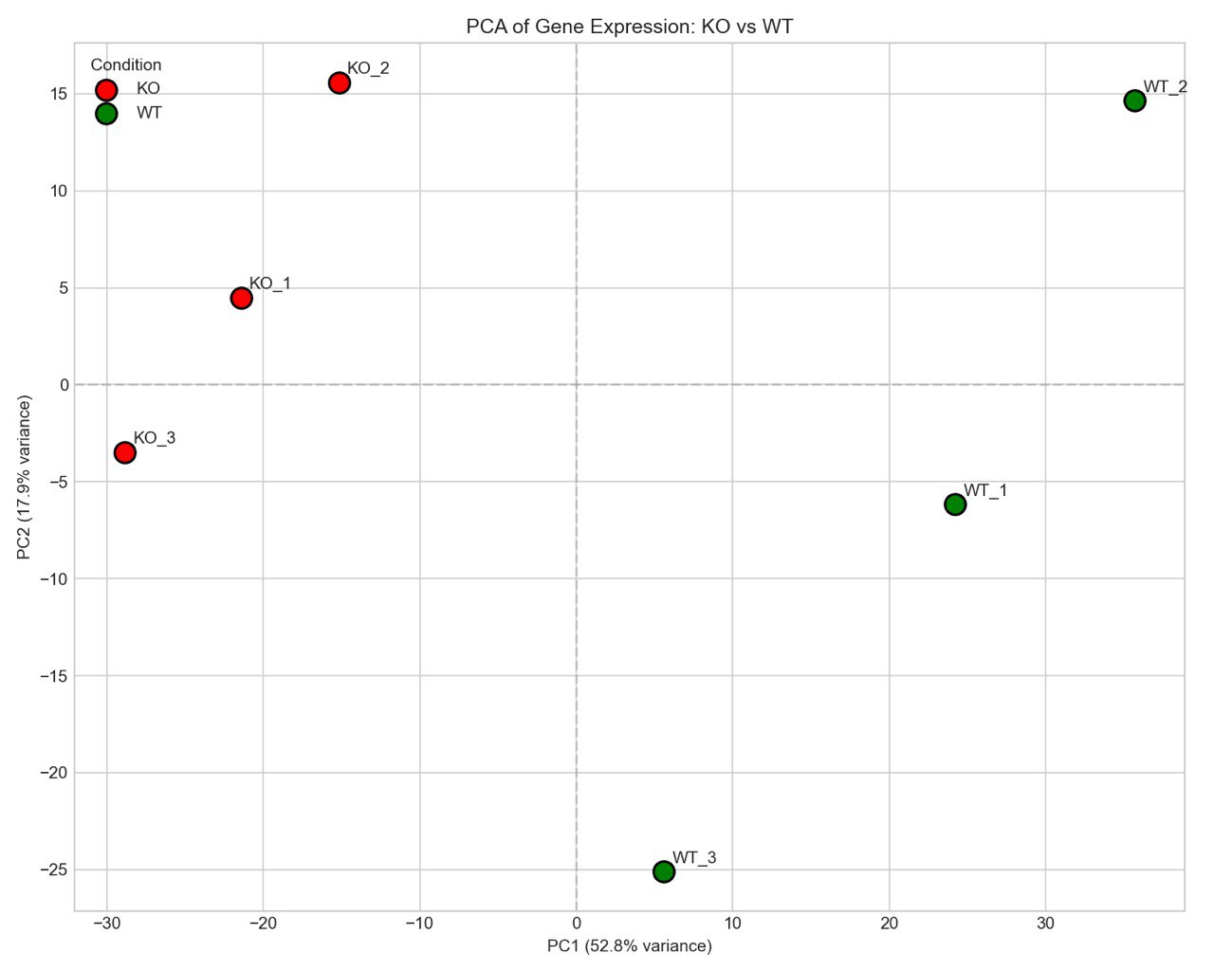
KO and WT samples separate cleanly along PC1, showing that their overall gene expression profiles are distinctly different

Sample correlation heat map
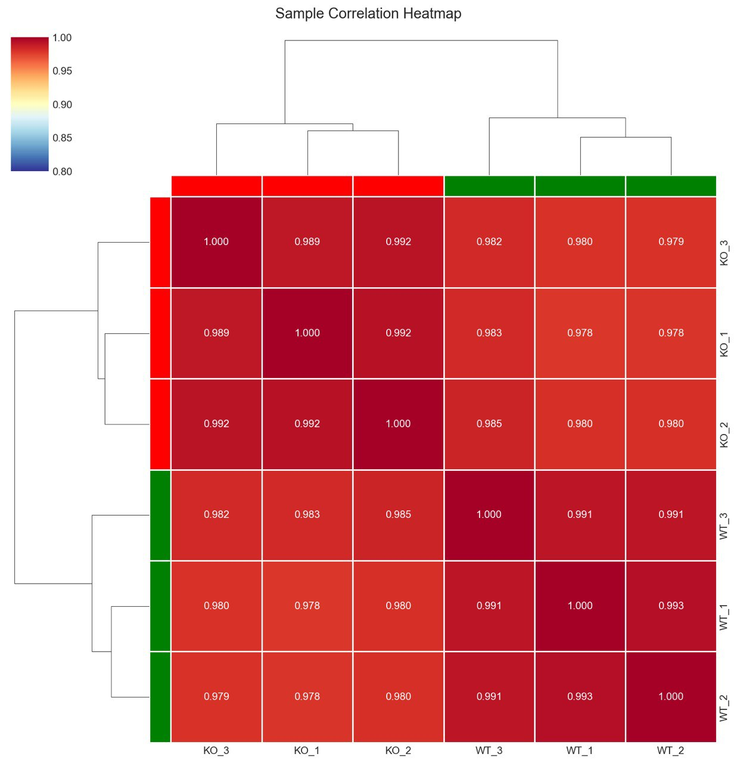
All samples show very high correlations, and KO samples cluster together while WT samples cluster together, confirming strong within-group similarity and clear separation between conditions.

MA Plot of Gene Expression
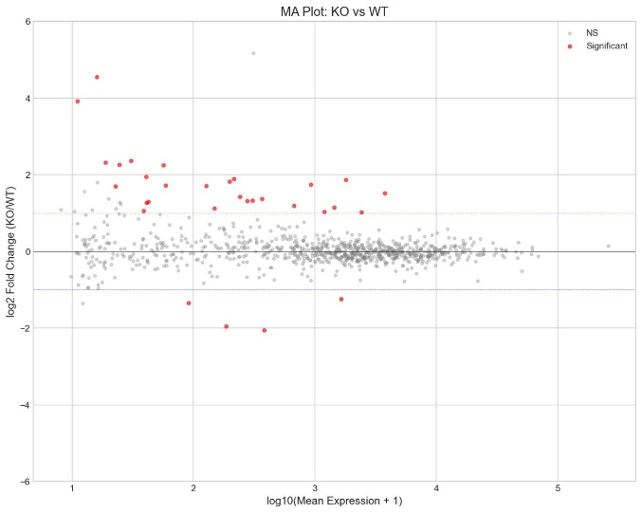
Most genes show similar expression between KO and WT, while a small subset of genes (the red points) show significant up- or down-regulation.

- Enrichment
