Project Title – Tech Blog

## Project Summary:

Tech Blog is a simple blogging website that has been developed so that company employees can post articles and customers can benefit from the content.

## Project Timeline:

Complete project has been developed in 5 sprint cycle of 1 Week each, so the total duration of the project is 1 month.

|  |  |  |  |  |
| --- | --- | --- | --- | --- |
| SNO | SPRINT NAME | DURATION | START DATE | END DATE |
| 1 | TBV1-NAV-HEADER | 1WEEK | JAN 2 2023 | JAN 6 2023 |
| 2 | TBV2-ABOUT | 1WEEK | JAN 9 2023 | JAN 13 2023 |
| 3 | TBV3-BLOGS | 1WEEK | JAN 16 2023 | JAN 20 2023 |
| 4 | TBV4-ADD-BLOG | 1WEEK | JAN 23 2023 | JAN 27 2023 |
| 5 | TBV5-FOOTER | 1WEEK | JAN 28 2023 | FEB 1 2023 |
|  |  |  |  |  |

## Github Repository Link:

## <https://github.com/ashmi0513/SimpliLearn-Phase1-Project.git>

## Project Results:

### Technical Tools:

HTML5, CSS, JAVASCRIPT

### Code Editor:

VSCODE

### Library:

Bootstrap5, Font Awesome

### Source Code Management Tool:

Git and Github

### Font:

Google Font – Poppins

# TBV1-NAV-HEADER (JAN 2 2023 – JAN 6 2023)

* **Step1:** Created folder “Tech Blog” and opened the folder in VS Code
* **Step2:** Created 3 files “index.html”, “style.css” and “script.js” in “Tech Blog” folder
* **Step3:** Opened “index.html” and wrote html starting code and linked both “style.css” and “script.js ” with html page.

<link rel="stylesheet" href="style.css">

<script src="script.js"></script>

* **Step4:** Opened index.html with live server to test if both “style.css” and “script.js ” are properly linked.
* **Step5:** Inserted Bootstrap CDN into the head section

<link href="https://cdn.jsdelivr.net/npm/bootstrap@5.3.0-alpha1/dist/css/bootstrap.min.css" rel="stylesheet" integrity="sha384-GLhlTQ8iRABdZLl6O3oVMWSktQOp6b7In1Zl3/Jr59b6EGGoI1aFkw7cmDA6j6gD" crossorigin="anonymous">

<script src="https://cdn.jsdelivr.net/npm/bootstrap@5.3.0-alpha1/dist/js/bootstrap.bundle.min.js" integrity="sha384-w76AqPfDkMBDXo30jS1Sgez6pr3x5MlQ1ZAGC+nuZB+EYdgRZgiwxhTBTkF7CXvN" crossorigin="anonymous"></script>

* **Step6:** Created a simple navbar using bootstrap classes (navbar,sticky-top, navbar-expand-md, navbar-brand, ms-3,navbar-nav, nav-item, nav-link and container-fluid).
* **Step7:** Navbar contains pointer to below section of the page: Home, About Us, Blogs and Add Blog.
* **Step8:** Changed the color of navbar using custom CSS: “nv-color” class.
* **Step9:** Created Head Banner below class is used for styling

**Bootstrap Class –** container-fluid

**Custom Class –** home-banner

* **Step10:** Tested the final page with different screen sizes and refactored code, used more internal documentation in html and css file.

**Final Result:**

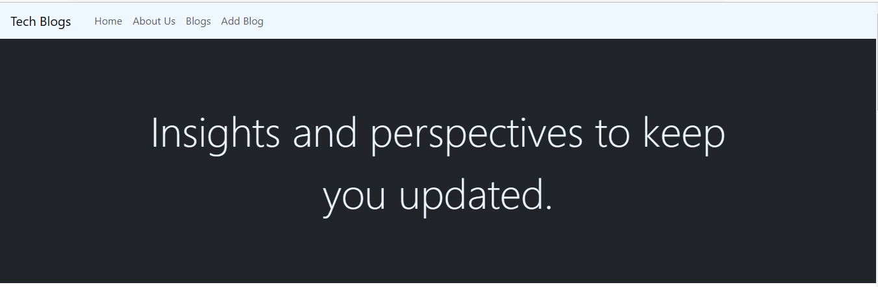

# TBV2-ABOUT (JAN 9 2023 – JAN 13 2023)

* **Step1:** Created new section with ID “about”. Section started with an H1 heading.
* **Step2:** Inserted a new container and divided the container into two column using Bootstrap classes(row, col-md-6, col-lg-6)
* **Step3:** Inserted an H2 heading followed by a paragraph in first division and an image in second division of the container.
* **Step4:** Inserted CDN for Google Font, Poppins with index.html

<link rel="preconnect" href="https://fonts.gstatic.com" crossorigin>

<link ref="https://fonts.googleapis.com/css2?family=Poppins:ital,wght@0,100;0,200;0,300;0,400;0,500;0,600;0,700;0,800;0,900;1,100;1,200;1,300;1,400;1,500;1,600;1,700;1,800;1,900&display=swap" rel="stylesheet">

* **Step5:** Customized Section heading and following containers using Custom CSS classes – section-heading, about-heading, about-content and image.
* **Step6:** Refactored code and tested the final website with different screen sizes.

**Final Result:**

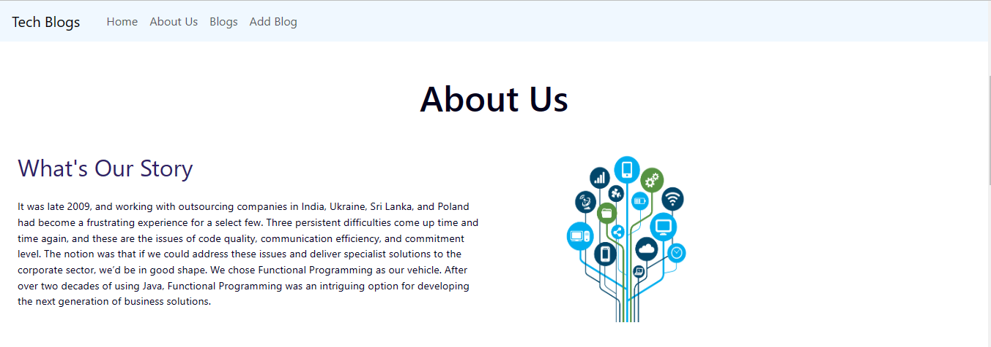

# TBV3-BLOGS (JAN 16 2023 – JAN 20 2023)

* **Step1:** Created new section with ID “blogs”. Section started with an H1 heading.
* **Step2:** Inserted a new container and divided the container into 3 columns for desktop screen and 2 columns for medium screen using Bootstrap classes (row, col-md-6, and col-lg-4).
* **Step3:** Created a container inside each column.
* **Step4:** Each Column starts with an image followed by blog title and paragraph.
* **Step5:** Customized Section heading and following containers using Custom CSS classes – section-heading, about-heading, about-content and image.
* **Step6:** Refactored code and tested the final website with different screen sizes.

**Final Result:**

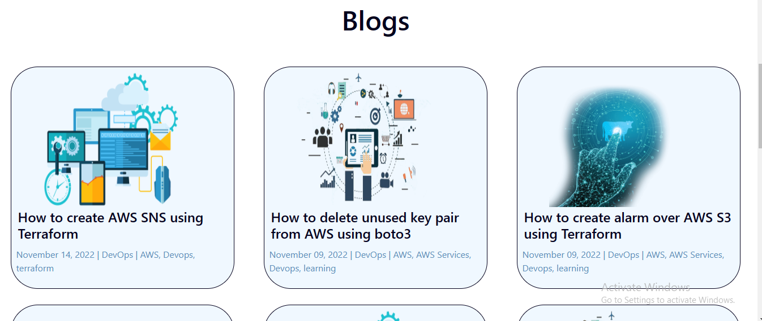

# TBV4-ADD-BLOGS (JAN 23 2023 – JAN 27 2023)

* **Step1:** Created new section with ID “add-blogs”. Section started with an H1 heading.
* **Step2:** Inserted a new container and added Bootstrap form into it for user to add blog.
* **Step3:** Form contains Blog Title, Category, Author Name and Date input container, Blog Content as textarea container and Submit Button.
* **Step4:** Opened “script.js” file and added event listener on submit button click event.
* **Step5:** When the submit button will be clicked, new blog will be submitted for review and form will reset.
* **Step7:** Customized Section heading and following containers using Custom CSS classes – section-heading, new-blog, myform.
* **Step8:** Refactored code and tested the final website with different screen sizes.

**Final Result:**

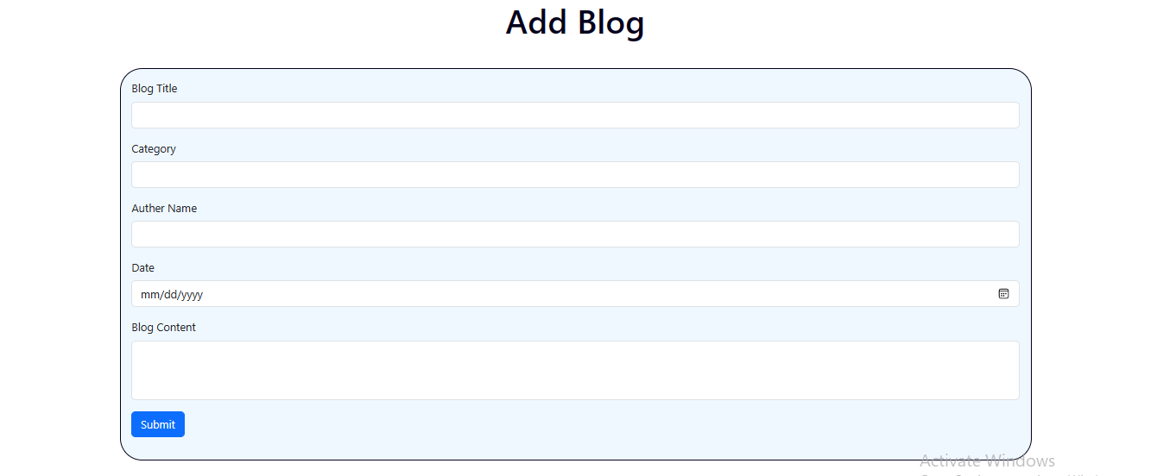

# TBV5-FOOTER (JAN 28 2023 – FEB 1 2023)

* **Step1:** Concluded the project with footer, provided footer an ID “footer”
* **Step2:** Inserted font awesome kit in the head section.

<script src="https://kit.fontawesome.com/a0abaa6b67.js" crossorigin="anonymous"></script>

* **Step3:** Footer is started with an unordered list that contains link to social media Facebook, LinkedIn, Instagram and Twitter followed by a paragraph that contains copyright details.
* **Step4:** Used font awesome social media icon as link.
* **Step5:** Customized the background, icon, links and paragraph using custom css.
* **Step6:** Refactored code and tested on multiple screen size.

**Final Result:**

