CSE411 COMPUTER VISION PROJECT
EfficientSAM for Medical Image Segmentation
Skin Lesion Analysis with a Cross-Modality Generalization Study (Skin · Chest X-ray · MRI)
Final Project Report — Complete Implementation
Team 27 · October 2026
Team member | Roll number
Ashmi S N | 2023BCS0196
Samradhi Rathore | 2023BCD0037
Nimisha M Iyer | 2023BCD0004
Thariq Muhammed | 2023BCD0007

Abstract
Segmentation foundation models such as the Segment Anything Model (SAM) are powerful but expensive: the ViT-H version has roughly 632 million parameters. Existing SAM-based work on skin lesions and chest X-rays almost always keeps this heavy backbone and reports accuracy only. This project asks whether EfficientSAM-Ti, a lightweight SAMI-pretrained ViT-Tiny variant with 10.2 million parameters, can segment medical images accurately, and whether it generalizes across imaging modalities.
We built one box-prompted pipeline and applied it unchanged to three modalities: skin lesions (ISIC 2018, 2,594 images), chest X-rays (Montgomery + Shenzhen, 704 images) and brain MRI (BraTS 2020, 105 tumor-positive 2D slices). Only the 4.06M-parameter mask decoder was fine-tuned (5 epochs for skin, 3 for X-ray and MRI); the encoder stayed frozen. On a Tesla T4 GPU, fine-tuning raised Dice from 0.8655 to 0.9344 on skin lesions, from 0.8741 to 0.9607 on chest X-ray and from 0.6982 to 0.8107 on MRI, at about 127–146 ms per image and with roughly 62× fewer parameters than SAM ViT-H. MRI was clearly the hardest domain. A Gradio application lets a user upload a dermoscopic image and view the predicted lesion overlay together with quantitative lesion features.

Headline results (validation split, box prompts)
Skin lesion Dice 0.9344 / IoU 0.8794 · Chest X-ray Dice 0.9607 / IoU 0.9253 · MRI Dice 0.8107 / IoU 0.6899 · 10,223,204 total parameters, 4,058,340 (39.7%) trained.

1. Introduction and Objectives
Accurate delineation of lesions and organs is a prerequisite for measurement, monitoring and downstream diagnosis, but pixel-level labels are expensive to create. Promptable foundation models offer a way to segment a new image from a simple cue such as a bounding box. The difficulty is cost: SAM's image encoder is large, which makes it hard to deploy interactively or on modest hardware. EfficientSAM replaces it with a small encoder pretrained by SAM-leveraged masked image pretraining (SAMI), reporting about 20× fewer parameters and 20× faster inference on natural images. Whether that efficiency survives on medical images was, according to our literature survey, untested.

1.1 Objectives
- Part A. Adapt EfficientSAM-Ti to skin-lesion segmentation on ISIC 2018, comparing zero-shot and decoder-fine-tuned performance.
- Part B. Apply the identical pipeline to chest X-ray and brain MRI to measure how well a single lightweight model generalizes across modalities.
- Efficiency. Report parameter count and inference speed next to Dice and IoU, an axis most surveyed papers omit.
- Usability. Deliver a working GUI for dermoscopic image upload and mask visualization.

1.2 Contributions
- The first side-by-side evaluation (among the 10 papers we surveyed) of one lightweight SAM variant on skin, X-ray and MRI under identical preprocessing, prompting, training and evaluation code.
- A decoder-only adaptation recipe that trains only 39.7% of the parameters and reuses the same 4,058,340-parameter budget for every modality.
- Quantitative evidence on where the efficiency–accuracy trade-off holds (X-ray, skin) and where it weakens (MRI), with qualitative examples including a failure analysis.

2. Literature Survey and Research Gap
We surveyed ten papers spanning the base models, general medical adaptations of SAM, skin- and X-ray-specific methods, a classical baseline and lightweight CT variants (Table 1).
Ref | Method | Key reported result | Limitation relevant to us
[1] | EfficientSAM: SAMI pretraining, ViT-Tiny/Small encoder | 42.3 box AP (Ti) on COCO zero-shot; ~20× fewer params than SAM-H | Natural images only; never evaluated on medical data
[2] | SAM (ViT-H, SA-1B) | Strong natural-image zero-shot; mean Dice 58.52% zero-shot on medical images (Ma & Wang) | 632M-parameter encoder; unstable on low-contrast structures
[3] | MedSAM: full fine-tuning on 1.57M pairs, 10 modalities | +22.51% Dice over zero-shot SAM | Not designed for efficiency; needs box prompts
[4] | SkinSAM: fine-tuned SAM (ViT-b/l/h) on HAM10000 | Dice 0.8879, IoU 0.7843 (ViT-b) | Full SAM backbone; no speed or parameter report
[5] | Med-SA: adapters on a frozen SAM | Beats full fine-tuning with limited data | Heavy frozen encoder; inference cost unchanged
[6] | YOLOSAMIC: YOLOv8 detector + SAM-Box | Fully automatic; robust to blur and pruning | Two chained models; still full SAM
[7] | LoRA-fine-tuned SAM for chest X-ray | Beats zero-shot SAM prompting | Needs a separate CNN for prompts; no efficiency data
[8] | U-Net (classic baseline) | Dice ~0.878, IoU ~0.783 on ISIC 2018 | No pretrained foundation knowledge
[9] | SAM-Adapter + ViT classifier | Dice 94.27% on ISIC 2018 | Frozen full encoder; no speed testing
[10] | RepMedSAM / EMedSAM: distilled lightweight encoders | RepMedSAM Dice 0.8688 on multi-organ CT | CT only; two-stage distillation
Table 1. Summary of the ten surveyed papers.

2.1 Identified gaps
- Skin-lesion SAM methods [4][6][9] all retain the heavy SAM encoder, so parameter count and inference cost stay near the original.
- Lightweight SAM variants [1][10] were tested only on natural images or CT, never on skin or chest X-ray.
- The chest-X-ray SAM paper [7] uses full SAM plus an extra CNN, with no speed or parameter comparison.
- General medical SAMs [3][5] cover many modalities but are not efficiency-oriented, and no surveyed work compares skin, X-ray and MRI in one study.

2.2 How this project differs
We combine EfficientSAM's lightweight SAMI encoder with skin-lesion segmentation, run the identical model zero-shot and lightly fine-tuned on chest X-ray and MRI, report parameters and speed alongside accuracy, and ship a working GUI.

3. System Architecture and Methodology
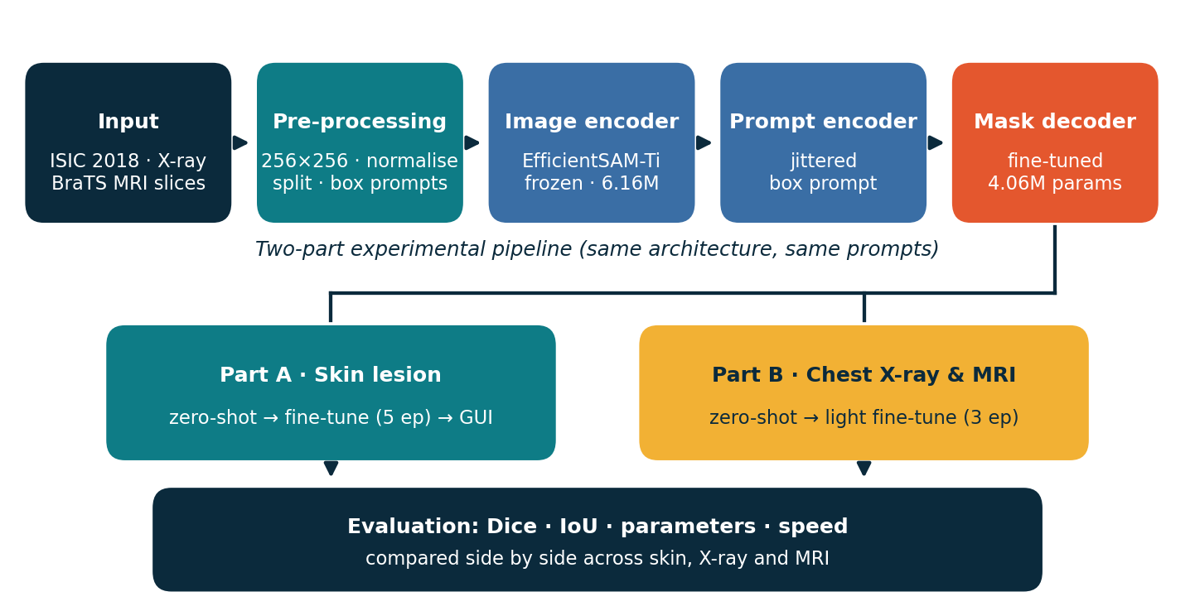
Figure 1. End-to-end pipeline: from input images through the EfficientSAM-Ti encoder, prompt encoder and mask decoder to the two-part evaluation.
Stage | Role | As implemented
Input | Three modalities, each with pixel-level masks | ISIC 2018, Montgomery + Shenzhen, BraTS 2020 (FLAIR slices)
Pre-processing | Common format, split before any model exposure | 256×256 resize, [0,1] tensors, 90/10 (skin) and 85/15 (X-ray, MRI) splits
Image encoder | SAMI-pretrained ViT-Tiny producing an image embedding | Pretrained checkpoint, frozen (~6.16M params)
Prompt encoder | Turns a box into sparse prompt tokens | Two corner points (labels 2 and 3); box derived from mask with up to 5 px random jitter
Mask decoder | Lightweight two-way transformer producing the mask | Only trainable part: 4,058,340 params, AdamW (lr 1e-4), Dice loss
Evaluation | Same metrics for every modality | Dice, IoU, parameter count, ms/image on a Tesla T4
Output | Part A GUI; Part B comparison report | Gradio app; results JSON/CSV and comparison plots
Table 2. Pipeline stages and their concrete implementation.

4. Datasets and Pre-processing
Modality | Source | Image–mask pairs | Train / Val | Target
Skin lesion | ISIC 2018 Task 1 (Kaggle mirror), dermoscopy | 2,594 | 2,334 / 260 | Lesion
Chest X-ray | Montgomery + Shenzhen (Kaggle mirror) | 704 | 598 / 106 | Lung fields
Brain MRI | BraTS 2020 (Kaggle), FLAIR axial slices | 105 | 89 / 16 | Whole tumor
Table 3. Datasets used in the study.

4.1 Pre-processing steps
- Resize and format. Images are converted to RGB and resized to 256×256; masks use nearest-neighbour resizing and are binarised at 0.5.
- Splitting. A fixed random seed (0) shuffles each dataset once, so the same split serves zero-shot evaluation and fine-tuning.
- Prompt generation. A bounding box is computed from the ground-truth mask and jittered by up to 5 pixels per side, simulating an imperfect user-drawn box. Empty masks fall back to a whole-image box.
- Path standardisation. Each Kaggle mirror has a different folder layout; all were normalised into image/mask file lists consumed by one dataset class.

4.2 MRI slice extraction
BraTS ships 3D NIfTI volumes (369 patients found). To keep the study within Colab free-tier compute and storage, we used the first 40 patients and extracted the three central axial FLAIR slices of each volume, discarding slices without tumor. Ground truth is the union of all tumor labels (whole tumor). This yielded 105 tumor-positive 2D slices. This is a deliberate scope decision for a generalization check, not a full MRI benchmark.

5. Implementation

5.1 Environment and model
All experiments ran on Google Colab with a Tesla T4 GPU using PyTorch and the official EfficientSAM repository. The EfficientSAM-Ti (ViT-Tiny) checkpoint with SAMI pretraining loaded successfully, and a single-image forward pass was checked first as a sanity test (Figure 2).
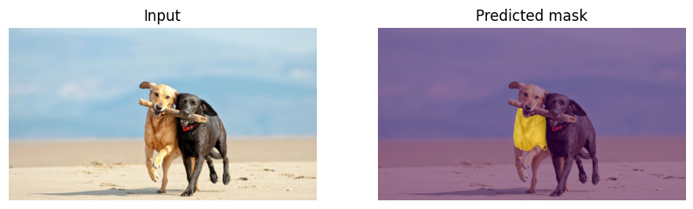
Figure 2. Sanity check: the untouched pretrained model produces a mask for a natural image (image → prompt → mask pipeline verified before any medical data was used).

5.2 Decoder-only fine-tuning
All parameters whose names contain “decoder” are trainable; everything else, including the whole image encoder, is frozen. The trainable budget is 4,058,340 of 10,223,204 parameters (39.7%) and is identical for all three modalities; each modality starts from a fresh copy of the pretrained model rather than from another modality's checkpoint.
Setting | Value
Optimizer / learning rate | AdamW, 1e-4
Loss | Dice loss on sigmoid logits
Batch size / input size | 4 / 256×256
Epochs | 5 (skin lesion), 3 (chest X-ray), 3 (MRI)
Prompt | Jittered box from ground truth (corner labels 2 and 3)
Hardware | Tesla T4 (Google Colab)
Table 4. Fine-tuning configuration shared across modalities.
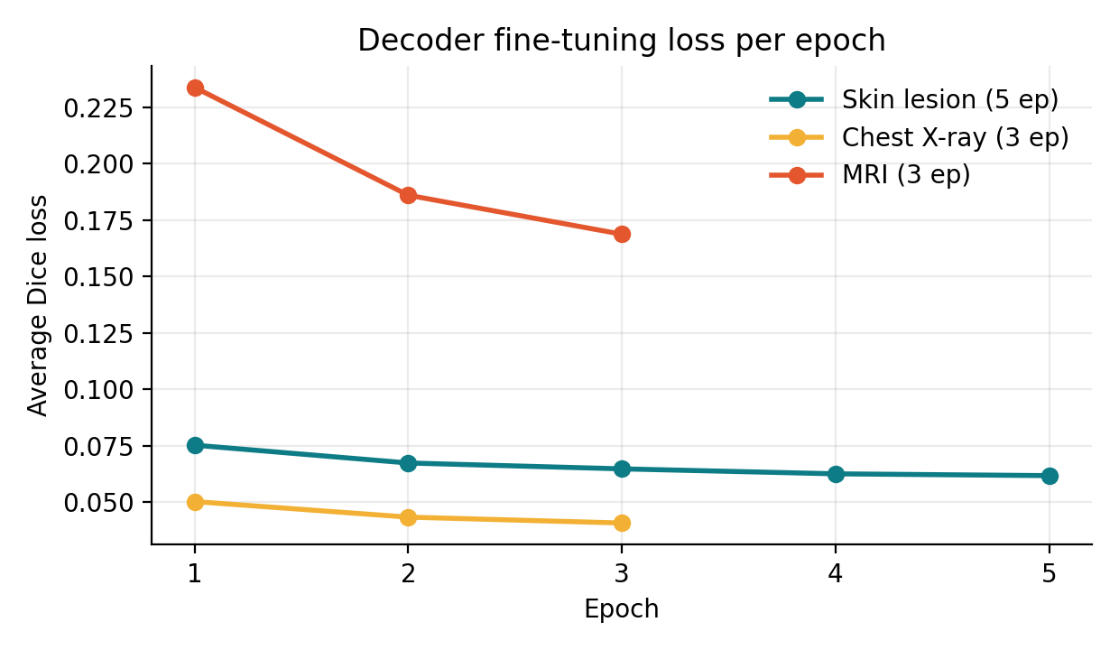
Figure 3. Average Dice loss per epoch from the training logs; all three runs decrease monotonically.

5.3 Evaluation protocol
For every held-out image, a box prompt is generated from the ground truth, the predicted logits are thresholded at 0, and per-image Dice and IoU are averaged. Zero-shot results use the untouched pretrained model; fine-tuned results use the adapted decoder, with the same evaluation function for all modalities. Inference speed is measured after 5 warm-up passes as the mean of 30 timed forward passes on a batch of 4 images, with GPU synchronisation, and reported per image.

5.4 Graphical user interface
The Gradio application loads the fine-tuned skin-lesion checkpoint and accepts an uploaded dermoscopic image. Because no ground-truth mask exists at inference time, the GUI uses a foreground point at the image centre as the prompt instead of a box. The interface returns four outputs: (1) the lesion boundary as a red overlay, (2) a cropped lesion patch, (3) a background-removed lesion image, and (4) quantitative features: area, perimeter, border compactness, asymmetry score, hue variation and the model's IoU confidence. Invalid or empty uploads are handled with an explicit message.
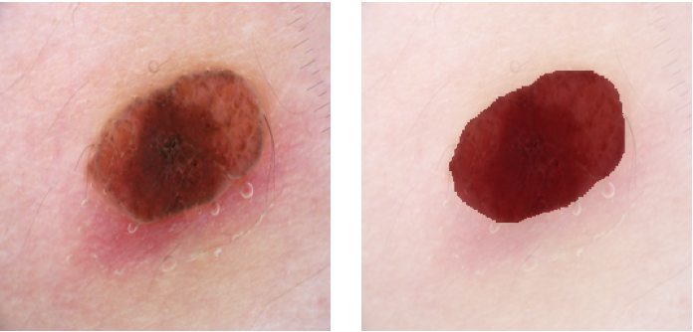
Figure 4. Example input (left) and the fine-tuned model's red lesion overlay (right), as displayed by the GUI's boundary-segmentation output (rendered from the evaluation notebook, box prompt).

6. Results

6.1 Cross-modality comparison
Modality | Setting | Dice | IoU | Speed (ms/image)
Skin lesion | Zero-shot | 0.8655 | 0.7714 | 145.85
Skin lesion | Fine-tuned | 0.9344 | 0.8794 | 145.85
Chest X-ray | Zero-shot | 0.8741 | 0.7831 | 143.31
Chest X-ray | Fine-tuned | 0.9607 | 0.9253 | 143.31
MRI (2D slices) | Zero-shot | 0.6982 | 0.5488 | 127.11
MRI (2D slices) | Fine-tuned | 0.8107 | 0.6899 | 127.11
Table 5. Dice, IoU and speed on the held-out validation splits (Tesla T4).
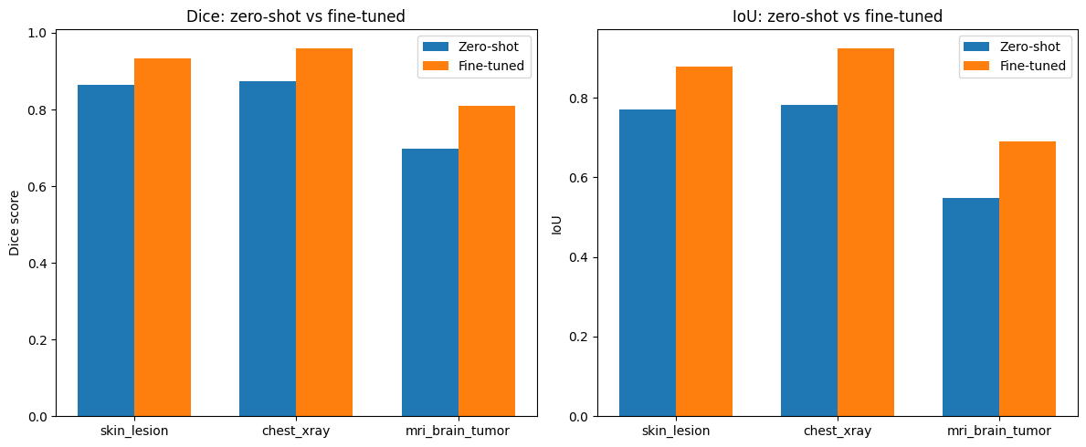
Figure 5. Dice (left) and IoU (right), zero-shot versus fine-tuned, for the three modalities (output of the comparison notebook).
Modality | ΔDice | ΔIoU | Final Dice rank | Relative Dice gain
Skin lesion | +0.0689 | +0.1080 | 2 | +8.0%
Chest X-ray | +0.0866 | +0.1422 | 1 | +9.9%
MRI (2D slices) | +0.1125 | +0.1411 | 3 | +16.1%
Table 6. Improvement from decoder fine-tuning.
Fine-tuning helps every modality. Chest X-ray reaches the best final scores, skin lesion follows closely, and MRI starts lowest and, despite the largest gain, still ends well below the others.

6.2 Qualitative results
Figures 6–8 show the input, ground truth, zero-shot prediction and fine-tuned prediction for two validation samples per modality.
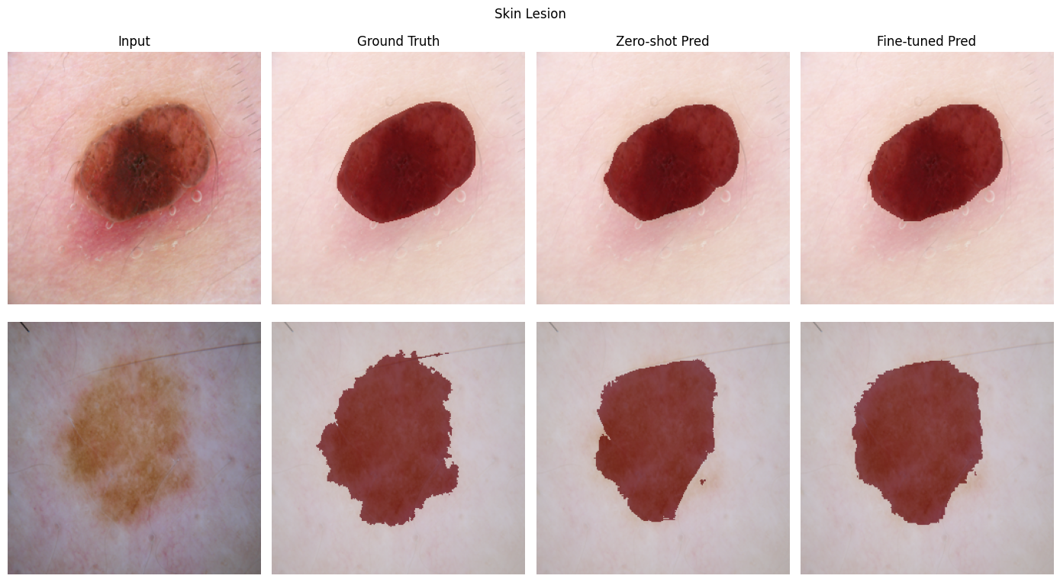
Figure 6. Skin lesion. Zero-shot already finds the lesion but over- or under-extends its border; the fine-tuned decoder follows the irregular boundary more closely.
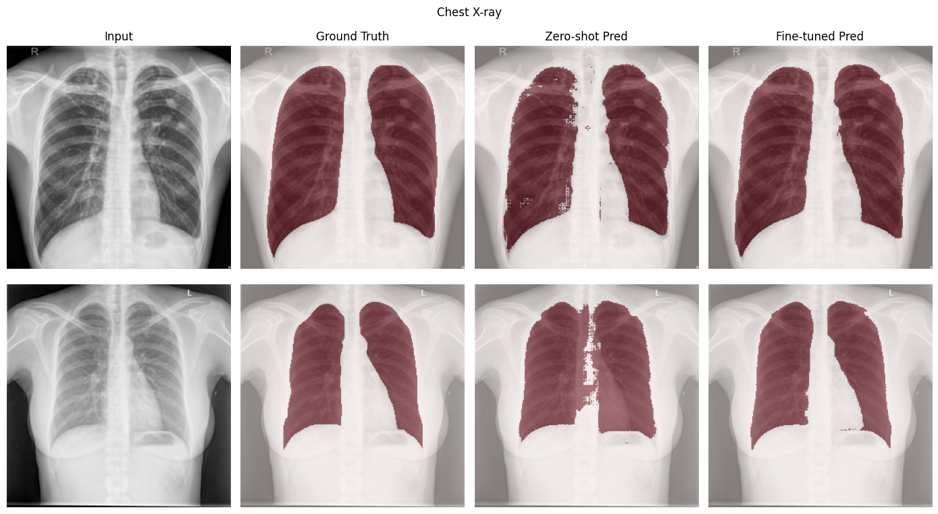
Figure 7. Chest X-ray. Zero-shot predictions show holes and ragged edges inside the lungs and around the mediastinum; fine-tuning yields clean, filled lung fields.
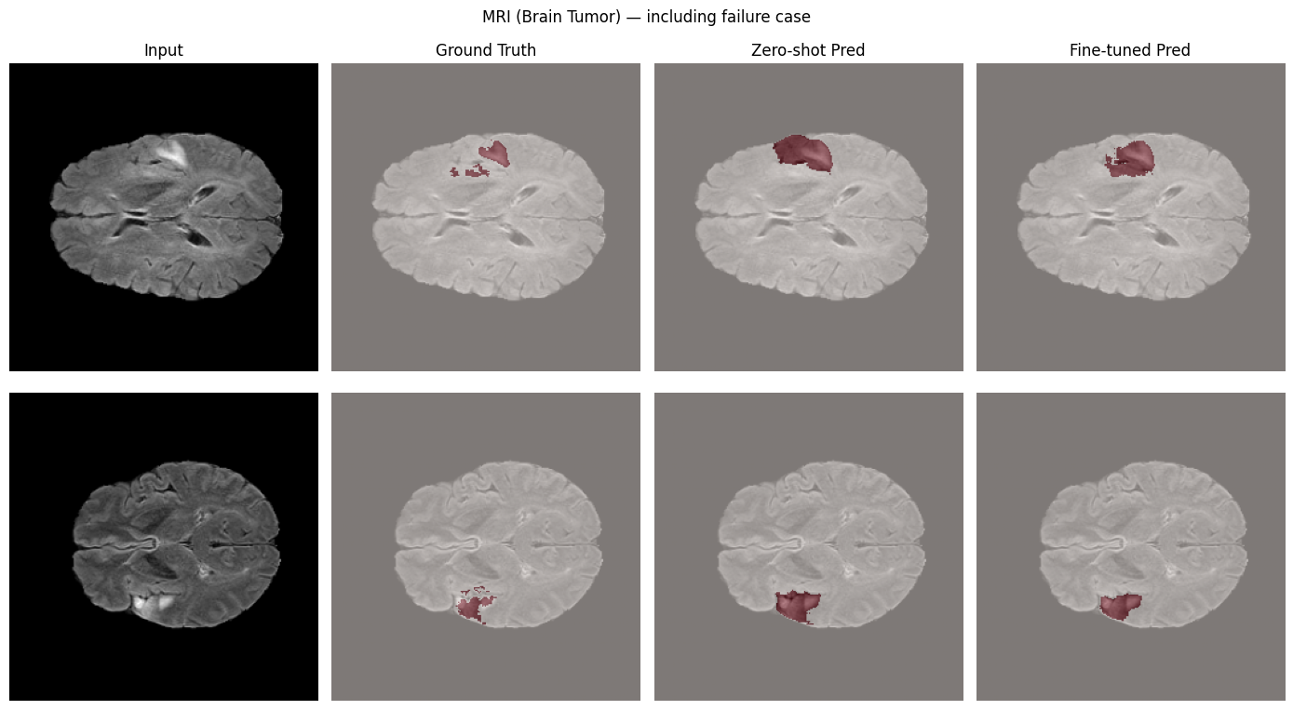
Figure 8. MRI (including failure cases). Zero-shot tends to over-segment the tumor region as a single blob; fine-tuning improves coverage but still misses the fragmented, scattered parts of the ground truth.

6.3 Efficiency
Model | Parameters | Source
SAM (ViT-H) | ~632M | Original SAM paper (survey ref [2])
EfficientSAM-Ti (this project) | 10,223,204 (≈61.8× fewer) | Measured on our checkpoint
of which encoder (frozen) | ≈6,164,864 | Total minus decoder
of which decoder (trained) | 4,058,340 (39.7%) | Measured
Table 7. Parameter budget.
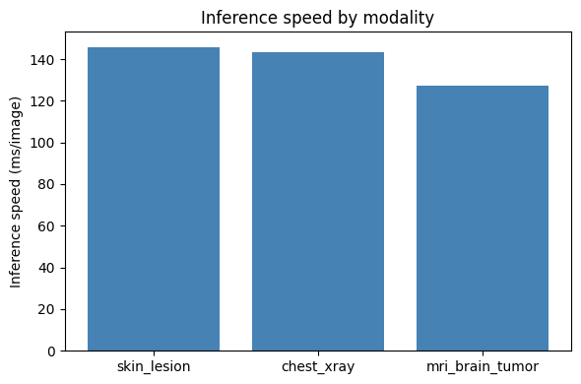
Figure 9. Inference speed by modality (ms/image on a Tesla T4).
Throughput is about 6.9 images per second for the skin model at 256×256 on a T4 GPU. The three modalities use the same architecture and input size, so the 127–146 ms spread most likely reflects timing variability on a shared Colab GPU rather than a real modality effect.

7. Discussion
- Efficiency is preserved. The encoder was never enlarged or unfrozen, so the ~62× parameter saving over SAM ViT-H holds end to end, and only 4.06M parameters were ever trained.
- The trade-off holds best on X-ray and skin. Fine-tuned skin-lesion Dice of 0.934 is above the SkinSAM (0.888) and U-Net (~0.878) figures in our survey, and chest-X-ray lung segmentation reaches 0.961. The skin comparison is indicative only: those papers use different datasets, splits and prompting protocols (see Section 8).
- MRI is the hardest domain. Zero-shot Dice is only 0.698 and fine-tuning reaches 0.811. Single-channel FLAIR slices with diffuse, fragmented tumor regions lie furthest from natural-image pretraining, and the MRI training set has only 89 images and 3 epochs of adaptation.
- Fine-tuning gives sharper boundaries, not just higher numbers. The qualitative figures show the decoder fixing the holes and ragged edges seen zero-shot, which a Dice difference alone understates.
- Why decoder-only works. A strong box prompt localises the target, so the pretrained encoder features are largely sufficient; adapting how the decoder turns them into a mask captures much of the domain gap at low cost.

8. Limitations and Deviations from the Original Plan
For an honest reading of the numbers, the following differences between the Task 1 proposal and what was implemented, and the following caveats, should be kept in mind.
Aspect | Proposal (Task 1) | Implemented
Input resolution | 1024×1024 (SAM-native) | 256×256, for Colab compute limits
Part A fine-tuning | Full (encoder + decoder, lower encoder LR) | Decoder-only, encoder frozen, 5 epochs
Loss | Dice + binary cross-entropy | Dice loss
Augmentation | Flips, rotations, brightness jitter | None applied in the final pipeline
Splits | ~70/15/15 train/val/test | 90/10 (skin), 85/15 (X-ray, MRI); no separate test set
Skin datasets | ISIC 2018 and/or HAM10000 | ISIC 2018 only
Prompt | Box or point | Box for evaluation; centre point in the GUI
Table 8. Planned versus implemented configuration.
- Oracle box prompts. Evaluation boxes come from the ground-truth masks, so reported scores assume a reasonably good user-drawn box. The GUI's centre-point prompt is weaker and will perform below these numbers on off-centre lesions.
- Small MRI validation set. Only 16 validation slices; the Dice estimate is noisy. In addition, slices were split at the slice level, so slices from the same patient can appear in both train and validation, which may inflate the MRI result. A patient-level split is needed for a clean estimate.
- Single run, validation-only reporting. No repeated seeds, confidence intervals or held-out test set; differences of a few Dice points should not be over-interpreted.
- Literature comparison is indicative. Different datasets, resolutions and prompt protocols mean the comparison with SkinSAM, U-Net and others is not like-for-like.
- Mask quality on MRI. Whole-tumor labels were merged into one binary class; sub-region (edema, enhancing, necrotic) segmentation was not attempted.

9. Conclusion and Future Work
EfficientSAM-Ti, adapted by training only its 4.06M-parameter mask decoder, reaches Dice 0.9344 on skin lesions and 0.9607 on chest X-ray lung fields, and 0.8107 on 2D brain-MRI slices, while remaining about 62× smaller than SAM ViT-H. Fine-tuning improved Dice by 6.9, 8.7 and 11.3 points respectively. The study shows that a lightweight, natural-image-pretrained SAM transfers well to dermoscopy and radiography with minimal adaptation, and that cross-sectional MRI is the modality where its efficiency–accuracy trade-off is weakest. All stages of the proposed methodology (datasets, pre-processing, model, Part A, Part B, comparison and GUI) were completed.

Future work
- Train and evaluate at 1024×1024 with a proper test set, patient-level MRI splits, multiple seeds and confidence intervals.
- Compare decoder-only tuning against adapters/LoRA and partial encoder unfreezing, and add Dice + BCE loss and the planned augmentations.
- Replace oracle boxes with an automatic detector or evaluate robustness to box noise and to point prompts.
- Scale MRI to all patients and multiple sequences, and extend to sub-region segmentation.
- Measure speed on edge hardware (CPU, mobile) and add quantisation or ONNX export (checkpoints for ONNX are already provided by the EfficientSAM repository).

10. Deliverables and Reproducibility
Deliverable | Description
Skin-lesion notebook | Part A: setup, zero-shot demo, fine-tuning, evaluation, parameter and speed measurement, Gradio GUI
Part B notebook | Shared utilities, chest X-ray and MRI zero-shot and fine-tuning, cross-modality comparison, qualitative plots
Fine-tuned checkpoints | efficientsam_ti_skinlesion_finetuned.pt, efficientsam_ti_xray_finetuned.pt, efficientsam_ti_mri_finetuned.pt
Result artifacts | results_skin.json, results_xray.json, results_mri.json, cross_modality_results.csv, Dice/IoU and speed plots
GUI | Gradio application using the fine-tuned Part A checkpoint
Reports | Task 2 survey, Task 3 architecture, Task 4–7 progress reports, this final report
Table 9. Final deliverables.
To reproduce: clone the EfficientSAM repository, load the EfficientSAM-Ti SAMI checkpoint, download the three Kaggle datasets, run the skin-lesion notebook and then the Part B notebook, which reads the saved results files for the comparison. Before sharing the notebooks, remove any hard-coded Kaggle credentials and use environment variables or Colab secrets instead.

References
[1] Y. Xiong et al., “EfficientSAM: Leveraged Masked Image Pretraining for Efficient Segment Anything,” CVPR, 2024.
[2] A. Kirillov et al., “Segment Anything,” ICCV, 2023.
[3] J. Ma et al., “Segment Anything in Medical Images,” Nature Communications, vol. 15, art. 654, 2024.
[4] M. Hu, Y. Li, and X. Yang, “SkinSAM: Empowering Skin Cancer Segmentation with Segment Anything Model,” arXiv:2304.13973, 2023.
[5] J. Wu et al., “Medical SAM Adapter: Adapting Segment Anything Model for Medical Image Segmentation,” arXiv:2304.12620, 2023.
[6] S. Gul et al., “YOLOSAMIC: A Hybrid Approach to Skin Cancer Segmentation with the Segment Anything Model and YOLOv8,” Diagnostics, vol. 15, no. 4, art. 479, 2025.
[7] “Fine-Tuned Segment Anything Model with Low-Rank Adaptation for Chest X-Ray Images,” Diagnostics, vol. 16, no. 6, art. 847, 2026.
[8] O. Ronneberger, P. Fischer, and T. Brox, “U-Net: Convolutional Networks for Biomedical Image Segmentation,” MICCAI, 2015.
[9] F. Binzagr and M. Hariri, “Foundation-Model-Driven Skin Lesion Segmentation and Classification Using SAM-Adapters and Vision Transformers,” Diagnostics, vol. 16, no. 3, art. 468, 2026.
[10] Z. Zhang et al., “RepMedSAM: Segment Anything in Medical Images with Lightweight CNN,” OpenReview, 2024; and “An Efficient Segment Anything Model for the Segmentation of Medical Images (EMedSAM),” Scientific Reports, 2024.

