DATA ANALYTICS PORTFOLIO PROJECT
CartWise Commerce
Cart Abandonment Pattern Analysis
An end-to-end analytics project using SQL, Python and Power BI
Prepared by | Ashmita
Document type | Project documentation / case study
Date | October 2026
Tools | PostgreSQL, Python (pandas, NumPy, Matplotlib, Seaborn, Jupyter), Power BI Desktop
Dataset | 10,000 shopping sessions and 2,500 customers, January–September 2026 (synthetic)
Note: This project uses synthetic data created for portfolio and educational purposes. No real customer information is used.

Table of Contents
1. Executive Summary 4
1.1 The problem 4
1.2 What was done 4
1.3 Key numbers 4
1.4 Headline findings 4
1.5 Recommended actions 5
2. Business Problem and Objectives 6
2.1 Business context 6
2.2 Business objective 6
2.3 Business questions 6
2.4 Definitions used throughout 6
3. Tools, Technology and Workflow 7
3.1 Technology stack 7
3.2 End-to-end workflow 7
3.3 Step-by-step workflow 7
4. Dataset Description 8
4.1 Overview 8
4.2 Entity relationship diagram 8
4.3 Data dictionary – customers table 8
4.4 Data dictionary – sessions table 9
4.5 Sample records 10
4.6 Session volumes by dimension 10
5. Data Validation and Cleaning 11
5.1 Creating the database tables (SQL) 11
5.2 Validation checks in SQL 11
5.3 Validation and cleaning in Python 12
6. SQL Business Analysis 14
6.1 SQL techniques used 14
6.2 Joining the two tables 14
7. Exploratory Data Analysis in Python 20
7.1 Purpose of the notebook 20
7.2 Notebook structure 20
7.3 Key metrics 20
7.4 A reusable analysis pattern 20
7.5 Device analysis 21
7.6 Product category analysis 21
7.7 Shipping and payment analysis 22
7.8 Abandonment reasons 22
7.9 Monthly trend 23
7.10 Cart value analysis 23
7.11 Exporting results 24
7.12 SQL vs Python vs Power BI: reconciliation 24
8. Power BI Dashboard 25
8.1 Purpose and audience 25
8.2 Data model 25
8.3 Measures and calculated columns 25
8.4 Design choices 25
8.5 Page 1: Overview 26
8.6 Page 2: Abandonment Patterns 27
8.7 Page 3: Checkout & Reason Analysis 28
8.8 Interactivity guide 28
9. Key Insights 29
9.1 Which factors matter most? 29
9.2 Device: mobile is the biggest opportunity 29
9.3 Shipping and price: the cost story 30
9.4 Customers, discounts and checkout 31
9.5 What does NOT matter much 31
9.6 What if? An illustrative impact estimate 31
10. Recommendations 33
10.1 Recommendation summary 33
10.2 Details 33
10.3 How success would be measured 34
10.4 Experiment design template 34
11. Limitations and Future Work 36
11.1 Limitations 36
11.2 Future work 36
Appendix 37
A. How to reproduce the project 37
B. Suggested repository structure 37
C. Glossary 37

Tip: if Word asks whether to update fields when you open this file, click Yes so page numbers refresh. After editing, right-click the table and choose Update Field → Update entire table.

1. Executive Summary

1.1 The problem
Online shoppers add products to their carts and then leave without paying. This is called cart abandonment, and every abandoned cart is revenue the business has already paid to attract. CartWise Commerce, a simulated e-commerce retailer, wanted to understand where, when and why its customers abandon carts so that the team can fix the most expensive leaks first.

1.2 What was done
The analysis uses three tools: PostgreSQL (database setup, validation and ten business queries), Python (cleaning, KPIs and six exploratory charts) and Power BI (an interactive three-page dashboard).

1.3 Key numbers
Metric | Value | Meaning
Total sessions | 10,000 | Shopping sessions with items in the cart
Abandoned sessions | 5,716 | Sessions that did not end in a purchase
Converted sessions | 4,284 | Sessions that ended in a purchase
Abandonment rate | 57.16% | Abandoned ÷ total sessions
Conversion rate | 42.84% | Converted ÷ total sessions

1.4 Headline findings
- More than half of all carts are lost. 57.16% of sessions end in abandonment.
- Mobile is the biggest gap. Mobile sessions abandon at 60.78% compared with 51.55% on desktop and 48.65% on tablet. Mobile also makes up 62.8% of all sessions and about two-thirds (66.7%) of all abandoned sessions.
- Paid shipping hurts. Sessions with paid shipping abandon at 62.35% versus 53.39% with free shipping, a gap of about 9 percentage points. “Unexpected Shipping Cost” is also the number one stated reason (18.56% of abandoned sessions).
- Cost and checkout friction explain most abandonment. Grouped together, cost-related reasons (shipping and price) account for 35.0% of abandoned sessions and checkout friction (payment issues, website errors, forced account creation) for 32.7%.
- New customers abandon more. New customers abandon at 62.02% versus about 54% for loyal and returning customers.
- Some factors barely matter. Payment method, product category and month each move the abandonment rate by less than about 4.3 percentage points, so they are weak levers compared with device and shipping.

1.5 Recommended actions
Show the full cost (including shipping) early and test a free-shipping threshold; fix the mobile checkout first; make payments more reliable and offer guest checkout; and build trust with new customers (details in Section 10).

2. Business Problem and Objectives

2.1 Business context
For an online store, the shopping cart is the point where interest turns into revenue. Industry conversations about e-commerce often focus on getting more visitors, but a cheaper way to grow is to convert more of the shoppers who have already chosen products. To do that, the business needs to know which customers, devices, products and checkout conditions are linked with abandoned carts.

2.2 Business objective
Objective: Identify the patterns behind shopping cart abandonment and understand how device type, product category, shipping cost, payment method, customer segment and checkout experience influence conversion.

2.3 Business questions
The analysis was organised around ten questions taken from the business requirements document (BRD). The table shows which tool answers each one.
# | Business question | SQL | Python | Power BI
Q1 | What is the overall abandonment rate? | Yes | Yes | Yes
Q2 | Which devices have the highest abandonment rate? | Yes | Yes | Yes
Q3 | Which product categories show more abandonment? | Yes | Yes | Yes
Q4 | Is paid shipping associated with abandonment? | Yes | Yes | Yes
Q5 | Which payment methods have higher abandonment rates? | Yes | Yes | Yes
Q6 | Which abandonment reasons occur most often? | Yes | Yes | Yes
Q7 | How do customer segments compare? | Yes | – | Yes
Q8 | How does abandonment change month by month? | Yes | Yes | Yes
Q9 | Does abandonment vary by discount? | Yes | – | Yes
Q10 | What is the relationship between cart value and abandonment? | Yes | Yes | Yes

2.4 Definitions used throughout
Term | Definition
Session | One shopping visit in which items were placed in a cart.
Abandoned session | A session whose outcome is “Abandoned” (no purchase).
Converted session | A session whose outcome is “Converted” (purchase completed).
Abandonment rate | Abandoned sessions ÷ Total sessions × 100
Conversion rate | Converted sessions ÷ Total sessions × 100

3. Tools, Technology and Workflow

3.1 Technology stack
Tool | Version / library | Used for
PostgreSQL | Relational database | Table design, primary and foreign keys, validation queries, business queries Q1–Q10
Python | 3.13.5 (Jupyter Notebook) | Exploratory data analysis (EDA)
pandas | 3.0.1 | Loading, cleaning, merging and aggregating data
NumPy | 2.2.6 | Numeric helpers such as infinite upper bound for value bands
Matplotlib | 3.10.8 | Chart rendering
Seaborn | 0.13.2 | Statistical bar and line charts
Power BI Desktop | – | Data model, measures, interactive dashboard

3.2 End-to-end workflow
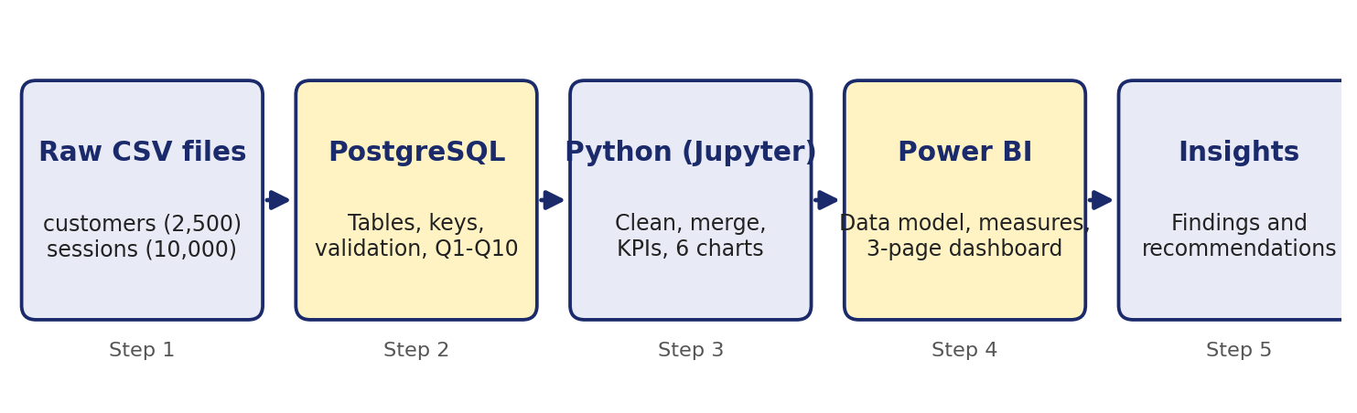
Figure 1: Project workflow from raw CSV files to insights

3.3 Step-by-step workflow
- Define the business objective and the ten business questions.
- Create the customers and sessions tables in PostgreSQL and load the CSV files.
- Validate the data: row counts, unique IDs, missing values, invalid values, orphan records and outcome–reason consistency.
- Analyse with SQL: one query per business question.
- Explore in Python: clean, merge, calculate KPIs and chart each dimension.
- Reconcile the SQL, Python and Power BI numbers so that all three agree.
- Visualise in Power BI with an overview page, a patterns page and a checkout and reasons page.
- Conclude with insights, recommendations and limitations.

4. Dataset Description

4.1 Overview
The data comes in two CSV files that are related through the customer ID. One row in customers describes a person; one row in sessions describes a single shopping session by that person. A customer can have many sessions, so the relationship is one-to-many.
Property | customers | sessions
Rows | 2,500 | 10,000
Columns | 7 | 14
Primary key | customer_id | session_id
Foreign key | – | customer_id → customers.customer_id
Date range | – | 1 Jan 2026 to 30 Sep 2026
Missing values | 0 | 0
Duplicate IDs | 0 | 0

4.2 Entity relationship diagram
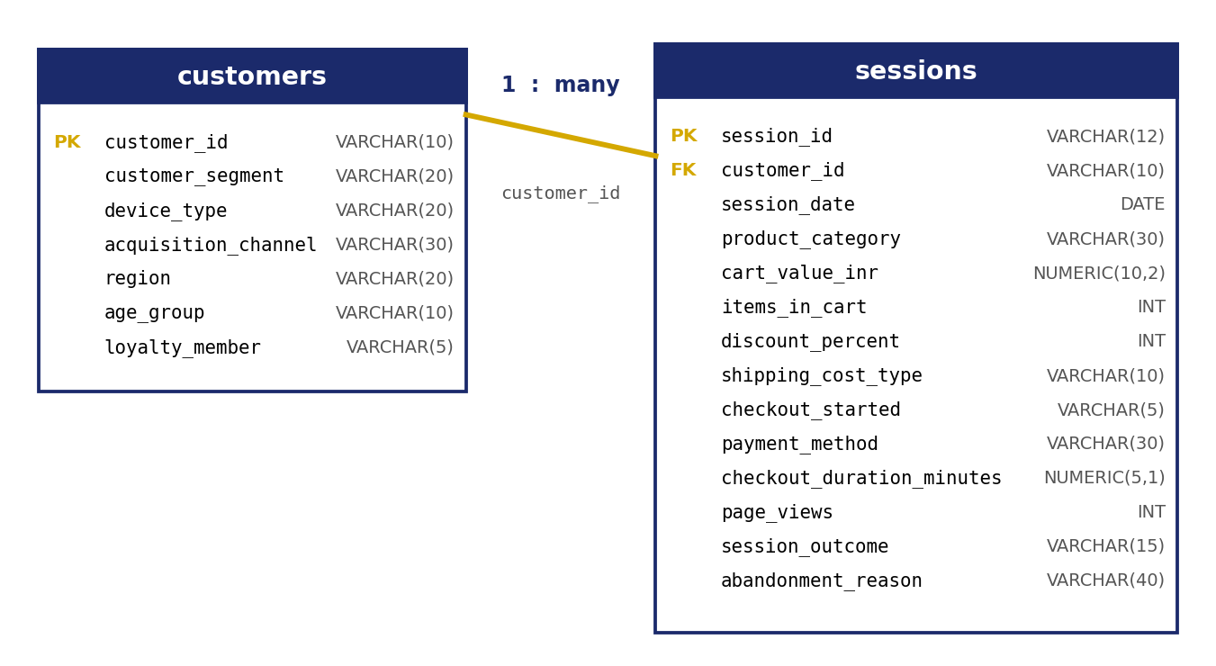
Figure 2: Entity relationship diagram of the two tables

4.3 Data dictionary – customers table
Column | SQL type | Description | Example values
customer_id | VARCHAR(10) | Unique customer identifier (primary key) | CUST00001
customer_segment | VARCHAR(20) | Customer relationship stage | New, Returning, Loyal
device_type | VARCHAR(20) | Main device used by the customer | Mobile, Desktop, Tablet
acquisition_channel | VARCHAR(30) | How the customer was acquired | Organic Search, Paid Search, Email, Direct, Referral, Social Media
region | VARCHAR(20) | Customer region in India | East, North, South
age_group | VARCHAR(10) | Age band | 18-24, 25-34, 35-44, 45-54
loyalty_member | VARCHAR(5) | Whether the customer is in the loyalty programme | Yes, No

4.4 Data dictionary – sessions table
Column | SQL type | Description | Example values
session_id | VARCHAR(12) | Unique session identifier (primary key) | SESS000001
customer_id | VARCHAR(10) | Customer who owns the session (foreign key) | CUST02221
session_date | DATE | Date of the session | 2026-08-17
product_category | VARCHAR(30) | Category of the products in the cart | Fashion, Books, Electronics
cart_value_inr | NUMERIC(10,2) | Cart value in Indian rupees | 857.10
items_in_cart | INT | Number of items in the cart | 2
discount_percent | INT | Discount offered on the cart | 0, 15, 25
shipping_cost_type | VARCHAR(10) | Whether shipping was free or paid | Free, Paid
checkout_started | VARCHAR(5) | Whether the shopper started checkout | Yes, No
payment_method | VARCHAR(30) | Payment method selected | UPI, Net Banking, Debit Card
checkout_duration_minutes | NUMERIC(5,1) | Minutes spent in checkout | 10.8
page_views | INT | Pages viewed in the session | 6
session_outcome | VARCHAR(15) | Final result of the session | Abandoned, Converted
abandonment_reason | VARCHAR(40) | Reason for abandonment; “Not Applicable” when converted | Payment Issue, Price Too High

Note: device_type belongs to the customers table, not the sessions table. Any device analysis therefore needs a join between the two tables, which is why Q2 and Q7 use JOIN while the other questions can query sessions alone.

4.5 Sample records
The first five rows of the sessions table (selected columns):
session_id | Category | Cart value (₹) | Discount | Shipping | Payment | Outcome | Reason
SESS000001 | Fashion | 857.10 | 15% | Paid | UPI | Abandoned | Website/Checkout Error
SESS000002 | Books | 1,644.79 | 0% | Paid | Net Banking | Converted | Not Applicable
SESS000003 | Home & Kitchen | 1,581.59 | 15% | Free | Debit Card | Abandoned | Website/Checkout Error
SESS000004 | Beauty | 1,731.22 | 25% | Paid | Debit Card | Converted | Not Applicable
SESS000005 | Sports | 1,527.27 | 0% | Free | Cash on Delivery | Abandoned | Unexpected Shipping Cost

4.6 Session volumes by dimension
Before looking at rates, it helps to know how many sessions sit behind each group. Small groups produce unstable percentages, so volumes are worth checking first.
Dimension | Group | Sessions | Share of all sessions
Device | Mobile | 6,277 | 62.8%
 | Desktop | 3,094 | 30.9%
 | Tablet | 629 | 6.3%
Shipping | Free | 5,793 | 57.9%
 | Paid | 4,207 | 42.1%
Category | Fashion | 2,785 | 27.9%
 | Home & Kitchen | 1,814 | 18.1%
 | Electronics | 1,679 | 16.8%
 | Beauty | 1,435 | 14.4%
 | Sports | 1,226 | 12.3%
 | Books | 1,061 | 10.6%
Payment | UPI | 3,192 | 31.9%
 | Credit Card | 1,998 | 20.0%
 | Debit Card | 1,781 | 17.8%
 | Cash on Delivery | 1,217 | 12.2%
 | Net Banking | 981 | 9.8%
 | Wallet | 831 | 8.3%

5. Data Validation and Cleaning
Analysis is only as reliable as the data behind it. Before answering any business question, the data was checked in two places: PostgreSQL (the SQL script) and Python (the notebook). Because the data was generated for a portfolio project it was already clean, but the checks are the same ones used on real data and document good practice.

5.1 Creating the database tables (SQL)
Two tables were created with a primary key on each and a foreign key linking sessions to customers. The foreign key guarantees that a session can never point to a customer who does not exist.
-- Create the customer table
CREATE TABLE customers (
customer_id VARCHAR(10) PRIMARY KEY,
customer_segment VARCHAR(20),
device_type VARCHAR(20),
acquisition_channel VARCHAR(30),
region VARCHAR(20),
age_group VARCHAR(10),
loyalty_member VARCHAR(5)
);

-- Create the sessions table
CREATE TABLE sessions (
session_id VARCHAR(12) PRIMARY KEY,
customer_id VARCHAR(10),
session_date DATE,
product_category VARCHAR(30),
cart_value_inr NUMERIC(10,2),
items_in_cart INT,
discount_percent INT,
shipping_cost_type VARCHAR(10),
checkout_started VARCHAR(5),
payment_method VARCHAR(30),
checkout_duration_minutes NUMERIC(5,1),
page_views INT,
session_outcome VARCHAR(15),
abandonment_reason VARCHAR(40),
CONSTRAINT fk_customer
FOREIGN KEY (customer_id)
REFERENCES customers(customer_id)
);
Design choices: NUMERIC(10,2) is used for money because it stores exact decimals (a floating-point type can introduce rounding errors). Dates use the DATE type so that month-based grouping works with DATE_TRUNC.

5.2 Validation checks in SQL
# | Check | Why it matters | Result
1 | Row counts of both tables | Confirms that the import loaded every row | 2,500 customers; 10,000 sessions
2 | COUNT(*) equals COUNT(DISTINCT id) | Detects duplicate IDs | Counts match: no duplicates
3 | NULLs in key columns | Missing IDs, dates, values or outcomes break calculations | 0 missing values
4 | Invalid values (negative cart value, items ≤ 0, discount outside 0–100, unknown outcome) | Catches impossible business values | 0 rows returned
5 | Sessions without a matching customer | Detects orphan records that would be lost in a join | 0 unmatched sessions
6 | Outcome vs abandonment reason | Converted sessions should say “Not Applicable”; abandoned ones should have a real reason | Consistent

The results above are confirmed by the equivalent Python checks in Section 5.3 on the same data.

Row counts and unique IDs
SELECT COUNT(*) AS total_customers FROM customers;
SELECT COUNT(*) AS total_sessions FROM sessions;

-- The counts should match within each table
SELECT COUNT(*) AS total_rows,
COUNT(DISTINCT customer_id) AS unique_customers
FROM customers;

SELECT COUNT(*) AS total_rows,
COUNT(DISTINCT session_id) AS unique_sessions
FROM sessions;

Missing values
SELECT
COUNT(*) FILTER (WHERE customer_id IS NULL) AS missing_customer_id,
COUNT(*) FILTER (WHERE session_date IS NULL) AS missing_session_date,
COUNT(*) FILTER (WHERE cart_value_inr IS NULL) AS missing_cart_value,
COUNT(*) FILTER (WHERE session_outcome IS NULL) AS missing_session_outcome
FROM sessions;

Invalid values and orphan records
-- Check invalid values
SELECT * FROM sessions
WHERE cart_value_inr < 0
OR items_in_cart <= 0
OR discount_percent NOT BETWEEN 0 AND 100
OR session_outcome NOT IN ('Abandoned', 'Converted');

-- Check for sessions without a matching customer
SELECT COUNT(*) AS unmatched_customer_sessions
FROM sessions s
LEFT JOIN customers c ON s.customer_id = c.customer_id
WHERE c.customer_id IS NULL;

Outcome and reason consistency
SELECT session_outcome, abandonment_reason, COUNT(*) AS session_count
FROM sessions
GROUP BY session_outcome, abandonment_reason
ORDER BY session_outcome, session_count DESC;

5.3 Validation and cleaning in Python
The notebook repeats the checks independently with pandas. Running the same checks in a second tool is a deliberate safeguard.
import pandas as pd
import numpy as np
import matplotlib.pyplot as plt
import seaborn as sns

customers = pd.read_csv("cart_abandonment_customers.csv")
sessions = pd.read_csv("cart_abandonment_sessions.csv")

print("Customers shape:", customers.shape) # (2500, 7)
print("Sessions shape:", sessions.shape) # (10000, 14)
The session dates were stored as text in day-month-year format (for example 17-08-2026). They were converted to a proper datetime type; errors="coerce" turns any unreadable date into a missing value instead of crashing, which makes problems visible.
sessions["session_date"] = pd.to_datetime(
sessions["session_date"],
errors="coerce"
)
print(sessions["session_date"].min()) # 2026-01-01
print(sessions["session_date"].max()) # 2026-09-30
# Missing values and duplicates
print(customers.isnull().sum())
print(sessions.isnull().sum())
print("Duplicate customer IDs:", customers["customer_id"].duplicated().sum())
print("Duplicate session IDs:", sessions["session_id"].duplicated().sum())

# Value validation
print(sessions["session_outcome"].value_counts())
print("Invalid cart values:", (sessions["cart_value_inr"] < 0).sum())
print("Invalid discounts:", (~sessions["discount_percent"].between(0, 100)).sum())

Joining the tables safely
df = sessions.merge(
customers,
on="customer_id",
how="left",
validate="many_to_one" # each session must match exactly one customer
)
print("Merged dataset shape:", df.shape) # (10000, 20)
Good practice: The argument validate="many_to_one" makes pandas raise an error if the customer table accidentally contained duplicate IDs. Without it, a join could silently multiply rows and inflate every count.

6. SQL Business Analysis
Each of the ten business questions is answered with one PostgreSQL query. The queries share the same structure: group the sessions by a dimension, count the total and abandoned sessions, and calculate the percentage. The result tables below show the values returned for the project dataset (these match the Python and Power BI results; see Section 7.12). The code is formatted compactly for this document.

6.1 SQL techniques used
Technique | Example | Why it was used
Conditional aggregation | COUNT(*) FILTER (WHERE ...) | Counts abandoned and converted sessions in a single pass, without a separate subquery.
Safe division | NULLIF(COUNT(*), 0) | Turns a zero denominator into NULL so the query can never fail with a divide-by-zero error.
Percentage maths | 100.0 * x / y | Using 100.0 forces decimal division; integer division would round down to 0.
Window function | SUM(COUNT(*)) OVER () | Calculates each reason’s share of the total without a second query.
Date truncation | DATE_TRUNC('month', date) | Groups daily sessions into months for the trend.
Value banding | CASE WHEN ... THEN ... | Turns a continuous cart value into five readable bands.
Joins | JOIN customers c ON ... | Brings customer attributes (device, segment) to the session level.

6.2 Joining the two tables
Before the analysis, the two tables were joined and the first 20 rows were inspected to confirm that the join works and that customer attributes appear next to each session.
SELECT s.session_id, s.customer_id, s.session_date, c.customer_segment,
c.device_type, c.acquisition_channel, c.region, c.loyalty_member,
s.product_category, s.cart_value_inr, s.items_in_cart,
s.discount_percent, s.shipping_cost_type, s.checkout_started,
s.payment_method, s.session_outcome, s.abandonment_reason
FROM sessions s
INNER JOIN customers c ON s.customer_id = c.customer_id
LIMIT 20;

Q1. What is the overall abandonment rate?
SELECT COUNT(*) AS total_sessions,
COUNT(*) FILTER (WHERE session_outcome = 'Abandoned') AS abandoned_sessions,
COUNT(*) FILTER (WHERE session_outcome = 'Converted') AS converted_sessions,
ROUND(100.0 * COUNT(*) FILTER (WHERE session_outcome = 'Abandoned')
/ NULLIF(COUNT(*), 0), 2) AS abandonment_rate_percent
FROM sessions;
Total sessions | Abandoned | Converted | Abandonment rate
10,000 | 5,716 | 4,284 | 57.16%

Insight: Roughly 6 out of every 10 shopping carts are abandoned. This is the baseline every other result is compared against.

Q2. Which devices have the highest abandonment rate?
Device type lives in the customers table, so the query joins the two tables first.
SELECT c.device_type,
COUNT(*) AS total_sessions,
COUNT(*) FILTER (WHERE s.session_outcome = 'Abandoned') AS abandoned_sessions,
ROUND(100.0 * COUNT(*) FILTER (WHERE s.session_outcome = 'Abandoned')
/ NULLIF(COUNT(*), 0), 2) AS abandonment_rate_percent
FROM sessions s
JOIN customers c ON s.customer_id = c.customer_id
GROUP BY c.device_type
ORDER BY abandonment_rate_percent DESC;
Device | Total sessions | Abandoned | Abandonment rate
Mobile | 6,277 | 3,815 | 60.78%
Desktop | 3,094 | 1,595 | 51.55%
Tablet | 629 | 306 | 48.65%

Insight: Mobile abandons about 9 percentage points more than desktop and 12 points more than tablet. Because mobile carries the most traffic, it is also the largest source of lost carts.

Q3. Which product categories show more abandonment?
SELECT product_category,
COUNT(*) AS total_sessions,
COUNT(*) FILTER (WHERE session_outcome = 'Abandoned') AS abandoned_sessions,
ROUND(100.0 * COUNT(*) FILTER (WHERE session_outcome = 'Abandoned')
/ NULLIF(COUNT(*), 0), 2) AS abandonment_rate_percent
FROM sessions
GROUP BY product_category
ORDER BY abandonment_rate_percent DESC;
Category | Total sessions | Abandoned | Abandonment rate
Electronics | 1,679 | 978 | 58.25%
Fashion | 2,785 | 1,611 | 57.85%
Home & Kitchen | 1,814 | 1,036 | 57.11%
Sports | 1,226 | 697 | 56.85%
Books | 1,061 | 603 | 56.83%
Beauty | 1,435 | 791 | 55.12%

Insight: Category differences are small (about 3 percentage points from top to bottom). Electronics is highest, but no category stands out as a special problem.

Q4. Is paid shipping associated with abandonment?
SELECT shipping_cost_type,
COUNT(*) AS total_sessions,
COUNT(*) FILTER (WHERE session_outcome = 'Abandoned') AS abandoned_sessions,
ROUND(100.0 * COUNT(*) FILTER (WHERE session_outcome = 'Abandoned')
/ NULLIF(COUNT(*), 0), 2) AS abandonment_rate_percent
FROM sessions
GROUP BY shipping_cost_type
ORDER BY abandonment_rate_percent DESC;
Shipping | Total sessions | Abandoned | Abandonment rate
Paid | 4,207 | 2,623 | 62.35%
Free | 5,793 | 3,093 | 53.39%

Insight: Yes. Paid shipping is associated with a rate about 9 percentage points higher than free shipping. Association is not proof of cause, but together with the reason analysis (Q6) it is a strong signal.

Q5. Which payment methods have higher abandonment rates?
SELECT payment_method,
COUNT(*) AS total_sessions,
COUNT(*) FILTER (WHERE session_outcome = 'Abandoned') AS abandoned_sessions,
ROUND(100.0 * COUNT(*) FILTER (WHERE session_outcome = 'Abandoned')
/ NULLIF(COUNT(*), 0), 2) AS abandonment_rate_percent
FROM sessions
GROUP BY payment_method
ORDER BY abandonment_rate_percent DESC;
Payment method | Total sessions | Abandoned | Abandonment rate
Net Banking | 981 | 569 | 58.00%
Debit Card | 1,781 | 1,024 | 57.50%
UPI | 3,192 | 1,831 | 57.36%
Credit Card | 1,998 | 1,142 | 57.16%
Cash on Delivery | 1,217 | 686 | 56.37%
Wallet | 831 | 464 | 55.84%

Insight: All six payment methods sit within about 2 percentage points of each other, so the method chosen is a weak predictor. Payment problems matter as a stated reason (Q6), but they are not concentrated in one method.

Q6. Which abandonment reasons occur most often?
Only abandoned sessions are counted here. The window function SUM(COUNT(*)) OVER () returns the grand total on every row, so each reason’s share can be computed in the same query.
SELECT abandonment_reason,
COUNT(*) AS abandoned_sessions,
ROUND(100.0 * COUNT(*) /
NULLIF(SUM(COUNT(*)) OVER (), 0), 2) AS percentage_of_abandoned_sessions
FROM sessions
WHERE session_outcome = 'Abandoned'
GROUP BY abandonment_reason
ORDER BY abandoned_sessions DESC;
Reason | Abandoned sessions | Share of abandoned
Unexpected Shipping Cost | 1,061 | 18.56%
Price Too High | 942 | 16.48%
Payment Issue | 796 | 13.93%
Website/Checkout Error | 571 | 9.99%
Comparison Shopping | 566 | 9.90%
Forced Account Creation | 503 | 8.80%
Changed Mind | 499 | 8.73%
Delivery Too Slow | 481 | 8.41%
Other | 297 | 5.20%
Total | 5,716 | 100.00%

Insight: The top three reasons (shipping cost, price and payment issues) make up nearly half (48.97%) of all abandoned sessions. Most of them are things the business can influence.

Q7. How do customer segments compare?
SELECT c.customer_segment,
COUNT(*) AS total_sessions,
COUNT(*) FILTER (WHERE s.session_outcome = 'Abandoned') AS abandoned_sessions,
ROUND(100.0 * COUNT(*) FILTER (WHERE s.session_outcome = 'Abandoned')
/ NULLIF(COUNT(*), 0), 2) AS abandonment_rate_percent
FROM sessions s
JOIN customers c ON s.customer_id = c.customer_id
GROUP BY c.customer_segment
ORDER BY abandonment_rate_percent DESC;
Segment | Abandonment rate
New | 62.02%
Loyal | 54.10%
Returning | 54.03%

Insight: New customers abandon about 8 percentage points more than customers who have bought before. Trust and familiarity appear to matter. Rates shown are taken from the Power BI dashboard (Page 2); the session counts per segment are returned when the query is run.

Q8. How does abandonment change month by month?
SELECT DATE_TRUNC('month', session_date)::DATE AS month_start,
COUNT(*) AS total_sessions,
COUNT(*) FILTER (WHERE session_outcome = 'Abandoned') AS abandoned_sessions,
ROUND(100.0 * COUNT(*) FILTER (WHERE session_outcome = 'Abandoned')
/ NULLIF(COUNT(*), 0), 2) AS abandonment_rate_percent
FROM sessions
GROUP BY DATE_TRUNC('month', session_date)
ORDER BY month_start;
Month | Total sessions | Abandoned | Abandonment rate
Jan 2026 | 1,167 | 641 | 54.93%
Feb 2026 | 990 | 572 | 57.78%
Mar 2026 | 1,127 | 667 | 59.18%
Apr 2026 | 1,046 | 593 | 56.69%
May 2026 | 1,146 | 669 | 58.38%
Jun 2026 | 1,071 | 604 | 56.40%
Jul 2026 | 1,164 | 671 | 57.65%
Aug 2026 | 1,210 | 676 | 55.87%
Sep 2026 | 1,079 | 623 | 57.74%

Insight: The rate stays in a narrow band between about 55% and 59% with no steady upward or downward trend. The problem is structural rather than seasonal.

Q9. Does abandonment vary by discount?
SELECT discount_percent,
COUNT(*) AS total_sessions,
COUNT(*) FILTER (WHERE session_outcome = 'Abandoned') AS abandoned_sessions,
ROUND(100.0 * COUNT(*) FILTER (WHERE session_outcome = 'Abandoned')
/ NULLIF(COUNT(*), 0), 2) AS abandonment_rate_percent
FROM sessions
GROUP BY discount_percent
ORDER BY discount_percent;
The query returns one row for each discount level. In Power BI the same field is grouped into four bands to make the chart easier to read:
Discount band | Abandonment rate
0% (no discount) | 60.72%
1–10% | 55.51%
11–20% | 56.16%
Above 20% | 53.43%

Insight: Carts with no discount abandon the most (60.72%). Any discount lowers the rate, but a bigger discount does not always help more (11–20% is slightly worse than 1–10%), so deep discounts should be used with care.

Q10. What is the relationship between cart value and abandonment?
A CASE expression sorts each cart into a value band. GROUP BY 1 refers to the first column in the SELECT list, and ORDER BY MIN(cart_value_inr) keeps the bands in their natural low-to-high order rather than alphabetical order.
SELECT
CASE
WHEN cart_value_inr < 1000 THEN 'Under ₹1,000'
WHEN cart_value_inr < 3000 THEN '₹1,000–₹2,999'
WHEN cart_value_inr < 5000 THEN '₹3,000–₹4,999'
WHEN cart_value_inr < 10000 THEN '₹5,000–₹9,999'
ELSE '₹10,000 and above'
END AS cart_value_band,
COUNT(*) AS total_sessions,
COUNT(*) FILTER (WHERE session_outcome = 'Abandoned') AS abandoned_sessions,
ROUND(100.0 * COUNT(*) FILTER (WHERE session_outcome = 'Abandoned')
/ NULLIF(COUNT(*), 0), 2) AS abandonment_rate_percent
FROM sessions
GROUP BY 1
ORDER BY MIN(cart_value_inr);
Cart value band | Total sessions | Abandoned | Abandonment rate
Under ₹1,000 | 2,793 | 1,629 | 58.32%
₹1,000–₹2,999 | 5,864 | 3,314 | 56.51%
₹3,000–₹4,999 | 1,023 | 600 | 58.65%
₹5,000–₹9,999 | 308 | 165 | 53.57%
₹10,000 and above | 12 | 8 | 66.67%

Insight: There is no clear pattern: the rate does not rise steadily with cart value. The 66.67% for ₹10,000+ rests on only 12 sessions, so it is too small to draw a conclusion from.

7. Exploratory Data Analysis in Python

7.1 Purpose of the notebook
The Jupyter notebook plays two roles. First, it is an independent check of the SQL answers, using a different tool and different code. Second, it produces charts that make the patterns easy to see. The notebook runs on Python 3.13.5 with pandas, NumPy, Matplotlib and Seaborn.

7.2 Notebook structure
Step | What the notebook does | Key code
1 | Install and import libraries | import pandas as pd
2 | Load the two CSV files and inspect shapes | pd.read_csv()
3 | Check data types and convert the date column | pd.to_datetime()
4 | Check missing values and duplicates | isnull().sum(), duplicated()
5 | Validate values and join the tables | merge(validate="many_to_one")
6 | Calculate key metrics | Total, abandoned, converted, rates
7 | Analyse device, category, shipping, payment, reasons, month, cart value | groupby().agg()
8 | Visualise each result | Seaborn barplot, lineplot
9 | Export cleaned data and analysis tables | to_csv()

7.3 Key metrics
total_sessions = len(df)
abandoned_sessions = (df["session_outcome"] == "Abandoned").sum()
converted_sessions = (df["session_outcome"] == "Converted").sum()

abandonment_rate = abandoned_sessions / total_sessions * 100
conversion_rate = converted_sessions / total_sessions * 100

# Output
# Total sessions: 10000
# Abandoned sessions: 5716
# Converted sessions: 4284
# Abandonment rate: 57.16%
# Conversion rate: 42.84%
The Python result (57.16%) is identical to the SQL result for Q1, which is the first successful cross-check.

7.4 A reusable analysis pattern
Every dimension is analysed with the same three-step pattern. First, a True/False column abandoned is created. Second, the data is grouped by the dimension. Third, the mean of the True/False column is taken, which is exactly the abandonment rate because True counts as 1 and False as 0.
device_analysis = (
df.assign(abandoned=df["session_outcome"].eq("Abandoned"))
.groupby("device_type")
.agg(
total_sessions=("session_id", "count"),
abandoned_sessions=("abandoned", "sum"),
abandonment_rate=("abandoned", "mean")
)
.reset_index()
)
device_analysis["abandonment_rate"] *= 100
Memory aid: The mean of a True/False column equals the proportion of True values. That is why mean() on abandoned gives the abandonment rate directly.

7.5 Device analysis
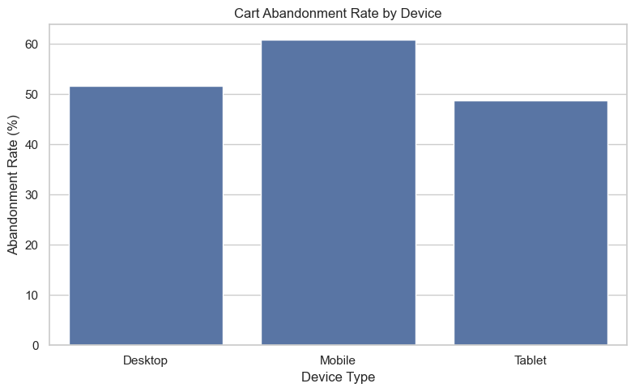
Figure 3: Cart abandonment rate by device (Python / Seaborn)
Mobile sessions abandon at 60.78%, desktop at 51.55% and tablet at 48.65%. The chart confirms the SQL result for Q2 and shows the gap visually: the mobile bar is clearly the tallest.

7.6 Product category analysis
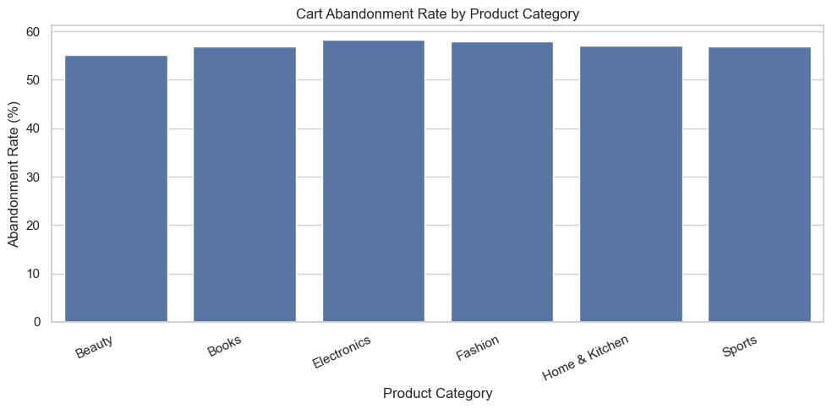
Figure 4: Cart abandonment rate by product category
The six bars are almost the same height. Electronics (58.25%) is highest and Beauty (55.12%) is lowest. This is a useful negative finding: product category is not what drives abandonment.

7.7 Shipping and payment analysis
Shipping and payment were analysed in the same cell. The shipping result is shown as a table, and the payment result as a chart.
Shipping type | Total sessions | Abandoned | Abandonment rate
Free | 5,793 | 3,093 | 53.39%
Paid | 4,207 | 2,623 | 62.35%

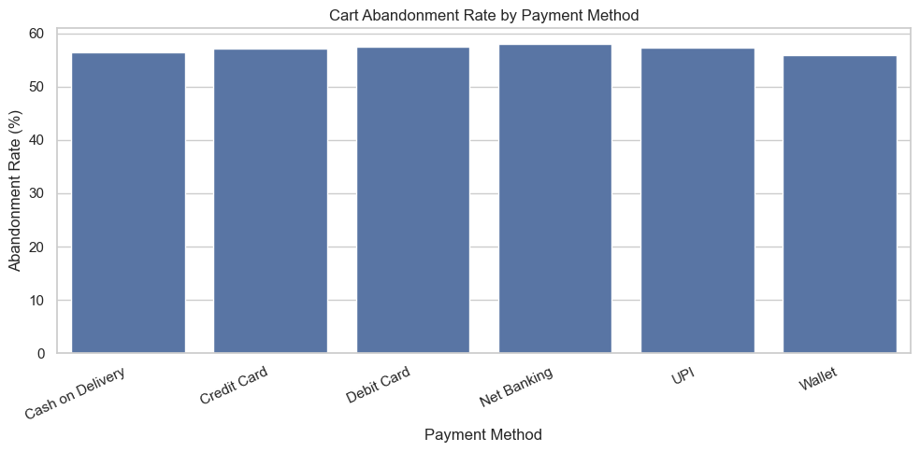
Figure 5: Cart abandonment rate by payment method
Payment methods differ by only about 2 percentage points, from 58.00% for Net Banking to 55.84% for Wallet.

7.8 Abandonment reasons
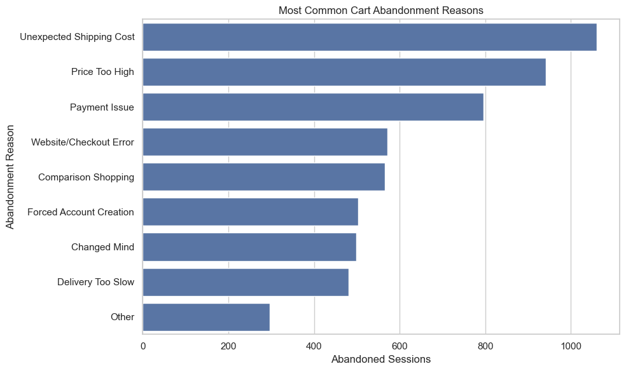
Figure 6: Most common cart abandonment reasons
The three largest bars are Unexpected Shipping Cost (1,061), Price Too High (942) and Payment Issue (796). The reasons add up to the 5,716 abandoned sessions, so every abandoned session has a recorded reason.

7.9 Monthly trend
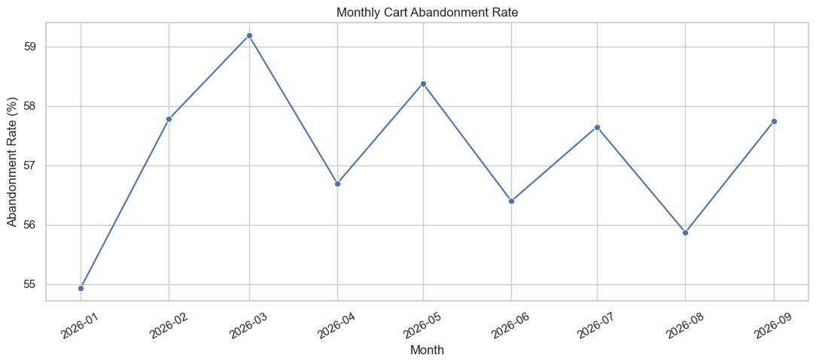
Figure 7: Monthly cart abandonment rate, January to September 2026
The line moves up and down between 54.93% (January) and 59.18% (March) without a lasting trend. Month-to-month changes of two to three percentage points are normal variation when each month has about 1,000 sessions.

7.10 Cart value analysis
df["cart_value_band"] = pd.cut(
df["cart_value_inr"],
bins=[0, 1000, 3000, 5000, 10000, np.inf],
labels=["Under ₹1,000", "₹1,000–₹2,999", "₹3,000–₹4,999",
"₹5,000–₹9,999", "₹10,000+"],
right=False # lower bound included, upper bound excluded
)
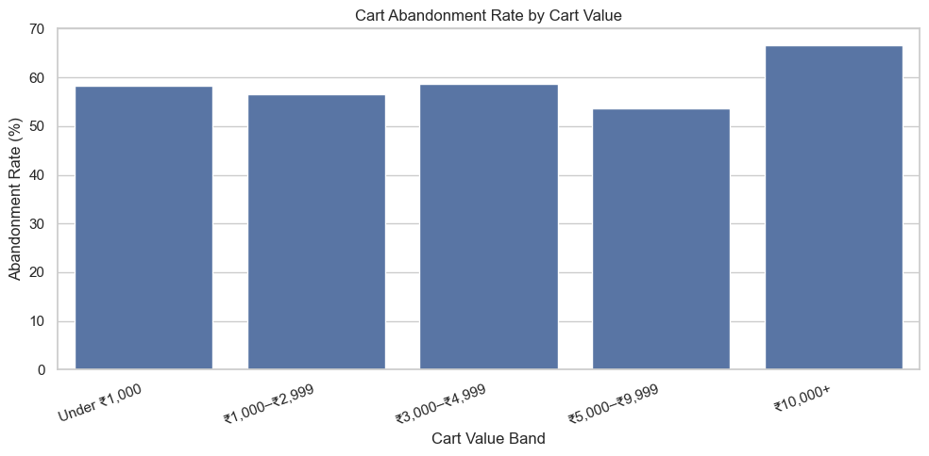
Figure 8: Cart abandonment rate by cart value band
The pandas bins use right=False, so a cart of exactly ₹1,000 falls into the second band. This matches the SQL CASE logic (< 1000), which is why the numbers agree exactly. The ₹10,000+ band has only 12 sessions and should not be over-interpreted.

7.11 Exporting results
The final cell exports the analysis tables and the cleaned datasets to CSV files so that they can be reused in Power BI, shared on GitHub or checked later.

7.12 SQL vs Python vs Power BI: reconciliation
A sample of results from each tool shows that the three agree.
Metric | Python notebook | Power BI dashboard | Agree?
Overall abandonment rate | 57.16% | 57.16% | Yes
Mobile abandonment rate | 60.78% | 60.78% | Yes
Paid shipping abandonment rate | 62.35% | 62.35% | Yes
Electronics abandonment rate | 58.25% | 58.25% | Yes
Net Banking abandonment rate | 58.00% | 58.00% | Yes
March 2026 abandonment rate | 59.18% | 59.18% | Yes
Unexpected Shipping Cost sessions | 1,061 | 1,061 | Yes
₹10,000+ band abandonment rate | 66.67% | 66.67% | Yes

The SQL queries use the same definitions as the pandas code, so they return the same values when run on the same data.

8. Power BI Dashboard

8.1 Purpose and audience
The dashboard turns the analysis into something a manager can explore without writing code. It is built for a business reader who wants to answer questions such as “Is mobile worse than desktop?” or “What happens if I only look at new customers on paid shipping?” in a few clicks.

8.2 Data model
Table | Role | Contents
cart_abandonment_customers | Dimension table | Customer attributes: segment, device, channel, region, age group, loyalty
cart_abandonment_sessions | Fact table | One row per session, with cart, checkout and outcome fields
DateTable | Calendar table | Month labels used by the monthly trend and the Month slicer

The customers table is related to the sessions table through customer_id (one customer, many sessions). This means that a slicer on a customer attribute such as device or segment filters the session charts as well. The star-style layout, with one fact table surrounded by dimension tables, is the standard Power BI design.

8.3 Measures and calculated columns
Measures are calculations that react to the filters the user chooses. The dashboard uses four core measures:
Measure | What it calculates
Total Sessions | Number of session rows in the current filter context
Abandoned Sessions | Number of sessions whose outcome is “Abandoned”
Abandonment Rate | Abandoned sessions divided by total sessions
Conversion Rate | Converted sessions divided by total sessions

Three calculated columns support grouping: Month Label (for the trend and slicer), Discount Band (0%, 1–10%, 11–20%, Above 20%) and Cart Value Band (five value ranges).
Why measures and not columns? A rate must be recalculated for each filter selection. A measure does this automatically, so the abandonment rate for “Mobile + New customers” is correct without extra work.

8.4 Design choices
- Canvas: 1920 × 1080 (16:9), set to fit the page, so it looks sharp on a standard monitor.
- Colour theme: a yellow header with navy, gold and soft purple-blue chart colours for a consistent, branded look.
- Navigation: page buttons in the header let users move between the three pages; a back button is provided on each page.
- Filters: dropdown slicers keep the page tidy; a Clear all slicers button resets every selection in one click.
- Layout logic: headline numbers first (Overview), then comparisons (Patterns), then reasons and detail (Checkout & Reasons). This follows the natural questions “how big?”, “where?” and “why?”.
- Context: a text box on the Overview page states the business objective and notes that the data is synthetic.

8.5 Page 1: Overview
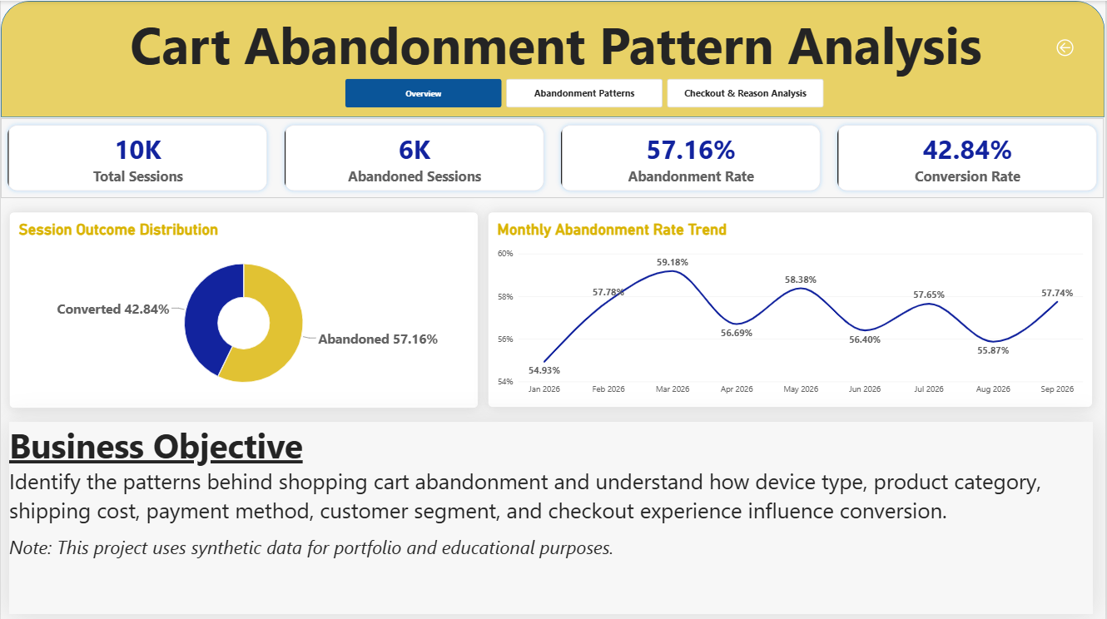
Figure 9: Dashboard page 1: Overview
Visual | Type | What it shows
Total Sessions, Abandoned Sessions, Abandonment Rate, Conversion Rate | KPI cards | 10K sessions, 6K abandoned, 57.16% abandonment, 42.84% conversion
Session Outcome Distribution | Donut chart | Abandoned 57.16% versus Converted 42.84%
Monthly Abandonment Rate Trend | Line chart | Monthly rate from 54.93% (Jan) to 59.18% (Mar); no sustained trend
Business Objective | Text box | States the project goal and that the data is synthetic

How to read it: the four cards give the answer in five seconds. The donut shows the split, and the line confirms that the problem is steady across the nine months, so it is not a one-off event.

8.6 Page 2: Abandonment Patterns
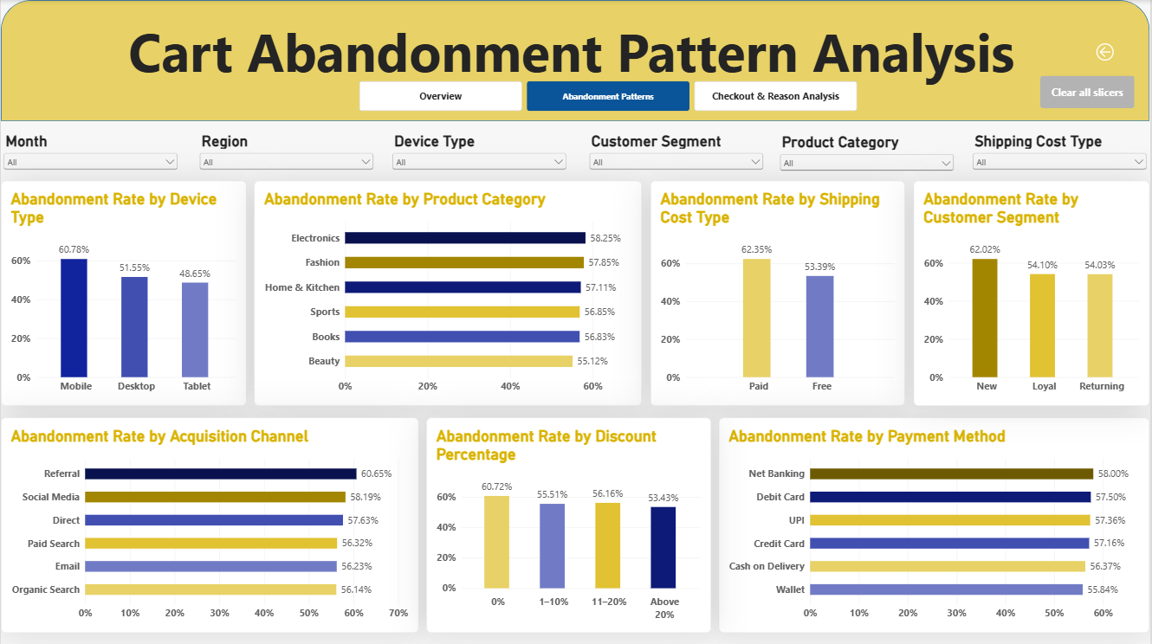
Figure 10: Dashboard page 2: Abandonment Patterns
This page compares abandonment across seven dimensions. Six slicers (Month, Region, Device Type, Customer Segment, Product Category and Shipping Cost Type) filter all seven charts together.
Chart | Highest group | Lowest group | Spread
By Device Type | Mobile 60.78% | Tablet 48.65% | 12.1 pp
By Product Category | Electronics 58.25% | Beauty 55.12% | 3.1 pp
By Shipping Cost Type | Paid 62.35% | Free 53.39% | 9.0 pp
By Customer Segment | New 62.02% | Returning 54.03% | 8.0 pp
By Acquisition Channel | Referral 60.65% | Organic Search 56.14% | 4.5 pp
By Discount Percentage | 0%: 60.72% | Above 20%: 53.43% | 7.3 pp
By Payment Method | Net Banking 58.00% | Wallet 55.84% | 2.2 pp

How to read it: look for bars that are clearly different from the others. Device, shipping and segment stand out; category and payment look almost flat.

8.7 Page 3: Checkout & Reason Analysis
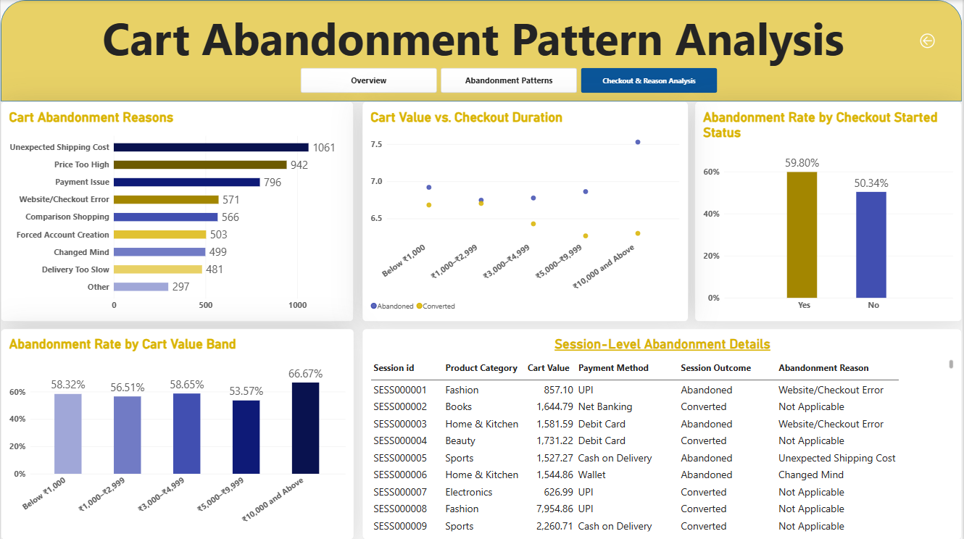
Figure 11: Dashboard page 3: Checkout & Reason Analysis
Visual | Type | What it shows
Cart Abandonment Reasons | Bar chart | Count of abandoned sessions per reason, led by Unexpected Shipping Cost (1,061)
Cart Value vs. Checkout Duration | Scatter chart | Average checkout duration (about 6.3–7.5 minutes) for each cart value band, split by abandoned and converted
Abandonment Rate by Checkout Started Status | Column chart | Yes: 59.80%; No: 50.34%
Abandonment Rate by Cart Value Band | Column chart | Five bands from 53.57% to 66.67% (the top band has only 12 sessions)
Session-Level Abandonment Details | Table | Session ID, category, cart value, payment method, outcome and reason for drill-down

How to read it: start with the reasons chart to see why people leave, then use the session table to inspect individual records behind any filter selection.

8.8 Interactivity guide
- Choose a value in any dropdown slicer (for example Device Type = Mobile). Every chart on the page updates.
- Combine slicers to ask precise questions, such as “New customers on mobile with paid shipping”.
- Click a bar or a donut slice to cross-filter the other visuals on the page.
- Press Clear all slicers to return to the full dataset.
- Use the page buttons at the top to switch between Overview, Abandonment Patterns and Checkout & Reason Analysis.

9. Key Insights
This section combines the SQL, Python and Power BI results into one story. The central question is: which factors separate high-abandonment groups from low-abandonment groups?

9.1 Which factors matter most?
A simple way to rank factors is to look at the gap between the highest and the lowest abandonment rate within each factor. A large gap means that the factor separates shoppers who abandon from shoppers who buy.
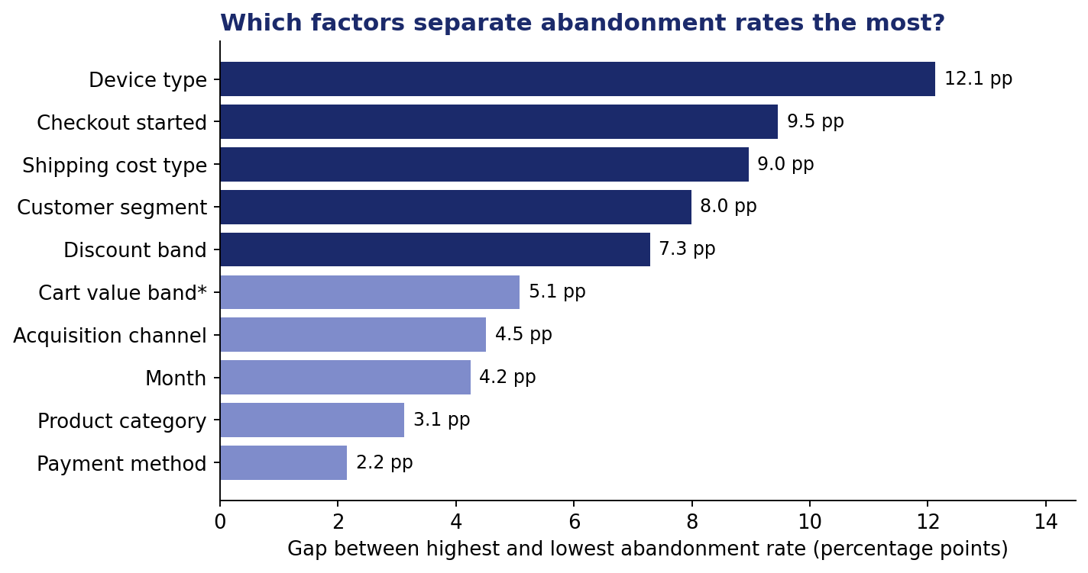
Figure 12: Gap between highest and lowest abandonment rate by factor (* top band excluded, only 12 sessions)
Rank | Factor | Highest | Lowest | Gap (pp)
1 | Device type | Mobile 60.78% | Tablet 48.65% | 12.1
2 | Checkout started | Yes 59.80% | No 50.34% | 9.5
3 | Shipping cost type | Paid 62.35% | Free 53.39% | 9.0
4 | Customer segment | New 62.02% | Returning 54.03% | 8.0
5 | Discount band | 0%: 60.72% | Above 20%: 53.43% | 7.3
6 | Cart value band* | ₹3,000–₹4,999: 58.65% | ₹5,000–₹9,999: 53.57% | 5.1
7 | Acquisition channel | Referral 60.65% | Organic Search 56.14% | 4.5
8 | Month | Mar 59.18% | Jan 54.93% | 4.3
9 | Product category | Electronics 58.25% | Beauty 55.12% | 3.1
10 | Payment method | Net Banking 58.00% | Wallet 55.84% | 2.2

Memory aid – “D-S-S”: Device, Shipping and Segment (new customers) are the three levers with the biggest and most actionable gaps.

9.2 Device: mobile is the biggest opportunity
- Mobile abandons at 60.78%, about 9 pp above desktop.
- Mobile is 62.8% of all sessions and accounts for 3,815 of the 5,716 abandoned sessions (66.7%).
- Even a small improvement on mobile therefore moves the overall rate more than a large improvement on tablet, which has only 629 sessions.

9.3 Shipping and price: the cost story
- Paid shipping: 62.35% abandonment versus 53.39% for free shipping.
- Unexpected Shipping Cost (18.56%) and Price Too High (16.48%) are the top two reasons.
- Carts with no discount abandon at 60.72%, higher than every discounted group.
- Free shipping still shows 53.39% abandonment, so shipping is a major driver but not the only one.
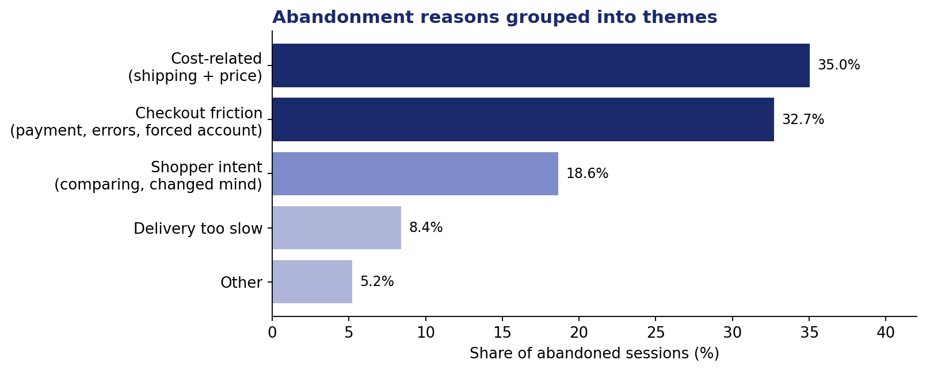
Figure 13: Abandonment reasons grouped into five themes (grouping defined for this document)
Grouping the nine reasons into themes makes the story clearer: cost-related reasons (35.0%) and checkout friction (32.7%) together explain two-thirds of abandonment, and both are within the business’s control. Shopper intent (comparison shopping and changed mind) accounts for 18.6%, which is harder to influence.
Theme | Reasons included | Share of abandoned sessions
Cost-related | Unexpected Shipping Cost (18.56%), Price Too High (16.48%) | 35.0%
Checkout friction | Payment Issue (13.93%), Website/Checkout Error (9.99%), Forced Account Creation (8.80%) | 32.7%
Shopper intent | Comparison Shopping (9.90%), Changed Mind (8.73%) | 18.6%
Delivery | Delivery Too Slow (8.41%) | 8.4%
Other | Other (5.20%) | 5.2%

9.4 Customers, discounts and checkout
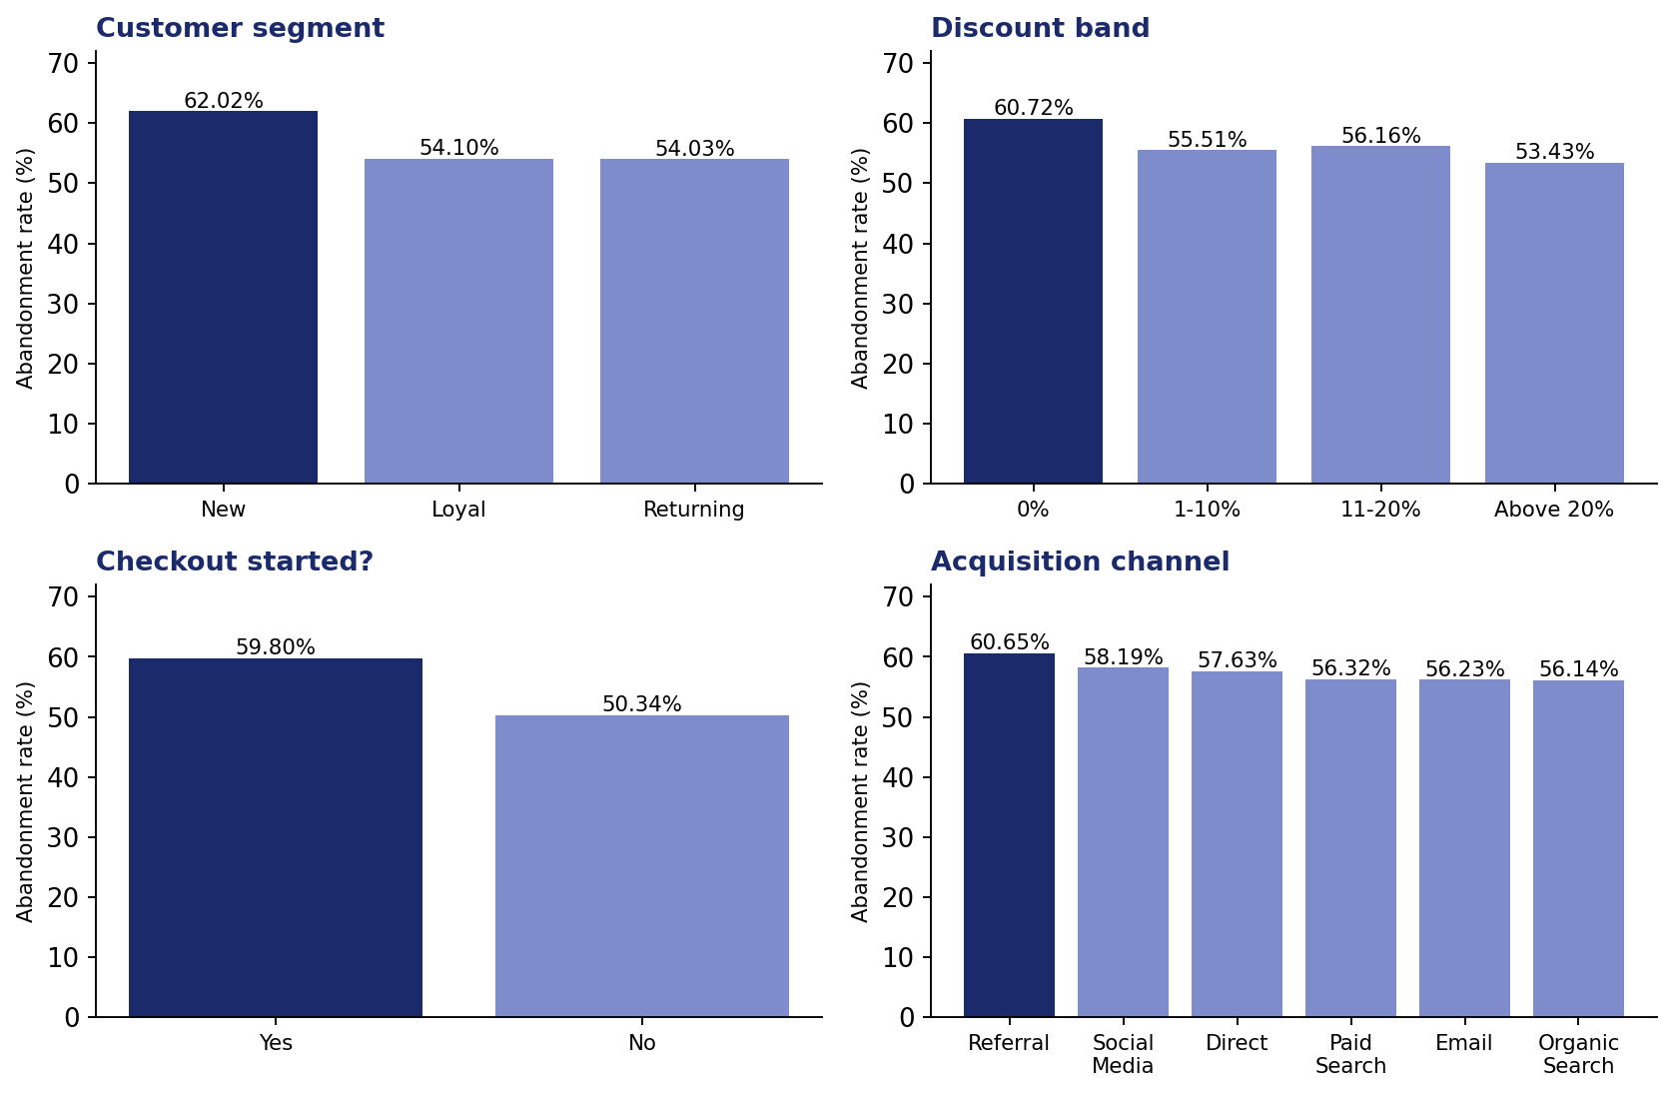
Figure 14: Abandonment rate by customer segment, discount band, checkout status and acquisition channel
- Customer segment: new customers abandon at 62.02%, about 8 pp above loyal and returning customers, which suggests a trust or familiarity gap.
- Acquisition channel: referral (60.65%) and social media (58.19%) customers abandon somewhat more than organic search (56.14%) customers, but the differences are modest.
- Discounts: any discount helps, and the largest discount band has the lowest rate, but the relationship is not a smooth staircase.
- Checkout started: sessions that started checkout abandon at 59.80% and those that did not at 50.34%. See the data note in Section 11.

9.5 What does NOT matter much
- Payment method: all methods are within about 2 pp of each other.
- Product category: all categories are within about 3 pp.
- Month: the rate moves around 57% with no seasonal trend.
- Cart value: no steady pattern; the highest band is too small to judge.

9.6 What if? An illustrative impact estimate
The table shows what would happen to the overall abandonment rate if a high-abandonment group performed as well as its better-performing counterpart. These are simple what-if calculations based on the observed data, not forecasts, and the effects of different fixes cannot be added together because the groups overlap.
Scenario | Calculation | Sessions recovered | New overall rate
Paid shipping drops to the free-shipping rate | 4,207 × (62.35% − 53.39%) | about 377 | about 53.4%
Mobile drops to the desktop rate | 6,277 × (60.78% − 51.55%) | about 579 | about 51.4%

10. Recommendations
Each recommendation links an observed pattern to an action, a measurable goal and a way to test it. Recommendations are ordered by the size of the evidence.

10.1 Recommendation summary
# | Recommendation | Evidence | Effort | Priority
1 | Fix the mobile checkout experience | Mobile: 60.78% vs 51.55% desktop; 66.7% of abandoned sessions | Medium | High
2 | Show total cost early and test a free-shipping threshold | Paid shipping 62.35% vs 53.39%; top reason 18.56% | Low–Medium | High
3 | Improve price transparency and offer targeted discounts | Price Too High 16.48%; 0% discount carts abandon at 60.72% | Medium | High
4 | Make payments more reliable | Payment Issue 13.93%; Website/Checkout Error 9.99% | Medium | Medium
5 | Offer guest checkout | Forced Account Creation 8.80% | Low | Medium
6 | Build trust for new customers | New customers 62.02% vs about 54% | Medium | Medium
7 | Recover abandoned carts with reminders | 57.16% of sessions end without a purchase | Low | Medium

10.2 Details

1. Fix the mobile checkout experience
- Action: audit the mobile checkout for slow pages, hard-to-tap fields and long forms; enable autofill, one-tap UPI and saved addresses.
- Goal: reduce mobile abandonment from 60.78% towards the desktop level of 51.55%.
- Test: A/B test a simplified mobile checkout against the current one.

2. Show total cost early and test a free-shipping threshold
- Action: display shipping cost on product and cart pages so there is no surprise at checkout; test free shipping above a minimum cart value.
- Goal: bring paid-shipping abandonment closer to 53.39%.
- Guardrail: monitor average order value and margin, because free shipping has a cost.

3. Improve price transparency and offer targeted discounts
- Action: use targeted offers (for example on the first order) rather than deep sitewide discounts, because the discount effect is not a smooth staircase.
- Goal: lower abandonment among no-discount carts without reducing margin unnecessarily.

4. Make payments more reliable
- Action: monitor payment failures, add automatic retry, and offer an alternative method when a payment fails.
- Goal: reduce the combined 23.9% share of Payment Issue and Website/Checkout Error reasons.

5. Offer guest checkout
- Action: let shoppers check out without creating an account and invite them to register afterwards.
- Goal: reduce the 8.80% of abandonments caused by forced account creation.

6. Build trust for new customers
- Action: show reviews, return policy and secure-payment badges; provide a first-order incentive.
- Goal: close part of the 8 pp gap between new and returning customers.

7. Recover abandoned carts
- Action: send reminder messages or emails with the cart contents; for “Unexpected Shipping Cost” carts, include a shipping offer.
- Goal: convert a share of the 5,716 abandoned sessions.

10.3 How success would be measured
KPI | Current value | Where to track it
Overall abandonment rate | 57.16% | Overview page
Mobile abandonment rate | 60.78% | Abandonment Patterns page, Device chart
Paid-shipping abandonment rate | 62.35% | Abandonment Patterns page, Shipping chart
Share of “Unexpected Shipping Cost” reasons | 18.56% | Checkout & Reason Analysis page
New-customer abandonment rate | 62.02% | Abandonment Patterns page, Segment chart

10.4 Experiment design template
Because the data shows association and not cause, the next step for any recommendation should be a controlled experiment. A simple template:
Element | Example for recommendation 2
Hypothesis | Showing shipping cost on the cart page reduces abandonment among paid-shipping sessions.
Test group / control group | Half of paid-shipping shoppers see the cost early; the other half see the current flow.
Primary metric | Abandonment rate
Guardrail metrics | Average order value, margin per order
Duration | Long enough to include several hundred sessions in each group
Decision rule | Roll out if the improvement is statistically significant and guardrails stay healthy.

11. Limitations and Future Work

11.1 Limitations
- Synthetic data. The data was generated for a portfolio project. Patterns are realistic in spirit, but results should not be treated as findings about a real business.
- Association, not causation. The analysis shows that paid shipping and high abandonment go together; it cannot prove that shipping cost causes abandonment. Only an experiment can.
- No significance testing. Rates were compared by their size alone. Small gaps (for example between payment methods) may be due to chance.
- Small groups. The ₹10,000+ cart band has only 12 sessions, and tablets have 629, so those percentages are less stable.
- Checkout-started definition. In the data, sessions that did not start checkout show a lower abandonment rate (50.34%) than those that did (59.80%). Some sample rows even show a converted session with checkout_started = No and a checkout duration of 0.0 minutes. In a real project this field definition would be confirmed with the data owner before drawing conclusions.
- Short period. Nine months cannot show yearly seasonality such as festival sales.
- Reasons are recorded labels. The stated abandonment reason is a single category per session and may not capture the true cause.

11.2 Future work
Idea | What it would add | Tools
Statistical tests | Chi-square tests to show which differences are significant | Python (scipy)
Funnel analysis | See exactly where in the journey (cart → checkout → payment) users drop out | SQL, Power BI
Predictive model | Predict which sessions will be abandoned (logistic regression, random forest) | Python (scikit-learn)
Customer segmentation | RFM or clustering to find high-value groups | Python
Interaction analysis | Device × shipping or segment × device combinations | SQL, Power BI
Revenue impact | Convert recovered sessions into estimated rupees using cart value | SQL, Power BI
Publish the dashboard | Share on Power BI Service with scheduled refresh | Power BI Service

Appendix

A. How to reproduce the project
- Install PostgreSQL and create a new database (for example cartwise).
- Run the CREATE TABLE statements for customers first and then sessions (the foreign key requires this order).
- Import cart_abandonment_customers.csv and cart_abandonment_sessions.csv into the two tables (for example with the import tool in pgAdmin).
- Run the validation queries from Section 5 and confirm 2,500 customers and 10,000 sessions.
- Run the ten business queries from Section 6.
- Open the Jupyter notebook, place the two CSV files in the same folder, and run all cells. Install dependencies with pip install pandas numpy matplotlib seaborn jupyter.
- Open the .pbix file in Power BI Desktop. If the data source path has changed, update it under Transform data → Data source settings.

B. Suggested repository structure
cartwise-cart-abandonment/
|-- README.md
|-- data/
| |-- cart_abandonment_customers.csv
| |-- cart_abandonment_sessions.csv
|-- sql/
| |-- cart_abandonment_analysis.sql
|-- notebooks/
| |-- cart_abandonment_eda.ipynb
|-- dashboard/
| |-- CartWise_Abandonment_Dashboard.pbix
| |-- screenshots/
|-- docs/
| |-- CartWise_Project_Documentation.docx

C. Glossary
Term | Meaning
BRD | Business requirements document: lists what the business needs to know.
KPI | Key performance indicator: a headline metric such as the abandonment rate.
EDA | Exploratory data analysis: examining data to find patterns before modelling.
Primary key | A column (or set of columns) that uniquely identifies each row.
Foreign key | A column that must match a primary key in another table.
Fact table | A table of events or transactions (here, sessions).
Dimension table | A table of descriptive attributes (here, customers and dates).
Measure | A Power BI calculation that is recalculated for the current filters.

