# Problem Definition

The goal of the program is to implement one of the most famous game “Animal Guess”. Here, a player thinks of an animal; the program tries to guess the animal depending on the responses the player provides. When the program reaches the leaf node, there would have been enough evidence to guess the animal correctly.

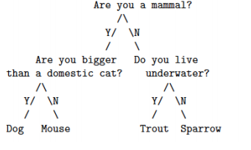

# Methodology

**If…else condition:**

If…else condition is used to decide the node it goes in the tree.

## Algorithm

1. Start
2. Print the 1st question. Depending on the answer (y/n) go to the respective node.
3. Print the 2nd question. Depending on the answer (y/n) go to the respective leaf.
4. Display the answer as the leaf.
5. End

## Source Code / Implementation

#include<stdio.h>

#include<conio.h>

void main()

{

char x,a;

printf("Are you a mammal?(y/n?)\n");

scanf("%c",&x);

if(x=='y')

{

printf("Are you bigger than a domestic cat?(y/n?)\n");

fflush(stdin);

scanf("%c",&a);

if(a=='y')

{

printf("Dog\n");

}

else

{

printf("Mouse\n");

}

}

else

{

printf("Do you live underwater?(y/n?)\n");

fflush(stdin);

scanf("%c",&a);

if(a=='y')

{

printf("Trout\n");

}

else

{

printf("Sparrow\n");

}

}

getch();

}

## Output:

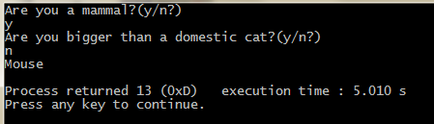

# Analysis

In the above program, we start the game at the root node. For every YES, we visit left child and for every NO we visit the right child – until the leaf node is reached. In the output above, the program traverses right when we say NO for the question, “Are you a mammal?” The next node contains the question, “Do you live underwater?” When we say YES the node next node is the leaf node. Here, the program has collected enough evidence to guess an animal properly. Thus, the program spits out the animal name as: “Trout”.