**AUDIT MANAGEMENT**

UI RESULTS (**<http://localhost:4200> **)

1. Register

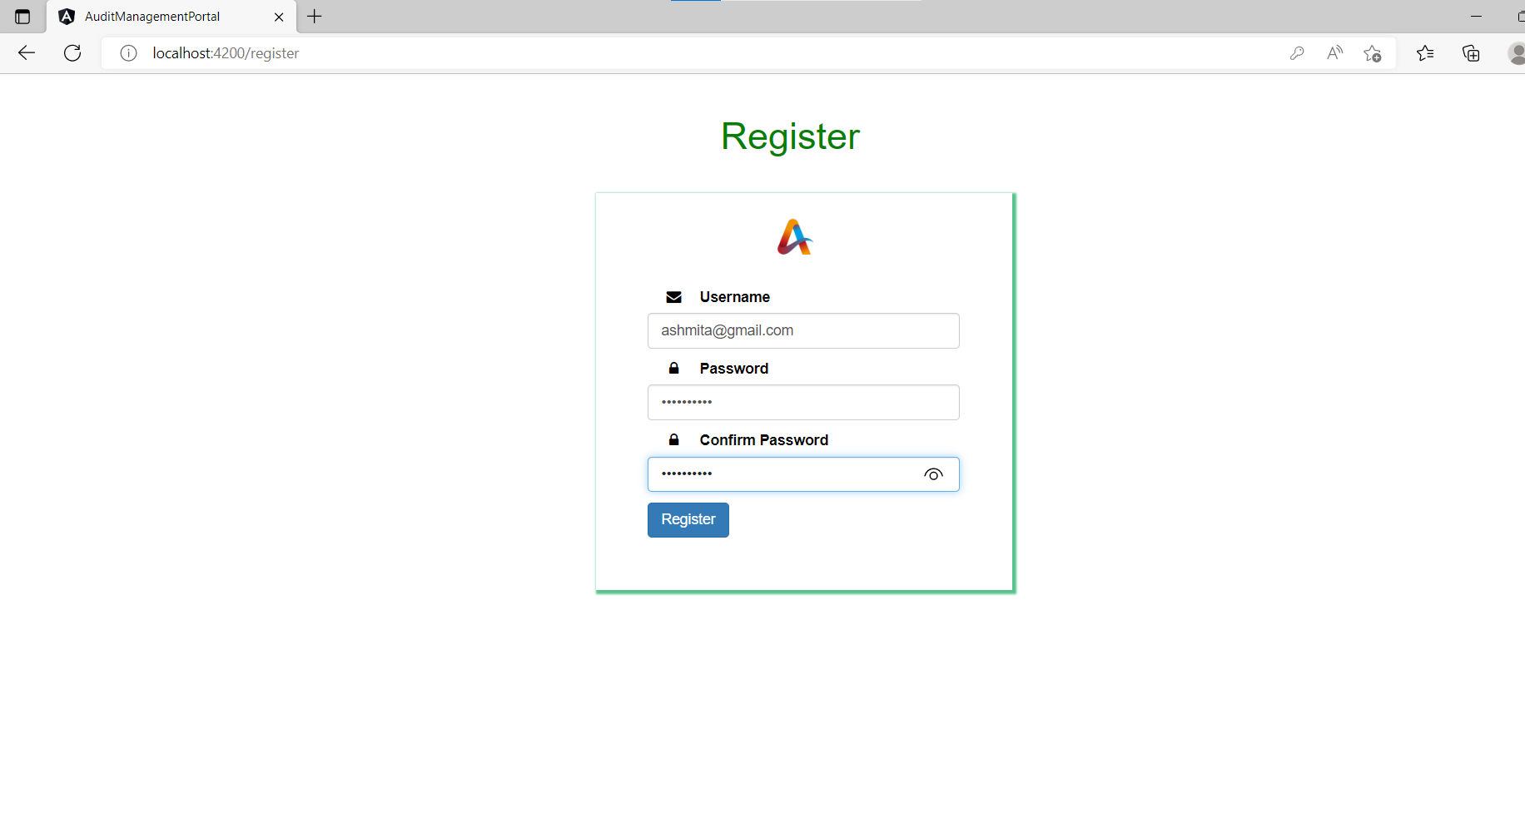

1. Login

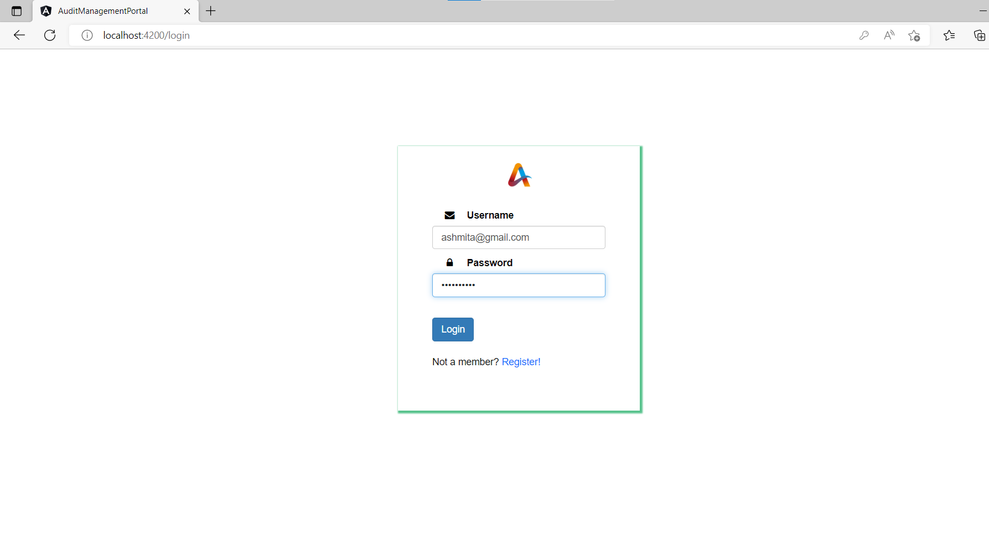

1. Incorrect Login

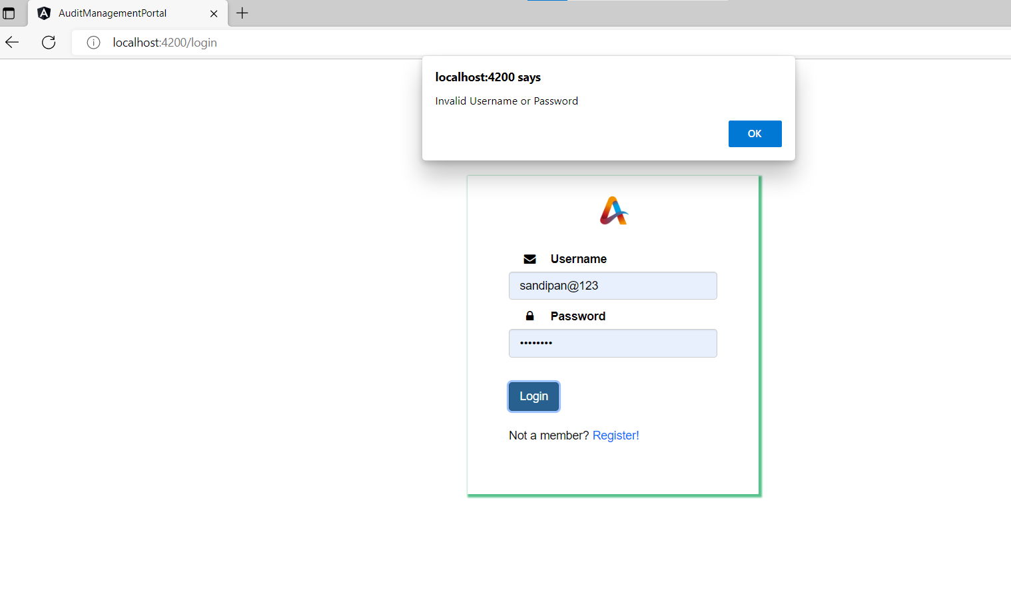

1. Project Details

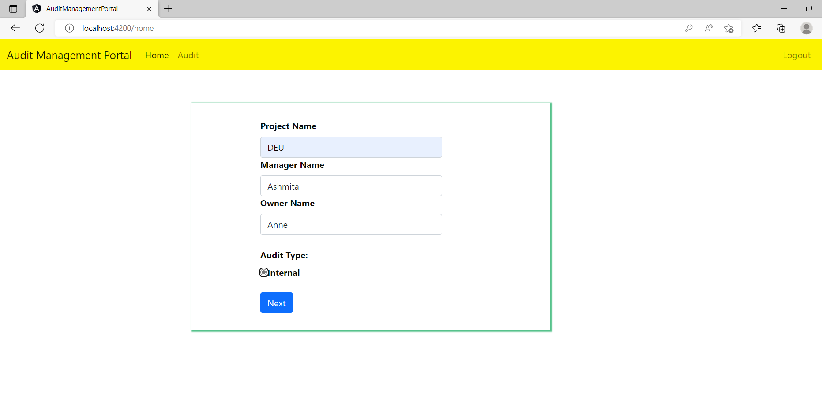

1. Audit Quetsions and Answers (test case 1)

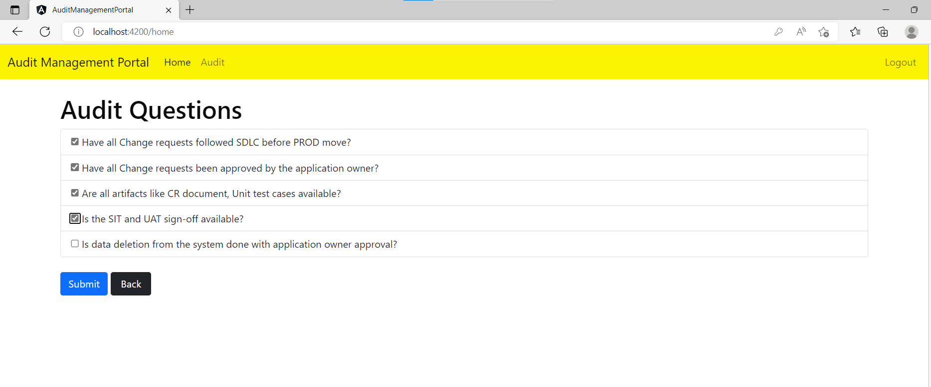

1. Project Execution Results(GREEN)

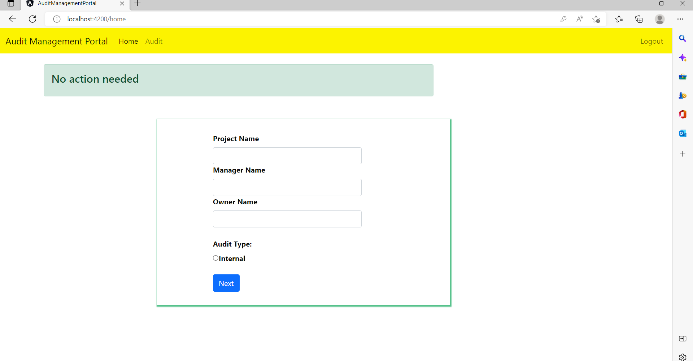

1. Audit questions and answers (test case 2)

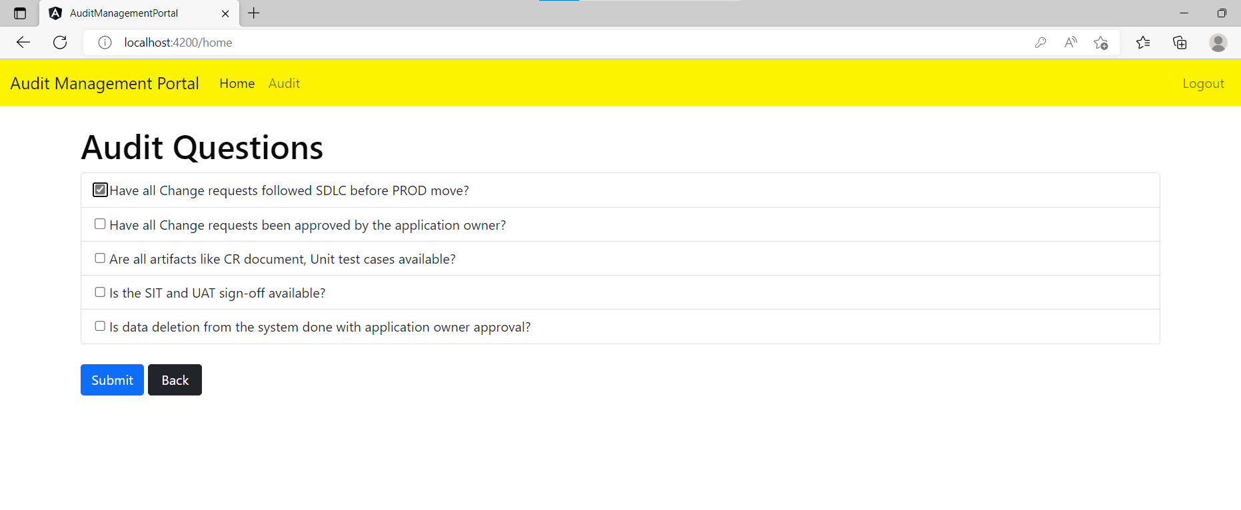

1. Project Execution Results(RED)

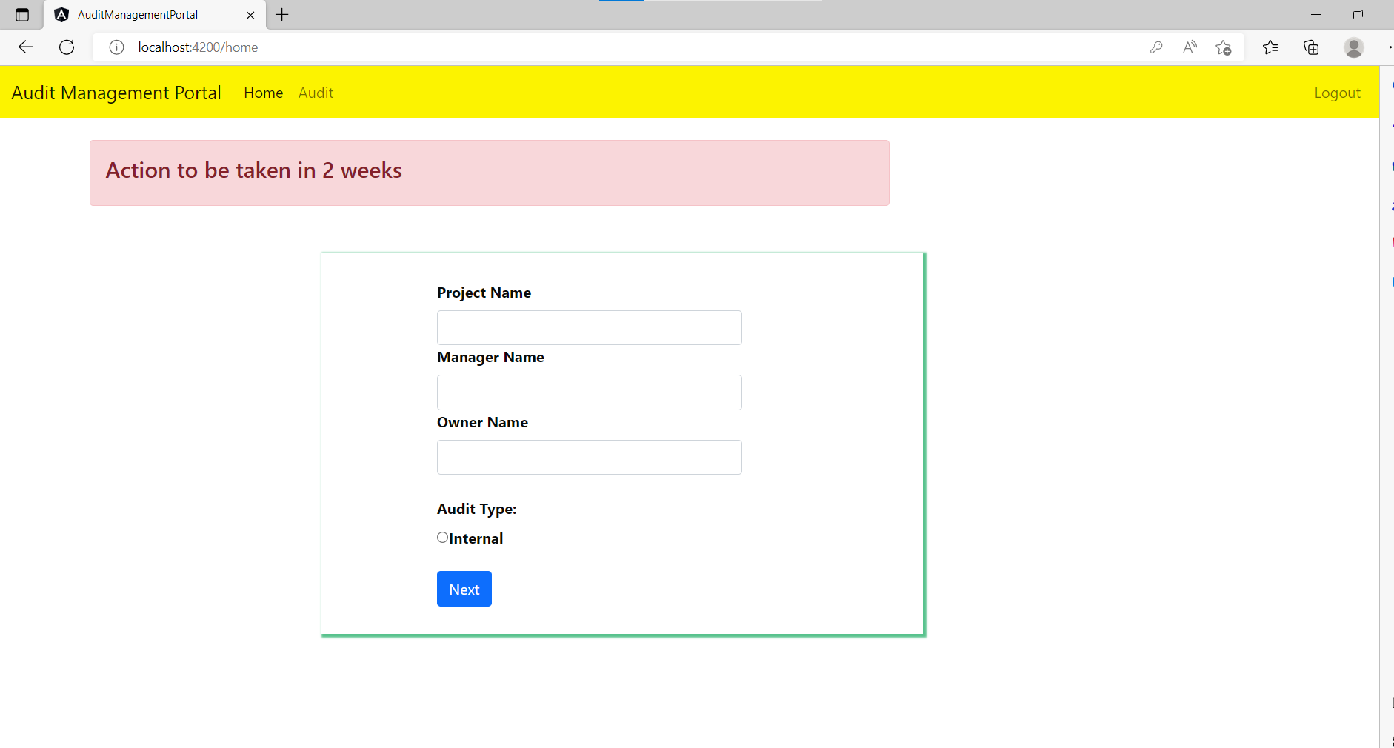

1. Validations

