**AUDIT MANAGEMENT**

POSTMAN RESULTS

1. Register with a username and password

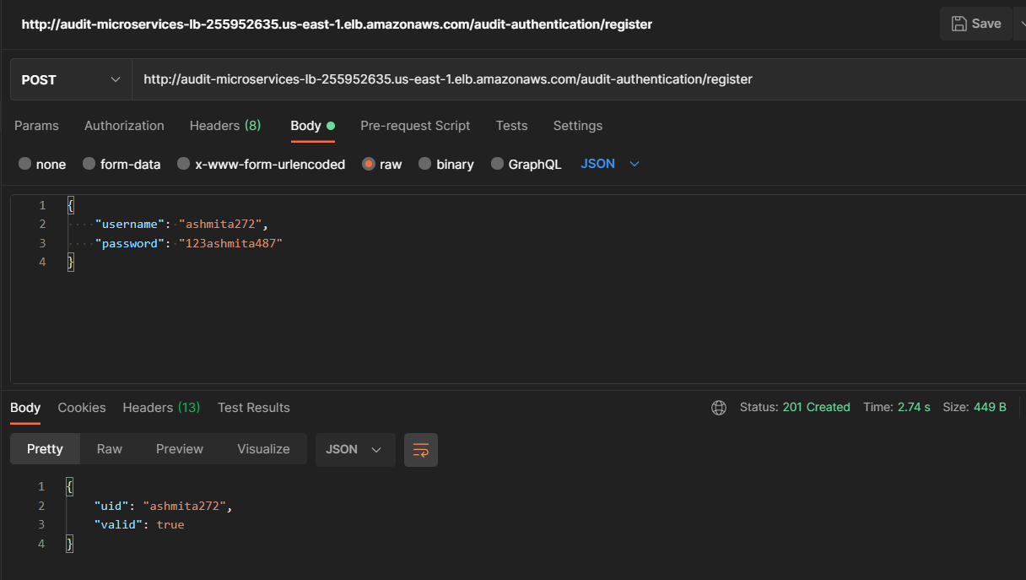

1. Login with the registered username and password

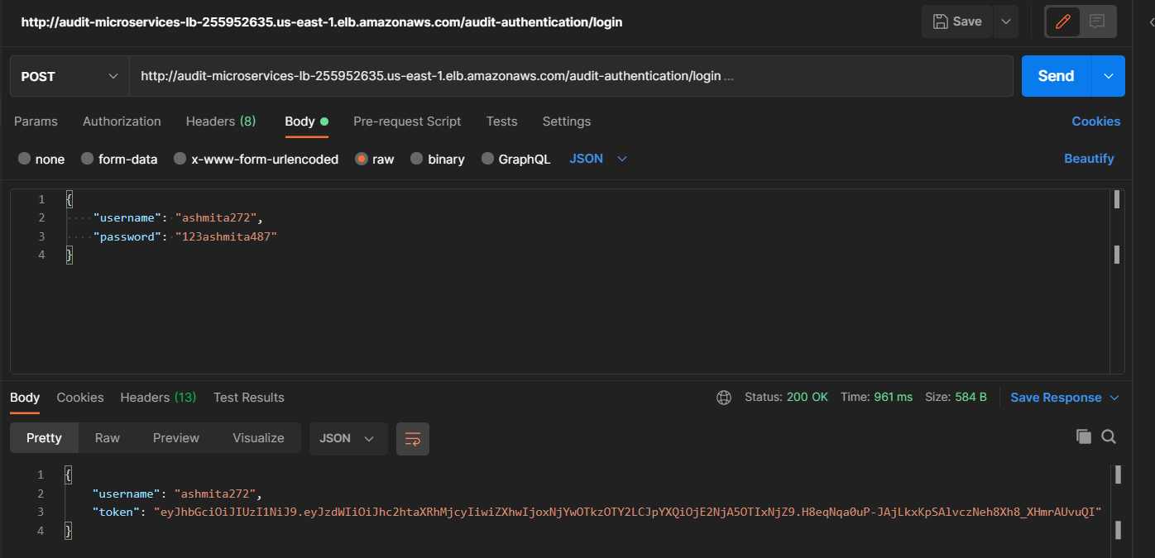

1. Validate the token

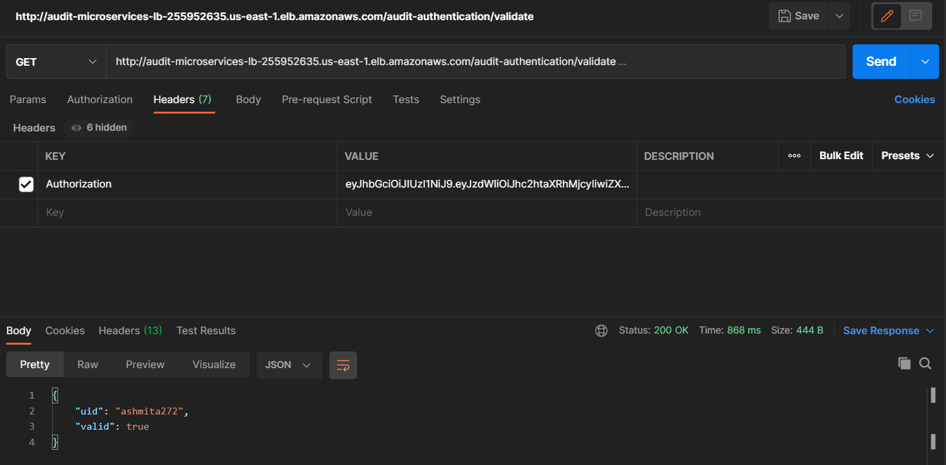

1. Get the questions list from the “/getChecklist” and the token must be inserted under the headers section within Authorization key.

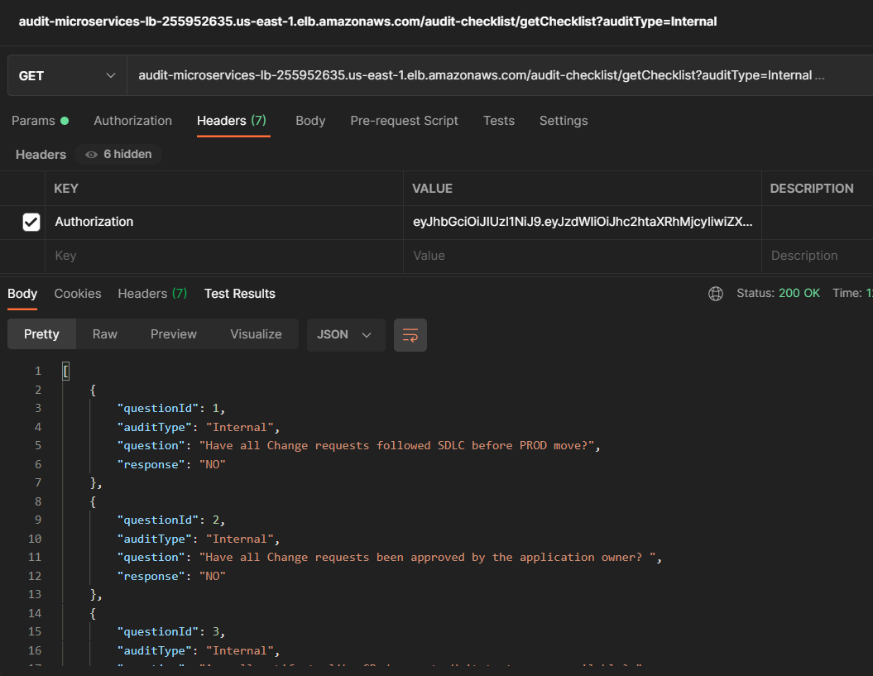

1. Get the Project Execution results

