**AUDIT MANAGEMENT**

Swagger Results

1. Audit-authentication

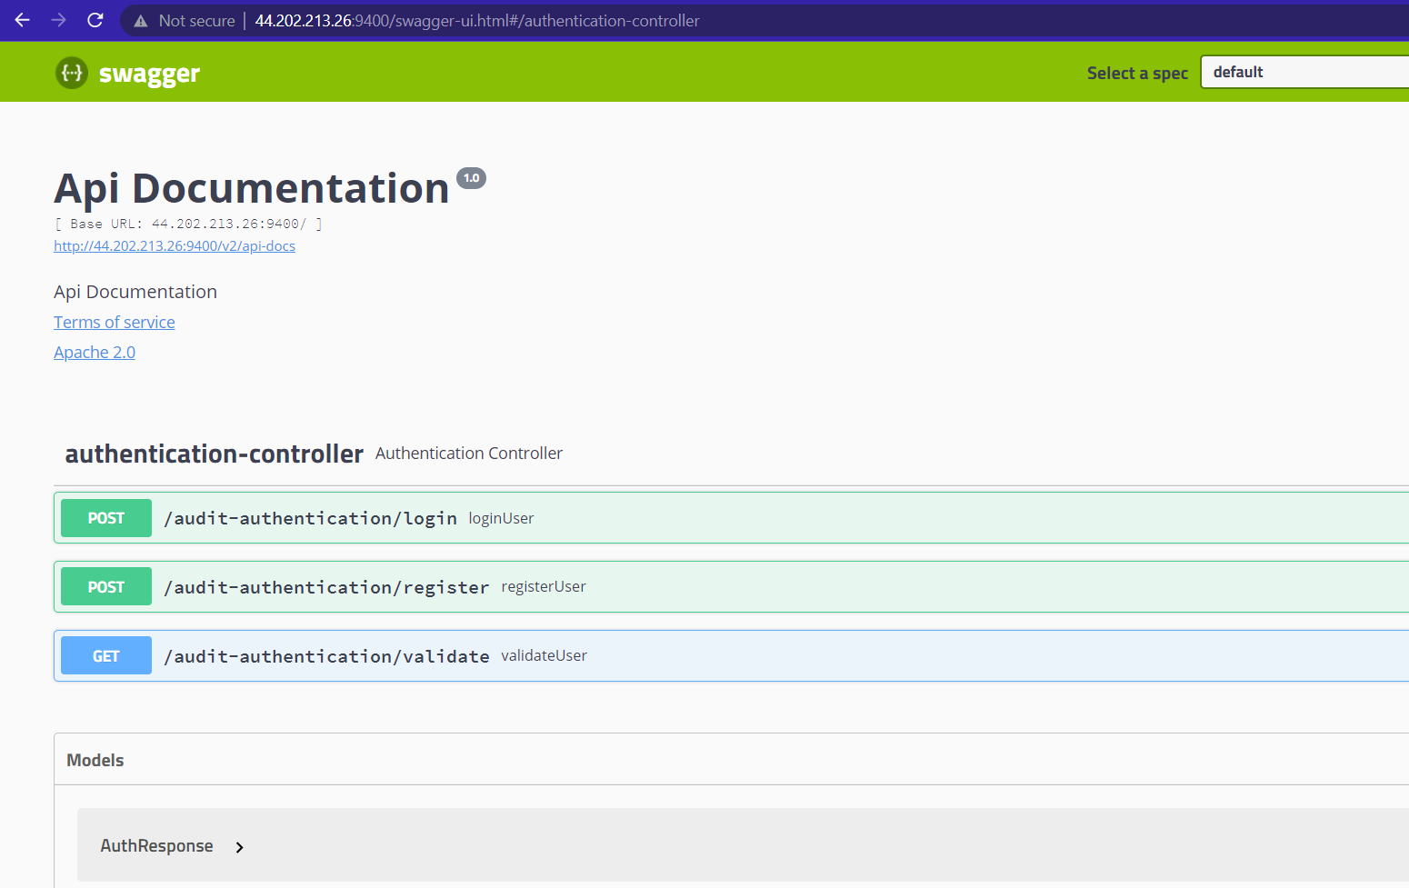

1. Audit-Checklist

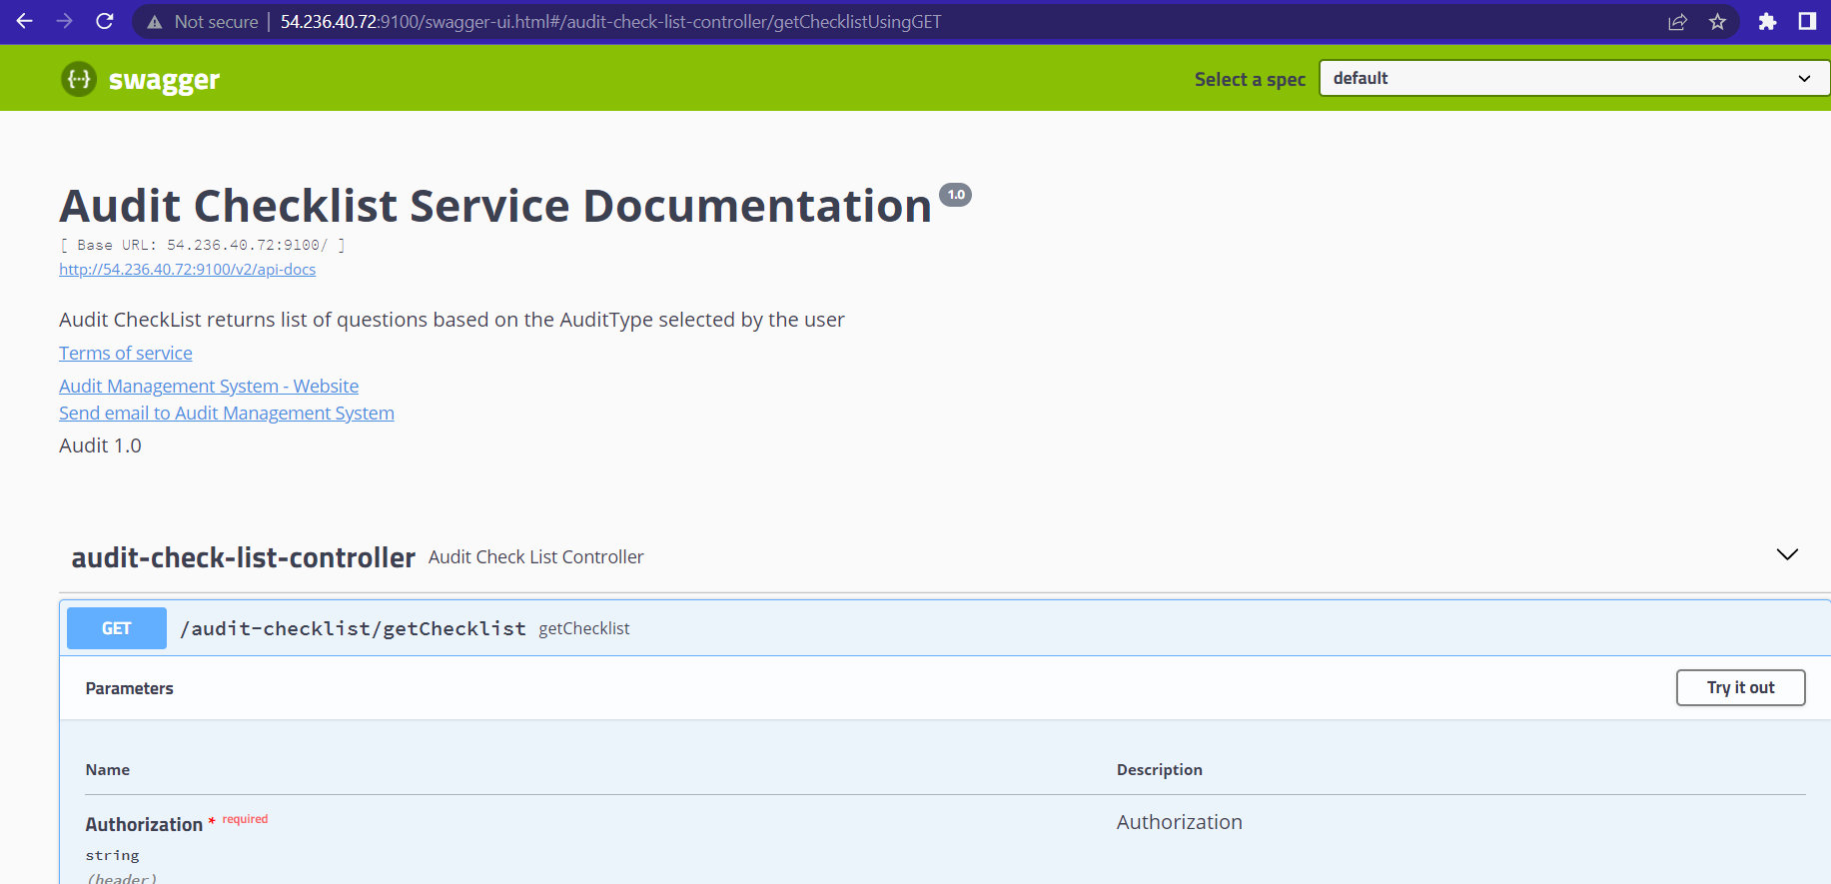

1. Audit-Severity

