ODT Summative 2
Idea Brief :
The project is an arcade-style claw machine capable of full three-axis movement (X, Y, and Z), where the claw mechanism opens and closes to grip candy placed inside the play area. Once a piece of candy is grabbed, the claw travels to a fixed drop position every time, releasing the object consistently into a collection chute. The machine is coin-operated; inserting a coin triggers the start of the game, activating an audio cue and illuminating internal LEDs to signal that play has begun, replicating the experience of an arcade game.
Basic Idea Sketch :
Claw machine design
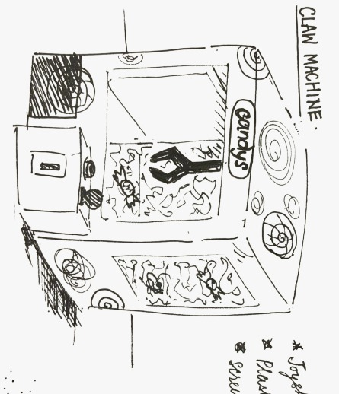

Gantry design
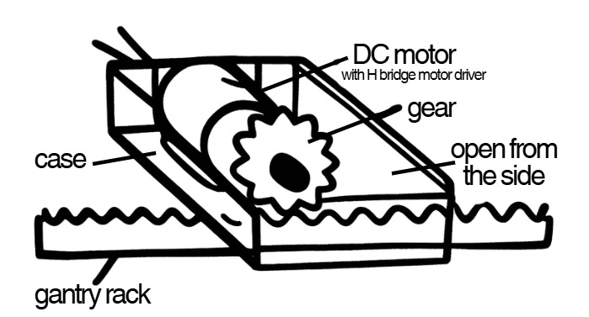
Controller box
