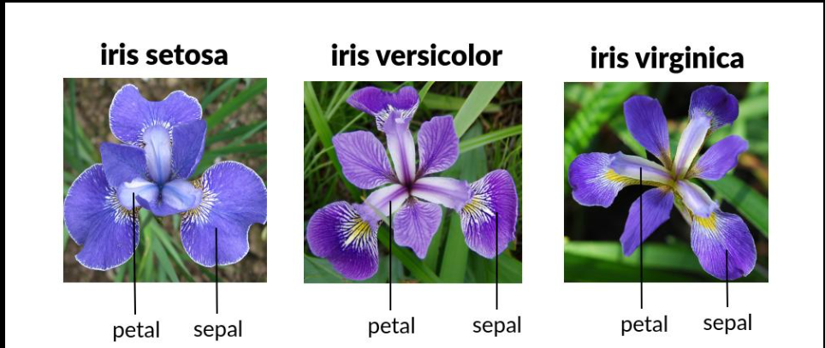
- Petals are the colorful parts of the flower.
- Sepals are the leaf-like structures that protect the flower bud.
The dataset measures the size of these parts.

What is the Goal?
Imagine you find a new Iris flower.
You measure:
Feature | Value
Sepal Length | 5.1
Sepal Width | 3.5
Petal Length | 1.4
Petal Width | 0.2
Can you determine whether it is:
- Iris Setosa
- Iris Versicolor
- Iris Virginica
That is the main purpose of this dataset.

1. Which species has the largest petals?
Calculate average petal length by species.
Example finding:
Species | Avg Petal Length
Setosa | Smallest
Versicolor | Medium
Virginica | Largest

2. Which measurement best identifies the species?
You might discover:
- Sepal lengths overlap a lot.
- Petal lengths are very different.
So petal measurements are more useful for classification.

3. Are petal length and petal width related?
Usually yes.
Flowers with longer petals tend to have wider petals.

import pandas as pd
# Load dataset
df = pd.read_csv("SocialMediaSentimentDataset.csv")
# Remove unwanted index column
df.drop("Unnamed: 0.1", axis=1, inplace=True)
# Remove leading/trailing spaces from all text columns
for col in df.select_dtypes(include="object").columns:
df[col] = df[col].str.strip()
# Convert timestamp to datetime
df["Timestamp"] = pd.to_datetime(df["Timestamp"])
# Remove duplicate rows
df.drop_duplicates(inplace=True)
# Standardize text columns
df["Sentiment"] = df["Sentiment"].str.capitalize()
df["Platform"] = df["Platform"].str.capitalize()
df["Country"] = df["Country"].str.title()
# Check results
print(df.info())
print(df.head())
# Save cleaned file
df.to_csv("cleaned_social_media_sentiment.csv", index=False)
Verify the cleaning
Run:
print("Missing Values:")
print(df.isnull().sum())
print("\nDuplicates:")
print(df.duplicated().sum())
print("\nUnique Sentiments:")
print(df["Sentiment"].unique())
print("\nUnique Platforms:")
print(df["Platform"].unique())
print("\nUnique Countries:")
print(df["Country"].unique())
# Sentiment counts
print(df["Sentiment"].value_counts())
# Platform counts
print(df["Platform"].value_counts())
# Top countries
print(df["Country"].value_counts().head(10))
# Average likes by sentiment
print(df.groupby("Sentiment")["Likes"].mean())
# Average retweets by sentiment
print(df.groupby("Sentiment")["Retweets"].mean())
Export for Power BI
df.to_csv("social_media_cleaned.csv", index=False)
Then import social_media_cleaned.csv into Power BI and build visuals such as:
- Sentiment Distribution (Pie Chart)
- Likes by Country (Bar Chart)
- Retweets by Platform
- Sentiment Trend by Month
- Top Hashtags
- KPI Cards (Total Likes, Total Retweets, Total Posts)
Before cleaning further, I would also check whether there are duplicate users, duplicate timestamps, or invalid sentiment values. Run:
print(df['Sentiment'].value_counts())
print(df['Platform'].value_counts())
print(df.duplicated().sum())
and share the output. That will tell us if any additional cleaning is needed. now can you explain all the code yoy have given me why these things need to do with reasonAbsolutely. Understanding why you're cleaning data is more important than just running the code. Let's go through each step.

1. Import Pandas
import pandas as pd
2. Load Dataset
df = pd.read_csv("t.csv")
Why?
Your data is stored in a CSV file.
This command:
- Reads the CSV
- Converts it into a DataFrame
A DataFrame is like an Excel sheet in Python.
Example:
Name | Age
Ram | 20
Sita | 22

3. Remove Unwanted Index Column
df.drop("Unnamed: 0.1", axis=1, inplace=True)
Why?
dataset contains:Unnamed: 0.1This is usually created when: df.to_csv()is saved without:
index=False The old row numbers become a column.
Example:
Unnamed:0.1 | User
0 | User123
1 | User456
The column doesn't contain useful information.
After deleting:
User
User123
User456
Cleaner dataset.
4. Remove Extra Spaces
for col in df.select_dtypes(include="object").columns:
df[col] = df[col].str.strip()
Why?
data contains spaces.Example:
" Positive "
instead of
"Positive"
Python sees them as different values.
Bad:
Positive
Positive
Positive
These become 3 separate categories.
After cleaning:
Positive
Positive
Positive
Now Power BI and Python count them correctly.

5. Convert Timestamp to DateTime
df["Timestamp"] = pd.to_datetime(df["Timestamp"])
Why?
Currently:
1/15/2023 12:30
is stored as text.
Python sees:
object
not
datetime
Without conversion:
❌ Can't analyze by month
❌ Can't analyze by year
❌ Can't create time trends
After conversion:
datetime64
Now you can do:
df["Timestamp"].dt.month
or
df["Timestamp"].dt.year
Very important for dashboards.

6. Remove Duplicate Records
df.drop_duplicates(inplace=True)
Why?
Sometimes same post appears twice.
Example:
User | Text
User1 | Great Day
User1 | Great Day
If duplicates exist:
- Total Posts become incorrect
- Likes become inflated
- Retweets become inflated
Removing duplicates improves accuracy.

7. Standardize Sentiment
df["Sentiment"] = df["Sentiment"].str.capitalize()
Why?
Imagine:
positive
Positive
POSITIVE
Python treats them as different categories.
Result:
df["Sentiment"].value_counts()
may show:
positive 200
Positive 300
POSITIVE 150
Wrong.
After cleaning:
Positive 650
Correct.

8. Standardize Platform Names
df["Platform"] = df["Platform"].str.capitalize()
Why?
Example:
twitter
Twitter
TWITTER
All should become:
Twitter
Otherwise Power BI creates multiple bars for the same platform.

9. Standardize Country Names
df["Country"] = df["Country"].str.title()
Why?
Example:
usa
USA
Usa
After cleaning:
Usa
Or you can use:
str.upper()
to make:
USA
This prevents duplicate country categories.

10. Check Data Structure
print(df.info())
Why?
Shows:
Column Names
Data Types
Missing Values
Example:
Text object
Likes int64
Timestamp datetime64
This helps verify cleaning worked.

11. Preview Data
print(df.head())
Why?
Shows first 5 rows.
Useful for checking:
- Column names
- Values
- Formatting
without printing all 732 rows.

12. Save Cleaned Data
df.to_csv("cleaned_social_media_sentiment.csv", index=False)
Why?
After cleaning:
You want a new file.
Original Dataset
↓
Clean Dataset
index=False prevents Python from creating another unwanted index column.

Why We Clean Data Before Power BI
Imagine:
Positive
positive
POSITIVE
Power BI would show:
Sentiment | Count
Positive | 100
positive | 50
POSITIVE | 25
This creates misleading charts.
After cleaning:
Sentiment | Count
Positive | 175
Correct.

