HOUSE PRICE PREDICTION
USING MACHINE LEARNING
Project Documentation
Project Detail | Information
Candidate Name | Ashmita Thiyam
Domain | Data Science
Dataset | Ames Housing Dataset
Dataset Source | Kaggle
Target Variable | SalePrice
Best Model | Random Forest Regression

Abstract
This project focuses on predicting house prices using machine learning techniques. The Ames Housing dataset was used to study the relationship between property characteristics and sale prices. Three regression models—Linear Regression, Decision Tree Regression, and Random Forest Regression—were trained and compared using standard regression evaluation metrics. Random Forest Regression produced the best overall performance and was integrated into a Streamlit dashboard for interactive house-price prediction and analysis.

Project Objective
The main objective is to develop a model that can estimate the sale price of a house from its characteristics and present the results through an interactive dashboard.

Key Result
Model | R² | MAE | RMSE
Random Forest Regression | 0.923131 | $15,260.49 | $24,825.36

1. Project Overview and Dataset
The Ames Housing dataset contains residential property information such as quality, living area, lot size, year built, garage details, bathrooms, neighborhood and other construction-related attributes. The target variable used for prediction is SalePrice. The dataset used in this project contains 2,930 properties.

Dataset Summary
Properties | Features | Median Sale Price | Average Sale Price
2,930 | 81 | $160,000 | $180,796

2. Methodology
The project follows a standard machine-learning workflow consisting of data preparation, feature engineering, model training, model evaluation and deployment through a Streamlit dashboard.

Feature Engineering
Feature | Definition
TotalSF | Total Bsmt SF + 1st Flr SF + 2nd Flr SF
TotalBathrooms | Full Bath + 0.5 × Half Bath + Bsmt Full Bath + 0.5 × Bsmt Half Bath
TotalPorchSF | Open Porch SF + Enclosed Porch + 3Ssn Porch + Screen Porch + Wood Deck SF

Models Used
Model | Description
Linear Regression | Used as a basic regression model for comparison.
Decision Tree Regression | Captures non-linear relationships through decision rules.
Random Forest Regression | An ensemble of decision trees used as the final model.
The trained Random Forest model is saved as house_price_model.pkl and is loaded directly by the Streamlit application. The application does not retrain the model during prediction.

3. Model Evaluation
The three regression models were evaluated using R², Mean Absolute Error (MAE), Mean Squared Error (MSE), and Root Mean Squared Error (RMSE). The recorded project results are shown below.
Model | R² | MAE | RMSE
Linear Regression | 0.887962 | $17,364.58 | $29,971.12
Decision Tree Regression | 0.814346 | $25,049.93 | $38,580.96
Random Forest Regression | 0.923131 | $15,260.49 | $24,825.36

Result Discussion
Random Forest Regression achieved the highest R² score among the three models. It also produced the lowest recorded MAE and RMSE, indicating that its predictions had smaller errors on the test set.
An R² score of 0.9231 means that the model explains approximately 92.31% of the variance in house prices in the test set. MAE represents the average absolute prediction error, while RMSE measures the typical error magnitude while giving greater weight to larger errors.
The exact MSE value is not included because it was not available in the final supplied results. No value has been estimated from the rounded RMSE.

4. Dashboard
The Streamlit dashboard provides an interface for entering property details and obtaining a price prediction from the trained Random Forest model. It also contains market-analysis graphs and model-diagnostic visualizations.

4. Dashboard — Property Valuation
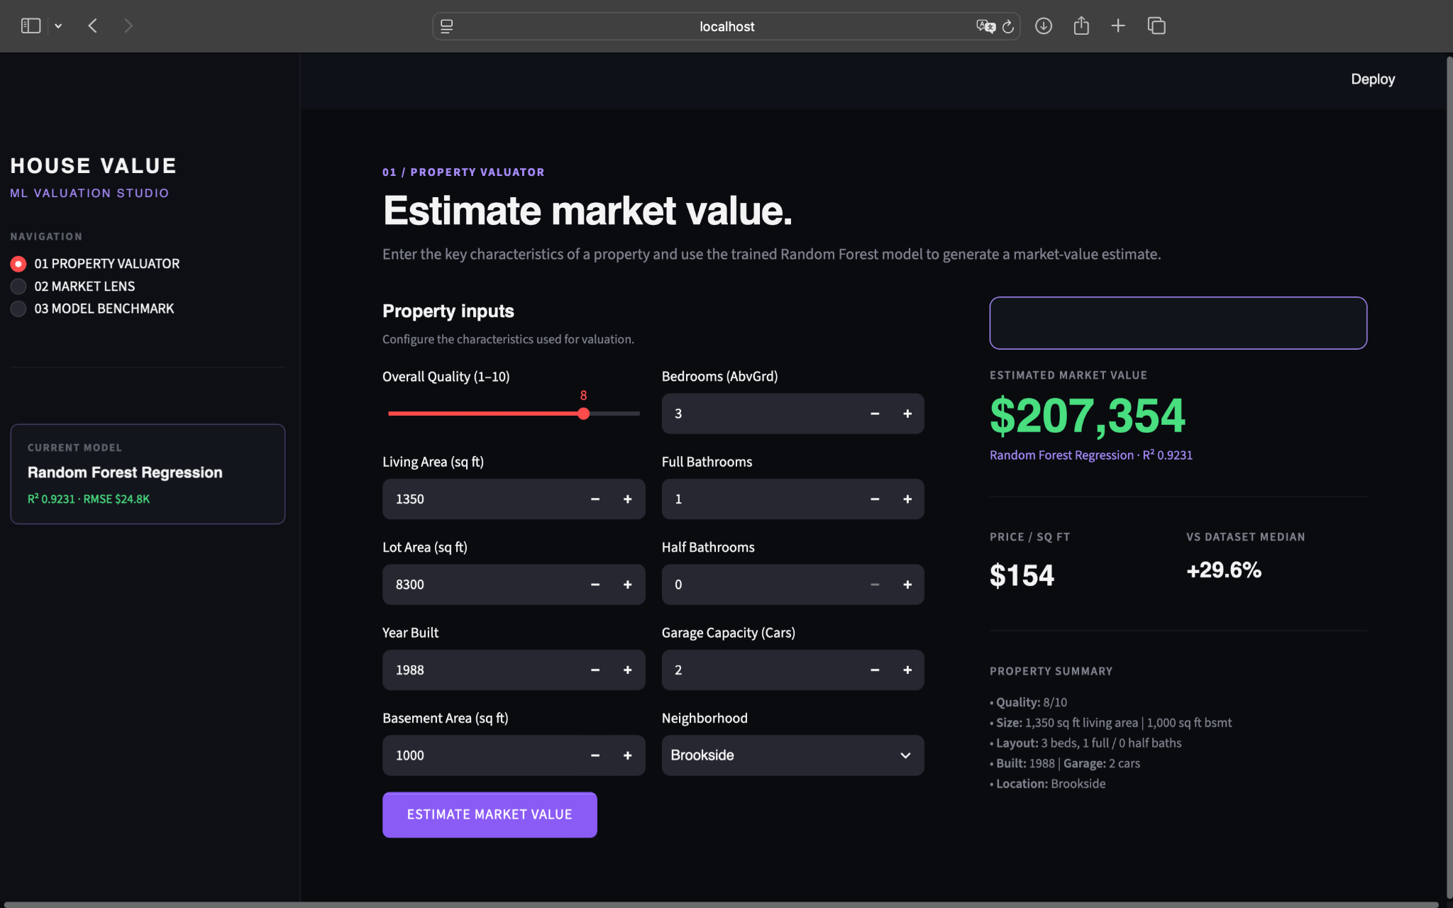
Figure 1. Property Valuator interface showing property inputs and predicted market value.
The user can enter features including overall quality, living area, lot area, year built, bedrooms, bathrooms, garage capacity, basement area and neighborhood. After selecting the prediction button, the application displays the estimated house price and supporting information.

5. Market Analysis
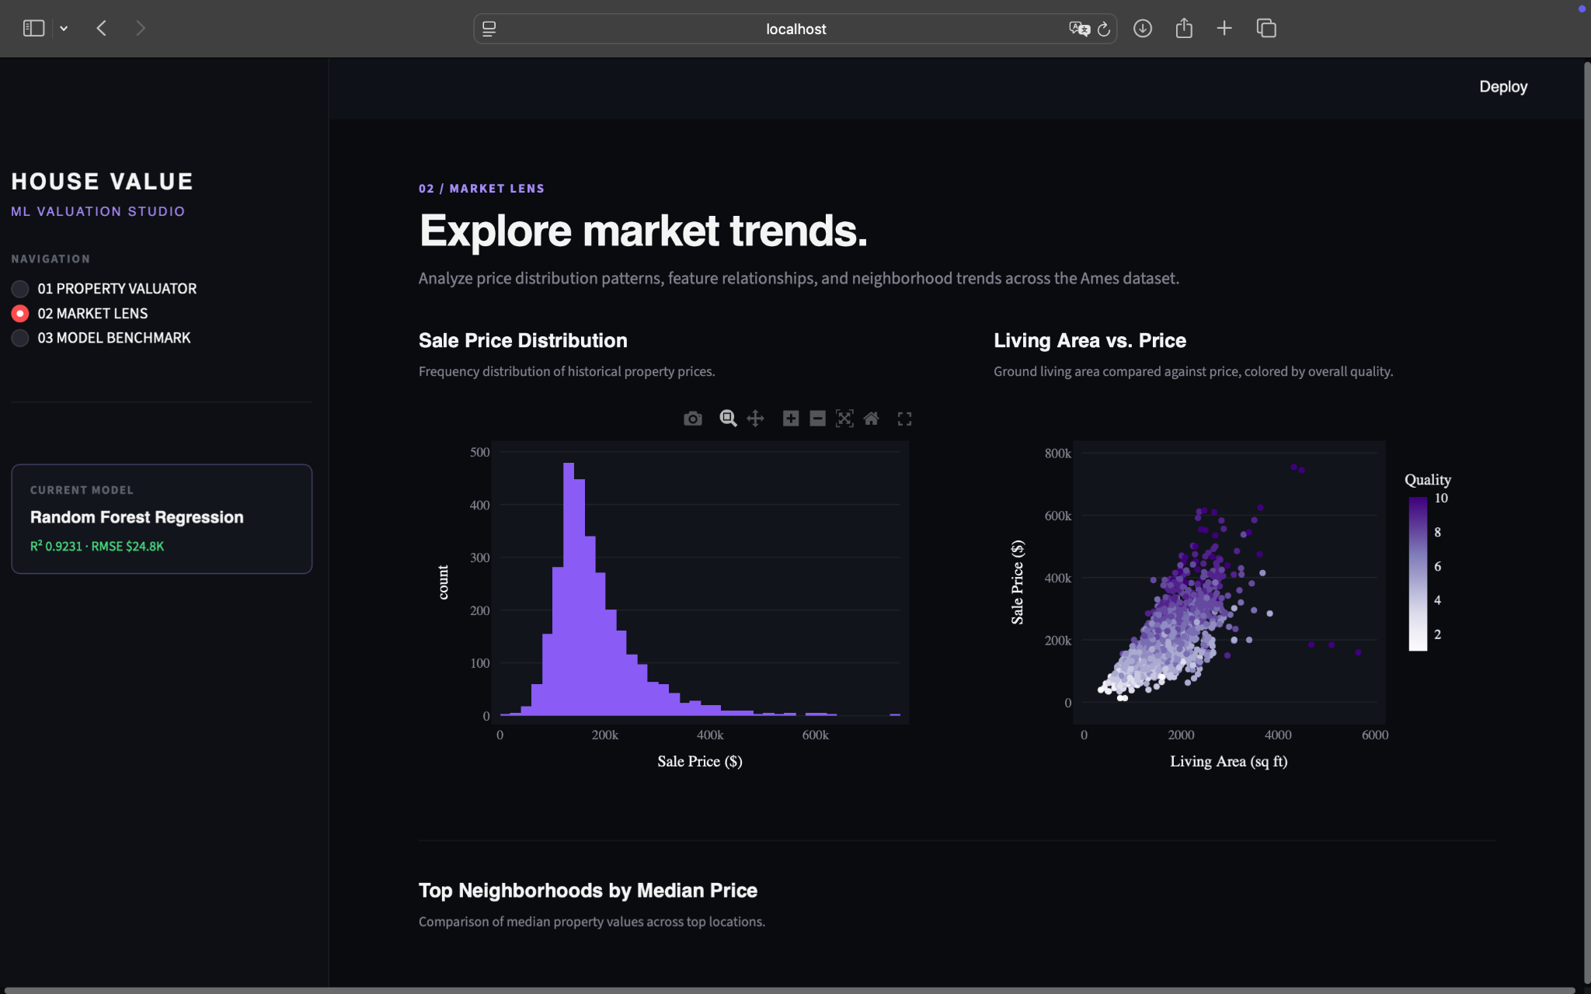
Figure 2. Market Lens showing the distribution of house prices and the relationship between living area and sale price.
The dashboard uses exploratory graphs to understand the dataset. The Sale Price Distribution shows the range and concentration of property prices. The Living Area vs. Sale Price graph helps illustrate how house size is related to price.
Additional dashboard analysis includes average sale price by neighborhood and the strongest numerical correlations with SalePrice. Correlation is used for exploratory analysis and is separate from Random Forest feature importance.

6. Model Diagnostics and Conclusion
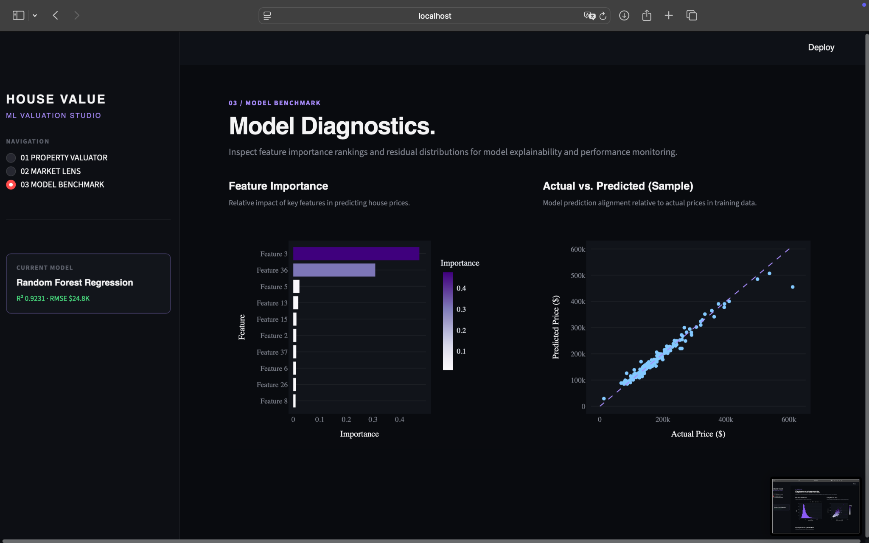
Figure 3. Model diagnostics showing Random Forest feature importance and Actual vs. Predicted prices.
Feature importance is used to identify the variables that contribute most to the Random Forest predictions. The Actual vs. Predicted graph provides a visual comparison between the model's predictions and the observed sale prices.

Conclusion
This project developed a house-price prediction system using the Ames Housing dataset and three regression algorithms. Random Forest Regression performed best, achieving an R² score of 0.9231, an MAE of approximately $15,260 and an RMSE of approximately $24,825.
The trained model was integrated into a Streamlit dashboard so that users can enter property characteristics and obtain a prediction while also exploring market patterns and model results. The project demonstrates the use of Data Science techniques from data preparation and feature engineering through model evaluation and application development.

References
1. Ames Housing Dataset — Kaggle.
2. House Price Prediction Jupyter Notebook.
3. Streamlit dashboard source code (app.py).

