**DIAGNOSE OF THE SUBTYPE OF ANAEMIA**

PROLOG CODE:

:-dynamic db_make_sure/2.

:-dynamic db_denied/2.

symptoms :- nl,

print( 'Does the patient exhibit any of the following signs:' ), nl,

print( 'weakness, lightheadedness, syncope, cardiac awareness,

pallor, tachycardia, jaundice.' ),

affirm,

syndrome( 1 ).

syndrome( 1 ) :- 'undist anaemia'.

'undist anaemia' :-

anaemia( RBC ),

print( 'Patient has anaemia. We now try to diagnose the specific type.' ),

'anaemia subtype'( RBC ).

'anaemia subtype'( RBC ) :- 'congenital haemolytic anaemia'( RBC ).

'anaemia subtype'( RBC ) :- 'acquired haemolytic anaemia'.

'acquired haemolytic anaemia' :-

ldh( high ), nl,

print('Based upon a diagnosis of anaemia and ' ),

print(' high LDH we obtain acquired haemolytic anaemia.' ).

'congenital haemolytic anaemia'( low ) :-

'congenital haemolytic history',

'congenital haemolytic determinant', nl,

print('Based upon a diagnosis of anaemia and '),

print( 'the just named symptom we diagnose congenital haemolytic anaemia.' ).

'deficiency anaemia' :- nl,

print( 'Diagnosis is a deficiency anaemia.' ).

'anaemia subtype'( RBC ):-

nl,print('Sorry , unable to determine your disease'),nl,

readln(_),

'congenital haemolytic history' :- jaundice.

'congenital haemolytic history' :- gallstones.

'congenital haemolytic history' :- sphenomegally.

'congenital haemolytic history' :- hepatomegaly.

'congenital haemolytic history' :- 'bony malformations'.

'congenital haemolytic history' :- 'mental retardation'.

'congenital haemolytic determinant' :- microcytosis.

'congenital haemolytic determinant' :- eliptocytosis.

'congenital haemolytic determinant' :- spherocytosis.

'congenital haemolytic determinant' :- anisopoikilocytosis.

'congenital haemolytic determinant' :- 'anaemia related to food'.

microcytosis :- labfindings( microcytosis ).

eliptocytosis :- labfindings( eliptocytosis ).

anisopoikilocytosis :- labfindings( anisopoikilocytosis ).

'anaemia related to food' :- evidence( 'anaemia related to food' ).

spherocytosis :- nl,

print( 'Is the % of spherocytosis > 50%' ), affirm.

anaemia( RBC ) :- symptom( anaemic ), rbc( RBC ).

symptom( anaemic ) :- hematocrit( low ).

evidence( X ) :- nl,

print('Has the patient evidence of '),

print( X ), affirm.

labfindings( X ) :- nl,

print('Are there laboratory findings of ' ),

print( X ), affirm.

jaundice :- evidence( jaundice ).

gallstones :- evidence( gallstones ).

sphenomegally :- evidence( sphenomegally ).

hepatomegally :- evidence( hepatomegally ).

'bony malformations' :- evidence( 'bony malformations' ).

'mental retardation' :- evidence( 'mental retardation' ).

'retarded growth and development' :-

evidence( 'retarded growth and development' ).

'crisis of viscera, bones' :-

evidence( 'crisis of viscera, bones' ).

/* Laboratory measurements: */

hematocrit( HLN ) :- hematocrtmeas( HEMAT ), hematcat( HEMAT, HLN ).

hematocrtmeas( HEMAT ) :- nl,

print( 'What is the hematocrit level % per deciliter?:' ),

read( HEMAT ).

hematcat( HEMAT, low ) :- HEMAT < 36,make_sure(HEMAT, low ).

hematcat( HEMAT, high ) :- HEMAT > 36, make_sure(HEMAT, low ).

not(make_sure (HEMAT, low )) :- HEMAT < 36.

rbc( HLN ) :- rbcmeas( RBC ), rbccat( RBC, HLN ).

rbcmeas(RBC) :- nl,

print( 'Input the RBC in millions/microliter:' ),

read( RBC ).

rbccat( RBC, low ) :- RBC < 4, make_sure(RBC, low ).

rbccat( RBC, high) :- RBC > 6, make_sure( RBC, high).

rbccat( RBC, norm ) :- RBC = 5, make_sure( RBC, norm ).

mcv( low ) :- mcv1( low ).

mcv( high ) :- mcv1( high ), not( arct( high ) ).

mcv1( HLN ) :- mcvmeas( MCV ), mcvcat( MCV, HLN ).

mcvcat( MCV, high) :- MCV > 96.

mcvcat( MCV, low ) :- MCV < 85.

mcvmeas( MCV ) :- nl,

print( 'What is the level of MCV in cubic microns:' ),

read( MCV ).

ldh( LDH ) :- nl,

print( 'What is the level of LDH (high,low, or norm)?: ' ),

read( LDH ).

arct( HLN ) :- arctmeas( ARCT ), arctcat( ARCT, HLN ).

arctcat( ARCT, high) :- ARCT > 96.

arctcat( ARCT, low ) :- ARCT < 85.

arctmeas( ARCT ) :- nl,

print( 'What is the absolute reticulocyte count in units of thousands:'),

nl,

read( ARCT ).

affirm :- nl,

print( '(Y/N) ? ' ),

read( ANS ),

nl,

yes( ANS).

yes( y ).

make_sure(X,Y):-db_make_sure(X,Y),!.

make_sure(X,Y):-not(denied(X,Y)),!.

denied(X,Y):-db_denied(X,Y),!.

remember(X,Y,[yes]):- assert(db_make_sure(X,Y)).

remember(X,Y,[no]):-assert(db_denied(X,Y)),fail.

OUTPUT:

If the hematocrits is lesser than 36 and RBC lesser than 3,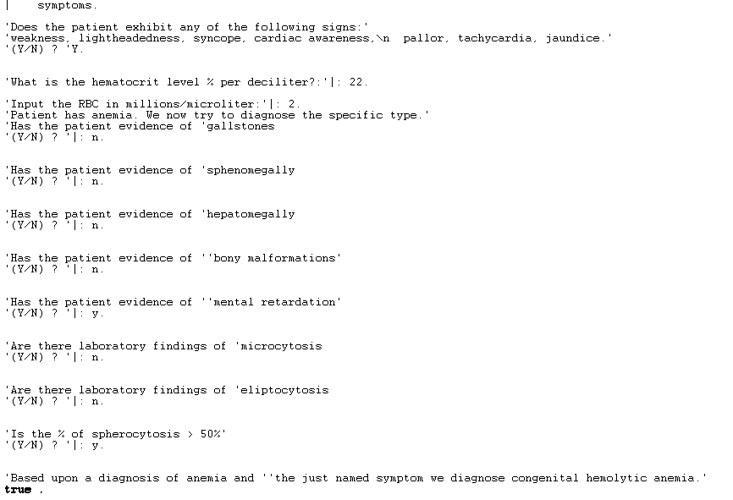

If the hematocrits is greater than 37,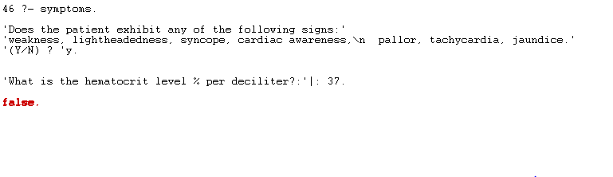

If the hematocrits is lesser than 36 and the RBC is greater than 5 then LDH is high,

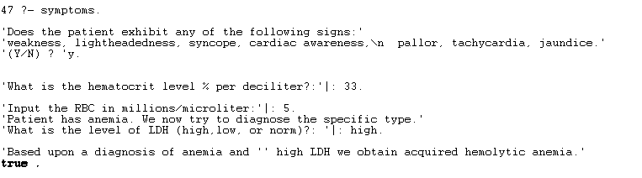

Decis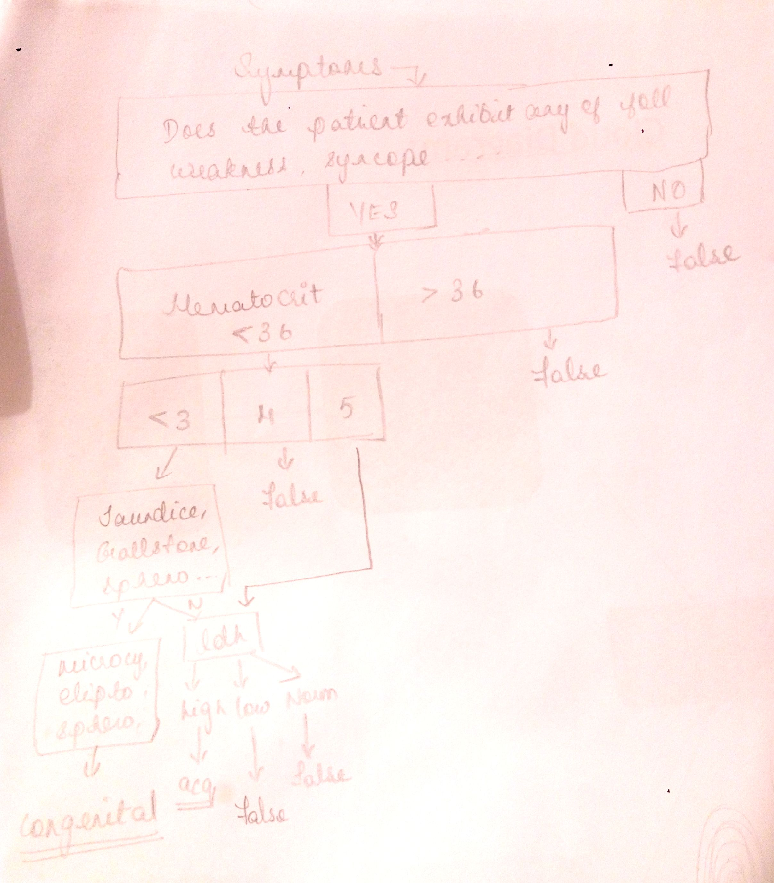ion Tree :