BLOOD CELL CLASSIFICATION USING DEEP LEARNING
Project Report
Submitted by: V. Lakshmi Ashmitha
Roll No:236K1A6840
Department of CSE
Ideal Institute of Tchnology
Year: 2025-2026

Abstract
The rapid advancement of deep learning technologies has significantly improved the performance of automated medical image analysis systems. This project presents a web-based application for Blood Cell Classification using Convolutional Neural Networks (CNN). The system allows users to upload microscopic blood cell images through a user-friendly web interface developed using Flask, HTML, and CSS. The uploaded images are pre-processed and passed to a trained deep learning model that classifies the blood cell into its respective category such as eosinophil, neutrophil, lymphocyte, or monocyte.
The proposed system aims to reduce manual effort, minimize diagnostic errors, and accelerate the process of medical analysis. Data preprocessing techniques such as resizing, normalization, and augmentation are applied to improve model performance. The trained CNN model demonstrates effective classification accuracy and reliable predictions. The integration of machine learning with a web framework provides a practical and scalable solution for real-time medical image classification. This project highlights the potential of artificial intelligence in healthcare applications and lays the foundation for further improvements in automated disease detection systems.

1. Introduction
Blood cell classification plays a vital role in medical diagnosis. Manual analysis is time-consuming and may lead to errors. Deep learning techniques such as CNN provide high accuracy in image classification tasks. This project demonstrates how machine learning can be integrated into web applications for healthcare solutions.
Blood cell classification plays a vital role in medical diagnosis. Manual analysis is time-consuming and may lead to errors. Deep learning techniques such as CNN provide high accuracy in image classification tasks. This project demonstrates how machine learning can be integrated into web applications for healthcare solutions.
Blood cell classification plays a vital role in medical diagnosis. Manual analysis is time-consuming and may lead to errors. Deep learning techniques such as CNN provide high accuracy in image classification tasks. This project demonstrates how machine learning can be integrated into web applications for healthcare solutions.
Blood cell classification plays a vital role in medical diagnosis. Manual analysis is time-consuming and may lead to errors. Deep learning techniques such as CNN provide high accuracy in image classification tasks. This project demonstrates how machine learning can be integrated into web applications for healthcare solutions.
Blood cell classification plays a vital role in medical diagnosis. Manual analysis is time-consuming and may lead to errors. Deep learning techniques such as CNN provide high accuracy in image classification tasks. This project demonstrates how machine learning can be integrated into web applications for healthcare solutions.
Blood cell classification plays a vital role in medical diagnosis. Manual analysis is time-consuming and may lead to errors. Deep learning techniques such as CNN provide high accuracy in image classification tasks. This project demonstrates how machine learning can be integrated into web applications for healthcare solutions.
Blood cell classification plays a vital role in medical diagnosis. Manual analysis is time-consuming and may lead to errors. Deep learning techniques such as CNN provide high accuracy in image classification tasks. This project demonstrates how machine learning can be integrated into web applications for healthcare solutions.
Blood cell classification plays a vital role in medical diagnosis. Manual analysis is time-consuming and may lead to errors. Deep learning techniques such as CNN provide high accuracy in image classification tasks. This project demonstrates how machine learning can be integrated into web applications for healthcare solutions.
Blood cell classification plays a vital role in medical diagnosis. Manual analysis is time-consuming and may lead to errors. Deep learning techniques such as CNN provide high accuracy in image classification tasks. This project demonstrates how machine learning can be integrated into web applications for healthcare solutions.
Blood cell classification plays a vital role in medical diagnosis. Manual analysis is time-consuming and may lead to errors. Deep learning techniques such as CNN provide high accuracy in image classification tasks. This project demonstrates how machine learning can be integrated into web applications for healthcare solutions.

2. Literature Survey
Various researchers have applied deep learning in medical imaging. CNN architectures have shown significant performance in classifying microscopic images. Data preprocessing and augmentation improve model accuracy and generalization.
Various researchers have applied deep learning in medical imaging. CNN architectures have shown significant performance in classifying microscopic images. Data preprocessing and augmentation improve model accuracy and generalization.
Various researchers have applied deep learning in medical imaging. CNN architectures have shown significant performance in classifying microscopic images. Data preprocessing and augmentation improve model accuracy and generalization.
Various researchers have applied deep learning in medical imaging. CNN architectures have shown significant performance in classifying microscopic images. Data preprocessing and augmentation improve model accuracy and generalization.
Various researchers have applied deep learning in medical imaging. CNN architectures have shown significant performance in classifying microscopic images. Data preprocessing and augmentation improve model accuracy and generalization.
Various researchers have applied deep learning in medical imaging. CNN architectures have shown significant performance in classifying microscopic images. Data preprocessing and augmentation improve model accuracy and generalization.
Various researchers have applied deep learning in medical imaging. CNN architectures have shown significant performance in classifying microscopic images. Data preprocessing and augmentation improve model accuracy and generalization.
Various researchers have applied deep learning in medical imaging. CNN architectures have shown significant performance in classifying microscopic images. Data preprocessing and augmentation improve model accuracy and generalization.

3. System Architecture
The system architecture consists of user interface, Flask server, preprocessing module, CNN model, and result display.
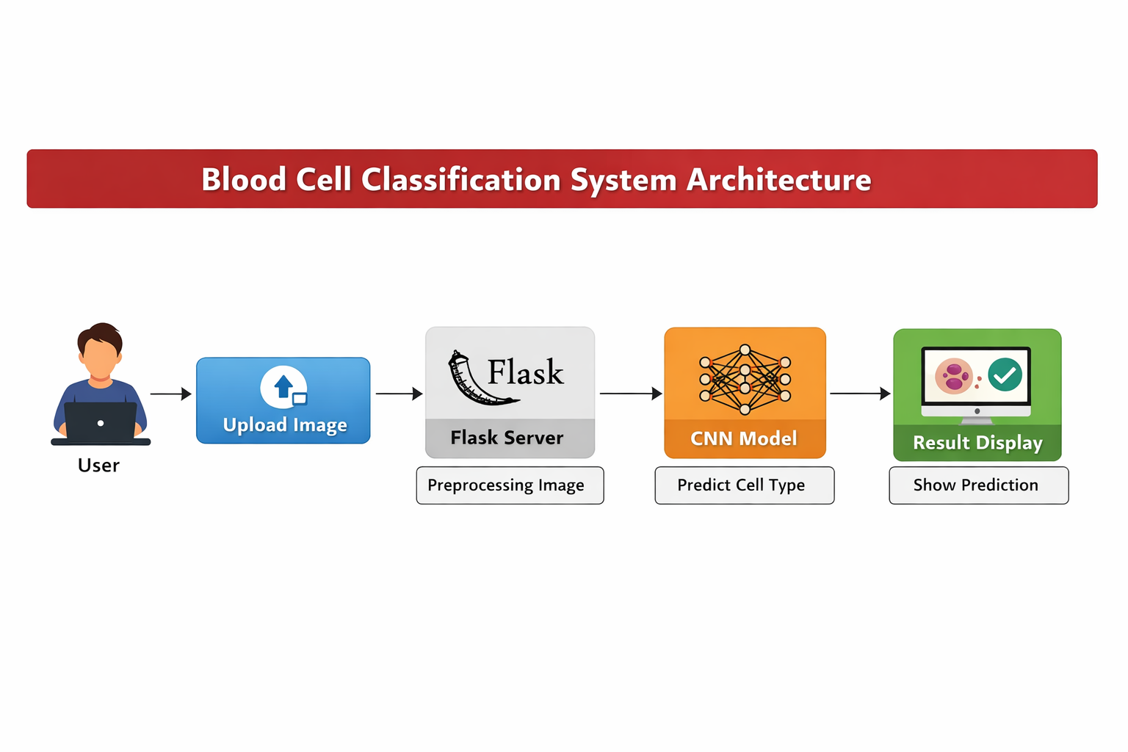
Figure 1: System Architecture Diagram

4. Technologies Used
• Python
• Flask
• HTML
• CSS
• TensorFlow/Keras
• NumPy
• OpenCV

5. Methodology
The methodology includes data collection, preprocessing, augmentation, model training, evaluation, and deployment. Images are resized and normalized before being passed to the CNN model. The trained model predicts the blood cell class.
The methodology includes data collection, preprocessing, augmentation, model training, evaluation, and deployment. Images are resized and normalized before being passed to the CNN model. The trained model predicts the blood cell class.
The methodology includes data collection, preprocessing, augmentation, model training, evaluation, and deployment. Images are resized and normalized before being passed to the CNN model. The trained model predicts the blood cell class.
The methodology includes data collection, preprocessing, augmentation, model training, evaluation, and deployment. Images are resized and normalized before being passed to the CNN model. The trained model predicts the blood cell class.
The methodology includes data collection, preprocessing, augmentation, model training, evaluation, and deployment. Images are resized and normalized before being passed to the CNN model. The trained model predicts the blood cell class.
The methodology includes data collection, preprocessing, augmentation, model training, evaluation, and deployment. Images are resized and normalized before being passed to the CNN model. The trained model predicts the blood cell class.
The methodology includes data collection, preprocessing, augmentation, model training, evaluation, and deployment. Images are resized and normalized before being passed to the CNN model. The trained model predicts the blood cell class.
The methodology includes data collection, preprocessing, augmentation, model training, evaluation, and deployment. Images are resized and normalized before being passed to the CNN model. The trained model predicts the blood cell class.
The methodology includes data collection, preprocessing, augmentation, model training, evaluation, and deployment. Images are resized and normalized before being passed to the CNN model. The trained model predicts the blood cell class.
The methodology includes data collection, preprocessing, augmentation, model training, evaluation, and deployment. Images are resized and normalized before being passed to the CNN model. The trained model predicts the blood cell class.

6. Implementation
Folder Structure:
my_project/
├── app.py
├── static/
└── templates/

Flask Backend Code (app.py)
from flask import Flask, render_template, request
import os
app = Flask(__name__)
UPLOAD_FOLDER = "static"
app.config["UPLOAD_FOLDER"] = UPLOAD_FOLDER
@app.route('/')
def home():
return render_template('home.html')
@app.route('/predict', methods=['POST'])
def predict():
file = request.files['image']
filepath = os.path.join(app.config['UPLOAD_FOLDER'], file.filename)
file.save(filepath)
prediction = "eosinophil"
return render_template('result.html',
prediction=prediction,
img_path=file.filename)
if __name__ == '__main__':
app.run(debug=True)

7. Application Screenshots

Home Page
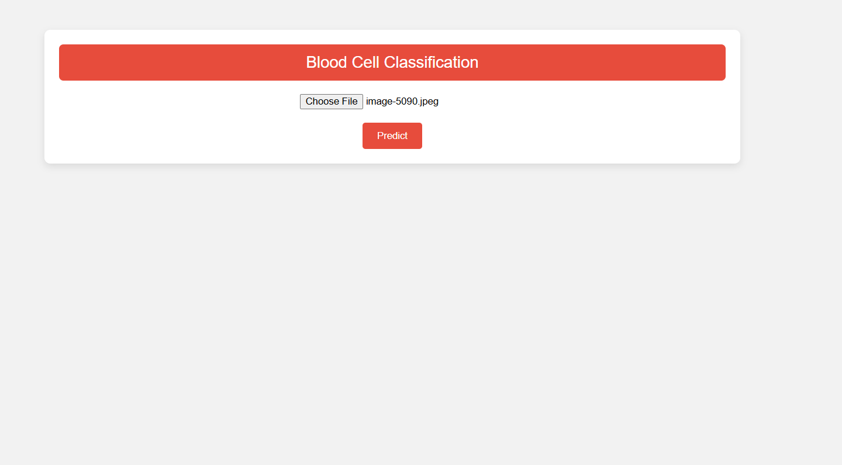

Result Page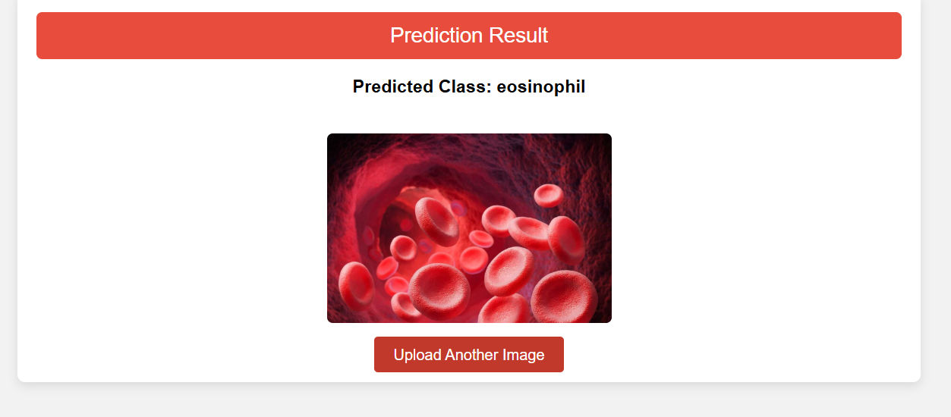

8. Results
The system successfully predicts the class of uploaded blood cell images. The web interface displays the predicted result clearly along with the uploaded image.
The system successfully predicts the class of uploaded blood cell images. The web interface displays the predicted result clearly along with the uploaded image.
The system successfully predicts the class of uploaded blood cell images. The web interface displays the predicted result clearly along with the uploaded image.
The system successfully predicts the class of uploaded blood cell images. The web interface displays the predicted result clearly along with the uploaded image.
The system successfully predicts the class of uploaded blood cell images. The web interface displays the predicted result clearly along with the uploaded image.
The system successfully predicts the class of uploaded blood cell images. The web interface displays the predicted result clearly along with the uploaded image.
The system successfully predicts the class of uploaded blood cell images. The web interface displays the predicted result clearly along with the uploaded image.
The system successfully predicts the class of uploaded blood cell images. The web interface displays the predicted result clearly along with the uploaded image.

9. Advantages
• Fast prediction
• High accuracy
• Easy to use
• Reduces manual effort
• Scalable system

10. Conclusion
The project demonstrates the practical implementation of deep learning in healthcare. The integration of CNN with Flask provides an efficient web-based diagnostic tool.
The project demonstrates the practical implementation of deep learning in healthcare. The integration of CNN with Flask provides an efficient web-based diagnostic tool.
The project demonstrates the practical implementation of deep learning in healthcare. The integration of CNN with Flask provides an efficient web-based diagnostic tool.
The project demonstrates the practical implementation of deep learning in healthcare. The integration of CNN with Flask provides an efficient web-based diagnostic tool.
The project demonstrates the practical implementation of deep learning in healthcare. The integration of CNN with Flask provides an efficient web-based diagnostic tool.
The project demonstrates the practical implementation of deep learning in healthcare. The integration of CNN with Flask provides an efficient web-based diagnostic tool.

11. Future Scope
The model accuracy can be improved using larger datasets and transfer learning. Future improvements include cloud deployment, mobile application integration, and real-time hospital usage.

12. References
1. Ian Goodfellow – Deep Learning
2. TensorFlow Documentation
3. Flask Official Documentation
4. Research papers on Medical Image Classification

