EXPERIMENT 14
WORKING WITH DATABASE
AIM: To create an application that stores and retrieve data from database
THEORY:
SQLite is a opensource SQL database that stores data to a text file on a device. Android comes in with built in SQLite database implementation.
SQLite supports all the relational database features. In order to access this database, you don't need to establish any kind of connections for it like JDBC,ODBC e.t.c
DataBaseHelper Class
For managing all the operations related to the database , an helper class has been given and is called SQLiteOpenHelper. It automatically manages the creation and update of the database. Its syntax is given below
public class DBHelper extends SQLiteOpenHelper {
public DBHelper(){
super(context,DATABASE_NAME,null,1);
}
public void onCreate(SQLiteDatabase db) {}
public void onUpgrade(SQLiteDatabase database, int oldVersion, int newVersion) {}
}

Fetching data from Database
We can retrieve anything from database using an object of the Cursor class. We will call a method of this class called rawQuery and it will return a resultset with the cursor pointing to the table. We can move the cursor forward and retrieve the data.
Cursor resultSet = mydatbase.rawQuery("Select * from TutorialsPoint",null);
resultSet.moveToFirst();
String username = resultSet.getString(0);
String password = resultSet.getString(1);

execSQL(String sql, Object[] bindArgs) - This method not only insert data , but also used to update or modify already existing data in database using bind arguments

ASSIGNMENT
- Write a program that creates a basic student application that allows insertion, updation and deletion of user details such as id, name, surname and marks using SQLite Database.
CODE
Activity_main.xml

<?xml version="1.0" encoding="utf-8"?>
<RelativeLayout xmlns:android="http://schemas.android.com/apk/res/android"
xmlns:app="http://schemas.android.com/apk/res-auto"
xmlns:tools="http://schemas.android.com/tools"
android:layout_width="match_parent"
android:layout_height="match_parent"
tools:context=".MainActivity">
<TextView
android:layout_width="wrap_content"
android:layout_height="wrap_content"
android:layout_marginTop="30dp"
android:layout_marginLeft="95dp"
android:text=" SQL DATABASE "
android:textSize="25dp"
android:textStyle="bold" />
<EditText
android:layout_width="match_parent"
android:layout_height="60dp"
android:layout_marginTop="90dp"
android:layout_marginLeft="50dp"
android:layout_marginRight="50dp"
android:hint=" NAME "
android:id="@+id/txtName" />
<EditText
android:id="@+id/txtSurname"
android:layout_width="match_parent"
android:layout_height="60dp"
android:layout_marginLeft="50dp"
android:layout_marginRight="50dp"
android:layout_marginTop="170dp"
android:hint=" SURNAME " />
<EditText
android:id="@+id/txtMarks"
android:layout_width="match_parent"
android:layout_height="59dp"
android:layout_marginLeft="50dp"
android:layout_marginRight="50dp"
android:layout_marginTop="250dp"
android:hint=" Marks " />
<EditText
android:id="@+id/txtId"
android:layout_width="match_parent"
android:layout_height="58dp"
android:layout_marginLeft="50dp"
android:layout_marginRight="50dp"
android:layout_marginTop="330dp"
android:hint=" ID " />
<Button
android:layout_width="wrap_content"
android:layout_height="wrap_content"
android:layout_marginTop="410dp"
android:layout_marginLeft="70dp"
android:text=" Add Data"
android:textStyle="bold"
android:textSize="15dp"
android:id="@+id/btnAdd" />
<Button
android:layout_width="wrap_content"
android:layout_height="wrap_content"
android:layout_marginTop="410dp"
android:layout_marginLeft="225dp"
android:text=" Display "
android:textStyle="bold"
android:textSize="15dp"
android:id="@+id/btnDisplay" />
<Button
android:layout_width="101dp"
android:layout_height="wrap_content"
android:layout_marginTop="480dp"
android:layout_marginLeft="70dp"
android:text=" Update"
android:textStyle="bold"
android:textSize="15dp"
android:id="@+id/btnUpdate" />
<Button
android:layout_width="wrap_content"
android:layout_height="wrap_content"
android:layout_marginTop="480dp"
android:layout_marginLeft="225dp"
android:text=" Delete"
android:textStyle="bold"
android:textSize="15dp"
android:id="@+id/btnDelete" />
</RelativeLayout>
MainActivity.Java
package com.example.mca1734.database;
import android.database.Cursor;
import android.database.sqlite.SQLiteDatabase;
import android.support.v7.app.AlertDialog;
import android.support.v7.app.AppCompatActivity;
import android.os.Bundle;
import android.view.View;
import android.widget.Button;
import android.widget.EditText;
import android.widget.Toast;
public class MainActivity extends AppCompatActivity {
DataBase mydb;
EditText Name, Surname, Marks, Id;
Button Add, Display, Update, Delete;
@Override
protected void onCreate(Bundle savedInstanceState) {
super.onCreate(savedInstanceState);
setContentView(R.layout.activity_main);
mydb = new DataBase(this);
Name = (EditText)findViewById(R.id.txtName);
Surname = (EditText)findViewById(R.id.txtSurname);
Marks = (EditText)findViewById(R.id.txtMarks);
Id = (EditText)findViewById(R.id.txtId);
Add = (Button)findViewById(R.id.btnAdd);
Display = (Button)findViewById(R.id.btnDisplay);
Update = (Button)findViewById(R.id.btnUpdate);
Delete = (Button)findViewById(R.id.btnDelete);
AddData();
DisplayData();
UpdateData();
DeleteData();
}
public void AddData(){
Add.setOnClickListener(new View.OnClickListener() {
@Override
public void onClick(View v) {
boolean res = mydb.inserdata(Id.getText().toString(),
Name.getText().toString(),
Surname.getText().toString(),
Marks.getText().toString());
if (res == true)
Toast.makeText(getApplicationContext(),"Data Inserted Successfully",Toast.LENGTH_LONG).show();
else
Toast.makeText(getApplicationContext(),"Data Not Inserted Successfully",Toast.LENGTH_LONG).show();
}
});
}
public void DisplayData(){
Display.setOnClickListener(new View.OnClickListener() {
@Override
public void onClick(View v) {
Cursor result = mydb.DisplayData();
if (result.getCount() == 0)
{
showmessage("Error", "Data not Found");
return;
}
StringBuffer buffer = new StringBuffer();
while (result.moveToNext()){
buffer.append("ID : " + result.getString(0) + "\n");
buffer.append("Name : " + result.getString(1) + "\n");
buffer.append("Surname : " + result.getString(2) + "\n");
buffer.append("Marks : " + result.getString(3) + "\n");
}
//Show Message
showmessage("Data", buffer.toString());
}
});
}
public void showmessage(String title, String message){
AlertDialog.Builder builder= new AlertDialog.Builder(this);
builder.setCancelable(true);
builder.setTitle(title);
builder.setMessage(message);
builder.show();
}
public void UpdateData(){
Update.setOnClickListener(new View.OnClickListener() {
@Override
public void onClick(View v) {
boolean res = mydb.updateData(Id.getText().toString(),
Name.getText().toString(),
Surname.getText().toString(),
Marks.getText().toString());
if (res == true)
Toast.makeText(getApplicationContext(),"Data Updated Successfully",Toast.LENGTH_LONG).show();

else
Toast.makeText(getApplicationContext(),"Data Not Updated Successfully",Toast.LENGTH_LONG).show();
}
});
}
public void DeleteData(){
Delete.setOnClickListener(new View.OnClickListener() {
@Override
public void onClick(View v) {
Integer res = mydb.deletedata(Id.getText().toString());
if (res > 0)
Toast.makeText(getApplicationContext(),"Data Deleted Successfully",Toast.LENGTH_LONG).show();
else
Toast.makeText(getApplicationContext(),"Data Data Found",Toast.LENGTH_LONG).show();
}
});
}
}
DataBase.java
package com.example.mca1734.database;
import android.content.ContentValues;
import android.content.Context;
import android.database.Cursor;
import android.database.sqlite.SQLiteDatabase;
import android.database.sqlite.SQLiteOpenHelper;
public class DataBase extends SQLiteOpenHelper{
public static final String DATABASE_NAME = "student.db";
public static final String TABLE_NAME = "student_table";
public static final String COL_1 = "ID";
public static final String COL_2 = "NAME";
public static final String COL_3 = "SURNAME";
public static final String COL_4 = "MARKS";
public DataBase(Context context) {
super(context, DATABASE_NAME, null, 1);
SQLiteDatabase db = this.getWritableDatabase();
}
@Override
public void onCreate(SQLiteDatabase db) {
db.execSQL("create table " + TABLE_NAME + "(ID INTEGER PRIMARY KEY,NAME TEXT, SURNAME TEXT, MARKS INTEGER)");
}
@Override
public void onUpgrade(SQLiteDatabase db, int oldVersion, int newVersion) {
db.execSQL("drop table " + TABLE_NAME,null);
onCreate(db);
}
public boolean inserdata(String id, String name, String surname, String marks){
SQLiteDatabase db = this.getWritableDatabase();
ContentValues contentValues = new ContentValues();
contentValues.put(COL_1,id);
contentValues.put(COL_2,name);
contentValues.put(COL_3,surname);
contentValues.put(COL_4,marks);
long result = db.insert(TABLE_NAME,null,contentValues);
if(result == -1)
return false;
else
return true;
}
public Cursor DisplayData(){
SQLiteDatabase db = this.getWritableDatabase();
Cursor res = db.rawQuery("Select * from " + TABLE_NAME, null);
return res;
}
public boolean updateData(String id, String name, String surname, String marks ) {
SQLiteDatabase db = this.getWritableDatabase();
ContentValues contentValues = new ContentValues();
contentValues.put(COL_1,id);
contentValues.put(COL_2,name);
contentValues.put(COL_3,surname);
contentValues.put(COL_4,marks);
long res = db.update(TABLE_NAME, contentValues,"id=?" ,new String[] {id});
if (res == -1)
return false;
else
return true;
}
public Integer deletedata(String id){
SQLiteDatabase db = this.getWritableDatabase();
return db.delete(TABLE_NAME, "id=?", new String[] {id});
}
}

OUTPUT
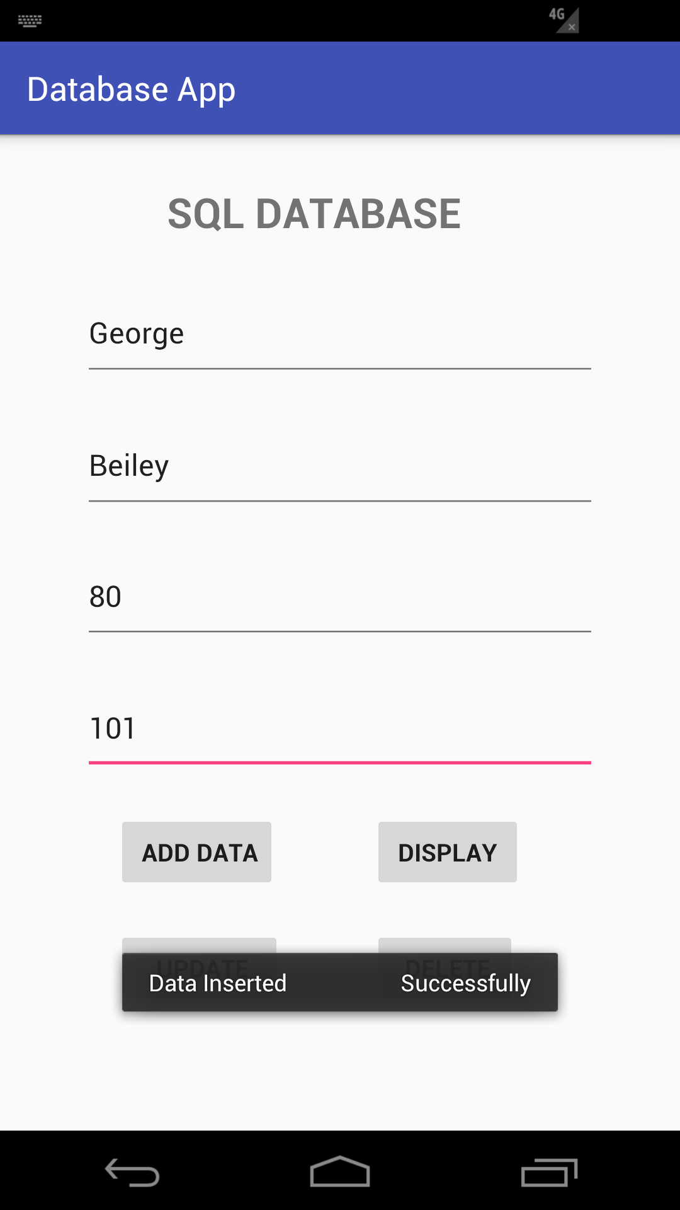
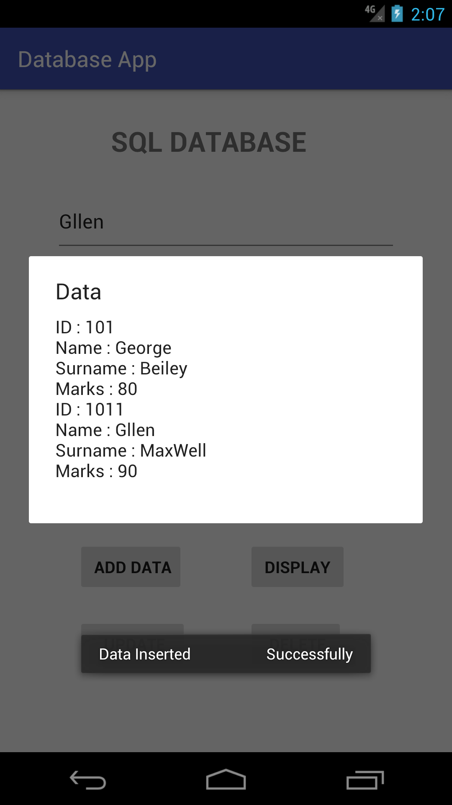
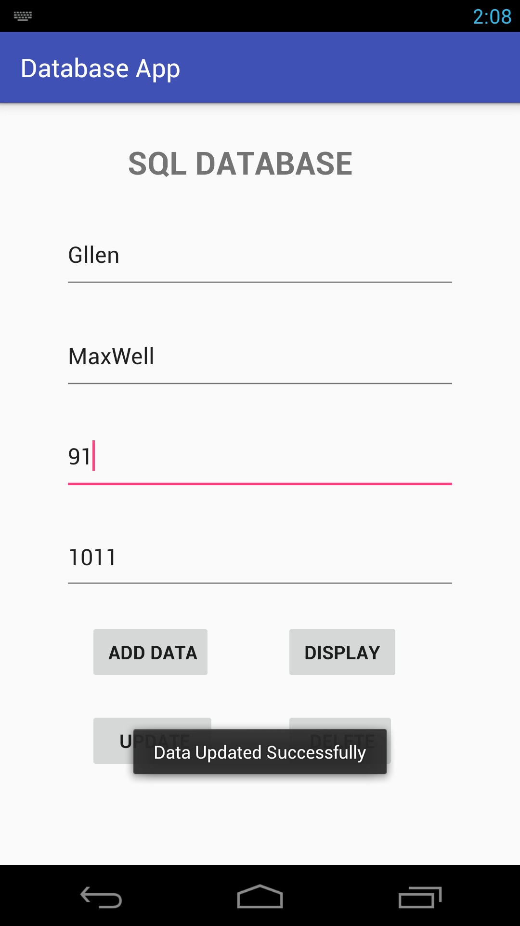
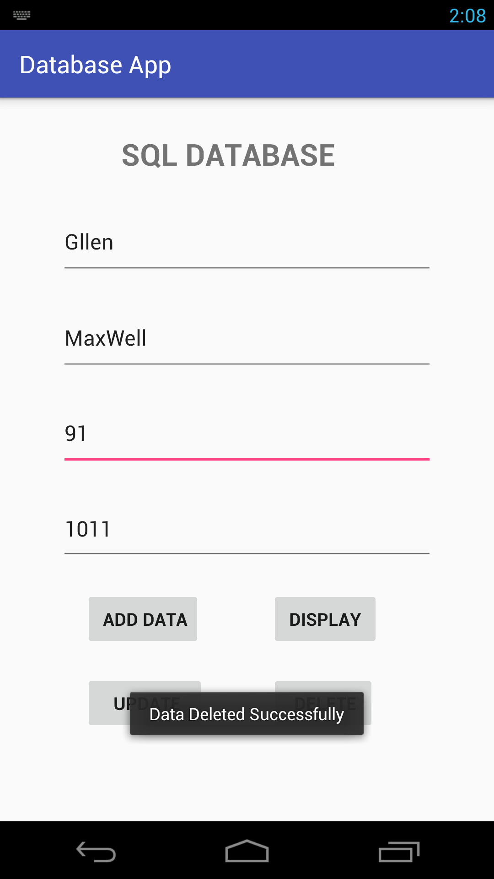

- Write a program that creates a contact application that allows insertion, updation and deletion of contact details using SQLite Database.

CODE
activity_main.xml

<?xml version="1.0" encoding="utf-8"?>
<RelativeLayout xmlns:android="http://schemas.android.com/apk/res/android"
xmlns:app="http://schemas.android.com/apk/res-auto"
xmlns:tools="http://schemas.android.com/tools"
android:layout_width="match_parent"
android:layout_height="match_parent"
tools:context=".MainActivity">
<TextView
android:layout_width="wrap_content"
android:layout_height="wrap_content"
android:layout_alignParentTop="true"
android:layout_centerHorizontal="true"
android:layout_marginTop="21dp"
android:text="Contact Details Database"
android:textSize="30dp" />
<EditText
android:id="@+id/cname"
android:layout_width="wrap_content"
android:layout_height="wrap_content"
android:layout_alignParentTop="true"
android:layout_centerHorizontal="true"
android:layout_marginTop="93dp"
android:hint="Name:" />
<EditText
android:id="@+id/contactNo"
android:layout_width="wrap_content"
android:layout_height="wrap_content"
android:layout_alignParentTop="true"
android:layout_centerHorizontal="true"
android:layout_marginTop="191dp"
android:hint="Contact Number:" />
<Button
android:id="@+id/btnInsert"
android:layout_width="wrap_content"
android:layout_height="wrap_content"
android:layout_alignParentBottom="true"
android:layout_alignParentStart="true"
android:layout_marginBottom="213dp"
android:layout_marginStart="58dp"
android:text="Add Data"
android:layout_alignParentLeft="true"
android:layout_marginLeft="58dp" />
<Button
android:id="@+id/btnDisplay"
android:layout_width="wrap_content"
android:layout_height="wrap_content"
android:layout_alignParentEnd="true"
android:layout_alignParentRight="true"
android:layout_alignTop="@+id/btnInsert"
android:layout_marginEnd="51dp"
android:layout_marginRight="51dp"
android:text="Display" />
<Button
android:id="@+id/btnUpdate"
android:layout_width="wrap_content"
android:layout_height="wrap_content"
android:layout_alignParentBottom="true"
android:layout_alignStart="@+id/btnInsert"
android:layout_marginBottom="105dp"
android:text="Update"
android:layout_alignLeft="@+id/btnInsert" />
<Button
android:id="@+id/btnDelete"
android:layout_width="wrap_content"
android:layout_height="wrap_content"
android:layout_alignStart="@+id/btnDisplay"
android:layout_alignTop="@+id/btnUpdate"
android:text="Delete"
android:layout_alignLeft="@+id/btnDisplay" />
</RelativeLayout>
MainActivity.java
package com.example.mca1732.contatctsdb;
import android.database.Cursor;
import android.support.v7.app.AlertDialog;
import android.support.v7.app.AppCompatActivity;
import android.os.Bundle;
import android.view.View;
import android.widget.Button;
import android.widget.EditText;
import android.widget.Toast;
public class MainActivity extends AppCompatActivity {
EditText cname,contactNo;
Button btnInsert,btnDisplay,btnUpdate,btnDelete;
DatabaseHelper myDb;
@Override
protected void onCreate(Bundle savedInstanceState) {
super.onCreate(savedInstanceState);
setContentView(R.layout.activity_main);
cname = findViewById(R.id.cname);
contactNo = findViewById(R.id.contactNo);
btnInsert = findViewById(R.id.btnInsert);
btnDisplay = findViewById(R.id.btnDisplay);
btnUpdate = findViewById(R.id.btnUpdate);
btnDelete = findViewById(R.id.btnDelete);
myDb = new DatabaseHelper(this);
AddData();
DisplayData();
DeleteData();
UpdateData();
}
public void AddData() {
btnInsert.setOnClickListener(new View.OnClickListener() {
@Override
public void onClick(View v) {
boolean res = myDb.insertData( cname.getText().toString(), contactNo.getText().toString());
if (res == true) {
Toast.makeText(getApplicationContext(), "Data Inserted Successfully", Toast.LENGTH_LONG).show();
} else {
Toast.makeText(getApplicationContext(), "Data NOT Inserted !!!", Toast.LENGTH_LONG).show();
}
}
});
}
public void DisplayData() {
btnDisplay.setOnClickListener(new View.OnClickListener() {
@Override
public void onClick(View v) {
Cursor result = myDb.displayData(cname.getText().toString(), contactNo.getText().toString());
if (result.getCount() == 0) {
//show msg
showMessage("Error", "Data Not Found");
return;
}
StringBuffer buff = new StringBuffer();
while (result.moveToNext()) {
buff.append("Name :" + result.getString(0) + "\n");
buff.append("Contact Number :" + result.getString(1) + "\n");
}
showMessage("Data ", buff.toString());
}
});
}
public void showMessage(String title, String msg) {
AlertDialog.Builder builder = new AlertDialog.Builder(this);
builder.setCancelable(true);
builder.setTitle(title);
builder.setMessage(msg);
builder.show();
}
public void UpdateData() {
btnUpdate.setOnClickListener(new View.OnClickListener() {
@Override
public void onClick(View v) {
boolean result = myDb.updateData(cname.getText().toString(), contactNo.getText().toString());
if (result == true) {
Toast.makeText(getApplicationContext(), "Data Updated Successfully", Toast.LENGTH_LONG).show();
} else {
Toast.makeText(getApplicationContext(), "Data NOT Updated !!!", Toast.LENGTH_LONG).show();
}
}
});
}
public void DeleteData() {
btnDelete.setOnClickListener(new View.OnClickListener() {
@Override
public void onClick(View v) {
Integer result = myDb.deleteData(cname.getText().toString());
if (result > 0) {
Toast.makeText(getApplicationContext(), "Data Deleted Successfully", Toast.LENGTH_LONG).show();
} else {
Toast.makeText(getApplicationContext(), "Data NOT Deleted !!!", Toast.LENGTH_LONG).show();
}
}
});
}
}
DatabaseHelper.java
package com.example.mca1732.contatctsdb;
import android.content.ContentValues;
import android.content.Context;
import android.database.Cursor;
import android.database.sqlite.SQLiteDatabase;
import android.database.sqlite.SQLiteOpenHelper;
public class DatabaseHelper extends SQLiteOpenHelper {
public static final String db_name = "Contact.db";
public static final String table_name = "Contact_table";
public static final String col1 = "Name";
public static final String col2 = "Contact";
public DatabaseHelper(Context context) {
super(context, db_name, null, 1);
}
@Override
public void onCreate(SQLiteDatabase db) {
db.execSQL("create table " + table_name + "(NAME TEXT PRIMARY KEY,Contact INTEGER)");
}
@Override
public void onUpgrade(SQLiteDatabase db, int oldVersion, int newVersion) {
db.execSQL("drop table " + table_name, null);
onCreate(db);
}
public boolean insertData(String name, String contact) {
SQLiteDatabase db = this.getWritableDatabase();
ContentValues cntntValues = new ContentValues();
cntntValues.put(col1, name);
cntntValues.put(col2, contact);
long result = db.insert(table_name, null, cntntValues);
if (result == -1) {
return false;
} else {
return true;
}
}
public Cursor displayData(String name, String contact) {
SQLiteDatabase db = this.getWritableDatabase();
Cursor res = db.rawQuery("select * from " + table_name, null);
return res;
}
public boolean updateData( String name, String contact) {
SQLiteDatabase db = this.getWritableDatabase();
ContentValues cntntValues = new ContentValues();
cntntValues.put(col1, name);
cntntValues.put(col2, contact);
long result = db.update(table_name, cntntValues, "name=?", new String[]{name});
if (result == -1)
return false;
else
return true;
public Integer deleteData(String name) {
SQLiteDatabase db = this.getWritableDatabase();
return db.delete(table_name, "name=?", new String[]{name});
}
}
OUTPUT
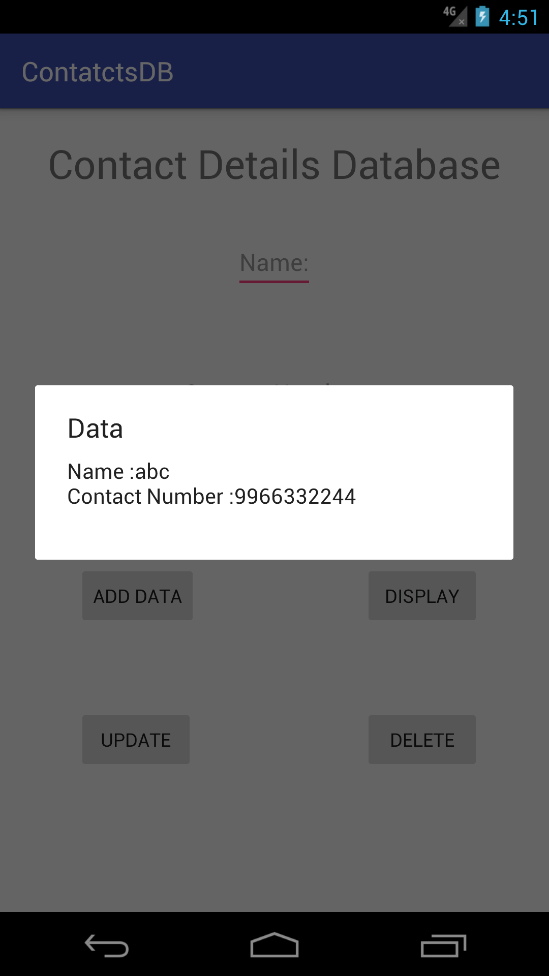
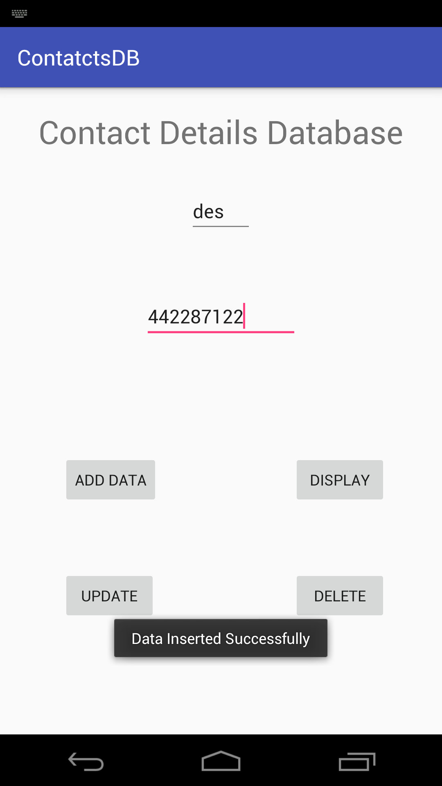
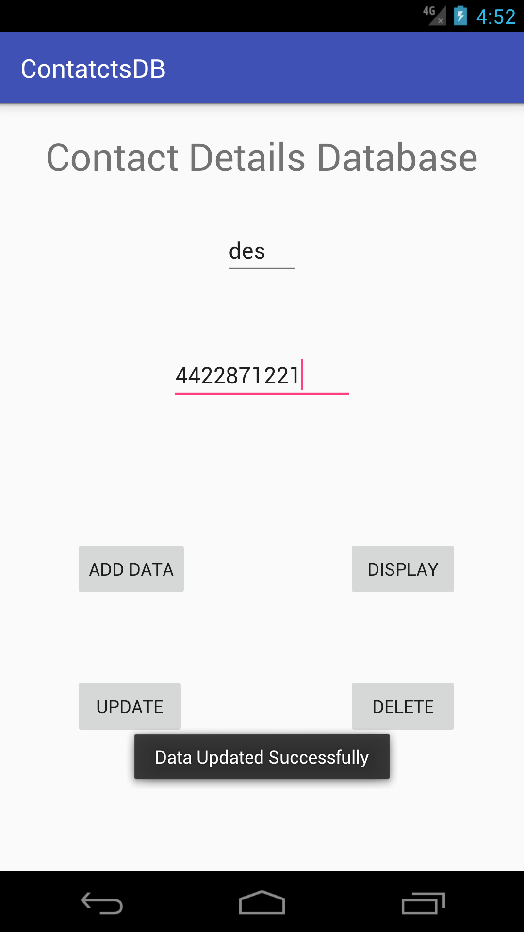
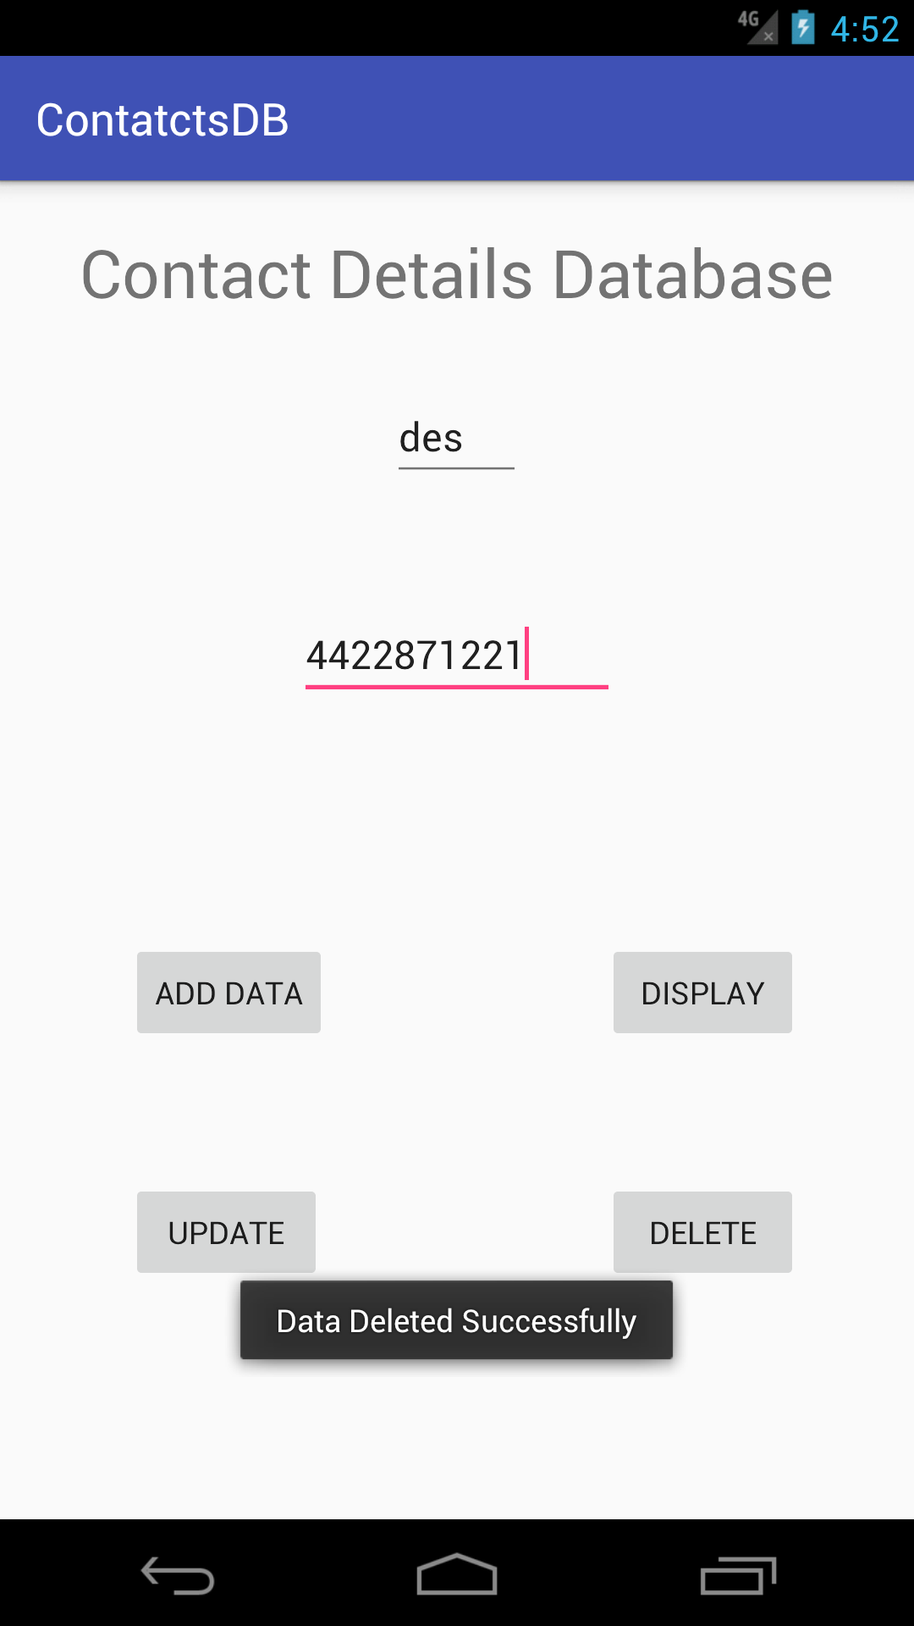
CONCLUSION:
-Hence we learn how to create an application that stores and retrieve data from database.

