COVER PAGE

DATA SCIENCE TOOLBOX: PYTHON PROGRAMMINGPROJECT REPORT
(Project Semester January-April 2025)

Electric Vehicle Analysis in Washington State

Submitted by

Ayush Salaria

Registration No 12324752

Programme and Section (CSE K23SG)
Course Code
INT:375

Under the Guidance of

Dr. Manpreet Singh Sehgal

Discipline of CSE/IT

Lovely School of Computer Science Engineering

Lovely Professional University, Phagwara

CERTIFICATE
This is to certify that Ayush Salaria bearing Registration no. 12324752 has completed INT 375 project titled, “Electric Vehicle Analysis in Washington State” under my guidance and supervision. To the best of my knowledge, the present work is the result of his/her original development, effort and study.

Signature and Name of the Supervisor
Designation of the Supervisor
School of Computer Science and Engineering
Lovely Professional University
Phagwara, Punjab.

Date: 12-04-2025

DECLARATION

I, Ayush student of Computer Science under CSE/IT Discipline at Lovely Professional University, Punjab, hereby declare that all the information furnished in this project report is based on my own intensive work and is genuine.

Date: 12-04-2025 Signature
Registration No. 12324752 Name of the student: Ayush

TABLE OF CONTENTS

1. Introduction
2. Source of Dataset
3. Dataset Preprocessing
4. Analysis on Dataset
i. General Description
ii. Specific Requirements
iii. Analysis Results
iv. Visualization
5. Conclusion
6. Future Scope
7. References

INTRODUCTION

With increasing concerns about climate change and fossil fuel depletion,
electric vehicles (EVs) have emerged as a promising solution for sustainable
transportation. This project aims to analyse real-world data from the
Washington State EV registry to extract meaningful insights using Python.

2. SOURCE OF DATASET
-----------------------------------------------------------------
- Title: Electric Vehicle Population Data
- Source: Washington State Government Open Data Portal
- Link: https://data.wa.gov/Transportation/Electric-Vehicle-Population-Data/7ias-nzb6
- Records: 235,692 entries
- Features: 17 columns (Make, Model Year, EV Type, Electric Range, County, etc.)

-----------------------------------------------------------------
3. DATASET PREPROCESSING
-----------------------------------------------------------------
The dataset was loaded using pandas and checked for null values. Data
types were validated, and only relevant columns were selected for analysis.
Rows with zero or missing electric range were filtered for specific objectives.

-----------------------------------------------------------------
4. ANALYSIS ON DATASET
-----------------------------------------------------------------

GENERAL DESCRIPTION

The data contains records of registered electric vehicles, including model
year, type (BEV/PHEV), manufacturer, and location.

SPECIFIC REQUIREMENTS

The project focuses on 5 objectives:
- Most Popular EV Manufacturers
- Yearly EV Registrations
- Distribution of EV Types
- Top Counties by EV Count
- Correlation of Electric Range and Model Year

ANALYSIS RESULTS

→ Objective 1: Tesla dominates the EV market in Washington. Nissan and Chevrolet follow.
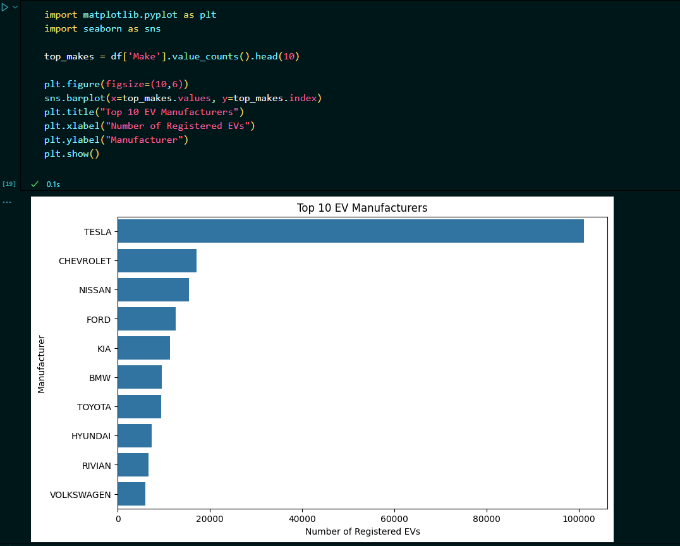

→ Objective 2: Registrations have grown significantly since 2018.
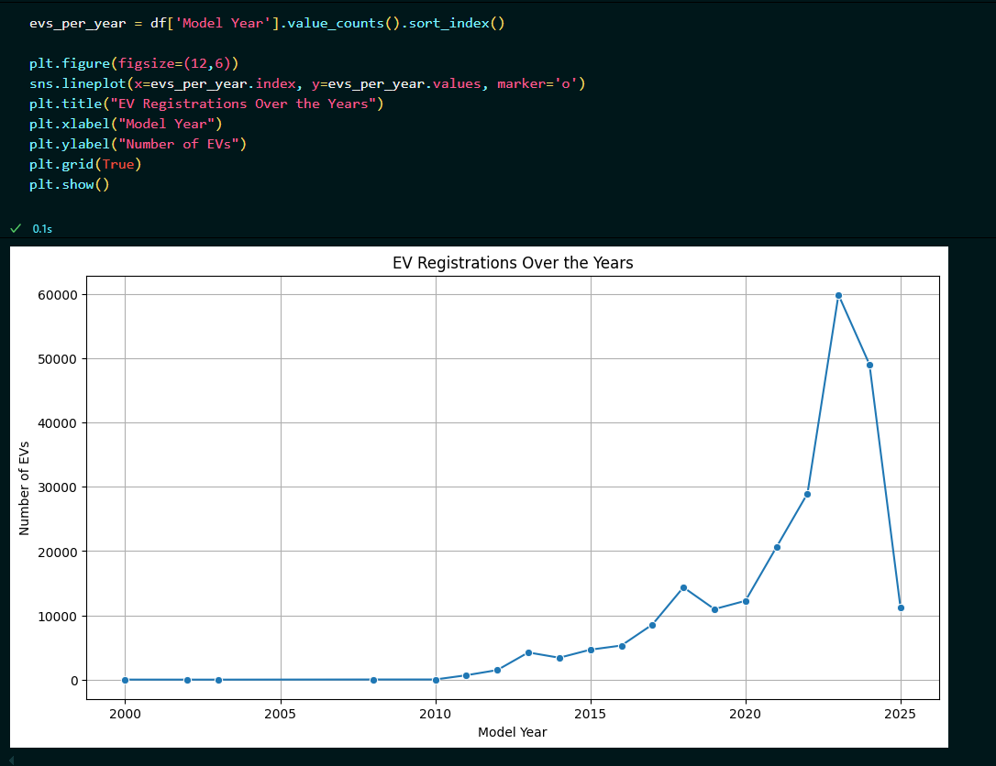

→ Objective 3: BEVs outnumber PHEVs, indicating a preference for fully electric models.
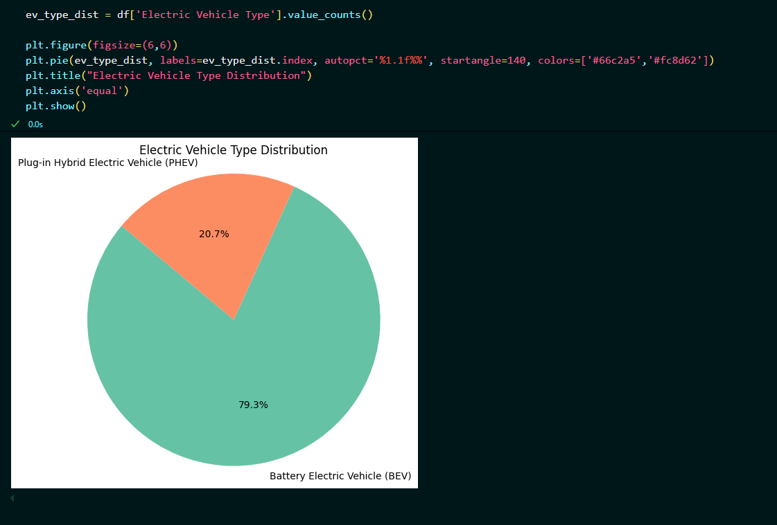

→ Objective 4: King County has the most EVs, highlighting urban EV adoption.
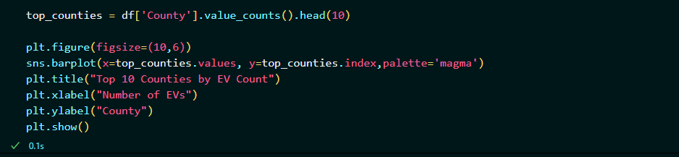
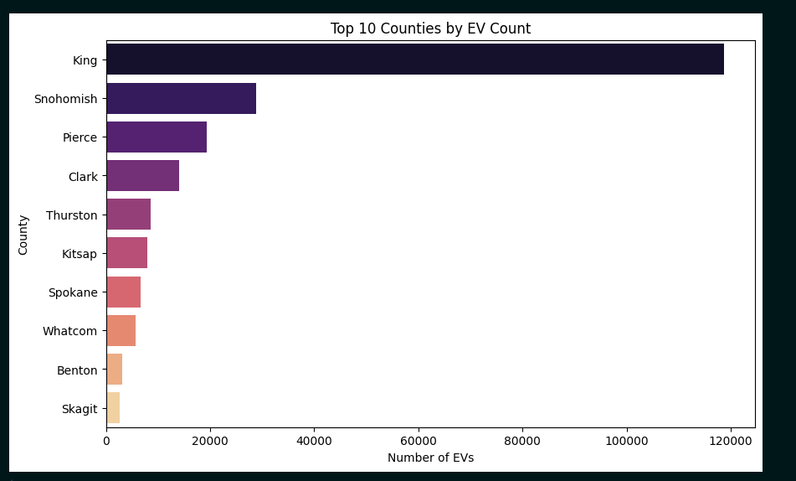
→ Objective 5: Newer vehicles tend to have higher electric ranges.
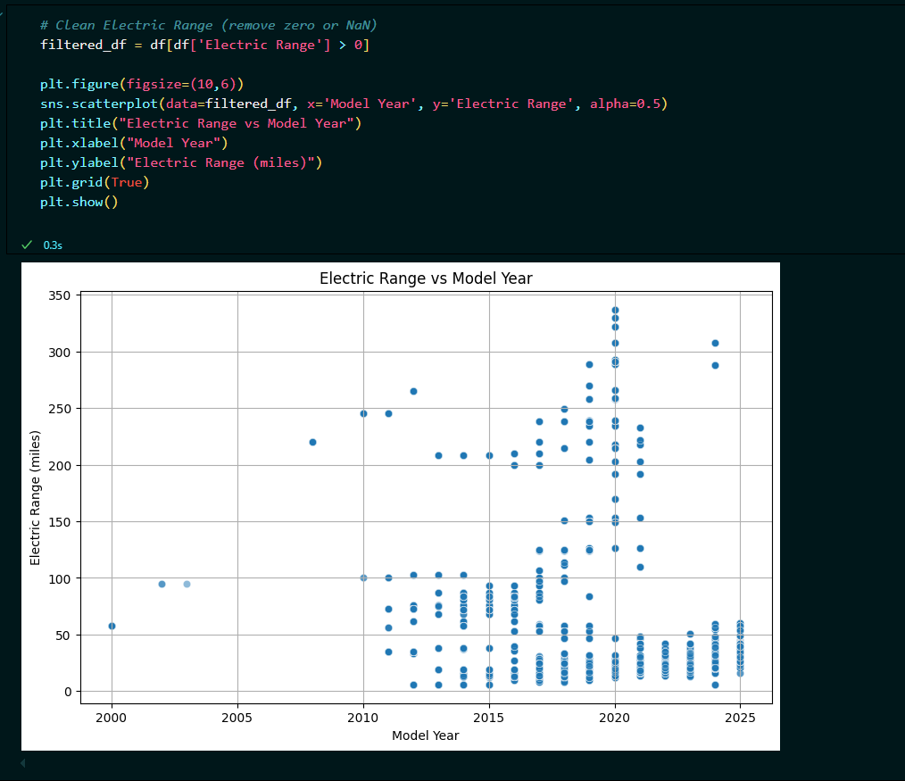

iv. VISUALIZATION

Bar charts, pie charts, scatter plots, and line graphs were created using
matplotlib and seaborn to clearly represent the insights derived from the data.

-----------------------------------------------------------------
5. CONCLUSION
-----------------------------------------------------------------
This project provides insights into the EV ecosystem in Washington. The data
shows growth in EV adoption and technological advancements in range.
It also reveals geographic and brand-based preferences among users.

-----------------------------------------------------------------
6. FUTURE SCOPE
-----------------------------------------------------------------
- Compare with data from other states or countries.
- Include fuel price trends for correlation.
- Predict future EV growth using machine learning.
- Map EV adoption with charging station availability.

-----------------------------------------------------------------
7. REFERENCES
-----------------------------------------------------------------
- https://data.wa.gov/
- https://pandas.pydata.org/
- https://matplotlib.org/
- https://seaborn.pydata.org/
- https://www.python.org/

LINKED IN POST:
