Statistical Inference Assignment Part 1

Ashish Tiwari

Sunday, July 26, 2015

## Setting up global options and loading knitr package for the assignment

library(knitr)  
opts_chunk$set(fig.width=7, fig.height=4, warning=FALSE, message=FALSE)

# Statistical Inference Course Part 1

## Overview

The assignment is to investigate the exponential distribution in R and compare it with the Central Limit Theorem. The exponential distribution can be simulated in R with rexp(n, lambda) where lambda is the rate parameter.

The mean of exponential distribution is 1/lambda and the standard deviation is also 1/lambda. We will set lambda = 0.2 for all of the simulations and investigate the distribution of averages of 40 exponentials. We will need to do a thousand simulations.

## Develop Simulations

# load neccesary libraries  
library(ggplot2)

## Set constants

lambda <- 0.2 # lambda for rexp  
n <- 40 # number of exponetials  
numberOfSimulations <- 1000 # number of tests

## Set the seed to create reproducability

set.seed(11081979)

## Run the test resulting in n x numberOfSimulations matrix

exponentialDistributions <- matrix(data=rexp(n * numberOfSimulations, lambda), nrow=numberOfSimulations)  
exponentialDistributionMeans <- data.frame(means=apply(exponentialDistributions, 1, mean))

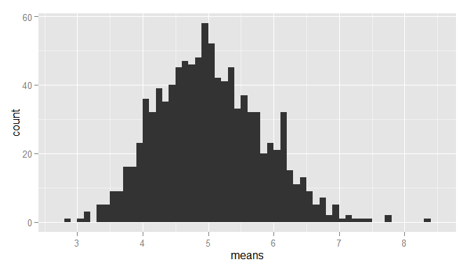

## Sample Mean versus Theoretical Mean

The expected mean $μ$ of a exponential distribution of rate $λ$ is

$μ=\frac{1}{λ}$

mu <- 1/lambda  
mu

## [1] 5

Let $\overline{X}$ be the average sample mean of 1000 simulations of 40 randomly sampled exponential distributions.

meanOfMeans <- mean(exponentialDistributionMeans$means)  
meanOfMeans

## [1] 5.027126

The expected mean and the avarage sample mean are very close

## Sample Variance versus Theoretical Variance

The expected standard deviation $σ$ of a exponential distribution of rate $λ$ is

$σ=\frac{1/λ}{\sqrt{n}}$

The e

sd <- 1/lambda/sqrt(n)  
sd

## [1] 0.7905694

The variance $Var$ of standard deviation $σ$ is

$Var=σ^{2}$

Var <- sd^2  
Var

## [1] 0.625

Let $Var_{x}$ be the variance of the average sample mean of 1000 simulations of 40 randomly sampled exponential distribution, and $σ_{x}$ the corresponding standard deviation.

sd_x <- sd(exponentialDistributionMeans$means)  
sd_x

## [1] 0.8020334

Var_x <- var(exponentialDistributionMeans$means)  
Var_x

## [1] 0.6432577

As you can see the standard deviations are very close Since variance is the square of the standard deviations, minor differnces will we enhanced, but are still pretty close.

## Distribution

Comparing the population means & standard deviation with a normal distribution of the expected values. Added lines for the calculated and expected means

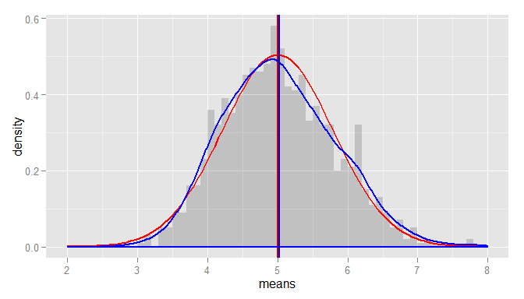

The graph, the calculated distribution of means of random sampled exponantial distributions, overlaps with the normal distribution with the expected values based on the given lamba