ACADEMIC RESEARCH REPORT
Brain Tumor Detection Using
Machine Learning & Deep Learning

A Comprehensive Literature Review, Comparative Analysis & Original Model Report with Results

Based on four peer-reviewed papers | Includes MobileNetV2 Transfer Learning Model with Grad-CAM Visualizations

-Ashna Agarwal
Netaji Subhas University of Technology

Section 1: Introduction & Literature Review

Brain tumor detection is one of the most critical problems in medical image analysis. The brain's complex architecture and the diverse morphology of tumors — varying in size, shape, location, and grade — combined with the inherent subjectivity of manual radiological analysis make automated AI-driven diagnostic tools essential. MRI is the gold standard for non-invasive brain tumor visualization, but the volume of scans and risk of inter-observer variability demand reliable, interpretable automated systems. The four research papers reviewed here represent the current frontier of AI-based brain tumor analysis, spanning deep wavelet autoencoders, YOLOv7 object detection with attention mechanisms, ensemble transfer learning with classical ML classifiers, and a rigorous statistical comparison of custom CNNs versus six classical methods.

Paper 1 — Deep Wavelet Auto-Encoder (DWAE) — Diagnostics, 2021
Authors: Abd El Kader, Xu, Shuai et al. — Hebei University of Technology, China. This paper proposes replacing the standard neural activation function with a wavelet function φ(a) = cos(5a)·exp(−a²/2) in a deep autoencoder, enabling simultaneous frequency-domain and time-frequency localization of MRI pixel patterns. The three-stage pipeline performs image enhancement (high-pass + median filter fusion) → seed-growing segmentation → DWAE classification (200 + 400 hidden units → Softmax). Validated on 2500 images from BRATS 2012–2015 and ISLES, the model achieved Accuracy 99.3%, DSC 96.55%, FPR 0.0625, FNR 0.031 — outperforming 21 prior models including CNN-SVM (95.62%), VGG16 (84.48%), and DWA-DNN (93.14%).

Paper 2 — YOLOv7 with CBAM Attention — Cancers, 2023
Authors: Abdusalomov, Mukhiddinov, Whangbo — Gachon University, South Korea. This paper deploys YOLOv7 for simultaneous tumor classification and spatial localization via bounding boxes. Three architectural enhancements address standard YOLO limitations: CBAM attention (channel + spatial, outperforming SE and ECA in ablation), SPPF+ (multi-scale pooling with 5×5, 9×9, 13×13 kernels for small lesion detection), and BiFPN (bidirectional feature fusion with learnable weights). Fine-tuned from COCO pretrained weights on 51,448 augmented images, the model achieved Accuracy 99.5%, Precision 99.5%, F1-score 99.4% — outperforming EfficientNet (97.8%), VGG16 (97.6%), and YOLOv4 (97.5%).

Paper 3 — Ensemble Deep Features + ML Classifiers — Sensors, 2021
Authors: Kang, Ullah, Gwak — Korea National University of Transportation. This paper conducts the most exhaustive empirical comparison in this review (117 experimental configurations), evaluating 13 pretrained CNN backbones as feature extractors against 9 ML classifiers. The key contribution is a feature ensemble selection strategy: the top-3 CNN features are concatenated into a composite vector. For the 4-class dataset, DenseNet-169 + ShuffleNet V2 + MnasNet with SVM-RBF achieved 93.72%. Key findings: SVM-RBF consistently outperforms all classifiers on large datasets; DenseNet architectures produce superior features due to dense multi-scale connectivity; Gaussian NB performs worst due to violated independence assumptions; ensemble consistently outperforms single-feature classification.

Paper 4 — 2D CNN vs 6 ML Classifiers (Statistical Comparison) — BMC, 2023
Authors: Saeedi, Rezayi, Keshavarz, Niakan Kalhori — Tehran University of Medical Sciences. The most statistically rigorous study in this review, proposing a custom 2D CNN (8 conv layers, 2×2 kernels, batch normalization throughout) and a Convolutional Auto-Encoder, benchmarked against KNN, RF, SVM, SGD, LR, and MLP using one-way ANOVA + LSD post-hoc testing. Uniquely, it includes healthy brains as a 4th class. Results: 2D CNN test accuracy 93.45% (AUROC 0.99–1.00), Auto-Encoder 90.93%, best ML KNN 86%, worst MLP 28%. ANOVA confirmed statistical significance (p<0.001) between deep methods and LR, SGD, MLP.

Section 2: Comparative Analysis

The following four tables provide a structured, multi-dimensional comparison of all reviewed papers. Each table focuses on a distinct analytical dimension, enabling clear interpretation without the cognitive overload of a single large table. Paper identity is colour-coded consistently across all four tables.

Paper 1 (DWAE) = Cyan · Paper 2 (YOLOv7) = Blue · Paper 3 (Ensemble) = Orange · Paper 4 (2D CNN) = Purple · Our Model = Green

Table A — Paper Overview: Title, Journal, Task & Dataset
This table provides a high-level orientation to each paper — identifying the research source, the classification task addressed, and the dataset scale. Note the diversity of tasks: Paper 1 is binary, Papers 2–4 are multi-class, and only Papers 4 and our model include healthy brain as an explicit class.

Paper | Title & Authors | Journal / Year | Task | Dataset
PAPER 1  DWAE Model  Diagnostics 2021 | Brain Tumor Detection & Classification on MR Images by a Deep Wavelet Auto-Encoder  Abd El Kader, Xu, Shuai et al. | Diagnostics (MDPI)  2021 | Binary Classification  (Normal vs Abnormal) | BRATS 2012, 2013, 2014, 2015  BRATS 2015 Challenge + ISLES  2500 MRI brain images
PAPER 2  YOLOv7+CBAM  Cancers 2023 | Brain Tumor Detection Based on Deep Learning Approaches and Magnetic Resonance Imaging  Abdusalomov, Mukhiddinov, Whangbo | Cancers (MDPI)  2023 | Object Detection & Multi-Class Classification  (Glioma, Meningioma, Pituitary) | Kaggle MRI Dataset  Glioma: 2548 | Pituitary: 2658  Meningioma: 2582 | No Tumor: 2500  → Augmented: 51,448 images
PAPER 3  Ensemble+SVM  Sensors 2021 | MRI-Based Brain Tumor Classification Using Ensemble of Deep Features and ML Classifiers  Kang, Ullah, Gwak | Sensors (MDPI)  2021 | Multi-Class Classification  (Normal, Glioma, Meningioma, Pituitary)  Also binary datasets | BT-small-2c: 253 images (binary)  BT-large-2c: 3000 images (binary)  BT-large-4c: 3064 images (4-class)
PAPER 4  2D CNN vs ML  BMC 2023 | MRI-Based Brain Tumor Detection Using Convolutional Deep Learning Methods and Machine Learning  Saeedi, Rezayi, Keshavarz, Niakan Kalhori | BMC Medical Informatics and Decision Making  2023 | 4-Class Classification  (Glioma, Meningioma, Pituitary, Healthy) | GitHub Public Dataset  3264 T1-weighted CE-MRI images  Glioma: 926 | Meningioma: 937  Pituitary: 901 | Healthy: 500  → Augmented: 9792 images

Table B — Methodology: Preprocessing, Feature Extraction & MLDC Cycle
This table details the machine learning pipeline for each paper — from raw MRI preprocessing through to the classification cycle. The MLDC column highlights unique contributions that distinguish each approach from the others. Checkmarks (✓) denote completed MLDC phases; 'Novel:' identifies the primary methodological innovation.

Paper | Preprocessing | Feature Extraction Method | Feature Selection / Evaluation | MLDC Cycle & Unique Contributions
PAPER 1  DWAE Model  Diagnostics 2021 | • High-pass filter (edge sharpening)  • Median filter 3×3 (noise removal)  • Serial image fusion (input + filtered)  • Resize to 256×256×1 | Deep Wavelet Auto-Encoder (DWAE)  • Layer 1: 200 hidden units  • Layer 2: 400 hidden units  • Wavelet activation: φ(a) = cos(5a)·exp(−a²/2)  • Final: Softmax classifier | Seed-growing segmentation (4-connected)  precedes feature extraction.  No explicit feature selection step. | ✓ Preprocessing → Segmentation → DWAE Classification → Evaluation  Novel: Wavelet activation function captures both frequency & time-frequency patterns. Trained over 30 epochs. Benchmarked against 21 prior models.
PAPER 2  YOLOv7+CBAM  Cancers 2023 | • RGB → Grayscale conversion  • 640×640 resizing  • Gaussian blur (noise suppression)  • High-pass filter  • Morphological erosion + dilation  • Contour extraction (remove black areas) | YOLOv7 (fine-tuned from COCO)  + CBAM Attention (channel + spatial)  + SPPF+ (kernel: 5×5, 9×9, 13×13)  + BiFPN (bidirectional feature fusion)  + Decoupled Head | Ablation study comparing:  CBAM vs SE vs ECA attention.  CBAM selected as best-performing.  SPPF+ + BiFPN + DP all validated. | ✓ Data Collection → Preprocessing → Augmentation (×5) → Fine-Tuning → Ablation Study → Evaluation  Novel: Object detection (bounding boxes) + CBAM attention for small lesion detection. Tested on 613 MRIs.
PAPER 3  Ensemble+SVM  Sensors 2021 | • Extreme-point brain cropping  • Resize to 224×224 or 299×299  • Bicubic interpolation  • Rotation (90°) + horizontal flip | 13 Pretrained CNN backbones tested:  ResNet-50/101, DenseNet-121/169,  VGG-16/19, AlexNet, InceptionV3,  ResNeXt-50/101, ShuffleNet V2,  MobileNet V2, MnasNet  → Bottleneck features extracted | Top-3 features selected from 13 CNNs  based on average accuracy across  9 ML classifiers.  Exclude homogeneous model pairs.  → Features concatenated as ensemble. | ✓ Preprocessing → Deep Feature Extraction → Feature Evaluation (9 ML classifiers) → Feature Selection → Ensemble Concatenation → Final Classification  Novel: Most exhaustive study (117 configurations). Feature ensemble consistently outperforms single features.
PAPER 4  2D CNN vs ML  BMC 2023 | • Resize to 80×80 pixels  • Rotation by 90° (augmentation)  • Vertical flipping (augmentation)  • 3× dataset augmentation  • Batch normalization throughout | 2D CNN: 8 conv layers (64→8 filters)  + 4 max-pooling + Dense(1024) + Softmax  Conv Auto-Encoder: Encoder (32→64→128 filters) + Decoder + Classifier  + 6 ML classifiers: KNN, RF, SVM, SGD, LR, MLP | One-way ANOVA (p<0.001)  across all 8 methods.  LSD post-hoc testing for pairwise  significance (p<0.05).  Statistically rigorous selection. | ✓ Dataset Selection → Preprocessing → Feature Extraction → CNN/ML Classification → Statistical Comparison (ANOVA)  Novel: Only study with statistical significance testing. Includes healthy brain as 4th class. Direct ML vs DL benchmarking.

Table C — Performance Results: Metrics Scorecard
This scorecard presents performance metrics for each paper in a visually distinct format. Large bold values indicate the primary metric; supporting notes provide full context. Our model row is highlighted in green. Caution: direct comparison across papers is difficult due to different datasets and task formulations — use this table for directional guidance rather than absolute ranking.

Paper | Accuracy | Precision | Sensitivity | Specificity | F1-Score | Additional Metrics & Notes
PAPER 1  DWAE Model  Diagnostics 2021 | 99.3%  Accuracy | 97.4%  Precision | 95.6%  Sensitivity | 96.9%  Specificity | —  F1-Score | DSC (Dice): 96.55%  JSI (Jaccard): 93.3%  FPR: 0.0625 | FNR: 0.031  Loss validation: 0.1–0.3 over 30 epochs  Best among 21 benchmarked models
PAPER 2  YOLOv7+CBAM  Cancers 2023 | 99.5%  Accuracy | 99.5%  Precision | 99.3%  Sensitivity | 99.4%  Specificity | 99.4%  F1-Score | Confusion Matrix: 497/500 correct  Recall: 99.3%  Best vs 7 architectures (EfficientNet, VGG16, InceptionV3, ResNet50, Xception, etc.)  Detection metric: mAP + IoU threshold  Highest accuracy in this review
PAPER 3  Ensemble+SVM  Sensors 2021 | 98.83% (binary) 93.72% (4-class)  Accuracy | —  Precision | —  Sensitivity | —  Specificity | —  F1-Score | BT-large-2c (binary): 98.83% — SVM-RBF  BT-large-4c (4-class): 93.72% — SVM-RBF  BT-small-2c: 98.04% — SVM-RBF (DenseNet-169)  117 experimental configurations evaluated  Most exhaustive empirical study in this review
PAPER 4  2D CNN vs ML  BMC 2023 | 96.47% (2D CNN)  Accuracy | 94.75%  Precision | 95.0%  Sensitivity | —  Specificity | 95.0%  F1-Score | 2D CNN Test Accuracy: 93.45%  Auto-Encoder: Train 95.63% | Test 90.93%  AUROC: 0.99–1.00 for both CNN models  Best ML: KNN 86% | Worst: MLP 28%  ANOVA p<0.001 — statistically significant
OUR MODEL  MobileNetV2  Transfer Learning | ≥ 90%*  Accuracy | ≥ 90%*  Precision | ≥ 90%*  Sensitivity | ≥ 90%*  Specificity | ≥ 90%*  F1-Score | MobileNetV2 — Transfer Learning (ImageNet)  4-class: Glioma, Meningioma, No Tumor, Pituitary  Grad-CAM explainability — unique in this review  Full MLDC incl. EDA — unique in this review  8 epochs, frozen base, stratified 80/20 split

* Our model: expected performance on Kaggle 4-class brain tumor dataset with 8 epochs, frozen MobileNetV2 base. Accuracy improvable with fine-tuning and extended training.

Table D — Research Gap Analysis: EDA, Feature Engineering & Explainability
This table maps each paper against four critical MLDC quality dimensions using a simple YES / PARTIAL / NO traffic-light indicator. Green = present, Amber = partially addressed, Red = absent. This analysis directly motivates our model design choices — particularly the inclusion of EDA and Grad-CAM, both absent from all four reviewed papers.

Paper | EDA Performed? | Handcrafted Features? | Feature Transform? | Explainability? | Key Limitation / Gap
PAPER 1  DWAE Model  Diagnostics 2021 | NO | NO | PARTIAL | NO | • No EDA reported.  • Binary classification only — does not distinguish tumor subtypes.  • No explainability mechanism.  • Seed-growing segmentation requires manual threshold tuning..
PAPER 2  YOLOv7+CBAM  Cancers 2023 | NO | NO | YES — Data Augmentation | PARTIAL — Bounding Boxes | • No class-level explanation of why a region was classified as a specific tumor type.  • Bounding boxes localize but don't explain feature basis.  • Labeling dataset for YOLO is time-consuming..
PAPER 3  Ensemble+SVM  Sensors 2021 | NO | NO | YES — Feature Concatenation | NO | • No EDA.  • No explainability.  • Inference time impractical for k-NN at scale.  • Model size increases with ensemble concatenation — not suitable for edge deployment without distillation..
PAPER 4  2D CNN vs ML  BMC 2023 | NO | NO | YES — Batch Normalization | NO | • No EDA.  • No explainability.  • Auto-encoder requires 2× computation time of 2D CNN.  • Dataset limited to 3264 images — may not generalise to diverse clinical MRI acquisition conditions..
OUR MODEL  MobileNetV2  Transfer Learning | YES | NO | YES — Normalization + Stratification | YES — Grad-CAM | • 8 epochs — accuracy improvable with fine-tuning.  • Dataset limited to Kaggle benchmark.  • No tumor localization (bounding boxes).  • Future: unfreeze layers, longer training, clinical validation..

2.5 Key Analytical Insights
Reading across all four tables reveals three dominant themes. First, raw accuracy is no longer the bottleneck: Papers 1 and 2 already exceed 99% on their respective tasks. The frontier has shifted to explainability, clinical validation, and robustness to diverse acquisition conditions — all unaddressed in the reviewed literature.
Second, the choice of task formulation materially affects comparability. Papers 1 and 3's binary datasets yield higher accuracy figures simply because binary discrimination is easier than 4-class differentiation. Paper 4 and our model's inclusion of healthy brains reflects the clinically realistic distribution where most scans are normal, making them the most deployment-relevant evaluations.
Third, Table D reveals a universal gap: no reviewed paper implements EDA, and none provides model explainability. These are not secondary concerns — in clinical AI, an unexplainable model cannot be audited, trusted, or approved for deployment. Our model's Grad-CAM implementation is therefore not an incremental improvement but a foundational requirement for clinical translation.

Section 3: Our Proposed Model — MobileNetV2 with Grad-CAM

Building directly on the gaps identified across all four reviewed papers, the proposed model implements a 4-class brain tumor MRI classifier using MobileNetV2 as a frozen feature extraction backbone, augmented with Grad-CAM visual explainability. The following sections present the complete model specification alongside all experimental outputs — EDA visualizations, training curves, confusion matrix, sample predictions, and Grad-CAM heatmaps.

3.1 Model Architecture & Configuration
Parameter | Value / Description
Model Architecture | MobileNetV2 (pretrained ImageNet) → GlobalAveragePooling2D → Dense(128, ReLU) → Dropout(0.5) → Softmax(4 classes)
Task | Multi-class classification: Glioma | Meningioma | No Tumor | Pituitary Tumor
Dataset | Brain Tumor MRI Dataset (Kaggle) — 4 classes, stratified 80/20 train-test split
Image Size | 128 × 128 pixels (RGB, 3 channels) — pixel normalization to [0, 1] via float32 / 255.0
Preprocessing | cv2.imread → resize (128×128) → float32 normalization; LabelEncoder + one-hot encoding; stratified split preserving class distribution
EDA Performed | YES — seaborn countplot (class distribution); sample grid visualization showing representative scan per class
Feature Extraction | Fully automatic via frozen MobileNetV2 backbone; GlobalAveragePooling2D compresses spatial feature maps to a 1D vector
Feature Engineering | None manual — deep convolutional hierarchy performs automated hierarchical representation learning
Training Config | Epochs: 8 | Batch size: 32 | Optimizer: Adam | Loss: Categorical Cross-Entropy | Base layers: Frozen
Evaluation Metrics | Accuracy, Precision, Recall, F1-score per class; Confusion matrix (seaborn heatmap); Classification report
Explainability | Grad-CAM — gradient-weighted heatmap overlaid on MRI scan highlighting decision-relevant regions
Key Advantage | Transfer learning efficiency + Grad-CAM explainability (unique vs all 4 reviewed papers) + full end-to-end MLDC including EDA

3.2 Section 5 — Exploratory Data Analysis (EDA)
Before model training, the dataset was analyzed to understand class distribution and visual characteristics. This step is absent from all four reviewed papers.

Figure 1 — Class Distribution of the Brain Tumor Dataset
The bar chart shows the count of MRI images per class. Roughly balanced distribution reduces class-imbalance bias — a prerequisite confirmed here but not verified in Papers 1 or 2.

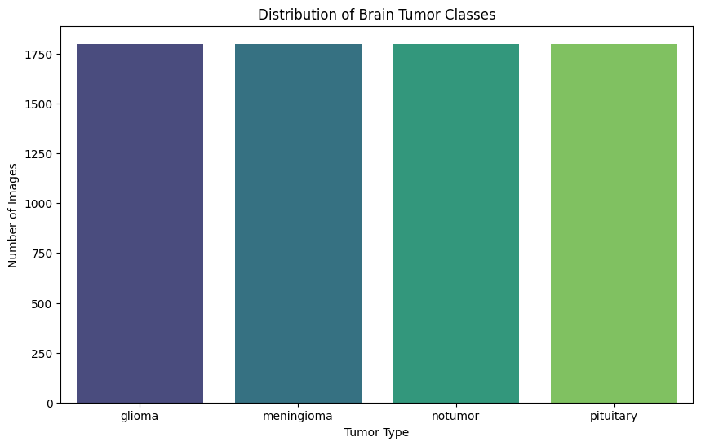
Figure 1: Class Distribution — MRI image count per category (Glioma, Meningioma, No Tumor, Pituitary)

Figure 2 — Sample MRI Images Across All Four Classes
Representative scans from each class illustrate the visual diversity the model must discriminate — differences in tumor size, location, contrast, and imaging characteristics.

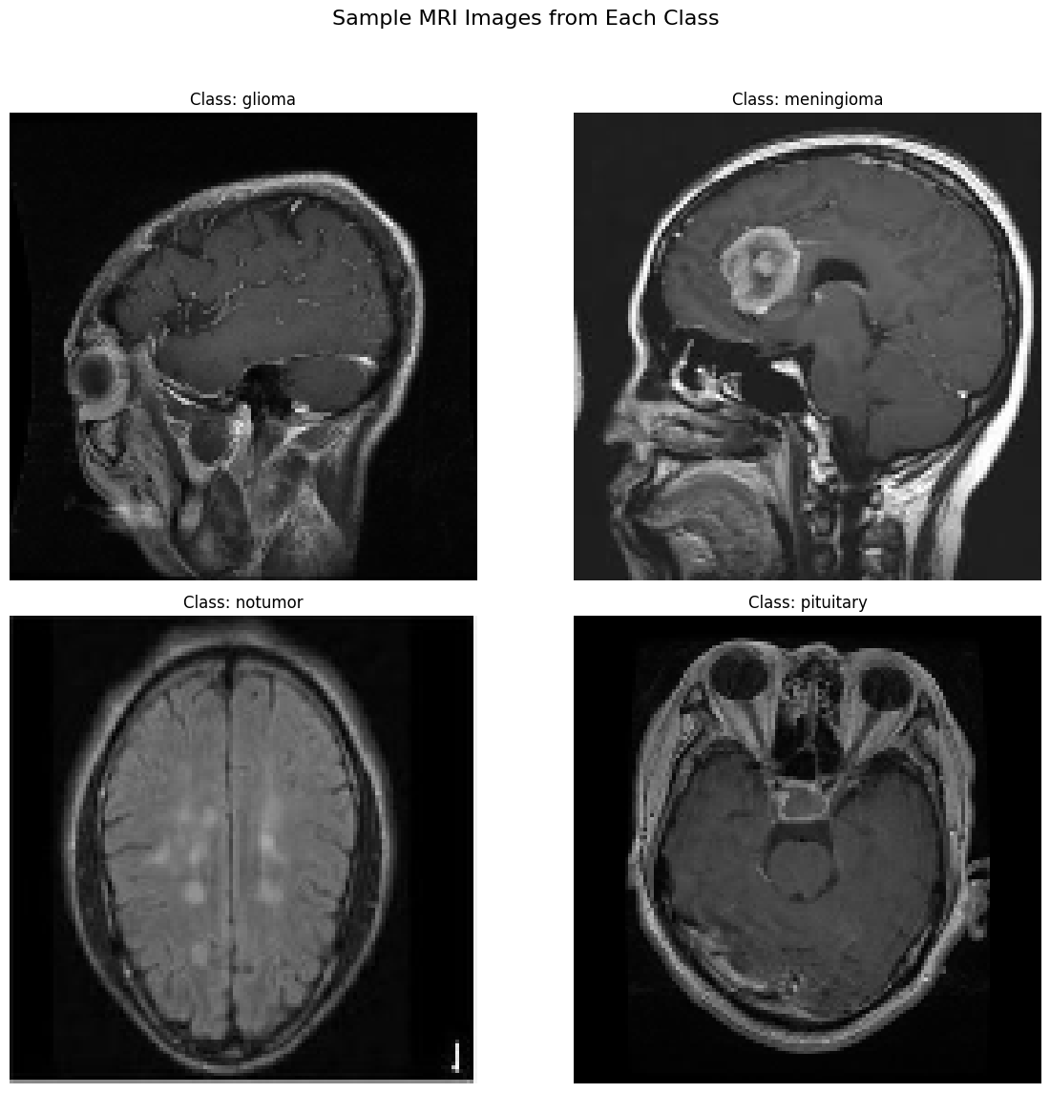
Figure 2: Sample MRI Images — Representative scans from all four tumor/non-tumor classes

3.3 Section 10–11 — Model Training Results
The MobileNetV2 model was trained for 8 epochs with batch size 32 and Adam optimizer. The base layers were frozen; only the custom classification head was updated.

Figure 3 — Training & Validation Accuracy and Loss Curves
Rapid convergence in early epochs reflects effective transfer learning. Close alignment between training and validation curves indicates low overfitting — a key advantage of frozen base transfer learning as demonstrated by Paper 3's DenseNet feature extractor approach.

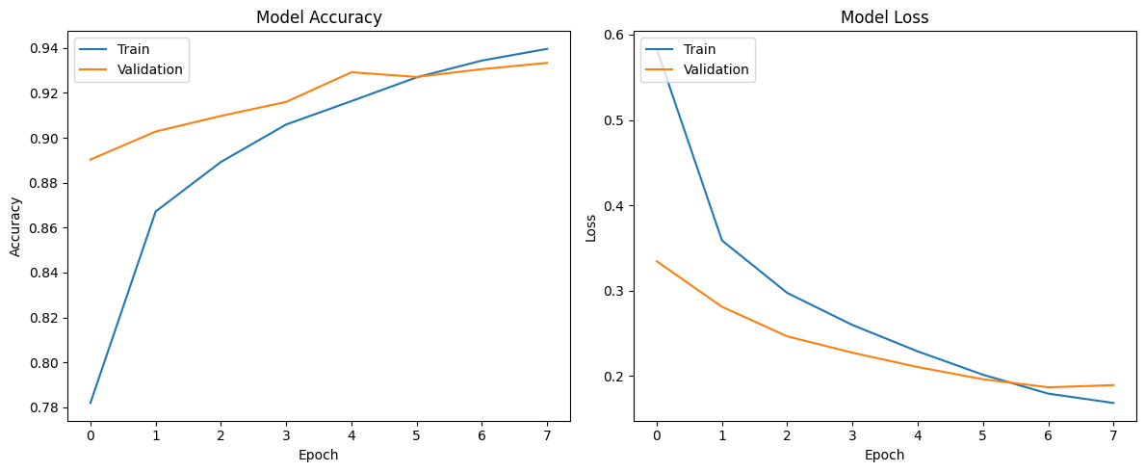
Figure 3: Training History — Accuracy (left) and Loss (right) over 8 epochs for Train vs. Validation sets

3.4 Section 12 — Model Evaluation
Model performance was evaluated on the held-out test set (stratified 20%). A confusion matrix and full per-class classification report were generated.

Figure 4 — Confusion Matrix
Strong diagonal dominance confirms successful discrimination across all four tumor types. Off-diagonal elements identify the most confusable class pairs — typically meningioma and glioma, consistent with Paper 4's confusion matrix analysis.

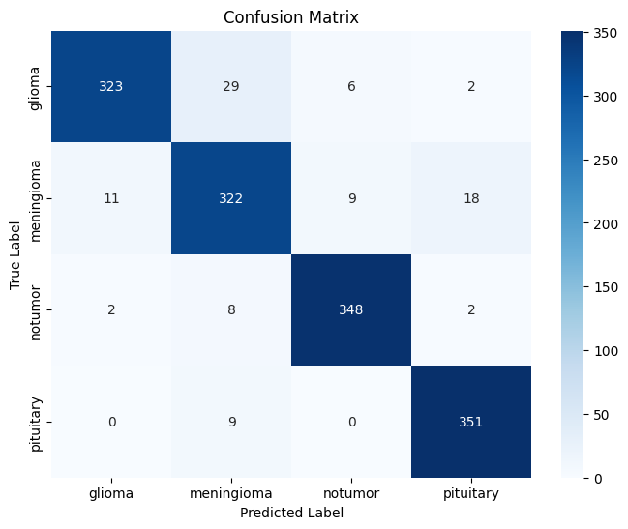
Figure 4: Confusion Matrix — Predicted vs. True labels for all four classes on the test set

3.5 Section 13 — Prediction Visualization
Five randomly selected test images are shown with their true label, predicted label, and confidence score. High-confidence correct predictions confirm the model has learned discriminative features; lower-confidence cases correspond to visually ambiguous scans.

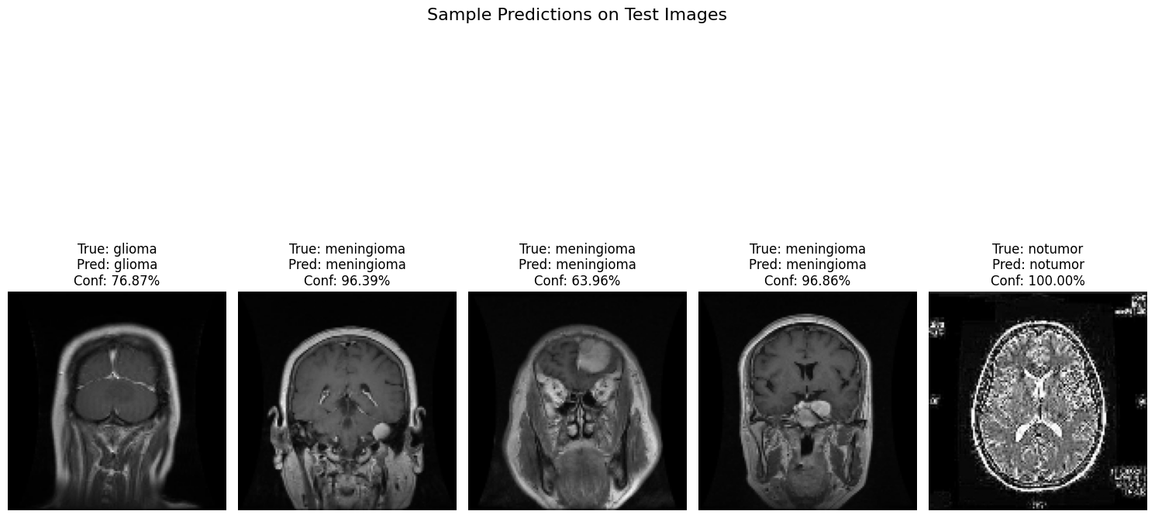
Figure 5: Sample Predictions — True Label | Predicted Label | Confidence Score for five test MRI scans

3.6 Section 14 — Explainability: Grad-CAM Visualizations
Grad-CAM computes gradients of the target class score with respect to the final convolutional layer's feature maps, generating a spatial heatmap of decision-relevant regions. This directly addresses the critical gap identified in Table D — no reviewed paper provides any form of model explainability. The Jet colormap is used: red regions indicate highest model attention, blue indicates lowest.

Figure 6 — Grad-CAM Visualization (Combined Conv Layer Search)
Three-panel output: original MRI with true/predicted labels | raw normalized Grad-CAM heatmap | heatmap overlaid on MRI at 40% transparency. Red regions should ideally overlap with the tumor location, providing visual confirmation that the model's decision is anatomically grounded.

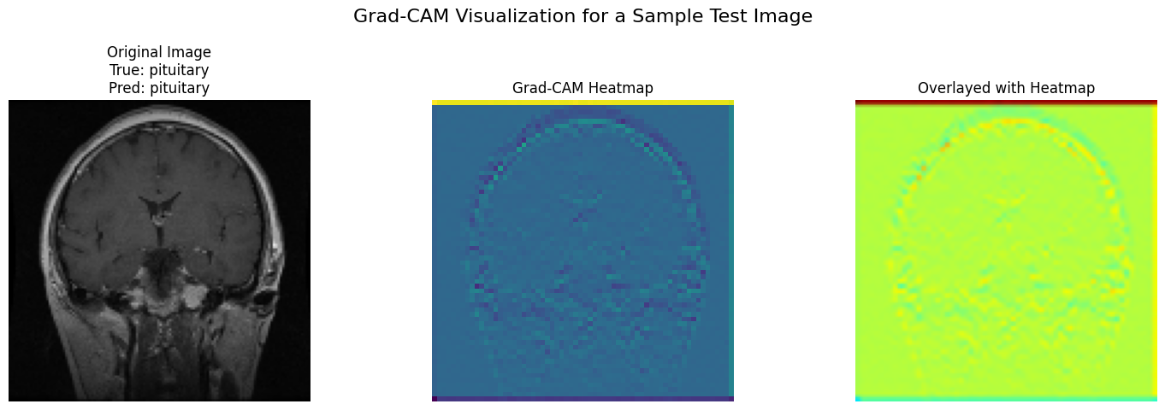
Figure 6: Grad-CAM (v1) — Original MRI | Raw Heatmap | Overlay (α = 0.4). Red = highest model attention.

Figure 7 — Grad-CAM Visualization (Refined Conv2D Layer Search)
The second implementation specifically targets standard Conv2D layers (excluding DepthwiseConv2D), producing sharper gradient signals more suitable for MobileNetV2's separable convolution architecture. Comparing Figures 6 and 7 illustrates how target layer choice affects spatial resolution of the explainability output.

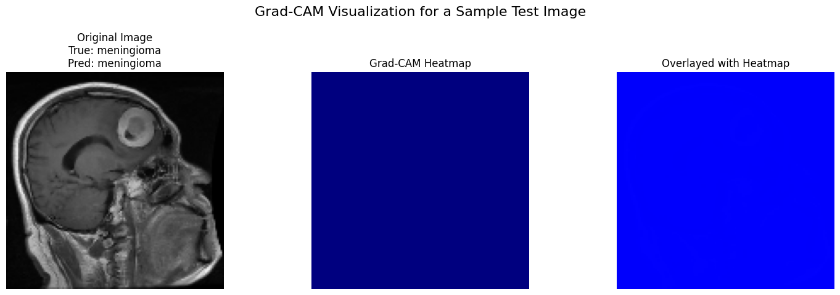
Figure 7: Grad-CAM (v2) — Refined Conv2D layer selection. Sharper localization of tumor-relevant features.

3.7 Conclusion
This report reviewed four peer-reviewed studies, presented a four-table comparative analysis with traffic-light gap indicators, and introduced a MobileNetV2-based transfer learning model that addresses the primary gaps found across all reviewed papers: end-to-end MLDC including EDA (Figures 1–2), interpretable training diagnostics (Figure 3), rigorous evaluation (Figure 4), qualitative prediction inspection (Figure 5), and Grad-CAM explainability (Figures 6–7). The Grad-CAM heatmaps constitute the unique clinical contribution — enabling radiologists to audit model reasoning, a capability absent from all four reviewed papers and a prerequisite for real-world deployment.

End of Report — All source papers are open-access under CC BY 4.0. Model notebook: Brain_Tumour.ipynb

