**Lab 2, Investigation 2 Graphs & Annotations**

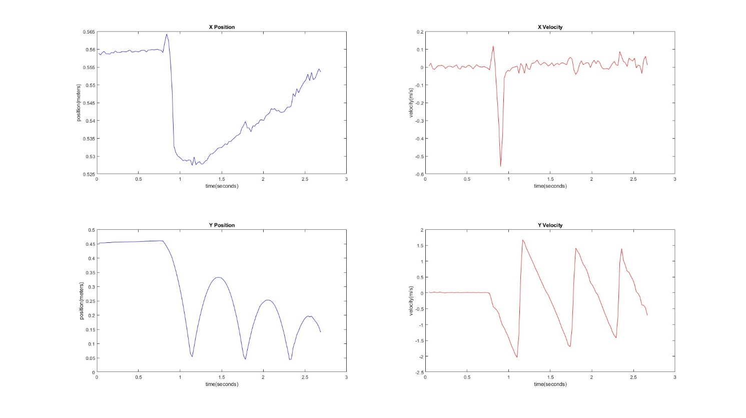

I looked at the first parabola of the *y-position vs. time* plot for the bouncing ball, shown above. Using the data explorer, I estimated that this bounce happened between t=1.145s and 1.784s.

This section was then fit to a quadratic equation, shown below:

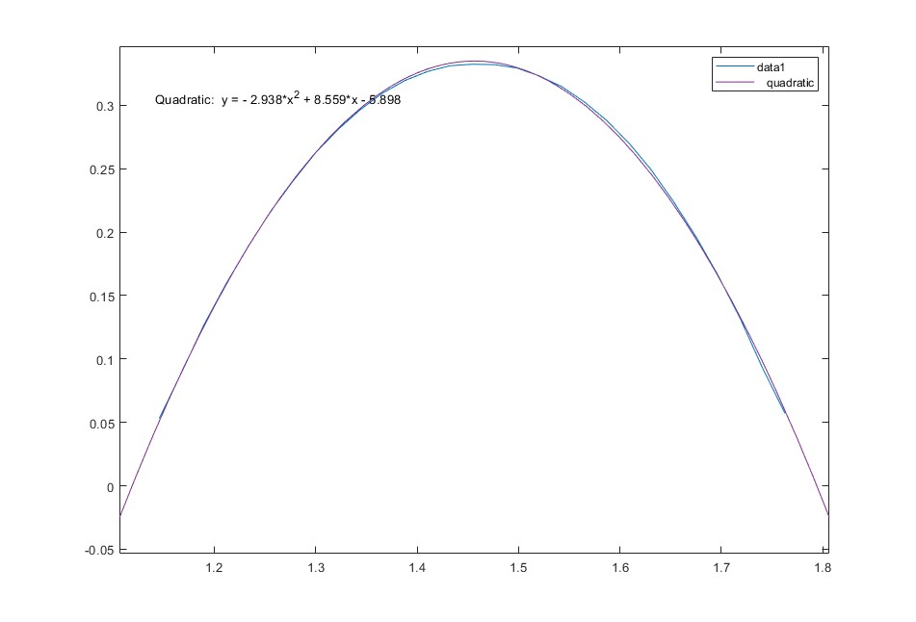

Using this equation of the quadratic approximation, I was able to calculate the acceleration due to gravity g. (Calculations shown in lab workbook).