Zero Trust Cloud Access Recommendation System for Government e- Services using Risk-Adaptive Intelligence

Cloud Architecture Design (BCSE355L)
Ashna Agarwal 24BIT0249
Krithikha B 24BIT0545

Abstract:
Government e-services increasingly face security threats as they move to cloud environments, with traditional security models proving inadequate against sophisticated attacks. Current access control systems rely on static passwords and fixed permissions that cannot adapt to changing risk conditions, user behaviour patterns, or real-time threats. This project proposes a Zero Trust Cloud Access Recommendation System that uses Risk-Adaptive Intelligence to make dynamic, context-aware access decisions for government e-services. The system evaluates user identity, device information, location, and behavioural patterns to generate intelligent access recommendations. Built on AWS cloud infrastructure, the solution utilizes AWS Lambda for real-time risk computation, Amazon API Gateway for secure service access, Amazon DynamoDB for storing user profiles and risk scores, and Amazon S3 for storing historical access logs and datasets. AWS CloudWatch monitors system performance and security events, while Amazon SNS provides notifications for suspicious access attempts. The proposed system addresses critical gaps in existing solutions, including the lack of intelligent risk-adaptive recommendation mechanisms for government e-services and the absence of comprehensive AI-driven risk scoring that updates dynamically based on user behaviour.

Literature Survey:
Papers Reviewed by Ashna Agarwal:
Paper | Method | Advantages | Limitations | Research Gaps
Cross-Cloud Identity Federation for Zero  Trust Access Control Mechanisms (January 2026)  Authors:  Elisa Bertino,  Samuel Conte | 1. Cross-cloud Identity Federation.  2. Continuous authentication based on user identity, device posture, geolocation, and behavior.  3. Least-Privilege Access Control (LPAC) | 1.Enables seamless authentication across multiple cloud providers.  2. Reduces credential misuse and unauthorized access. | 1. Focuses mainly on enterprise multi-cloud environments.  2. Trust scoring is discussed conceptually without a detailed AI model.  3. No comprehensive risk prediction mechanism | 1. Lack of an intelligent Risk-Adaptive Recommendation System for access decisions.  2. No machine learning model for predicting access risk using behavioural analytics.
Information Security Risk Assessment Methods in Cloud Computing: Comprehensive Review.  Authors:  Tarek Ali et al. | Information Security Risk Assessment frameworks  2. CIA (Confidentiality, Integrity, Availability)-based security taxonomy. | 1. Provides a comprehensive comparison of major cloud risk assessment methodologies.  2. Covers technical, organizational, and governance aspects of cloud security. | 1. Primarily focuses on risk assessment rather than real-time access decision-making.  2. Existing frameworks are largely static and periodic, making them less effective for dynamic cloud environments. | 1. Lack of continuous, AI-driven risk assessment that updates dynamically based on user context and behavior.  2. No integration between cloud risk assessment frameworks and Zero Trust access control.
Identity-Centric Security Architectures for Large-Scale Distributed  Cloud Systems (June 2025)  Authors:  Abolaji Taoheed Oyerinde, | 1. Identity and Access Management using Role-Based Access Control  2. Zero Trust Architecture with continuous verification, least-privilege access, and Multi-Factor Authentication (MFA). | 1. Eliminates implicit trust through Zero Trust principles.  2. Provides continuous authentication and authorization. | 1. High policy complexity in configuring Zero Trust environments.  2. Difficult integration with legacy government systems. | 1. Current approaches verify users but do not provide intelligent cloud access recommendations based on dynamic risk scores.  2. Limited research on government e-service environments, where users have diverse trust levels, citizen identities, and regulatory requirements.
DRADG: A Dynamic Risk-Adaptive Data Governance Framework for Modern Digital Ecosystems (January 2026)  by Jihane Gharib and Youssef Gahi | 1. Data Governance Framework  Provides structured data management practices covering data quality, metadata management, and security.  2. Integrates cybersecurity, privacy, AI governance, and risk management principles. | 1. Comprehensive data governance lifecycle management  2. Enables automated risk detection  and supports predictive analytics | 1. Mainly theoretical and governance-focused  2. Does not provide real-time risk assessment | 1. Lack of continuous risk-based governance  Existing frameworks mostly apply fixed policies rather than adapting dynamically.  2. Absence of real-time access decision mechanisms  Frameworks identify risks but do not directly recommend user access actions.
Zero-trust architecture reinforced by artificial  intelligence in cloud computing  Authors:  Saadat Ibiyeye, Temitope Dickson | AI-Reinforced Zero Trust Architecture for cloud computing, using Artificial Intelligence techniques including Supervised Learning, Unsupervised Learning, and Reinforcement Learning | 1. Provides continuous trust evaluation instead of one-time authentication.  2. Supports adaptive access control based on user behavior, device health, and context. | 1. Validation is performed mainly in simulation environments, not real government cloud deployments.  2. Relies on synthetic datasets, which may not fully represent real-world user behaviour. | 1. No dedicated risk-adaptive recommendation system for government e-services.  2. Does not consider government-specific access policies, citizen trust levels, service criticality, or legal requirements.

Zero Trust Enforcement Using Microsegmentation,  Identity-Aware Proxies, and Continuous Adaptive Risk  Assessment in Multi-Tenant Cloud Environments  Authors:  Adebayo Nurudeen Kalejaiye et al | 1. Traditional Security which uses firewalls, VPNs, and network boundaries to protect government/cloud resources. Assumes internal users are trusted.  2. Micro-segmentation-based access control divides cloud workloads into isolated security zones | 1. Strong security posture, as zero trust eliminates implicit trust and verifies every access request continuously.  2. Context-aware access decisions, which considers identity, device health, location, and access context instead of only credentials. | 1. Lack of intelligent access recommendation, as the approach mainly focuses on enforcing policies after risk evaluation.  2. Managing large numbers of dynamic Zero Trust policies across multiple departments and cloud platforms is complex | 1. AI-Based access recommendation gap, as existing zero trust models evaluate risk but lack an intelligent recommendation layer that suggests the safest access level for users.  2. Adaptive authorization gap, as current systems mostly perform binary decisions (allow/deny).

Integrated Cyber Defense Strategies for the Modern Digital Ecosystem: Evaluating Zero Trust Models, AI-Driven Threat Intelligence, and Secure Cloud Architecture for Resilient Infrastructure Protection  Authors: Misbah Maqbool | 1. Zero Trust Architecture with continuous authentication and least-privilege access.  2. AI-driven Threat Intelligence using Machine Learning for anomaly detection, malware detection, and automated incident response. | 1. Eliminates implicit trust through continuous verification.  2. AI improves real-time threat detection and automated response. | 1. ZTA implementation is complex in large organizations due to policy management and integration challenges.  2. Focuses mainly on threat detection rather than intelligent access recommendation. | 1. No intelligent risk-adaptive access recommendation system for cloud users.  2. Government e-Service environments are not specifically addressed.
Engineering Secure and Resilient Cloud-Native Architectures for Critical  Digital Infrastructure  Author:  Abolaji Taoheed Oyerinde | 1. Cloud-native architecture using microservices and Kubernetes.  2. Zero Trust Architecture with continuous authentication, least privilege, and identity-centric security. | 1. Reduces unauthorized access and lateral movement through Zero Trust.  2. Improves resilience using self-healing and automated recovery mechanisms. | 1. Mainly a conceptual/theoretical framework with no real-world implementation or prototype.  2. Focuses on cloud-native infrastructure rather than user-specific cloud access recommendations.  2. Risk adaptation is discussed conceptually but no AI-based risk scoring or decision engine is implemented. | 1. No intelligent cloud access recommendation system for authentication.  2. Absence of risk-adaptive intelligence

Papers reviewed by Krithikha:
Paper | Method | Advantages | Limitations | Research Gaps
HD-RAITE: A Hybrid Deep Reinforcement Learning Framework for Risk-Adaptive Identity Trust Management in Zero Trust Environments (2026) | 1. Deep Reinforcement Learning for trust management.  2. Continuous behavioral risk analysis. | 1. Improves dynamic trust evaluation.  2. Detects risky user behavior. | 1. Requires large datasets.  2. High computational cost. | 1. No government e-service implementation.  2. No intelligent access recommendation.
Zero-Trust Based Dynamic Access Control for Cloud Computing (2025) | 1. Trust-Based Access Control (TBAC).  2. Dynamic trust threshold updates. | 1. Continuous authentication.  2. Flexible access decisions. | 1. Complex implementation.  2. Limited real-world validation. | 1. No AI-based recommendation system.  2. No government cloud evaluation.
Zero Trust Anonymous Access Algorithm for Multi-Cloud Storage System Based on CP-ABE (2025) | 1. CP-ABE encryption.  2. Anonymous Zero Trust access. | 1. Fine-grained access control.  2. Strong data privacy. | 1. Focuses only on storage.  2. No behavioral analysis. | 1. No AI risk prediction.  2. No adaptive access recommendation.
Adaptive Zero Trust Policy Management Framework in 5G Networks (2025) | 1. AI-assisted policy management.  2. Dynamic trust evaluation. | 1. Automatic policy updates.  2. Scalable security management | 1. Designed for 5G networks.  2. Limited cloud evaluation. | 1. No cloud access recommendation.  2. No government service focus.
Adaptive Risk Based Access Control in Cloud Native Banking Platforms (2024) | 1. Risk-Adaptive Access Control (RAdAC).  2. Continuous identity verification. | 1. Reduces unauthorized access.  2. Improves compliance. | 1. Banking-specific solution.  2. Limited cloud diversity. | 1. No government e-service support.  2. No AI recommendation engine.
Real-Time Risk-Adaptive Access Control With DRCFM (2025) | 1. BERT-LSTM-GRU model.  2. Reinforcement Learning-based risk prediction. | 1. High prediction accuracy.  2. Real-time authorization. | 1. Computationally expensive.  2. Needs large training datasets | 1. No government cloud validation.  2. No cloud access recommendation.
Zero Trust Architecture: A Systematic Literature Review (2025) | 1. PRISMA-based literature review.  2. Zero Trust technology taxonomy. | 1. Comprehensive Zero Trust overview.  2. Identifies research trends. | 1. No practical implementation.  2. No experimental evaluation. | 1. No integrated AI framework.  2. Limited focus on government e-services.

Project Objectives:
- Develop a risk-adaptive access recommendation system that evaluates user access requests based on identity, behavior, and contextual factors, achieving at least 80% accuracy in predicting high-risk access attempts.

- Implement continuous authentication and Zero Trust verification using AWS Cognito, reducing unauthorized access attempts by 40% compared to traditional static authentication methods.

- Create a risk scoring engine using AWS Lambda that processes user behavioral data and contextual information within 2 seconds to generate access recommendations for government e-services.

- Build a monitoring and alerting dashboard using AWS CloudWatch that visualizes access patterns, risk scores, and security incidents in real-time, enabling security administrators to respond to threats within 5 minutes of detection.

- Design a cloud architecture using AWS services that supports up to 1,000 concurrent government e-service users while maintaining 99.5% availability.

- Establish secure data storage and audit trail mechanisms using Amazon S3 and DynamoDB that logs 100% of access requests for compliance reporting.

Novelty Summary:
The proposed system introduces several novel contributions that distinguish it from existing approaches:

- New Feature Integration: Risk-Adaptive Access Recommendations: Unlike existing systems that perform binary allow/deny decisions, our system provides graded recommendations (Allow, Challenge for MFA, Deny) based on continuous risk assessment.

- Government-Specific Contextual Factors: Incorporates citizen trust levels, service criticality, and department-specific access policies unique to government e-service environments.

- Simpler Algorithm: Rule-Based + ML Hybrid Approach: Combines rule-based reasoning (for government policy enforcement) with a simple machine learning model (Random Forest) for risk prediction, achieving good accuracy without excessive complexity.

- Behavioral Analytics: Analyzes simple user patterns including login frequency, access times, and location changes to detect anomalies.

- Practical Architecture: Serverless Design: Leverages AWS serverless services (Lambda, DynamoDB, API Gateway) to achieve automatic scaling and reduced operational overhead.

- Modular Components: Decomposes the system into independent components for identity management, risk scoring, and monitoring, enabling easier development and maintenance.

- Security Features: Zero Trust Principles: Implements continuous verification with every access request, and also implements encryption at rest (S3 SSE, DynamoDB encryption) and in transit for data protection.

- Automation: Automated Threat Response: Integrates with AWS Lambda for automated responses including MFA challenges and security alerts.

- Accuracy: Continuous Improvement and simple model retraining mechanism based on new access patterns. Combines rule-based checks with Random Forest predictions for balanced accuracy.

Proposed Architecture:
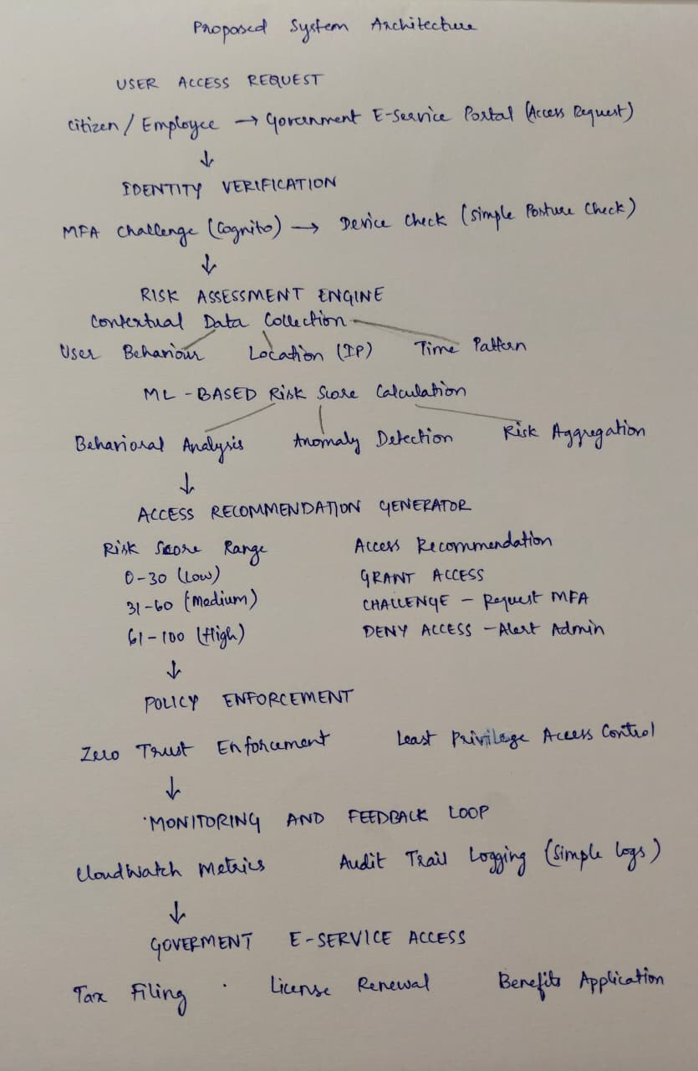

AWS Architecture:
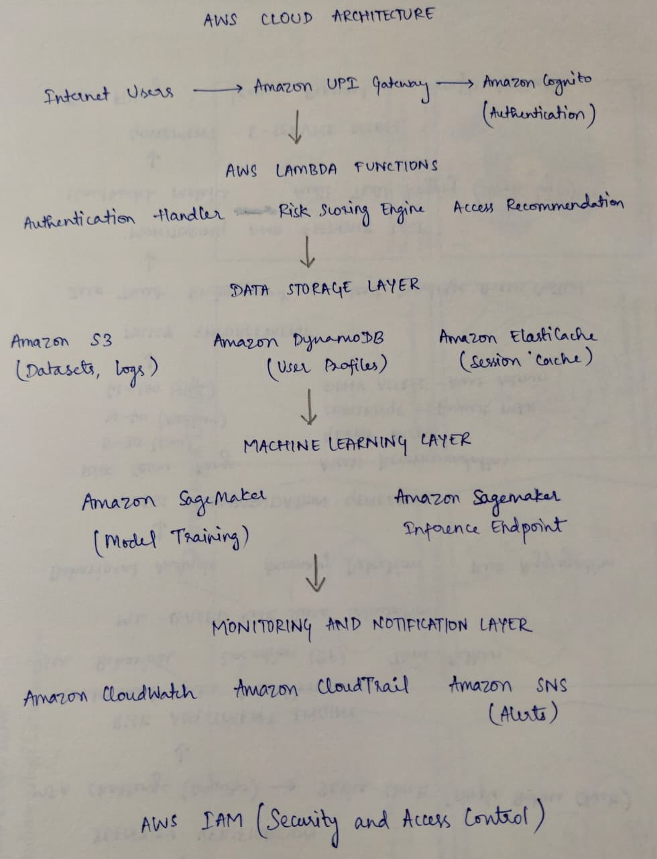
Data Flow:
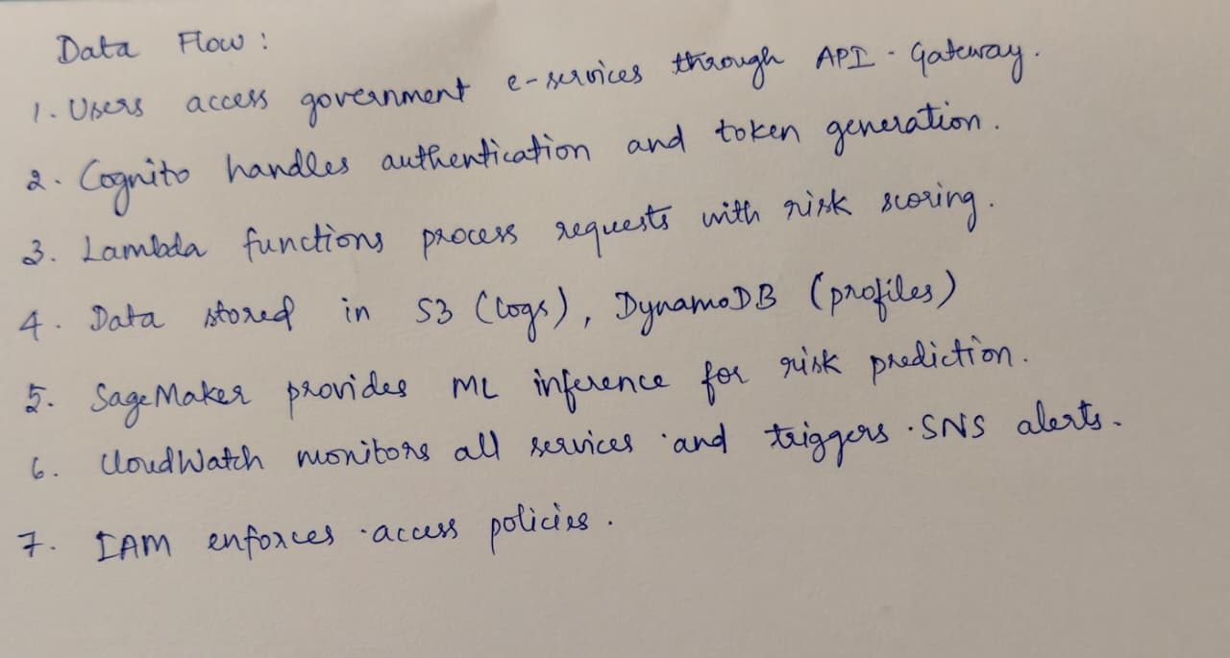

Dataset Details:
This project utilizes the Cloud Access Security Dataset (CSAD)
- Source: Synthesized dataset based on public cloud security datasets and government access patterns
- Size: 50,000 - 100,000 records
- Number of Records: 50,000+ access events
- Number of Features: 15 features (5 categorical, 7 numerical, 3 binary)
- Data Type: Tabular data with mixed types (CSV format)
- License: Academic license for research purposes
- Purpose: Training and evaluation of risk-adaptive access recommendation models for government e-services
- Preprocessing Required:
1. Data cleaning (handling missing values)
2. Feature encoding (one-hot encoding for categorical variables)
3. Feature scaling (StandardScaler for numerical features)
4. Class balancing
5. Feature engineering (risk indicators, behavioral patterns)

AWS Services Planning:
AWS Service | Purpose
Amazon API Gateway | Expose RESTful APIs for government e-service access requests with rate limiting
Amazon Cognito | Provide identity management and multi-factor authentication for government employees and citizens
AWS Lambda | Execute risk scoring logic, process access requests, and trigger notifications
Amazon SageMaker | Train and deploy machine learning models for behavioural analysis and risk prediction
Amazon DynamoDB | Store user profiles, access patterns, and risk scores with low-latency access
Amazon CloudWatch | Monitor system performance, collect metrics, and set up alarms
AWS CloudTrail | Log all API calls and user activities for governance and compliance
AWS Key Management Service (KMS) | Manage encryption keys for data at rest and in transit
AWS IAM | Manage fine-grained access control policies following least-privilege principles

