Computer Architecture Lab
(EL-2012)
LABORATORY REPORT

Fall 2026

(Lab#03)

Apply Behavioral-level Verilog to Design and Simulate Combinational Modules

Student Name: Muhammad Ashnab Safdar Roll No: 24I-6500 Section: CE-A

Date performed: 1/9/2026

MARKS AWARDED: ________ / 10

Signature and date of Instructor: _________________
Lab Instructors: Dr. Nasir Ali Shah, Engr. Fasih Ahmad

______________________________________________________________________________________________________________________________________________________

NATIONAL UNIVERSITY OF COMPUTER AND EMERGING SCIENCES, ISLAMABAD
Prepared by: | Fasih Ahmad |  | Version: 1.0
Verified by: | Dr. Nasir Ali Shah |  | Updated: Fall 2026
Task 1:

Description:
Write a Verilog module that accepts two 4-bit numbers and a control signal and adds or subtracts the numbers, depending on the value of the control signal. Make a testbench to simulate and check addition and subtraction.
Code:
module adder_sub(A,B, ctrl, Cout);

input [0:3]A;
input [0:3]B;
input ctrl;
output reg [0:4] Cout;

always @ (*)
begin
case(ctrl)
1'b1:Cout=A+B;
1'b0:Cout=A-B;
endcase
end
endmodule

module testbench_adder_sub();
reg [0:3] a;
reg [0:3] b;
reg ctrl;
wire[0:4] result;

adder_sub uut( a,b,ctrl,result);
initial
begin
a = 0; b = 0; ctrl = 0; #10;

a = 4'd5; b = 4'd3; ctrl = 1'b0; #10;

a = 4'd12; b = 4'd6; ctrl = 1'b0; #10;

a = 4'd9; b = 4'd4; ctrl = 1'b1; #10;

a = 4'd4; b = 4'd6; ctrl = 1'b1; #10;

end
endmodule
Output:
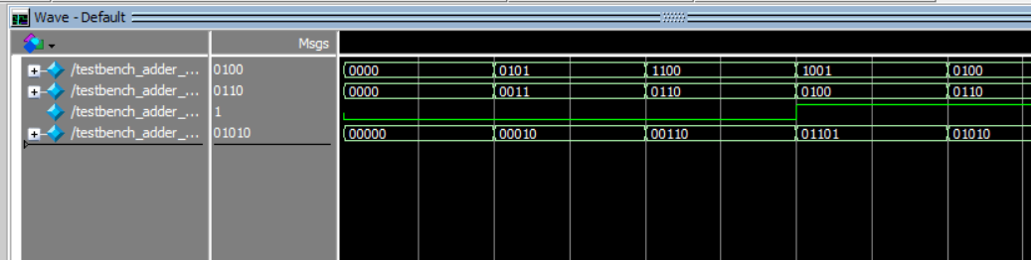

Task 2:

Description:
Write a testbench to simulate and test both select cases for a given Verilog module with two 1-bit data inputs (A, B), a 1-bit Select line and a 1-bit output Y such that the module outputs A & B when Select=0 and A | B when Select=1
Code:
module mux2x1(A,B, ctrl, Cout);

input A;
input B;
input ctrl;
output reg Cout;

always @ (*)
begin
case(ctrl)
1'b1:Cout=A|B;
1'b0:Cout=A&B;
endcase
end
endmodule

module testbench_mux2x1();

reg a;
reg b;
reg ctrl;
wire result;

mux2x1 uut (.A(a),.B(b),.ctrl(ctrl),.Cout(result));

initial begin

ctrl = 1'b0; a = 1'b0; b = 1'b0; #10;
ctrl = 1'b0; a = 1'b0; b = 1'b1; #10;
ctrl = 1'b0; a = 1'b1; b = 1'b0; #10;
ctrl = 1'b0; a = 1'b1; b = 1'b1; #10;
end

endmodule
Output:
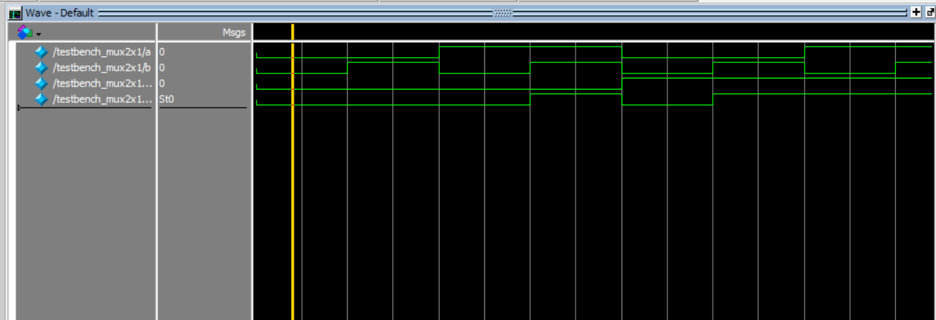

Task 3:

Description:
Write a Verilog module that compares two 2-bit binary numbers and returns three signals: equal, greater-than, less-than that indicate the results of the comparison. Write a testbench to simulate and verify all combinations.
Code:
module comparator_2bit(
input [1:0] A,
input [1:0] B,
output reg eq, // 1 if A == B
output reg gt, // 1 if A > B
output reg lt // 1 if A < B
);
always @(*) begin
if (A == B) begin
eq = 1;
gt = 0;
lt = 0;
end
else if (A > B) begin
eq = 0;
gt = 1;
lt = 0;
end
else begin
eq = 0;
gt = 0;
lt = 1;
end
end

endmodule

module comparator_2bit_testbench;

reg [1:0] A, B;
wire eq, gt, lt;

integer i, j;

comparator_2bit uut (.A(A),.B(B),.eq(eq),.gt(gt),.lt(lt));

initial
begin

for (i = 0; i < 4; i = i + 1) begin
for (j = 0; j < 4; j = j + 1) begin
A = i[1:0];
B = j[1:0];
#10;
end
end
end
Output:
