IBM HR Attrition & Performance Analysis
Data Analysis Report — How Employees Left the Organization

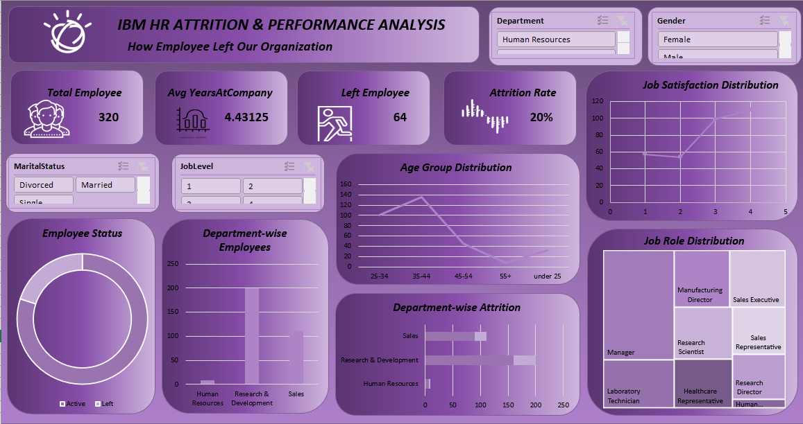
Figure 1: HR Attrition & Performance Dashboard

1. Introduction
This report is based on IBM's HR Attrition & Performance dashboard. The purpose of this analysis is to review employee attrition trends, its likely causes, and the departments most affected, so that management can make better decisions to retain talent. The dashboard also allows filtering data by department, gender, marital status, and job level.

2. Key Metrics
320  Total Employees | 4.43  Avg Years at Company | 64  Employees Left | 20%  Attrition Rate

The organization currently has 320 employees, of whom 64 (20%) have left the company. This attrition rate is considered quite high — a healthy organization typically maintains an attrition rate between 10% and 15%. The average tenure of employees is 4.43 years, indicating that most of the workforce is relatively early to mid-career in terms of experience.

3. Department-wise Analysis
According to the 'Department-wise Employees' and 'Department-wise Attrition' charts:
• Research & Development (R&D) is the largest department and also shows the highest attrition rate among all departments.
• Sales is the second-largest department, with a notable employee count and a significant attrition rate as well.
• Human Resources (HR) is the smallest department and has a comparatively low attrition rate.
This trend indicates that R&D and Sales require immediate attention for employee retention, as these two departments contribute the most to overall attrition.

4. Age Groups & Job Satisfaction
The Age Group Distribution chart shows that the majority of employees fall between 25 and 44 years of age, peaking in the 35–44 age bracket, followed by a gradual decline. This suggests the workforce is largely composed of young and moderately experienced professionals.
The Job Satisfaction Distribution chart shows that the number of employees increases as satisfaction level rises, meaning most employees report high job satisfaction. However, the presence of employees at lower satisfaction levels cannot be ignored, as this group is at greater risk of leaving the organization.

5. Job Role Distribution
According to the Job Role Distribution tree map, the largest roles are as follows:
Job Role | Status
Manager | Largest group
Research Scientist | Large group
Sales Executive / Sales Representative | Large group
Manufacturing Director | Medium group
Laboratory Technician, Healthcare Representative, Research Director | Smaller groups

This distribution shows that managerial and research roles (Manager, Research Scientist) make up a large share of the workforce, while sales-related roles are also present in significant numbers.

6. Conclusions & Recommendations
• A 20% attrition rate is concerning; conducting exit interviews or surveys is recommended to identify the underlying reasons.
• Retention programs should be prioritized for the R&D and Sales departments.
• Employees with low job satisfaction should be identified and offered targeted interventions such as career growth opportunities, training, and better benefits.
• Since the average tenure is only 4.43 years, onboarding and career development processes should be strengthened to improve long-term retention.
• Further deep-dive analysis should be conducted using the gender, marital status, and job-level filters to uncover specific attrition patterns.

This report has been prepared based on the provided dashboard.

