**Milestone 2**

**20/20 Entertainment**

Ashna Guliani, Ross Blassingame, Cory Cranford, Souneth Ly,

Andres Salinas, Keegan Sotebeer

**Link to GitHub Repository:** <https://github.com/ashnaguliani/JusticeForHarambe>

**Link to Trello Board:** <https://trello.com/b/1ibvbOC7/legend-of-harambe>

**REQUIREMENTS**

**User Requirements**

1. The user shall be able to play the game with default settings.
2. The user shall have the option to customize settings.
3. The user shall have the option to enter a username to log their score after playing.

**Functional Requirements**

1.1. The game shall have a stored set of default gameplay settings.

     2.1. The game shall have the ability to save/initialize custom game settings.

     3.1. The game shall have a leaderboard that displays user’s personal high scores.

**Non-Functional Requirements**

     1.1.1. The stored set of default gameplay settings shall be loaded and implemented upon

   selection of a “Quick Play” button.

     1.1.2. Default settings shall be saved in the settings database.

     2.1.1. Custom settings mode shall be reachable upon selection of a button on the home

   screen.

     2.1.2. Custom settings shall be saved in the settings database.

     3.1.1. At the end of gameplay, a user-input box shall prompt the user to enter a name.

     3.1.2. Usernames and their scores shall be saved in the leaderboard database.

**PROJECT PLAN**

**Snapshot of Trello Board**

Shown in the figure below is a snapshot of the team Trello board as it currently looks. The team’s first 2-3 week sprint will begin next week. Due to the fact that development has not begun yet, all of the task cards related to developing the iPhone game still reside in the To-Do list. Note that more tasks can be found by scrolling down in the To-Do list, and thus are not all shown in this snapshot.

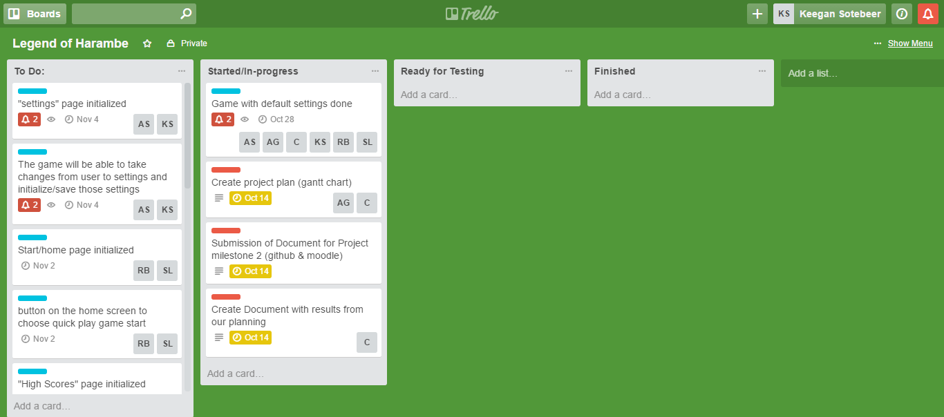

**Snapshot of Schedule**

Shown below is a summary of all of the tasks associated with completion of the first three week sprint, along with the team members assigned to each task and their due dates. The plan for the upcoming three week sprint is to develop the framework of the game at a high level. This involves beginning to implement all of the functions desired from the game, such as creating the main game play mode in Unity, implementing some default game settings, buttons to navigate between different activities within the app, and databases that can be used to store scores and custom user settings. The first two weeks will be spent implementing and developing these features and the final week of the sprint will be spent analyzing the first product iteration from a market perspective and planning ways to improve and increase functionality for the next sprint.

