SBA2

1. Write a program to reverse the String (use char[] or String built in method)

Program :

import java.lang.\*;

import java.io.\*;

import java.util.\*;

//class of ReverseString

public class Main

{

public static void main(String[] args) {

String input="Hello I am Ashna";

char[] inp=input.toCharArray();

for (int i=inp.length-1; i>=0; i--)

System.out.print(inp[i]);

}

}

Output:

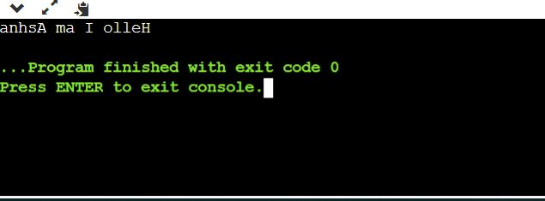

1. Write programs to depict the usage of contains(), length(), replace(), concat(), equals()
   1. length():

Program:

public class Main

{

public static void main(String[] args) {

String s1="AshnaKhader";

String s2="Hello";

System.out.println("string length is:" +s1.length());

System.out.println("string length is:" +s2.length());

}

}

Output:

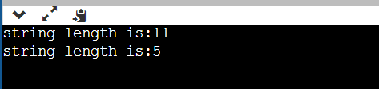

* 1. replace

Program:

public class Main

{

public static void main(String[] args) {

String s1="ashnaKhader";

String replaceString=s1.replace('a','e');

System.out.println(replaceString);

}

}

Output:

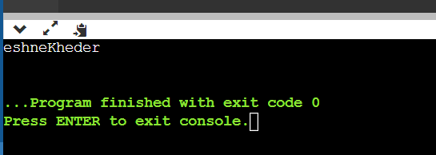

1. equals()

Program:

public class Main

{

public static void main(String[] args) {

String s1="ashnaKhader";

String s2="ashnaKhader";

String s3="ASHNAKHADERTP";

String s4="hello";

System.out.println(s1.equals(s2));

System.out.println(s1.equals(s3));

System.out.println(s1.equals(s4));

}

}

Output:

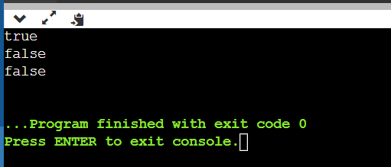

1. Contains()

Program

public class Main

{

public static void main(String[] args) {

String s1="Hello I am Ashna";

//true

System.out.println(s1.contains("Ashna"));

//false

System.out.println(s1.contains("hi"));

}

}

Output

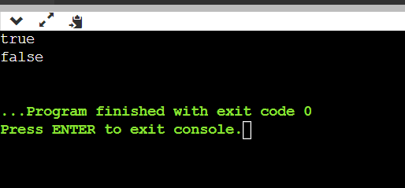

1. Concat()

Program

public class Main

{

public static void main(String[] args) {

String s1="Hello ";

s1.concat(" i am");

System.out.println(s1);

s1=s1.concat("i am Ashna");

System.out.println(s1);

System.out.println(s1.contains(s1));

}

}

Output:

