IOT PROJECT

SMART FARMING

OBJECTIVES:

After performing the project, the user should be able to:

1. Construct and test a smart farming application using microcontroller, microcomputer, humidity, temperature and soil moisture sensor.
2. Read the values of the sensor using the microcontroller and microcomputer and store its value on cloud database and also show its reading on a dashboard over the cloud.

THEORY

In IoT-based smart farming, a system is built for monitoring the crop field with the help of sensors (light, humidity, temperature, soil moisture, etc.) and automating the irrigation system. The farmers can monitor the field conditions from anywhere. IoT-based smart farming is highly efficient when compared with the conventional approach.

The applications of IoT-based smart farming not only target conventional, large farming operations, but could also be new levers to uplift other growing or common trends in agricultural like organic farming, family farming (complex or small spaces, particular cattle and/or cultures, preservation of particular or high-quality varieties, etc.), and enhance highly transparent farming.

MATERIALS NEEDED

1 Raspberry Pi Microcomputer

1 Arduino Microcontroller

1 DHT11 Sensor for temperature and Humidity

1 Soil Moisture Sensor

EQUIPEMENTS NEEDED

DC Power Supply

Multimeter

Bread Board

PROCEDURES

1. Construct the architecture diagram as shown in figure 1.

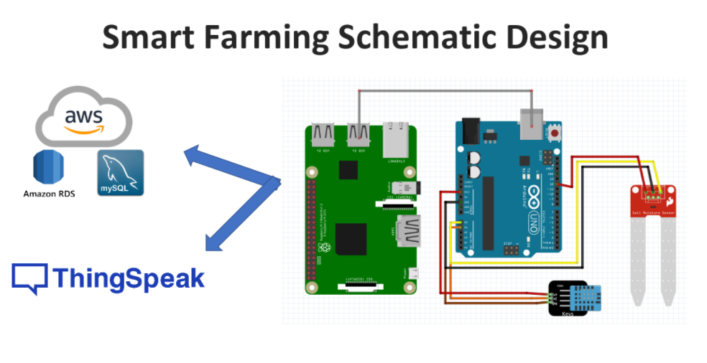

Figure 1

1. Set-up the Database over the Cloud to store the values coming from the sensor. In this project the user will be using the MySQL on the RDS of AWS as shown in figure 2.

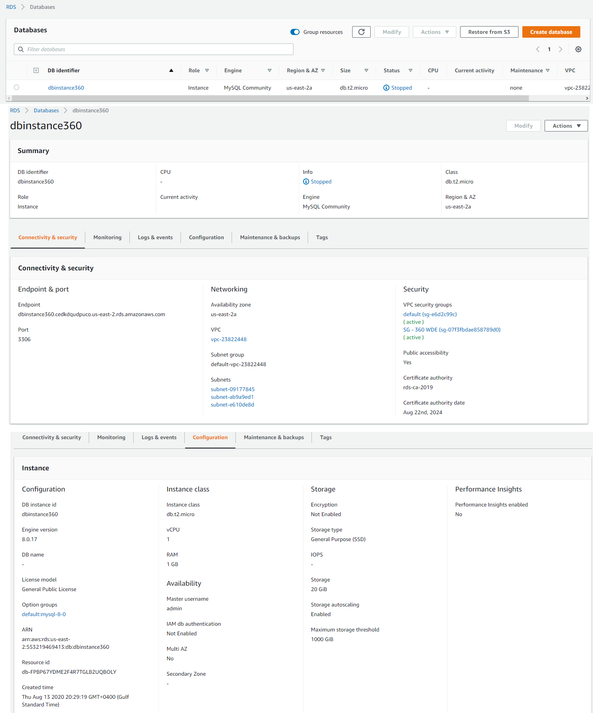

Figure 2

1. Set-up the Dashboard over the Cloud to view the sensor reading on an organize manner. In this project the user will be Thingspeak as a Dashboard platform to show sensor reading on an organize manner as shown in figure 3.

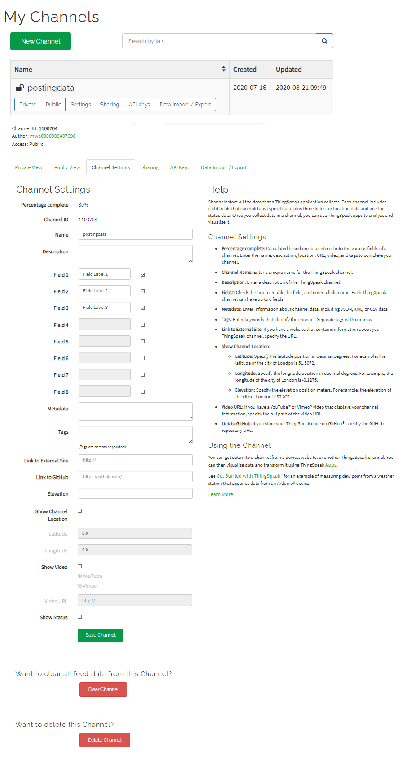

Figure 3

1. Make a program that will take the data from the temperature sensor, humidity sensor, soil moisture sensor to the Arduino microcontroller. The program should be able to convert analog signal from the temperature sensor, humidity sensor, soil moisture sensor to digital reading that is understandable by the users with interval of 30 seconds as shown in figure 4.

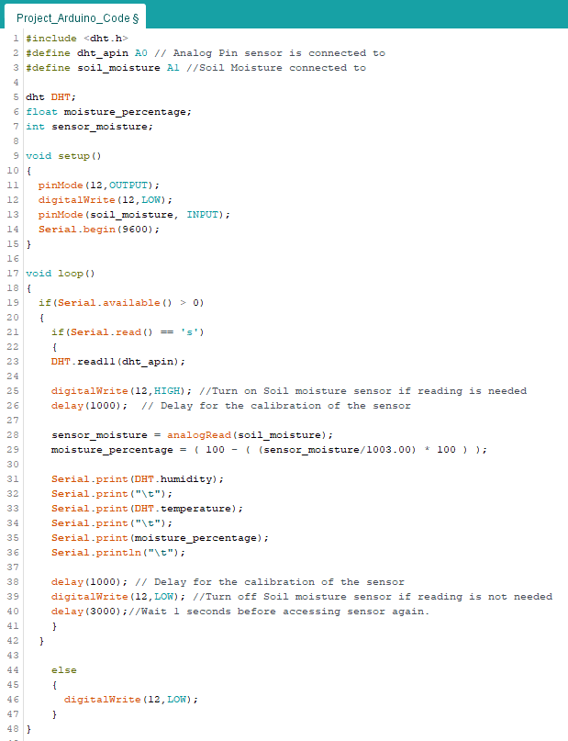

Figure 4

1. 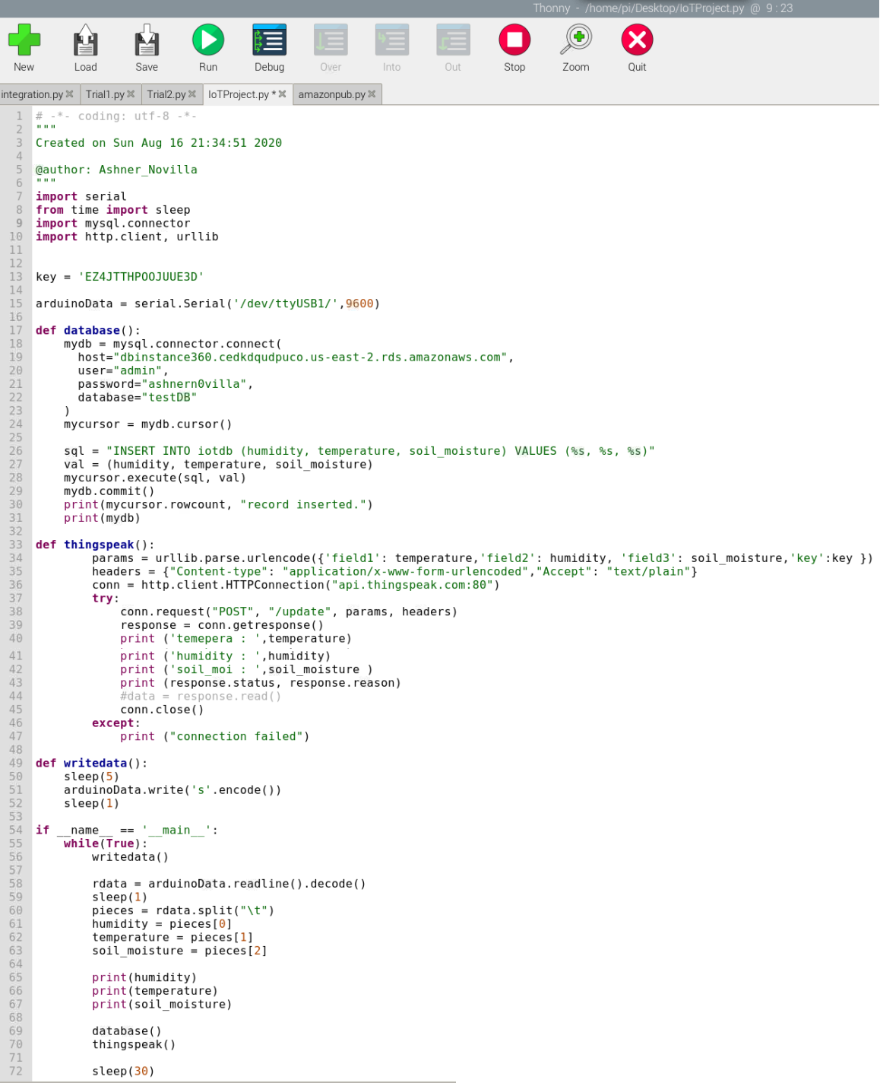Make a program that will collect the data gather by the Arduino microcontroller from the sensors and send and visualize over the cloud using Raspberry Pi microcomputer. The program should be able to transfer data to MySQL on AWS RDS and send data to Thingspeak for visualization and analysis as shown in figure 5.

Figure 5

1. Monitor the MySQL Database on RDS of AWS logging. Check if the data being log on the database match the data being showed by Raspberry Pi microcomputer and data being visualize in Thingspeak (reading should match) as shown in figure 6.1 and 6.2.

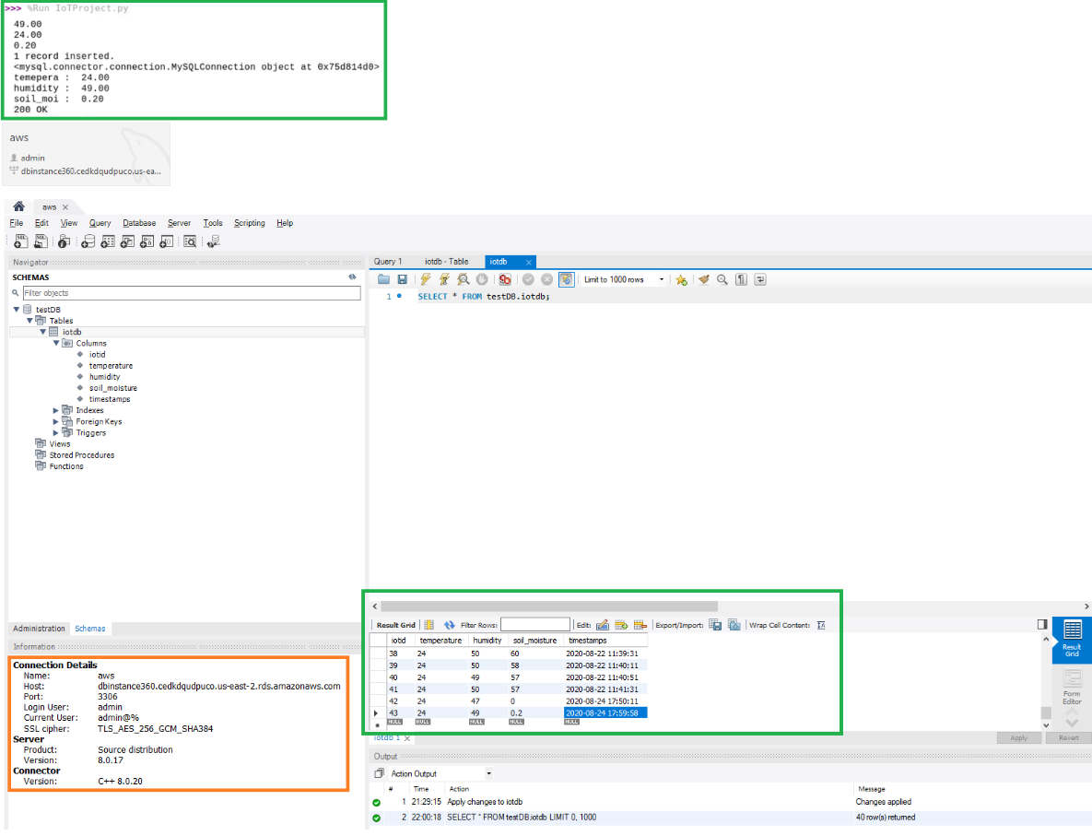

Figure 6.1

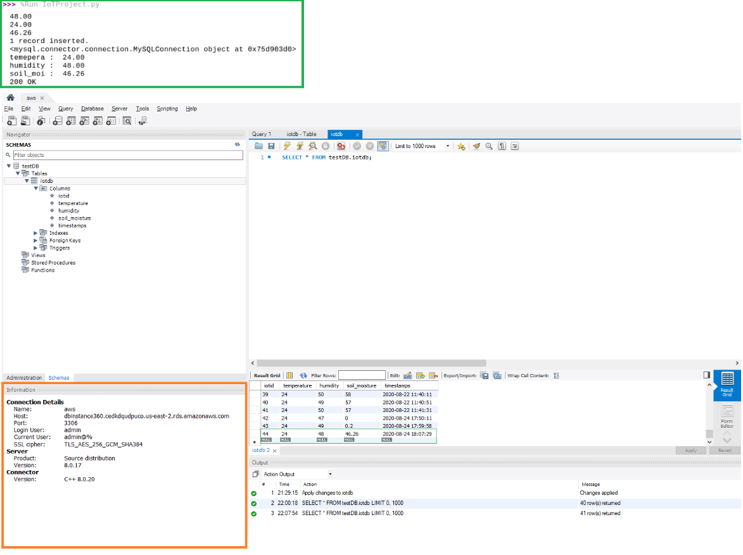

Figure 6.2

1. Monitor the data being visualize in Thingspeak. Check if the data being log in Thingspeak match the data being showed by Raspberry Pi microcomputer & data being stored in MySQL Database on RDS of AWS (reading should match) as Figure 7.

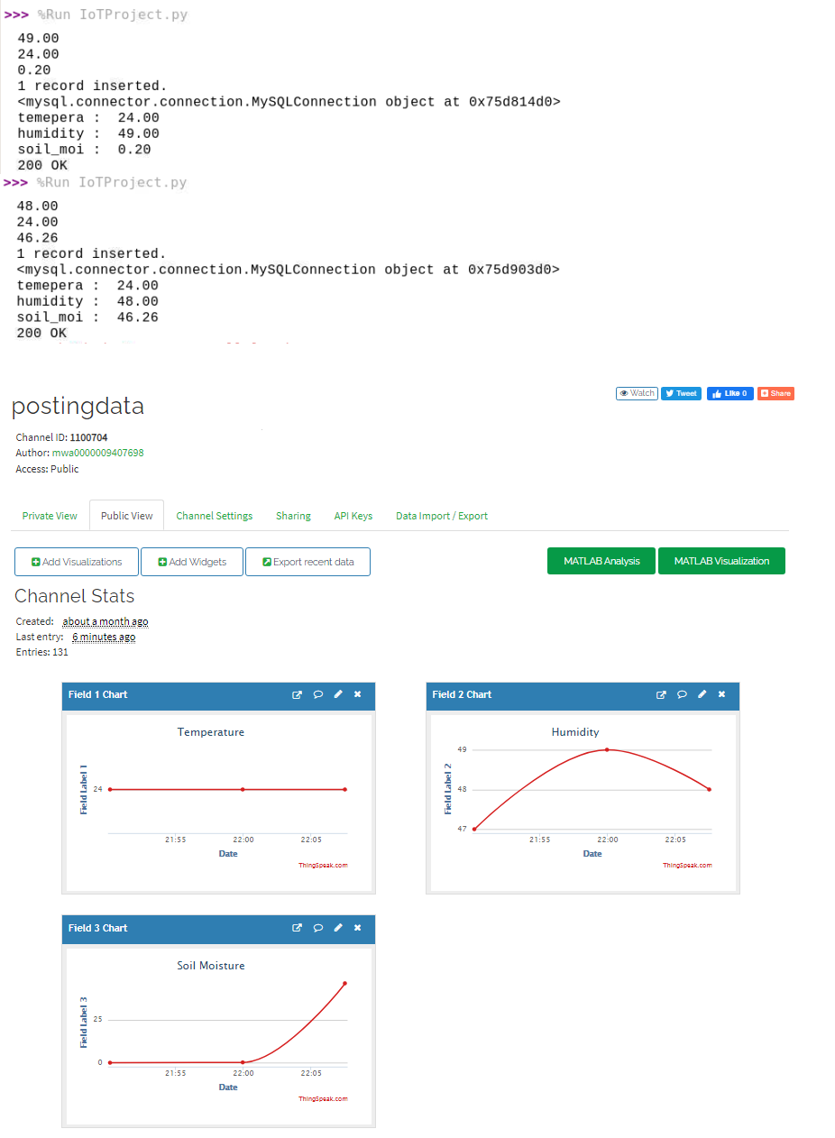

Figure 7