CHAPTER 1
CREATE REACT APP

1.1 INTRODUCTION:

REACT A JavaScript library for building user interfaces. Learn Once, Write Anywhere We don’t make assumptions about the rest of your technology stack, so you can develop new features in React without rewriting existing code.
React makes it painless to create interactive Uis. Design simple views for each state in your application, and React will efficientlyupdate and render just the right components when your data changes.
Component-Based build encapsulated components that manage their own state, then compose them to make complex Uis.Since component logic is written in JavaScript instead of templates, you can easily pass rich data through your app and keep state out of the DOM.

1.2 INSTALLATION:

Create a New React App when starting a react project, a simple HTML page withscript tags might still be the best option. It only takes a minute to set up!
npx create-react-app my-app
cd my-app
npm start

Following steps:

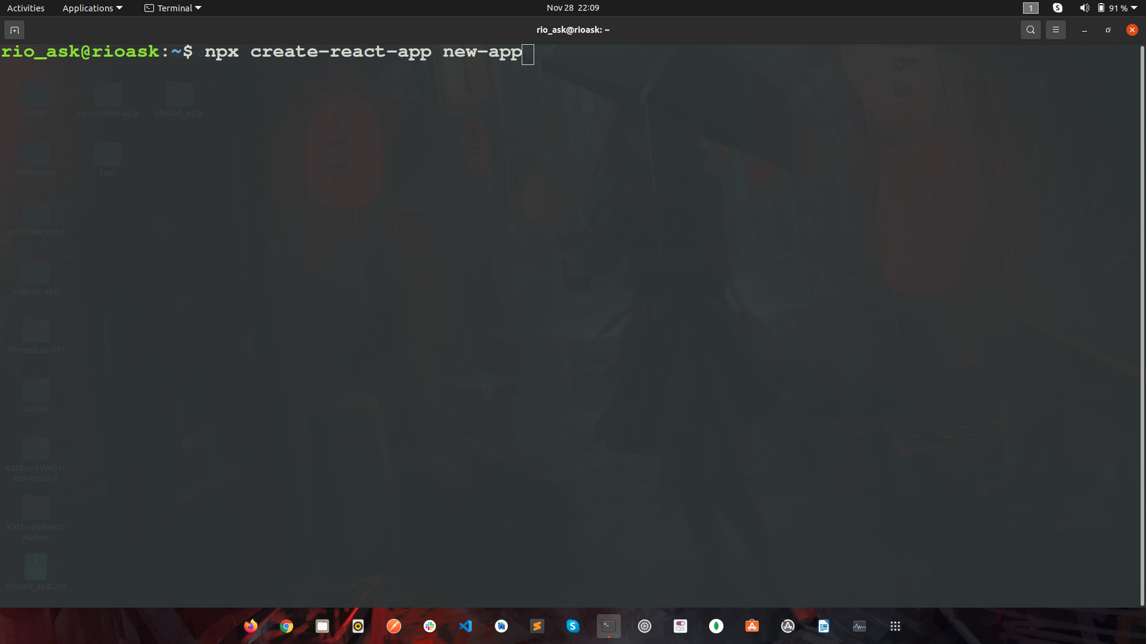

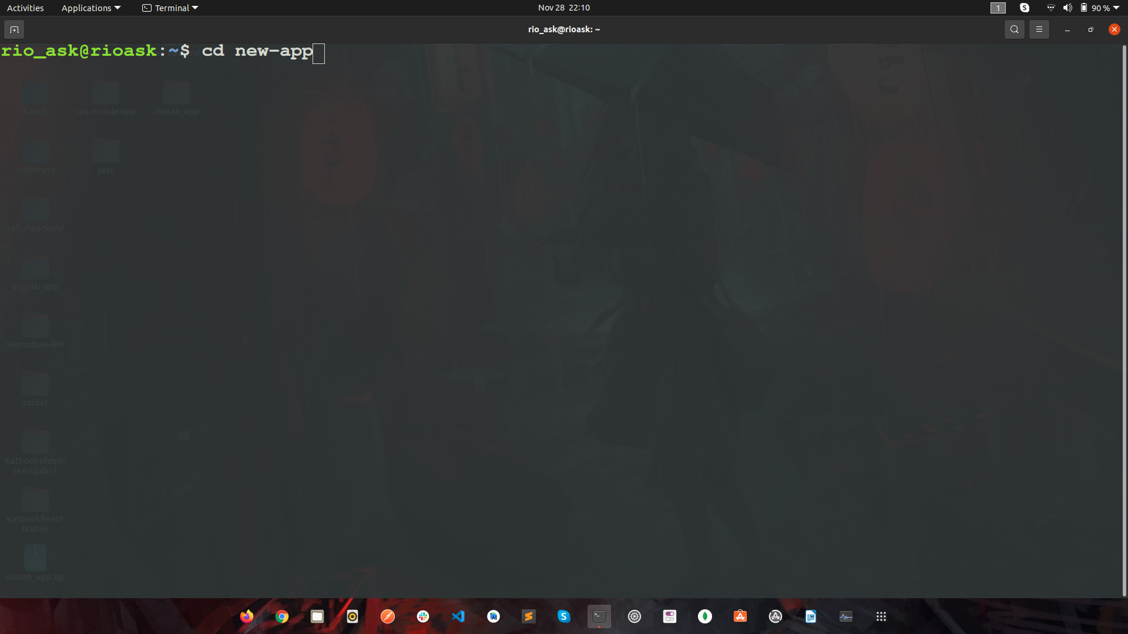
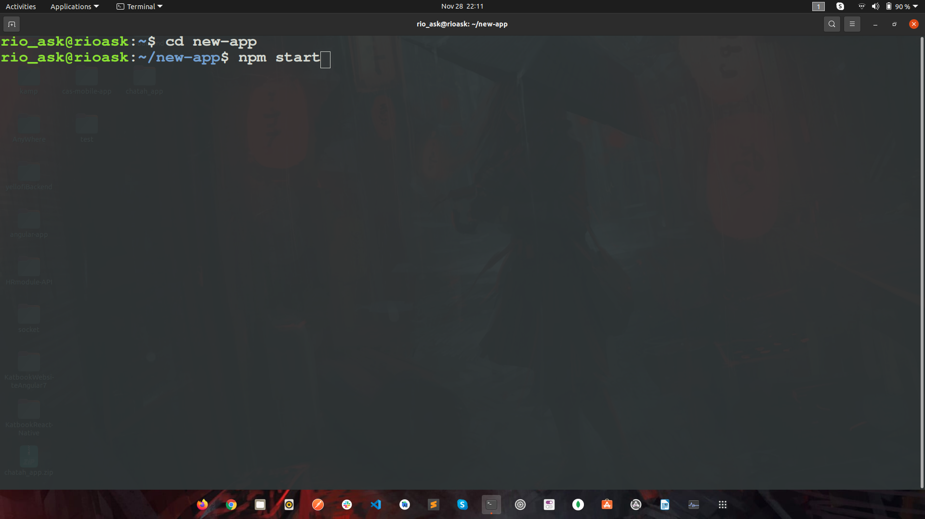

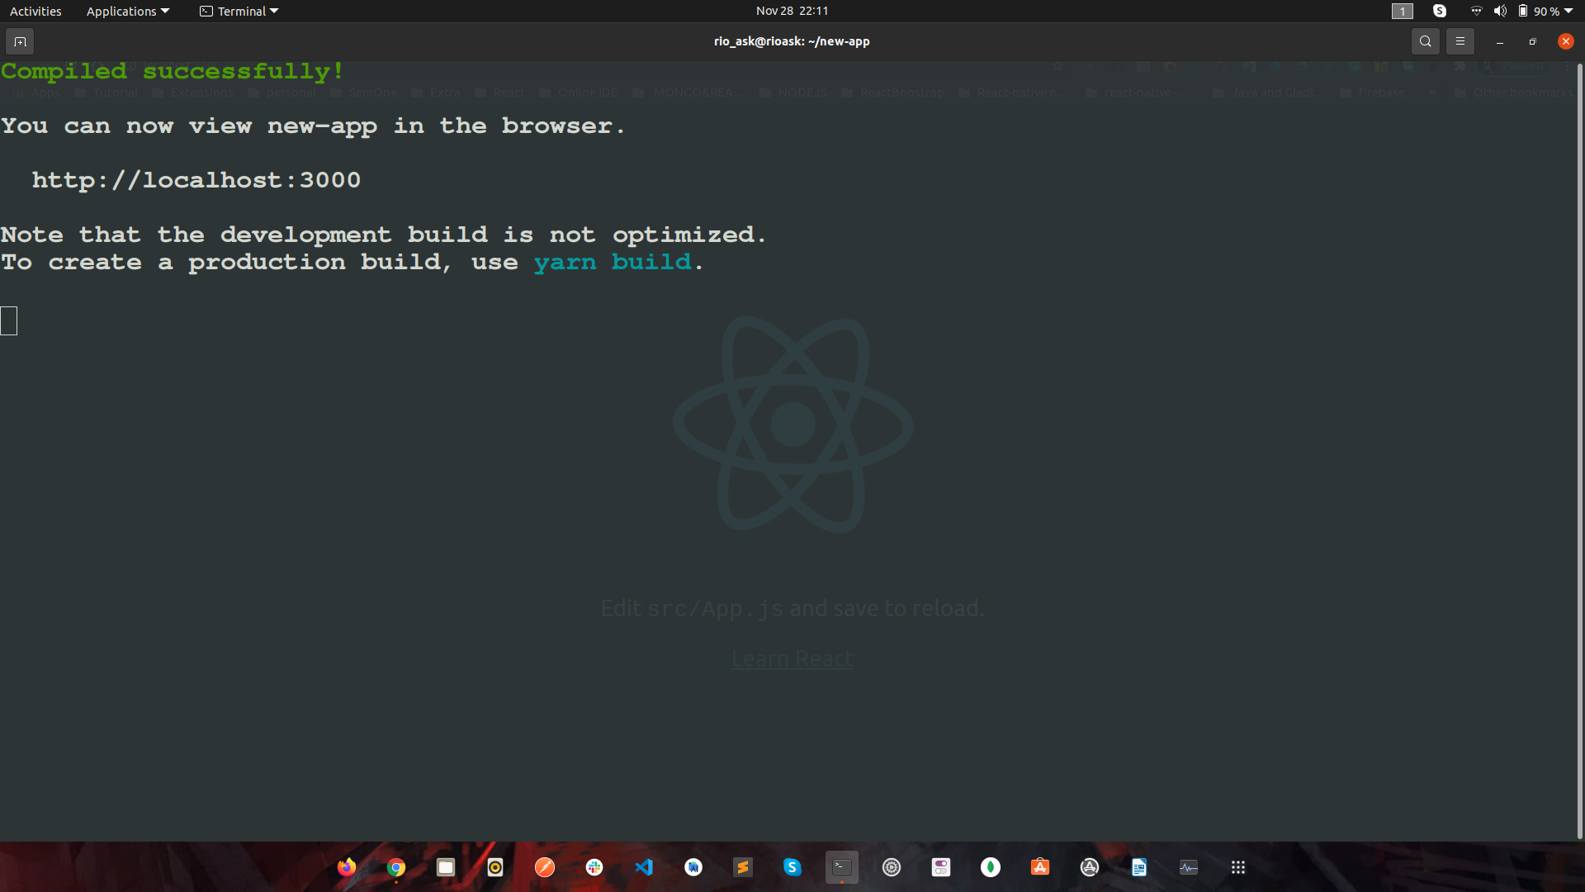

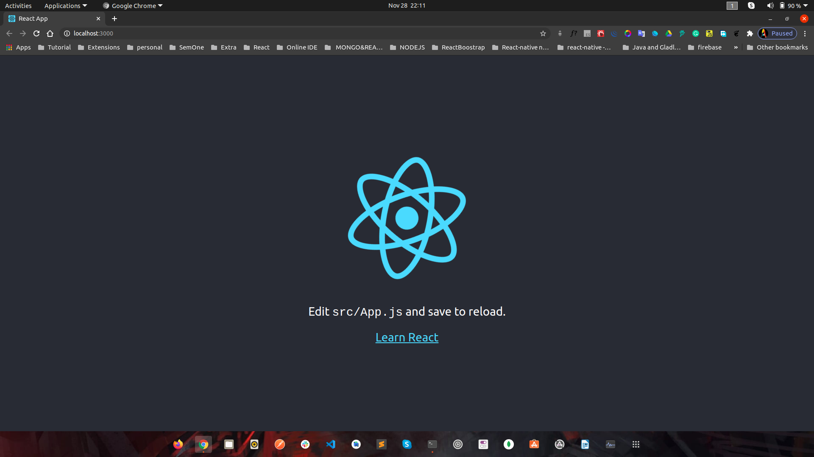

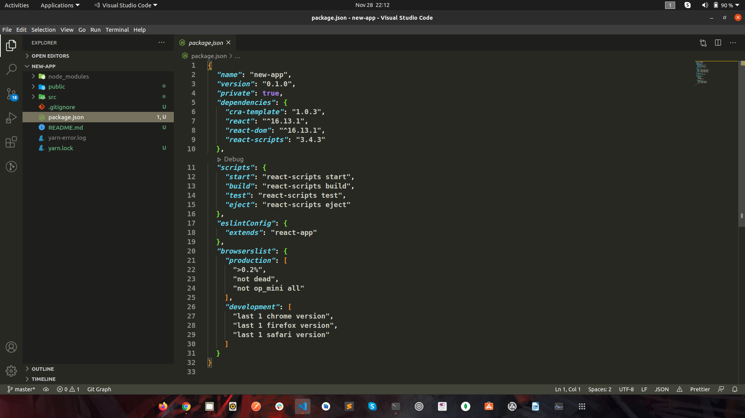
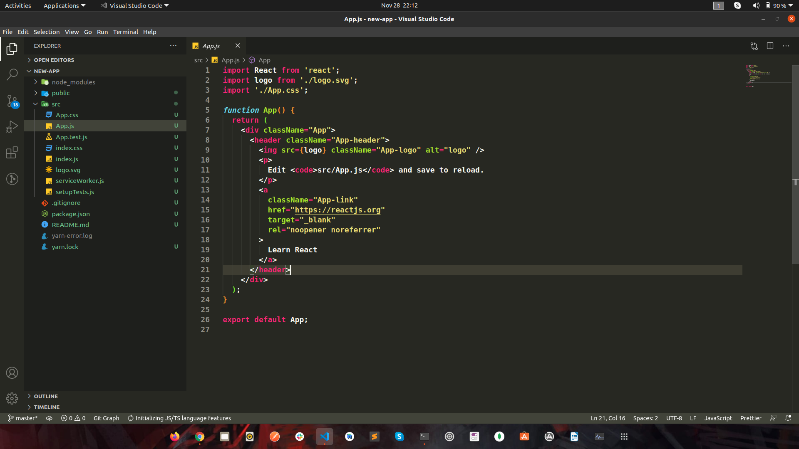

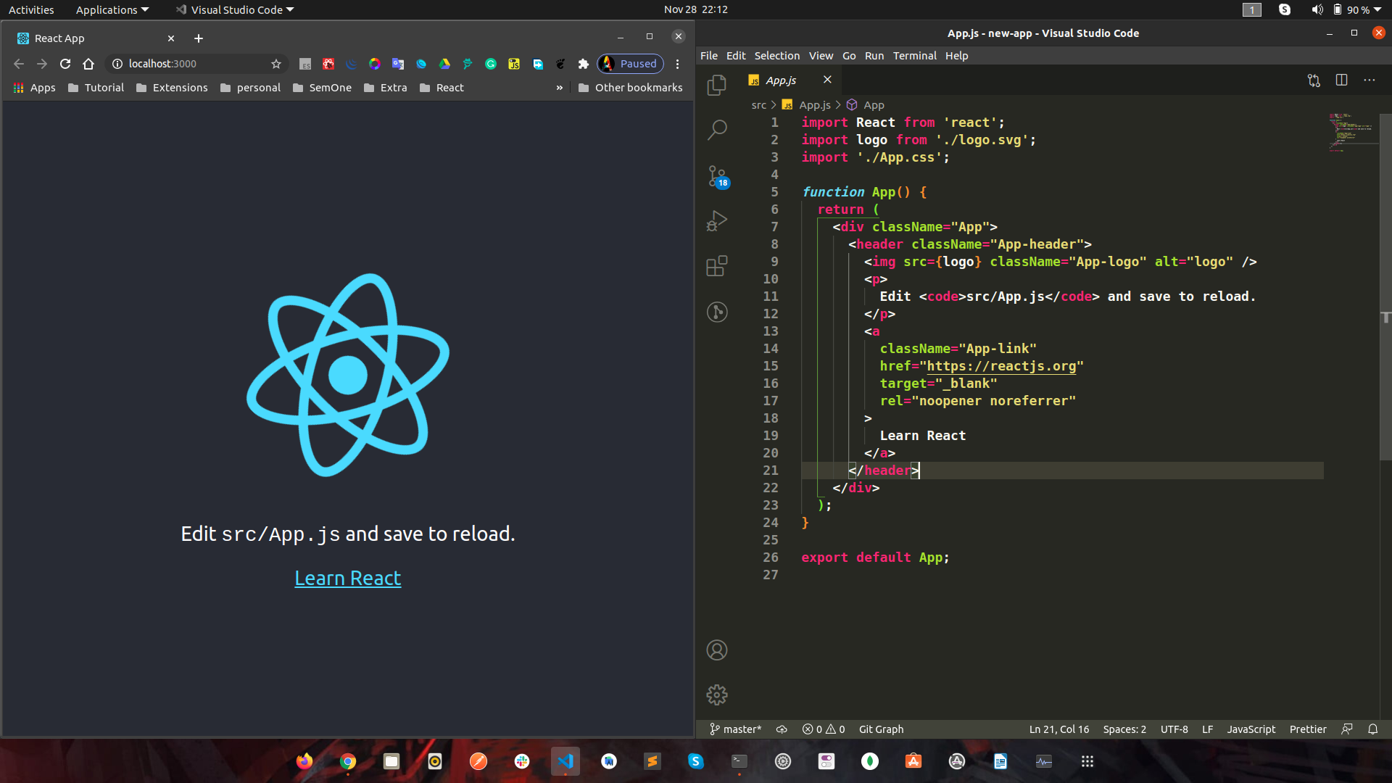

Conclusion:
Reactjs code directly in the Nodejs environment. The React DOM has component specifically designed to work with nodejs tha reduce lines of code, making server-side rendering comparatively easy.

Ref - https://nodejs.org/en/

npm is a package manager for the Node JavaScript platform. Its puts modules in place so tha node can find them, and manages dependency conflicts intelligently. Most commonly, it’s used to publish, discover install, nad develop node programs. Run npm --help to get list of available commands.

Ref - https://www.npmjs.com/

