CHAPTER 5
STATE

5.1 USING STATE IN CLASS COMPONENT :

React components has a built-in state object. The state object is where you store property values that belongs to the component. When the state object changes, the component re-renders.

The state object is initialized in the constructor:

Create dir : -> /src/Components/Class/ClassState.js

GitHub url : https://github.com/ashok-FD/new-app/tree/State

import React, { Component } from 'react'

class ClassState extends Component {
constructor(props) {
super(props);
this.state = {
value: "This is class state",
};
}

render() {
return (
<div>
<p style={{textDecoration:'underline'}}>ClassState</p>
<p>{this.state.value}</p>
</div>
)
}
}

export default ClassState

4.2 USING STATE IN FUNCTIONAL COMPONENTS :

Create dir : -> /src/Components/Function/FunctionState.js

import React, { useState } from 'react'

function FunctionState() {
const [value,setValue] = useState("This is Function State")

return (
<div>
<p style={{textDecoration:'underline'}}>FunctionState</p>
<p>{value}</p>
</div>
)
}

export default FunctionState

Ref:

https://www.w3schools.com/react/react_state.asp
https://reactjs.org/docs/state-and-lifecycle.html

4.3 SETSTATE IN CLASS COMPONENT :

SetState (or) changing the state object, To change a value in the same object, use the this.setState() method. When a value in the state object changes, the component will re-render, meaning that output will change according to the new values.

import React, { Component } from 'react'

class ClassState extends Component {
constructor(props) {
super(props);
this.state = {
value: "This is class state",
};
this.stateChange = this.stateChange.bind(this);
}

stateChange(){
this.setState({value:`This is class state value: ${Math.floor(Math.random()*100)}`})
}

render() {
return (
<div>
<p style={{textDecoration:'underline'}}>ClassState</p>
<p>{this.state.value}</p>
<button onClick={this.stateChange}>Change Class State</button>
</div>
)
}
}

export default ClassState

4.3 SETSTATE IN FUNCTIONAL COMPONENT :

import React, { useState } from 'react'

function FunctionState() {
const [value,setValue] = useState("This is Function State")

const stateChange = () => {
setValue(`This is class state value: ${Math.floor(Math.random()*100)}`);
}

return (
<div>
<p style={{textDecoration:'underline'}}>FunctionState</p>
<p>{value}</p>
<button onClick={stateChange}>Change Function State</button>
</div>
)
}

export default FunctionState

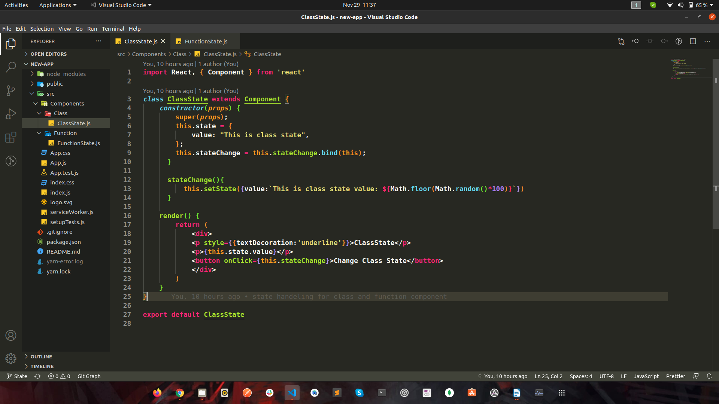
VSCODE VIEW ON GITHUB CLONE :

