

MAXIMIZING THE LIFETIME OF WIRELESS SENSOR NETWORKS WITH MOBILE SINK IN DELAY-TOLERANT APPLICATIONS
A PROJECT REPORT
Submitted by
A.Chitra(070606126012)
A.Geetha Priya(070606126015)
G.Malar Devi(070606126019)
in partial fulfillment for the award of the degree
of
BACHELOR OF TECHNOLOGY
In
INFORMATION TECHNOLOGY
SRI SHAKTHI INSTITUTE OF ENGINEERING
AND TECHNOLOGY, COIMBATORE
ANNA UNIVERSITY COIMBATORE 641047
APRIL 2011

ANNA UNIVERSITY COIMBATORE 641047

BONAFIDE CERTIFICATE

Certified that this project report “MAXIMIZING THE LIFETIME OF WIRELESS SENSOR NETWORKS WITH MOBILE SINK IN DELAY- TOLERANT APPLICATIONS” is the bonafide work of “A.Chitra (070606126012), A.Geetha Priya (070606126015), G.Malar Devi (070606126019)” who carried out the project work under my supervision.

SIGNATURE SIGNATURE
SUPERVISOR HEAD OF THE DEPARTMENT

Information Technology, Information Technology,
Sri Shakthi Institute of Engg & Tech, Sri Shakthi Institute of Engg &Tech,
Coimbatore - 641062 Coimbatore - 641062

------------------------- -------------------------------------
Internal Examiner External Examiner

CHAPTER NO. | TITLE | PAGE NO.
ABSTRACT
LIST OF TABLES
LIST OF FIGURES
LIST OF ABBREVIATIONS

1. | INTRODUCTION  1.0 NETWORKING  1.1 NETWORKING DESIGN  1.1.1 CLIENT-SERVER  1.1.2 PEER TO PEER  1.2 WIRELESS NETWORKS  1.3 WIRELESS SENSOR NETWORKS  1.3.1 CHARACTERISTICS  1.3.2 ALGORITHM  1.3.3 APPLICATIONS
2. | SYSTEM ANALYSIS  2.1 EXISTING SYSTEM  2.1.1 DRAWBACKS  2.2 PROPOSED SYSTEM  2.2.1 ADVANTAGES  2.3 FEASIBILITY STUDY  2.3.1 ECONOMIC FEASIBILITY  2.3.2 TECHNILCAL FEASIBILITY  2.3.3 OPERATIONAL FEASIBILITY
3. | SYSTEM SPECIFICATION  3.1 HARDWARE REQUIREMENTS  3.2 SOFTWARE REQUIREMENTS
4. | SOFTWARE DESCRIPTION  4.1 SIMULATION  4.2 FEATURES
5. | PROJECT DESCRIPTION  5.1 PROBLEM DEFINITION  5.2 SCOPE OF THE PROJECT  5.3 MODULE DESCRIPTION  5.3.1 MODULES  5.3.1.1. NODE CREATION  5.3.1.2. CALCULATING THE COVERAGE AREA  5.3.1.3. STATIC SINK IMPLEMENTATION  5.3.1.4.USING DELAY TOLERENT APPLICATION  5.4 PROCESS FLOW DIAGRAM  5.5 INPUT DESIGN  5.6 OUTPUT DESIGN
6. | SOFTWARE TESTING  6.1 WHITE BOX TESTING  6.2 BLAK BOX TESTING  6.3 VALIDATION TESTING  6.4 INTEGRATION TESTING
7. | CONCLUSION AND FUTURE ENHANCEMENTS  7.1 CONCLUSION  7.2 FUTURE ENHANCEMENTS
8. | REFERENCES
APPENDIX | SOURCE CODE  SNAPSHOTS

ABSTRACT

A wireless sensor network (WSN) consists of sensor nodes capable of collecting information from the environment and communicating with each other via wireless transceivers. The collected data will be delivered to one or more sinks, generally via multihop communication. The sensor nodes are typically expected to operate with batteries and are often deployed in not easily accessible or hostile environments, sometimes in large quantities. It can be difficult or impossible to replace the batteries of the sensor nodes. On the other hand, the sink is typically rich in energy. Since the sensor energy is the most precious resource in a WSN, efficient utilization of the energy to prolong the network lifetime has been the focus of much of the research on WSNs. Although the lifetime of a WSN can be defined in many ways, we adopt the widely used definition, which is the time until the first node exhausts its energy. Much work has been done during recent years to increase the lifetime of a WSN. Among them, in spite of the difficulties in realization, taking advantage of mobility in theWSN has attracted much interest from researchers . We can take the mobile sink as an example of mobility in a WSN. Communication in a WSN often has the many-to-one property in that data from a large number of sensor nodes needs to be concentrated to one or a few sinks. Since multihop routing is generally needed for distant sensor nodes to send data to the sink. The nodes near the sink can be burdened with relaying a large amount of traffic from other nodes. This phenomenon is sometimes called the “crowded center effect” or the “energy hole problem. It results in early energy depletion at the nodes near the sink, potentially disconnecting the sink from the remaining sensors that still have plenty of energy. However, by moving the sink in the sensor field, one can avoid or mitigate the energy hole problem and expect an increased network lifetime.

CHAPTER 1
1.INTRODUCTION
1.0 NETWORKING
Computer networking is the engineering discipline concerned with the communication between computer systems or devices. A computer network is any set of computers or devices connected to each other with the ability to exchange data. Networking is the practice of linking two or more computing devices together for the purpose of sharing data. Networks are built with a mix of computer hardware and computer software. The three types of networks are: the Internet, the Intranet, and Extranet. Examples of different network methods are:
- Local area network (LAN), which is usually a small network constrained to a small geographic area. An example of a LAN would be a computer network within a building.
- Metropolitan area network (MAN), which is used for medium size.
- Wide area network (WAN) that is usually a larger network that covers a large geographic area.
- Wireless LANs and WANs (WLAN & WWAN) are the wireless equivalent of the LAN and WAN.

1.1 NETWORK DESIGN
Computer networks also differ in their design. The two types of high-level network design are called client-server and peer-to-peer. Client-server networks feature centralized server computers that store email, Web pages, files and or applications. On a peer-to-peer network, conversely, all computers tend to support the same functions. Client-server networks are much more common in business and peer-to-peer networks much more common in homes.
    - Client-Server:

The term client-server refers to a popular model for computer networking that utilizes client and server devices each designed for specific purposes. The client-server model can be used on the Internet as well as local area networks (LANs). The client-server model was originally developed to allow more users to share access to database applications. Compared to the mainframe approach, client-server offers improved scalability because connections can be made as needed rather than being fixed. The client-server model also supports modular applications that can make the job of creating software easier. In so-called "two-tier" and "three-tier" types of client-server systems, software applications are separated into modular pieces, and each piece is installed on clients or servers specialized for that subsystem.
The client-server model distinguishes between applications as well as devices. Network clients make requests to a server by sending messages, and servers respond to their clients by acting on each request and returning results. One server generally supports numerous clients, and multiple servers can be networked together in a pool to handle the increased processing load as the number of clients grows.

1.1.2 Peer-to-Peer:

Peer to peer is an approach to computer networking where all computers share equivalent responsibility for processing data. Peer-to-peer networking (also known simply as peer networking) differs from client-server networking, where certain devices have responsibility for providing or "serving" data and other devices consume or otherwise act as "clients" of those servers. Computers in a peer to peer network run the same networking protocols and software.

Peer networks allow data to be shared easily in both directions, whether for downloads to your computer or uploads from your computer. On the Internet, peer to peer networks handle a very high volume of file sharing traffic by distributing the load across many computers. Because they do not rely exclusively on central servers, P2P networks both scale better and are more resilient than client-server networks in case of failures or traffic bottlenecks.
1.2 WIRELESS NETWORKS
Wireless network refers to any type of computer network that is not connected by cables of any kind. It is a method by which telecommunications networks and enterprise (business), installations avoid the costly process of introducing cables into to a building, or as a connection between various equipment locations. Wireless telecommunications networks are generally implemented and administered using a transmission system called radio waves. This implementation takes place at the physical level, (layer), of the network structure.
Wireless networks utilize radio waves and/or microwaves to maintain communication channels between computers. Wireless networking is a more modern alternative to wired networking that relies on copper and/or fiber optic cabling between network devices.
Advantages & Disadvantages:
A wireless network offers advantages and disadvantages compared to a wired network. Advantages of wireless include mobility and elimination of unsightly cables. Disadvantages of wireless include the potential for radio interference due to weather, other wireless devices, or obstructions like walls.

1.3 WIRELESS SENSOR NETWORKS
The WSN is built of "nodes" - from a few to several hundreds or even thousands, where each node is connected to one (or sometimes several) sensors. Each such sensor network node has typically several parts: a radio transceiver with an internal antenna or connection to an external antenna, a microcontroller, an electronic circuit for interfacing with the sensors and an energy source, usually a battery. A sensor node might vary in size from that of a shoebox down to the size of a grain of dust, although functioning "motes" of genuine microscopic dimensions have yet to be created. The cost of sensor nodes is similarly variable, ranging from hundreds of dollars to a few pennies, depending on the complexity of the individual sensor nodes. Size and cost constraints on sensor nodes result in corresponding constraints on resources such as energy, memory, computational speed and communications bandwidth. The topology of the WSNs can vary from a simple star network to an advanced multi-hop wireless mesh network. The propagation technique between the hops of the network can be routing or flooding.
1.3.1 Characteristics
The main characteristics of a WSN include:
- Power consumption constrains for nodes using batteries or energy harvesting
- Ability to cope with node failures
- Mobility of nodes
- Dynamic network topology
- Communication failures
- Heterogeneity of nodes
- Scalability to large scale of deployment
- Ability to withstand harsh environmental conditions
- Easy of use
- Unattended operation.
Sensor nodes can be imagined as small computers, extremely basic in terms of their interfaces and their components. They usually consist of a processing unit with limited computational power and limited memory, sensors or MEMS (including specific conditioning circuitry), a communication device (usually radio transceivers or alternatively optical), and a power source usually in the form of a battery. Other possible inclusions are energy harvesting modules, secondary ASICs, and possibly secondary communication devices (e.g. RS-232 or USB).
The base stations are one or more distinguished components of the WSN with much more computational, energy and communication resources. They act as a gateway between sensor nodes and the end user as they typically forward data from the WSN on to a server. Other special components in routing based networks are routers, designed to compute, calculate and distribute the routing tables. Many techniques are used to connect to the outside world including mobile phone networks, satellite phones, radio modems, high power WiFi links etc.

1.3.2 Algorithms
The algorithmic approach to modelling, simulating and analyzing WSNs differentiates itself from the protocol approach by the fact that the idealised mathematical models used are more general and easier to analyze. However, they are sometimes less realistic than the models used for protocol design, since an algorithmic approach often neglects timing issues, protocol overhead, the routing initiation phase and sometimes distributed implementation of the algorithms

Distributed sensor network

If a centralised architecture is used in a sensor network and the central node fails, then the entire network will collapse, however the reliability of the sensor network can be increased by using distributed architecture.
Distributed architecture is used in WSNs for the following reasons:
- Sensor nodes are prone to failure,
- For better collection of data
- To provide nodes with backup in case of failure of the central node
We also take care of nodes sensing redundant information and forwarding the data that is of no use. There is also no centralised body to allocate the resources and they have to be self organised.
1.3.3 Applications:
The applications for WSNs are varied, typically involving some kind of monitoring, tracking, or controlling. In a typical application, a WSN is deployed in a region where it is meant to collect data through its sensor nodes.

Air pollution monitoring

Wireless Sensor Networks have been deployed in several cities (Stockholm, London or Brisbane) to monitor the concentration of dangerous gases for citizens. The sensor nodes can control important parameters like CO, CO2, NO2 or CH4, which are generated by vehicles and industry, and have a severe impact in the human health. This way, the public institutions have a good tool to design plans to reduce pollution, improve the air quality and ensure the compliance with current legislation.

Greenhouse monitoring
Wireless sensor networks are also used to control the temperature and humidity levels inside commercial greenhouses. When the temperature and humidity drops below specific levels, the greenhouse manager must be notified via e-mail or cell phone text message, or host systems can trigger misting systems, open vents, turn on fans, or control a wide variety of system responses.

Landslide detection
A landslide detection system makes use of a wireless sensor network to detect the slight movements of soil and changes in various parameters that may occur before or during a landslide. And through the data gathered it may be possible to know the occurrence of landslides long before it actually happens.

CHAPTER 2
SYSTEM ANALYSIS:
  - EXISTING SYSTEM:
In the existing systems in some applications, several thousands of sensor nodes might be deployed over the monitored region. For example, in agricultural scenarios, in environmental monitoring or in border surveillance applications, such large-scale sensor networks would be necessary. Moreover, the diameter of the region might easily be several kilometers. In this case, scalability of the network is a very important design issue. In order to obtain a scalable network, the sensor nodes should be divided into clusters. The nodes within a cluster will then be connected to the sink nodes dedicated for that cluster. shows such a sensor network with several nodes and three clusters with three sink nodes. During the design phase of a large-scale sensor network, the designer should decide on the number of clusters, and more important than that, the optimum locations of the sink nodes. We call this problem as the “multiple sink sensor network design problem” and try to provide some solutions.

DISADVANTAGES:
- No storage of data
- Consumption of more energy.
- Crowded Center Effect.

PROPOSED SYSTEM
This paper proposes a framework to maximize the lifetime of a WSN by taking advantage of sink mobility. Compared with other mobile sink proposals, the main novelty is that we consider the case where the underlying applications tolerate delayed information delivery to the sink. One of the application examples is battle field surveillance, where sensor nodes are deployed to monitor the movement of enemy vehicles or troops. A mobile sink attached to an unmanned aerial vehicle flies over the monitored region regularly to harvest the collected intelligence. To avoid being intercepted or detected by enemy forces, the mobile sink needs to operate in only a few safe locations within a limited operation time. Another example is habitat monitoring where a mobile robot is used to collect information from the sensor nodes in the field. If much of the habitat area is not accessible by the robot or if it is desirable to minimize disturbance to the targeted animal species, the mobile robot will trace predetermined paths and stop by a set of prearranged locations regularly for data collection. In our proposal, within a prescribed delay tolerance level, each node does not need to send the data immediately as it becomes available. Instead, the node can store the data temporarily and transmit it when the mobile sink is at the location most favorable for achieving the longest network lifetime. To find the best solution within the proposed framework, we formulate optimization problems that maximize the lifetime of the WSN subject to the delay bound constraints, node energy constraints, and flow conservation constraints. Another one of our contributions is that we compare our proposal with several other lifetime maximization proposals and quantify the performance differences among them. Our computational experiments have shown that our proposal increases the lifetime significantly when compared to not only the stationary sink model but also more traditional mobile sink models without delay tolerance.
ADVANTAGES:
- Can store the data temporarily.
- Crowded Center Effect can be avoided.

FEASIBILITY STUDY:
Systems analysis is the process of examining a business situation for the purpose of developing a system solution to a problem or devising improvements to such a situation. Before the development of any system can begin, a project proposal is prepared by the users of the potential system and/or by systems analysts and submitted to an appropriate managerial structure within the organization.The feasibility study investigates the problem and the information needs of the stakeholders. It seeks to determine the resources required to provide an information systems solution, the cost and benefits of such a solution, and the feasibility of such a solution. The analyst conducting the study gathers information using a variety of methods, the most popular of which are:
- Interviewing users, employees, managers, and customers.
- Developing and administering questionnaires to interested stakeholders, such as potential users of the information system.
- Observing or monitoring users of the current system to determine their needs as well as their satisfaction and dissatisfaction with the current system.
- Collecting, examining, and analyzing documents, reports, layouts, procedures, manuals, and any other documentation relating to the operations of the current system.
- Modeling, observing, and simulating the work activities of the current system.
The goal of the feasibility study is to consider alternative information systems solutions, evaluate their feasibility, and propose the alternative most suitable to the organization. The feasibility of a proposed solution is evaluated in terms of its components. These components are:
Economic feasibility
The economic viability of the proposed system. The proposed project's costs and benefits are evaluated. Tangible costs include fixed and variable costs, while tangible benefits include cost savings, increased revenue, and increased profit. A project is approved only if it covers its cost in a given period of time. However, a project may be approved only on its intangible benefits such as those relating to government regulations, the image of the organization, or similar considerations.
Technical feasibility
The possibility that the organization has or can procure the necessary resources. This is demonstrated if the needed hardware and software are available in the marketplace or can be developed by the time of implementation.
Operational feasibility
The ability, desire, and willingness of the stakeholders to use, support, and operate the proposed computer information system. The stakeholders include management, employees, customers, and suppliers. The stakeholders are interested in systems that are easy to operate, make few, if any, errors, produce the desired information, and fall within the objectives of the organization.

CHAPTER 3
SYSTEM SPECIFICATION
3.1. HARDWARE USED:
Processor : Pentium III
Processor speed : 1.5 GHZ
Memory (RAM) : 256MB
Hard disk : 40GB
Monitor : 15”color monitor
Keyboard : Logitech 104 keys
Mouse : Logitech scroll mouse

3.2. SOFTWARE USED:

Operating System : Fedora 8.0
Language : C++ & TCL Scripting

CHAPTER 4
SOFTWARE DESCRIPTION
SIMULATORS
4.1 Introduction
Simulation is the imitation of some real thing, state of affairs, or process. The act of simulating something requires capturing the essential characteristics, activities and rules of a selected physical or abstract system. Simulations are often used to model natural, machine or human systems in order to gain insight to gain insight into their functioning. In addition, it is a very important mechanism to understanding interactions between various systems, parts of which may be difficult to recreate or control in the real world. In technology, simulations are used widely for testing, performance optimization and measurement, safety engineering, training and education. Simulation is specifically necessary in the context of our research, since it involves wireless networks. It is almost impossible to reproduce the wireless propagation environment, difficult to use real radio-wave based transmission to test our concept, and non-trivial to use real wireless sensor/devices to present our research idea. Use of a simulator solves all these challenges. Simulators for communication networks can provide near accurate reproductions of most features in the environment, like noise, probability of loss or alteration of data. They often allow user implementations of protocols for transmission, propagation, reception or other communication aspects to work with their ”ether”. Mostly, they provide a data-view model of wireless devices. Thus, using simulators allows us to concentrate on the research idea instead of physical implementation details. They enable building a valid model whose behavior and functioning can be repeated and measured; in short, a statistically verifiable proof of concept.

NS (SIMULATOR)
NS or the network simulator (also popularly called NS-2, in reference to its current generation) is a discrete event network simulator. NS is used in the simulation of routing protocols, among others, and is heavily used in ad-hoc networking research. ns supports popular network protocols, offering simulation results for wired and wireless networks alike. It is popular in research given its open source model and online documentation. However, modeling is a very complex and time-consuming task in ns-2, since it has no GUI and one needs to learn scripting language, queuing theory and modeling techniques. Of late, there have been complaints that results are not consistent (probably because of continuous changes in the code base) and that certain protocols are replete with bugs.

NS-2 a discrete event driven simulation
- Physical activities are translated to events
- Events are queued and processed in the order of their scheduled occurrences
- Time progresses as the events are processed

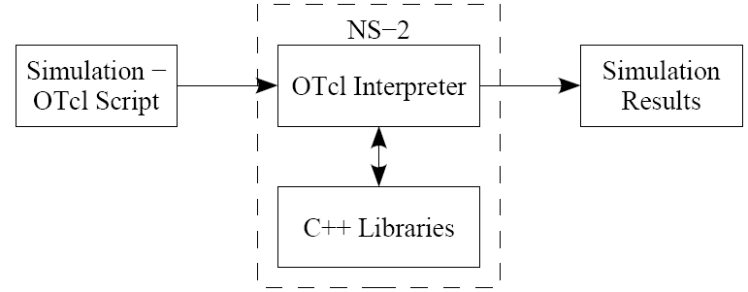
From the user’s perspective, NS−2 is an Tcl interpreter that takes an Tcl script as input and produces a trace file as output.
NS-2 Hierarchy:
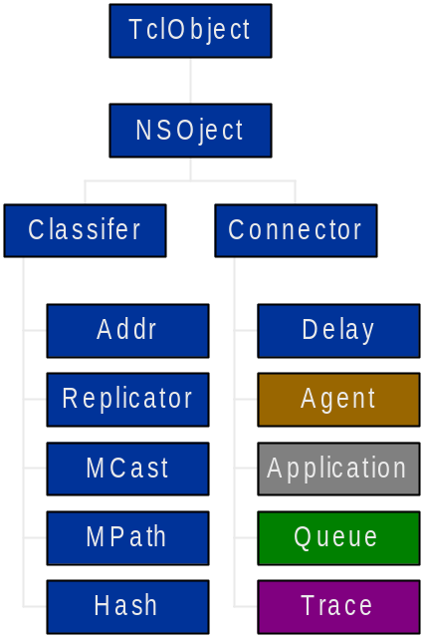
.

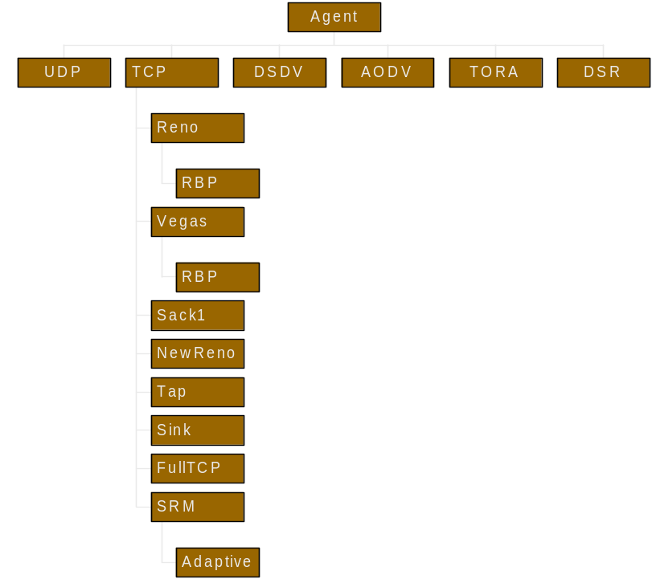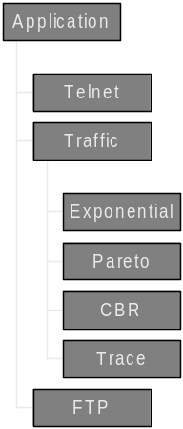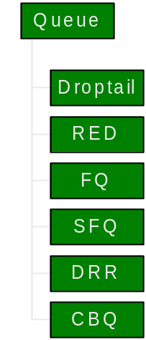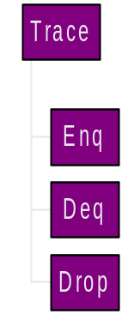

Overview:
- Maintained through VINT project
- NS2 :collaborative simulation environment
  - Freely distributed and open source
  - Supports NT research and education
    - Protocol design, traffic analysis etc.
  - Provides common reference
Platforms Supported:
- Most UNIX and UNIX-like systems
  - FreeBSD
  - Linux
  - Solaris
- Windows 98/2000/2003/XP
  - Cygwin required
NS2 Components:
- NS – Simulator
- NAM – Network AniMator
  - visual demonstration of NS output
- Preprocessing
  - Handwritten TCL or
  - Topology generator
- Post analysis
  - Trace analysis using Perl/TCL/AWK/MATLAB
Two Language Structure of NS2:
NS2 consists mainly of two languages: C++ and Tcl. Each of these two languages has its own strengths and weaknesses. NS2 beautifully integrates these two languages to draw out their strengths.
Why two languages? (Tcl & C++):
- C++: Detailed protocol simulations require systems programming language
  - byte manipulation, packet processing, algorithm implementation
  - Run time speed is important
  - Turn around time (run simulation, find bug, fix bug, recompile, re-run) is slower
- Tcl: Simulation of slightly varying parameters or configurations
  - quickly exploring a number of scenarios
  - iteration time (change the model and re-run) is more important.

CHAPTER 5
5.1 PROJECT DESCRIPTION:

Although the lifetime of a WSN can be defined in many ways, we adopt the widely used definition, which is the time until the first node exhausts its energy. Much work has been done during recent years to increase the lifetime of a WSN. We can take the mobile sink as an example of mobility in a WSN.
Communication in a WSN often has the many-to-one property in that data from a large number of sensor nodes needs to be concentrated to one or a few sinks. Since multihop routing is generally needed for distant sensor nodes to send data to the sink, the nodes near the sink can be burdened with relaying a large amount of traffic from other nodes. This phenomenon is sometimes called the “crowded center effect” or the “energy hole problem”.
It results in early energy depletion at the nodes near the sink, potentially disconnecting the sink from the remaining sensors that still have plenty of energy. However, by moving the sink in the sensor field, one can avoid.
SCOPE OF THE PROJECT
This paper proposes a framework to maximize the lifetime of the wireless sensor networks (WSNs) by using a mobile sink when the underlying applications tolerate delayed information delivery to the sink. Within a prescribed delay tolerance level, each node does not need to send the data immediately as it becomes available. Instead, the node can store the data temporarily and transmit it when the mobile sink is at the most favorable location for achieving the longest WSN lifetime.
5.2 Overview of the Project
In our proposal, within a prescribed delay tolerance level, each node does not need to end the data immediately as it becomes available. Instead, the node can store the data temporarily and transmit it when the mobile sink is at the location most favorable for achieving the longest network lifetime.
To find the best solution within the proposed framework, we formulate optimization problems that maximize the lifetime of the WSN subject to the delay bound constraints, node energy constraints, and flow conservation constraints. Another one of our contributions is that we compare our proposal with several other lifetime maximization proposals and quantify the performance differences among them.
Our proposal is more sophisticated than most previous lifetime-improvement proposals that we know of. It integrates the following energy-saving techniques, multipath routing, a mobile sink, delayed data delivery, and active region control, into a single optimization problem. Such sophistication comes at a cost. Whether the proposal should be adopted in practice will depend on the trade-off between the lifetime gain and the actual system cost. The latter includes all costs/complexity in implementing the proposal and in actual operations. These may include extra communication protocols for coordination and control, e.g., new routing and rate control protocols, extra memory for keeping delayed data and memory-management costs, and application- level costs incurred by delayed information delivery.
Even if the decision is not to adopt it due to a high cost or high complexity, the framework in the paper is still useful because it can supply the practitioners with a performance benchmark, e.g., how much lifetime improvement opportunity there is. By also formulating the optimization problems related to other proposals and providing cross comparison, the paper provides extra convenience for comparing and understanding different proposals.
We now briefly review the most relevant work on how to exploit mobility to increase the network lifetime. Shah et al. introduced mobile agents, which move around and collect data from nearby sensor nodes on behalf of the immobile sink.
When the mobile agents move to the vicinity of the sink, they forward the collected data to the sink. In that framework, communication occurs only from the sensor nodes to the mobile agents or from the mobile agents to the sink via a single hop; the sensor nodes do not relay traffic. Hence, it is different from our multihop communication framework.
It was assumed that the mobile agents have plenty of energy. The movement of each mobile agent is modeled as a random walk. It was shown that the queues in the mobile agents and the sensor nodes are finite and the delay of the collected data is bounded. However, the authors did not show the quantitative improvement of the network lifetime by using mobile agents.

  - Module Description
    - Node Creation
Creating sixteen nodes in an screen size of 700 and 500 as X and Y axis.
In this module we are defining the node movement.
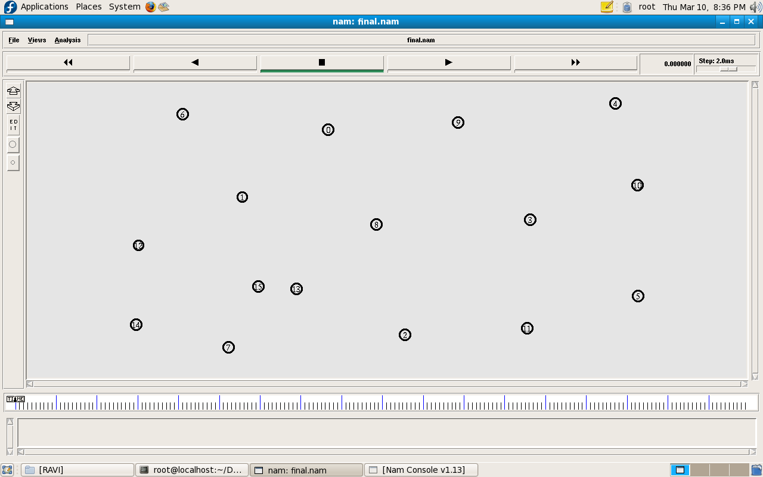

    - Allocating Coverage Area For Nodes
Every node has its own coverage area.
This module allocates coverage area for each node.
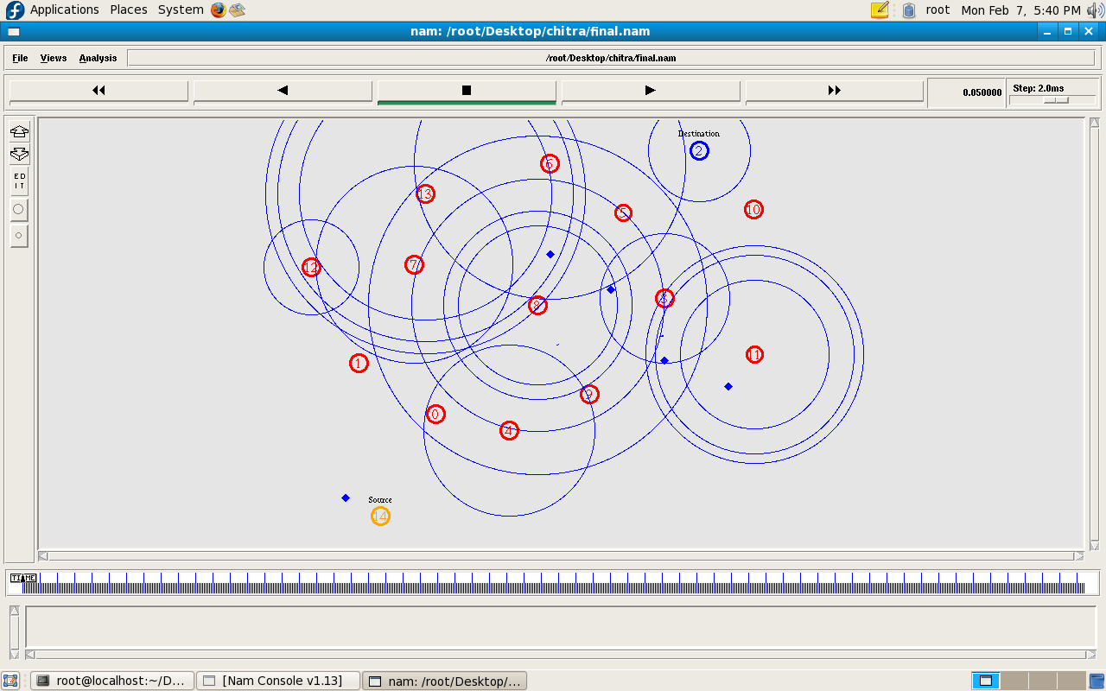

    - Static Sink Implementation
In the static sink model (SSM), the sink is located at the origin and remains stationary during the operation of the WSN.
Data originated from the sensor nodes flow into the sink in a multihop fashion.
As soon as the data become available at a node, it gets transmitted toward the sink.
Sink is residing at a particular position and collect the data from each node.

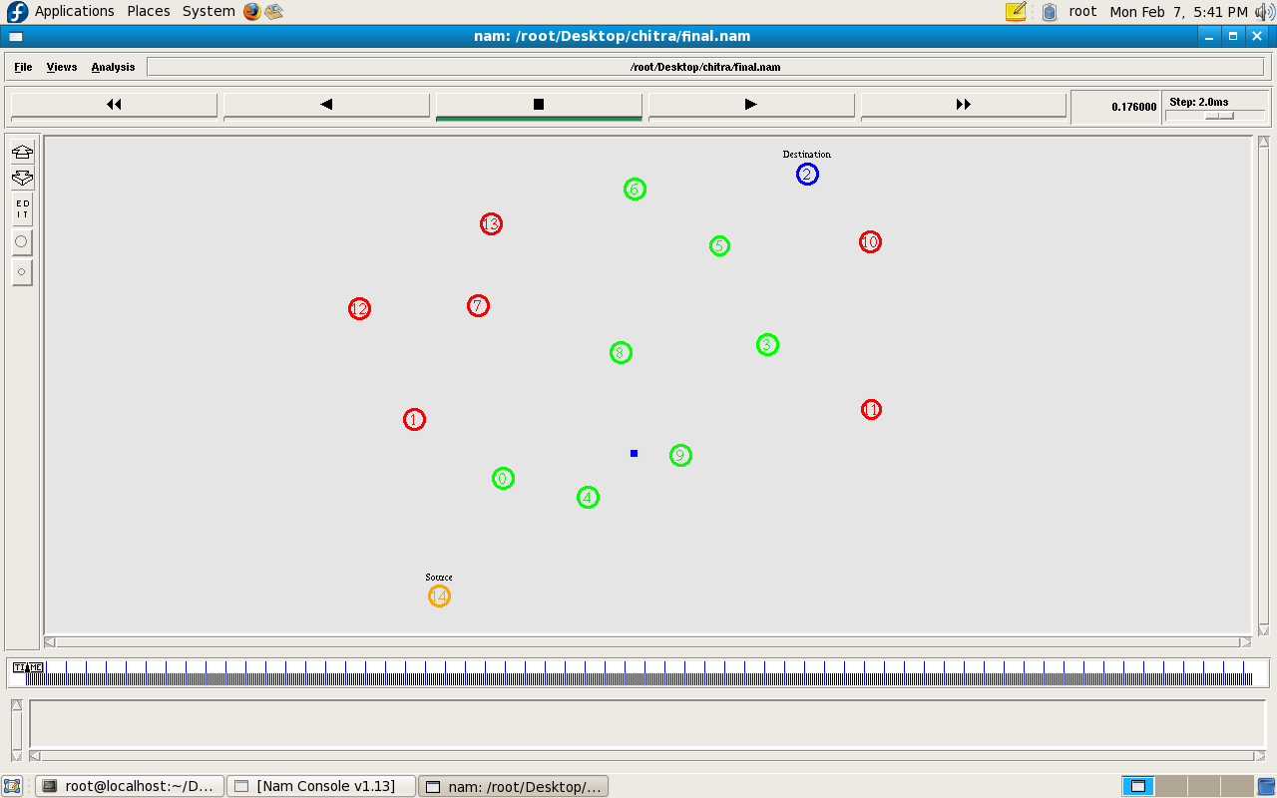

    - Implementation of Delay-Tolerant in Mobile Sink
In the mobile sink model (MSM), we assume that the sink can move around within the sensor field and stop at certain locations to gather the data from the sensor nodes.
Let L be the set of possible locations where the sink can stop (also known as sink stops).
The sink does not necessarily stop at (i.e., stays for a positive duration) all locations in L in the interest of maximizing the network lifetime
The nodes are not active at all the time.
When node is not active it continues to gather data and should store the newly generated data.
The sink can move around within the sensor field to gather the data from the sensor nodes.
In the DT-MSM, the nodes do not always participate in communication for all the sink stops; they each wait until the sink’s location is most favorable for energy saving, and then send data at the higher rate.

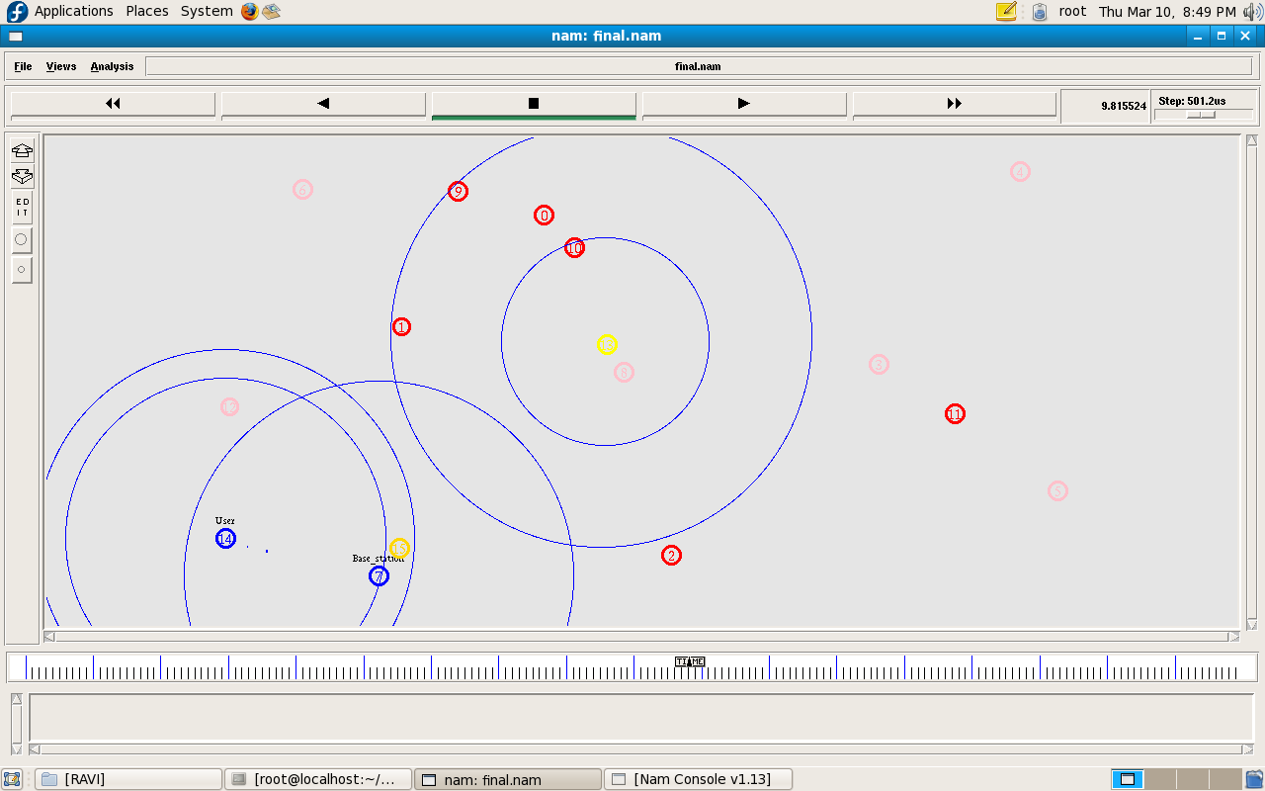

CHAPTER 6
SYSTEM TESTING
TESTING PHASE
Software testing is a critical element of software quality assurance and represents the ultimate review of specification, design and code generation. Once the source code has been generated, software must be tested to uncover as many errors as possible before delivery to the customer. In order to find the highest possible number of errors, tests must be conducted systematically and test cases must be designed using disciplined techniques.
TYPES OF TESTING
Whitebox Testing
White box testing sometimes called as glass box testing, is a test case design method that uses the control structures of the procedural design to derive test cases. Using white box testing methods, the software engineer can derive test case that
- Guarantee that all independent paths with in a module have been exercised at least once
- Exercise all logical decisions on their true and false sides
- Execute all loops at their boundaries and within their operational bounds
- Exercise internal data structures to ensure their validity.

“Logic errors and incorrect assumptions are inversely proportional to the probability that a program path will be executed. “
Errors tend to creep into our work when we design and implement functions, conditions are or control that are out of the mainstream. Everyday processing tends to be well understood, while special case processing tends to fall into the cracks.
“We often to believe that a logical path is not executed when, in fact, it may be executed on a regular basis. “
The logical flow of a program is sometimes counterintuitive, meaning that our unconscious assumptions about flow of control and data may lead us to make design errors that are uncovered only once path testing commences.
“Typographical errors are random”.
When a program is translated into programming language source code, it is likely that some typing errors will occur. Many will be uncovered by syntax and typing checking mechanisms, but others may go undetected until testing begins. It is as likely that a type will exist on an obscure logical path as on a mainstream path.
Blackbox Testing
Black box testing, also called as behavioral testing, focuses on the functional requirements of the software. That is, black box testing enables the software engineer to derive sets of input conditions that will fully exercise all functional requirements for a program.
Black box testing attempts to find errors in the following categories:
- Incorrect or missing functions
- Interface errors
- Errors in data structures or external data base access
- Behavior or performance errors
- Initialization and termination errors
In the black box testing have to correct or incorrect the message it will display on the window. The message should be enable on a few seconds, this will helps to test whether the checking. If any error in the data structure and external data base access, they can control the initialization errors and termination errors.
Validation Testing
Validation testing provides the final assurance that software meets all functional, behavioral and performance requirements. Validation testing can be defined in many ways, but a simple definition is that validations succeed when the software functions in a manner that is expected by the user. The software once validated must be combined with other system element. System testing verifies that all elements combine properly and that overall system function and performance is achieved.
One of the two possible conditions exists, after validation test has been conducted: The function or performance characteristics confirm to the specifications and are accepted. A derivation from specification is uncovered and a deficiency lists is created.
After the integration of the modules, the validation test was carried out over the system. It was found that all the modules work well together and meet the overall system function and performance.

Integration testing
Integration testing is a systematic technique for constructing the program structure while at the same time conducting test to uncover errors associated with interfacing. The objective is to take unit –tested modules and build a program structure that has been dictated by design. Careful test planning is required to determine the extent and nature of system testing to be performed and to establish criteria by which the result will be evaluated.
Data can be lost across an interface. One module can have adverse affect on the. All the modules were integrated after unit-tested all the modules, while integration, Top-Down Integration was followed, where in modules are integrated by moving downward through the control hierarchy, beginning with the main module.
Since the modules were unit –tested for no errors, the integration of those modules was found perfect and working fine. As a next step to integration, other modules were integrated with the former modules.
After the successful integration of the modules, the system was found to be running with no uncovered errors, and also all the modules were working as per the design of the system, without any deviation from the features of the proposed system design.

CHAPTER 7

7.1 CONCLUSION

In order to maximize the lifetime of a sensor network, energy resources of each individual sensor node must be consumed effectively. In large-scale sensor networks, the network must be divided into smaller sub-networks, not only to increase manageability of the network, but also to increase the network lifetime. We have introduced the multiple sink network design problem, where the best places for the sink nodes should be calculated depending on several different design criteria. We have demonstrated a sample sink location case, where the number of sink nodes was known before the deployment phase. We have implemented the solution for this BSL problem, and presented the corresponding energy and disconnected region maps on a sample sensor network for different snapshots in time. We have observed how the disconnected region increases with time. We have encountered with failures at the sensor nodes that are close to the sink nodes, because these nodes have served a larger branch set. However, not every sensor node that is close to sink nodes fail early, since these nodes might coincidentally have a very small number of sensor nodes to serve. So we can conclude that reconstructing the minimum energy tree after energy failures occur could prolong the network lifetime. We have also proposed a solution technique for the MSPOP problem, and simulated its implementation on random networks. We have analyzed the effect of adding new sinks to the network lifetime. We have presented methods to deploy economically feasible amount of sink nodes while prolonging the network lifetime.

7.2 Future Enhancement
In this paper, we proposed a new framework for improving the network lifetime by exploiting sink mobility and delay tolerance. It is expected to be useful in applications that can tolerate a certain amount of delay in data delivery. We presented the mathematical formulations for optimizing the network lifetime under the proposed framework. We identified several properties that our models possess. To validate the framework’s ability for improving network lifetime, we conducted extensive experiments and found that the framework is superior to the models published previously, including the static sink model and the mobile sink model without delay tolerance. The lifetime gain of the proposed model is significant when compared to the
previous models. Furthermore, as the number of sink locations increases, the optimal network lifetime increases substantially. The results of the paper can both be applied to practical situations and be used as benchmarks for studying energy-efficient network designs. We can point out three interesting future work directions. The paper has not touched upon the issue of finding efficient algorithms to solve the optimization problems, but has relied on standard, centralized algorithms. The first direction is to find simpler, preferably distributed, algorithms, which are clearly more generally applicable. The goal is likely to be attainable since the problems, formulated in this paper, are extension of the network-flow problems and many efficient algorithms are known for such problems. The second direction is to relax some of the simplifying assumptions of the formulations. For instance, we can bring the nonzero traveling time by the sink and/or the finite link transmission rate into the formulations. Either one seems to make the problems very difficult, but more relevant at the same time. The third direction is to consider where to choose for sink stops so that the network lifetime can be optimized.

8.REFERENCES:

1.Z.M. Wang, S. Basagni, E. Melachrinoudis, and C. Petrioli, “Exploiting Sink Mobility for Maximizing Sensor Network Lifetime,” Proc. 38th Hawaii Int’l Conf. System Sciences, 2005.

2. M. Gatzianas and L. Georgiadis, “A Distributed Algorithm for Maximum Lifetime Routing in Sensor Networks with Mobile Sink,” IEEE Trans. Wireless Comm., vol. 7, no. 3, pp. 984-994, Mar. 2008.

3. J. Luo and J.-P. Hubaux, “Joint Mobility and Routing for Lifetime Elongation in Wireless Sensor Networks,” Proc. IEEE INFOCOM, 2005.

4. R.C. Shah, S. Roy, S. Jain, and W. Brunette, “Data Mules: Modeling a Three-Tier Architecture for Sparse Sensor Networks,” Proc. First IEEE Int’l Workshop Sensor Network Protocols and Applications (SNPA ’03), pp. 30-41, May 2003.

5. S. Basagni, A. Carosi, E. Melachrinoudis, C. Petrioli, and Z.M. Wang, “A New MILP Formulation and Distributed Protocols for Wireless Sensor Networks Lifetime Maximization” Proc. IEEE Int’l Conf. Comm., pp. 3517-3524, June 2006.

6. W. Wang, V. Srinivasan, and K.-C. Chua, “Using Mobile Relays to Prolong the Lifetime of Wireless Sensor Networks,” Proc. ACM MobiCom, pp. 270-283, 2005.

7. I. Papadimitriou and L. Georgiadis, “Maximum Lifetime Routing to Mobile Sink in Wireless Sensor Networks,” Proc. 13th IEEE Int’l Conf. Software, Telecomm. and Computer Networks (SoftCom ’05), 2005.

8. S. Gandham, M. Dawande, R. Prakash, and S. Venkatesan, “Energy Efficient Schemes for Wireless Sensor Networks with Multiple Mobile Base Stations,” Proc. IEEE Global Telecomm. Conf. (GLOBECOM ’03), Dec. 2003.
9. Y. Shi and Y.T. Hou, “Theoretical Results on Base Station Movement Problem for Sensor Network,” Proc. IEEE INFOCOM, 2008.

10. L. Popa, A. Rostamizadeh, R.M. Karp, and C. Papadimitriou, “Balancing Traffic Load in Wireless Networks with Curveball Routing,” Proc. ACM MobiHoc, pp. 170-179, Sept. 2007.

11. J. Li and P. Mohapatra, “An Analytical Model for the Energy Hole Problem in Many-to-One Sensor Networks,” Proc. Vehicular Technology Conf., pp. 2721-2725, Jan. 2005.

12. J. Li and P. Mohapatra, “Analytical Modeling and Mitigation Techniques for the Energy Hole Problem in Sensor Networks,” Pervasive and Mobile Computing, vol. 3, no. 8, pp. 233-254, 2007.

13. S.K.D. Xiaobing Wu and G. Chen, “Avoiding Energy Holes in Wireless Sensor Networks with Nonuniform Node Distribution,” IEEE Trans. Parallel and Distributed Systems, vol. 19, no. 5, pp. 710- 720, May 2008.

14. S. Basagni, A. Carosi, E. Melachrinoudis, C. Petrioli, and Z.M. Wang, “Controlled Sink Mobility for Prolonging Wireless Sensor Networks Lifetime,” Wireless Networks, vol. 14, no. 6, pp. 831-858, Feb. 2007.

15. W.R. Heinzelman, A. Chadrakasan, and H. Balakrishnan, “Energy-Efficient Communication Protocol for Wireless Microsensor Networks,” Proc. 33rd Hawaii Int’l Conf. System Sciences, Jan. 2000.

16. T.S. Rappaport, Wireless Communications: Principles and Practice. Prentice Hall, 1996.

17. R.K. Ahuja, T.L. Magnanti, and J.B. Orlin, Network Flows: Theory,
Algorithms, and Applications. Prentice Hall, 1993.

18. N. Garg and J. Konemann, “Faster and Simpler Algorithms for Multicommodity Flow and Other Fractional Packing Problems,” Proc. 39th Ann. Symp. Foundations of Computer Science, pp. 300-309, 1998.

19. J. Chang and L. Tassiulas, “Routing for Maximum System Lifetime in Wireless Ad Hoc Networks,” Proc. 37th Ann. Allerton Conf. Comm., Control, and Computing, Sept. 1999.

20. J. Chang and L. Tassiulas, “Maximum Lifetime Routing in Wireless Sensor Networks,” IEEE/ACM Trans. Networking, vol. 12, no. 4, pp. 609-619, Aug. 2004.

21. W.B. Heinzelman, “Application Specific Protocol Architectures for Wireless Networks,” PhD dissertation, Massachusetts Inst. Of Technology, 2000.

