Computer Vision for Insect Pest Detection in Nepalese Agriculture: A Systematic Review, Research Gaps, and Future Directions
Ashok Dahal
ashokdahal717@gmail.com

Abstract
Insect pests represent an important constraint to agricultural productivity because they can damage crops directly and reduce both yield and quality. In Nepal, insect pest management remains an important agricultural challenge across food crops and horticultural systems. Conventional pest identification generally depends on field observation, farmer experience, agricultural technicians, and expert diagnosis. Although these approaches remain valuable, they may be time-consuming, subjective, difficult to scale, and dependent on the availability of trained personnel. Recent advances in computer vision and deep learning have created opportunities for automated image-based pest recognition, localization, and monitoring.
This paper presents a systematic review of computer-vision-based approaches for insect pest detection and recognition in agricultural systems, with particular emphasis on their relevance to Nepalese agriculture. The review examines major computer-vision tasks, including image classification, object detection, and image segmentation, as well as deep-learning architectures such as convolutional neural networks, transfer-learning models, YOLO-based detectors, lightweight networks, and vision transformers. Particular attention is given to datasets, image acquisition conditions, pest classes, annotation strategies, evaluation metrics, computational requirements, and deployment considerations. The review further maps important crops and insect-pest problems relevant to Nepal against the current state of computer-vision research.
Rather than presenting a new experimentally trained model, this study synthesizes existing evidence and identifies methodological, dataset, geographic, environmental, and deployment-related research gaps. The review proposes a future research agenda centered on Nepal-specific field-image datasets, expert annotation, robust object detection, cross-region validation, lightweight deployment, and practical decision-support systems. The findings are intended to provide a foundation for a subsequent experimental study and end-to-end computer-vision system for insect pest detection in Nepalese agricultural environments.
Keywords: computer vision, insect pest detection, deep learning, agricultural artificial intelligence, object detection, YOLO, Nepalese agriculture, systematic review, crop protection

1. Introduction
Agriculture remains a fundamental component of Nepal’s economy and food system. The country produces a wide range of cereal, vegetable, fruit, and cash crops under diverse ecological conditions extending from the Terai to the hills and mountains. Official agricultural statistics document the production of major crops and horticultural commodities across Nepal and demonstrate the importance of crops such as rice, maize, wheat, potato, and vegetables within the national agricultural system [1]. However, agricultural production is affected by multiple biological and environmental constraints, among which insect pests are an important concern.
Insect pests can reduce agricultural productivity by feeding on leaves, stems, roots, flowers, fruits, and seeds. The consequences range from visible crop damage to reduced plant vigor, lower market quality, and yield losses. The importance of pest problems is also evident in Nepalese field studies. For example, research conducted in maize-growing areas of Nepal has investigated yield losses associated with insect pests and farmers’ pest-management practices [2]. Similarly, studies of rice fields in Nepal have documented substantial insect diversity and abundance, demonstrating the complexity of pest populations encountered in agricultural environments [3]. Recent research has also examined important pest problems in tomato and cucurbit production [4,5].
Accurate pest identification is an important component of effective pest management. Traditionally, pest identification has relied on direct visual observation, farmer knowledge, agricultural extension personnel, field scouting, trapping, and consultation with specialists. These approaches remain essential because agricultural pest management involves ecological and agronomic knowledge that cannot be replaced by image recognition alone. Nevertheless, conventional identification can become difficult when pests are small, visually similar, present at different developmental stages, partially obscured, or found under variable field conditions.
The increasing availability of smartphones and advances in artificial intelligence have created an alternative possibility: image-based automated pest recognition. Computer vision enables machines to extract visual information from images and use that information to classify, locate, or segment objects. In agriculture, this capability can potentially support automated identification of insect pests from photographs captured in fields.
The development of deep-learning methods has substantially expanded the capability of computer vision. Convolutional neural networks (CNNs) have become widely used for image classification, while object-detection frameworks such as Faster R-CNN and YOLO enable simultaneous identification and localization of objects. More recently, transformer-based architectures have also been applied to image-recognition tasks. The YOLO family, in particular, has attracted attention for applications where both detection accuracy and inference speed are important [6,7].
However, high performance on a benchmark dataset does not necessarily imply reliable performance in agricultural fields. Insect pest recognition presents several distinctive challenges. Different pest species can have highly similar visual appearances, while members of the same species can appear substantially different across egg, larval, pupal, and adult stages. The IP102 benchmark, for example, was introduced specifically to address challenges associated with large-scale insect-pest recognition and contains more than 75,000 images covering 102 pest species. The authors also highlighted class imbalance and differences between controlled datasets and real-world field conditions as important challenges [8].
These challenges become particularly important when considering Nepal. A model trained on images collected in another geographical region may encounter changes in insect appearance, crop varieties, environmental conditions, illumination, background, camera characteristics, and pest prevalence when deployed in Nepal. Consequently, simply importing an existing model or dataset may not provide a reliable solution for Nepalese agriculture.
Despite increasing research in agricultural computer vision, there remains a need to systematically examine how existing computer-vision approaches address insect pest detection and to determine how applicable these approaches are to Nepalese agricultural conditions. A systematic review can provide this synthesis without requiring the immediate development and training of a new model. PRISMA 2020 emphasizes transparent reporting of systematic reviews, including how studies are identified, selected, analyzed, and reported [9].
Therefore, this study aims to systematically review research on computer-vision-based insect pest detection and recognition, examine datasets and methodological trends, evaluate the comparability of reported evaluation approaches, map relevant pest problems to major Nepalese crops, and identify research gaps that should guide future Nepal-specific experimental work.
The main objectives of this review are:
- To examine existing computer-vision approaches for agricultural insect-pest recognition and detection.
- To categorize existing studies according to computer-vision task, model architecture, crop, pest species, dataset, and experimental setting.
- To analyze the characteristics and limitations of datasets used for insect-pest research.
- To examine evaluation metrics and discuss the comparability of reported results.
- To identify research gaps relevant to Nepalese agricultural environments.
- To propose a future research agenda for the development of robust and deployable pest-detection systems in Nepal.
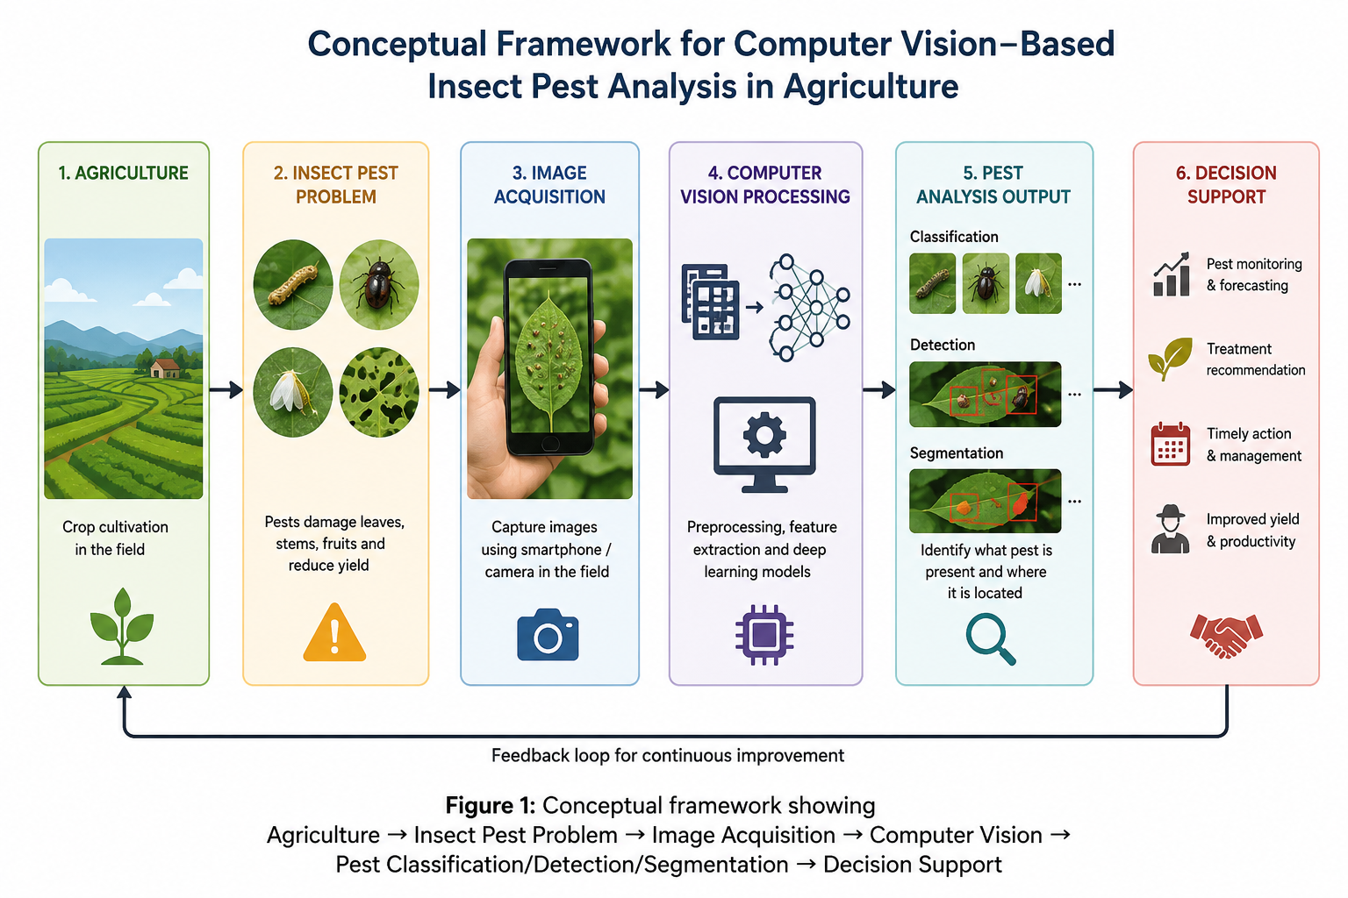
Figure 1. Conceptual framework for computer-vision-based insect pest analysis in agriculture.

2. Background

2.1 Conventional Insect Pest Identification
Traditional pest identification is generally based on visual inspection and expert knowledge. Farmers or agricultural technicians may observe insects directly on plants, examine characteristic damage symptoms, use traps, or consult taxonomic references. Expert identification can be highly accurate, particularly when morphological characteristics are examined carefully.
However, traditional approaches may face scalability limitations. Agricultural areas can be geographically dispersed, while trained entomologists and agricultural technicians may not be continuously available. Furthermore, identification can become difficult when insects are very small, visually similar, partially hidden, or present at different life stages.
It is therefore important to emphasize that computer vision should be viewed as a decision-support technology rather than a replacement for agricultural expertise. A practical system should assist farmers and agricultural professionals while allowing uncertain cases to be referred for expert confirmation.

2.2 Image-Based Pest Identification
Image-based pest identification transforms the pest-recognition problem into a computer-vision problem. A digital image is provided to a computational model, which extracts visual features and produces a prediction.
Depending on the desired output, the task can be formulated as:
- image classification,
- object detection,
- semantic segmentation, or
- instance segmentation.
The choice of task is important because agricultural applications do not always require the same type of output.

2.3 Image Classification
Image classification assigns an image to one or more predefined categories.
For example:
Input: photograph containing a pest
Output: “Fall armyworm”
Classification is appropriate when the primary question is:
“Which pest species is represented in this image?”
CNN architectures such as ResNet, DenseNet, EfficientNet, and MobileNet have been widely used for image-recognition tasks. ResNet introduced residual learning to facilitate the training of substantially deeper networks [10], while EfficientNet proposed systematic scaling of network depth, width, and image resolution to improve the accuracy-efficiency trade-off [11].
However, classification alone has an important limitation: it does not explicitly identify where the pest occurs within an image.

2.4 Object Detection
Object detection simultaneously identifies an object’s class and its spatial location.
For agricultural pest detection, the output can consist of bounding boxes:
Input: photograph of a crop
Output:
- Pest A — confidence 0.94 — bounding box
- Pest A — confidence 0.89 — bounding box
- Pest B — confidence 0.81 — bounding box
This is particularly useful when an image contains multiple insects or when the system must indicate where a pest is located.
YOLO introduced a unified object-detection framework that predicts bounding boxes and class probabilities using a single network [6]. Later YOLO versions continued to emphasize the trade-off between detection accuracy and computational speed. YOLOv4, for example, investigated combinations of training and architectural techniques intended to achieve high detection accuracy while maintaining real-time performance [7].
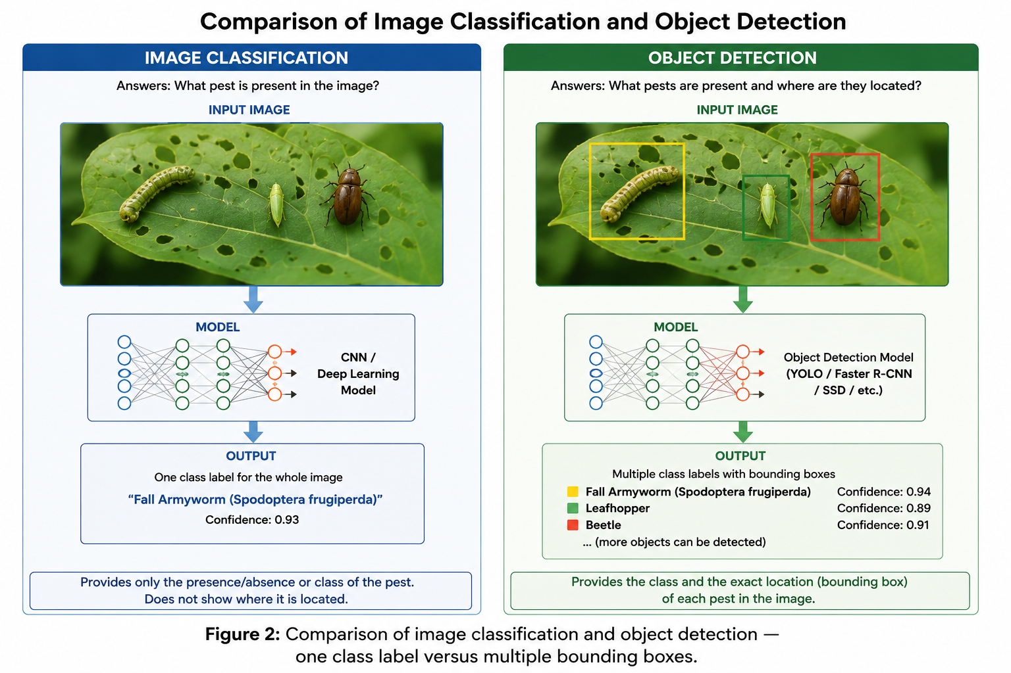
Figure 2. Comparison of image classification and object detection for insect pest analysis.

2.5 Image Segmentation
Segmentation provides a more detailed representation than classification or bounding-box detection.

2.5.1 Semantic Segmentation
Each pixel is assigned to a semantic class.

2.5.2 Instance Segmentation
Different objects belonging to the same class are separated from each other.
For pest monitoring, segmentation could potentially identify the exact pixels occupied by insects or damaged plant regions.
Segmentation can therefore be useful when the research question involves:
- exact pest boundaries,
- pest size estimation,
- damage-area estimation,
- multiple overlapping insects, or
- detailed plant-damage analysis.
However, segmentation usually requires more detailed annotations and therefore increases dataset-development costs.
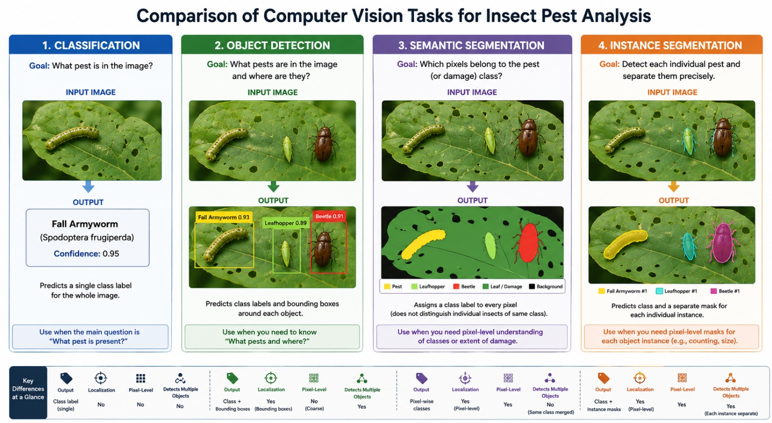
Figure 3. Comparison of classification, object detection, semantic segmentation, and instance segmentation.

2.6 Convolutional Neural Networks
CNNs have played a central role in modern computer vision. Rather than manually designing visual features, CNNs learn hierarchical representations from training images.
Earlier approaches to insect recognition often relied on manually engineered characteristics such as color, texture, shape, or edge information. Deep CNNs allow these representations to be learned directly from data.
ResNet is an important example of a deep CNN architecture. Its residual-learning formulation addressed optimization difficulties associated with increasing network depth and demonstrated strong image-recognition performance [10].
For pest recognition, CNNs can therefore be used to learn characteristics such as:
- body shape,
- wing structure,
- color patterns,
- texture,
- antennae,
- legs,
- crop-damage patterns.
However, the usefulness of learned features depends strongly on the quality and diversity of the training dataset.

2.7 Transfer Learning
Training a deep neural network from scratch requires substantial amounts of labeled data and computational resources. Transfer learning provides an alternative approach in which a model previously trained on a large dataset is adapted to a new task.
For example, a CNN pretrained on ImageNet can be fine-tuned using images of agricultural pests.
This is particularly relevant to Nepal because constructing a large, expert-annotated pest dataset from scratch is expensive.
A future Nepal-specific system could therefore investigate:
pretrained model → Nepalese pest dataset → fine-tuning → field evaluation
rather than training a very deep network from random initialization.

2.8 YOLO-Based Detectors
The YOLO family has become particularly relevant to real-time object detection because it formulates detection as a single end-to-end prediction problem [6].
For agricultural applications, real-time detection can be valuable because a practical system may eventually run on:
- smartphones,
- edge computers,
- drones,
- agricultural robots,
- low-cost field devices.
However, YOLO should not automatically be considered the best architecture for pest detection. Small insects, dense insect populations, occlusion, and complex backgrounds can create difficult detection conditions. Therefore, model selection should ultimately be based on experimental evidence and deployment requirements rather than popularity.

2.9 Vision Transformers
Vision Transformers (ViTs) apply transformer architectures to image patches rather than relying entirely on convolutional operations. Dosovitskiy et al. demonstrated that a pure transformer architecture can perform strongly on image-classification tasks when pretrained on sufficiently large datasets [12].
Transformers may provide useful capabilities for modeling relationships between distant regions of an image. Nevertheless, their computational and data requirements should be considered carefully when the eventual target environment is resource-constrained.
For Nepal-specific agricultural deployment, lightweight CNNs or compact detection models may sometimes be more practical than very large transformer models.

2.10 Lightweight and Edge Models
A research model with high accuracy but large computational requirements may not be suitable for field deployment.
MobileNet was designed specifically for efficient mobile and embedded vision applications and uses depthwise separable convolutions to reduce computational requirements [13]. EfficientNet similarly emphasizes accuracy-efficiency trade-offs [11].
This suggests that future Nepal-focused research should not evaluate models only according to predictive performance. It should also consider:
- inference latency,
- model size,
- memory consumption,
- energy consumption,
- hardware requirements,
- offline capability.

3. Systematic Review Methodology

3.1 Review Design
This study adopts a systematic-review design to identify, organize, and synthesize research on computer-vision-based agricultural insect pest detection.
The reporting of the review should follow the principles of PRISMA 2020. PRISMA 2020 provides guidance for transparent reporting of systematic reviews and includes a 27-item reporting checklist and updated flow diagrams [9].
The review protocol and eligibility criteria were defined before final study selection to reduce arbitrary inclusion of studies.

3.2 Research Questions
The review is guided by the following research questions:
RQ1: What computer-vision methods have been used for agricultural insect pest recognition and detection?
RQ2: Which crops and insect pest species have received the greatest research attention?
RQ3: What datasets, image-acquisition environments, annotation strategies, and dataset sizes have been used?
RQ4: Which evaluation metrics are commonly reported, and to what extent are results comparable across studies?
RQ5: What limitations related to generalization, dataset quality, environmental variation, and deployment are reported?
RQ6: What research gaps are particularly relevant to insect pest detection in Nepalese agriculture?
RQ7: What methodological and technological directions should guide future Nepal-specific experimental research?

3.3 Information Sources
To identify relevant studies on computer-vision-based insect pest detection in agriculture, searches were conducted across multiple scholarly databases. The databases used in this systematic review were IEEE Xplore, SpringerLink, and ScienceDirect. These databases were selected because they provide substantial coverage of research in computer vision, artificial intelligence, machine learning, deep learning, and agricultural applications.
The searches were restricted to studies published between 2018 and 2025. The retrieved records were exported from each database and combined into a single dataset for subsequent duplicate removal and eligibility assessment.
The database searches produced a total of 381 records, comprising 171 records from IEEE Xplore, 199 records from SpringerLink, and 11 records from ScienceDirect.
Table 1. Database search results.
Database | Records identified
IEEE Xplore | 171
SpringerLink | 199
ScienceDirect | 11
Total | 381

3.4 Search Strategy
The search strategy was developed around three main concepts: agricultural insect pests, computer vision and image-based techniques, and agricultural or crop applications.
The general search strategy was based on combinations of the following terms:
("insect pest" OR "crop pest" OR "agricultural pest")
AND
("computer vision" OR "machine vision" OR "image processing"
OR "image recognition" OR "image classification"
OR "object detection" OR segmentation
OR "deep learning" OR "machine learning"
OR CNN OR "convolutional neural network"
OR YOLO OR "Faster R-CNN" OR "Mask R-CNN"
OR transformer OR "vision transformer")
AND
(agricultur* OR crop* OR farm* OR field*)
Database-specific adaptations of the search expression were used where necessary to account for differences in search syntax and available search fields.
A separate Nepal-focused search was used to identify studies specifically addressing agricultural pest detection in Nepal:
(Nepal OR Nepalese)
AND
("insect pest" OR "crop pest" OR "agricultural pest")
AND
("computer vision" OR "machine vision"
OR "image recognition" OR "image classification"
OR "object detection" OR "deep learning"
OR "machine learning" OR CNN OR YOLO)
Additional crop-specific searches used combinations of pest-related terms, computer-vision terms, and crop names relevant to Nepal, including rice, maize, wheat, potato, tomato, and other important agricultural crops.
All retrieved records were exported for duplicate checking and subsequent eligibility assessment.

3.5 Inclusion Criteria
A retrieved study was considered eligible for inclusion when it satisfied the following criteria:
- The study addressed agricultural insect pests, including pest identification, recognition, classification, detection, counting, monitoring, or segmentation.
- The study employed image-based or computer-vision-based techniques, including image processing, machine learning, deep learning, CNN-based methods, object detection, or image segmentation.
- The study was associated with an agricultural or crop-related application.
- The study provided sufficient methodological information to determine the computer-vision approach, dataset, experimental procedure, or evaluation method.
- The publication was a peer-reviewed research article or conference paper.
- The study was published between 2018 and 2025.
- Studies involving both plant diseases and insect pests were included when insect-pest detection, recognition, classification, or monitoring formed a substantive component of the study.

3.6 Exclusion Criteria
A study was excluded when it satisfied one or more of the following conditions:
- It focused exclusively on plant disease detection or classification without an insect-pest component.
- It focused on non-agricultural insect classification or recognition without relevance to agricultural pest management.
- It did not use image-based or computer-vision information for pest recognition, detection, classification, counting, monitoring, or segmentation.
- It relied exclusively on acoustic, sound-based, or non-visual sensing for pest detection.
- It addressed pest forecasting or prediction without an image-based pest-recognition or detection component.
- It focused on unrelated agricultural computer-vision applications such as crop classification, yield prediction, soil analysis, or crop mapping.
- It was a review, survey, editorial, opinion article, bibliometric study, or other secondary publication rather than a primary research study.
- It did not provide sufficient methodological information to determine whether it satisfied the inclusion criteria.
- It was outside the predefined publication period of 2018–2025.

3.7 Study Selection and Eligibility Screening
The study-selection procedure consisted of two main stages following database retrieval:
Duplicate removal → Eligibility assessment
A total of 381 records were retrieved from the three selected databases: 171 from IEEE Xplore, 199 from SpringerLink, and 11 from ScienceDirect.
The records were combined into a single dataset and examined for duplicate publications using bibliographic information, including publication title and DOI. No duplicate title or DOI was identified among the retrieved records; therefore, 381 records remained after duplicate removal.
The remaining records were then assessed against the predefined inclusion and exclusion criteria. Records were excluded when they did not address agricultural insect pests using image-based or computer-vision techniques, when they focused exclusively on plant diseases, non-agricultural insects, acoustic pest detection, pest forecasting without visual recognition, unrelated agricultural applications, or secondary literature.
Based on eligibility assessment of the exported bibliographic records, 244 records were excluded and 137 records met the predefined eligibility criteria.
The study-selection process is summarized in Figure 4. The 137 records represent the eligibility-stage review corpus; the detailed benchmark values discussed later are drawn from the cited primary sources rather than from a pooled meta-analysis of all 137 records.
Table 2. Study-selection summary.
Selection stage | Number
Records identified from IEEE Xplore | 171
Records identified from SpringerLink | 199
Records identified from ScienceDirect | 11
Total records identified | 381
Duplicate records removed | 0
Records assessed for eligibility | 381
Records excluded | 244
Records meeting eligibility criteria | 137
Records retained in eligible review corpus | 137
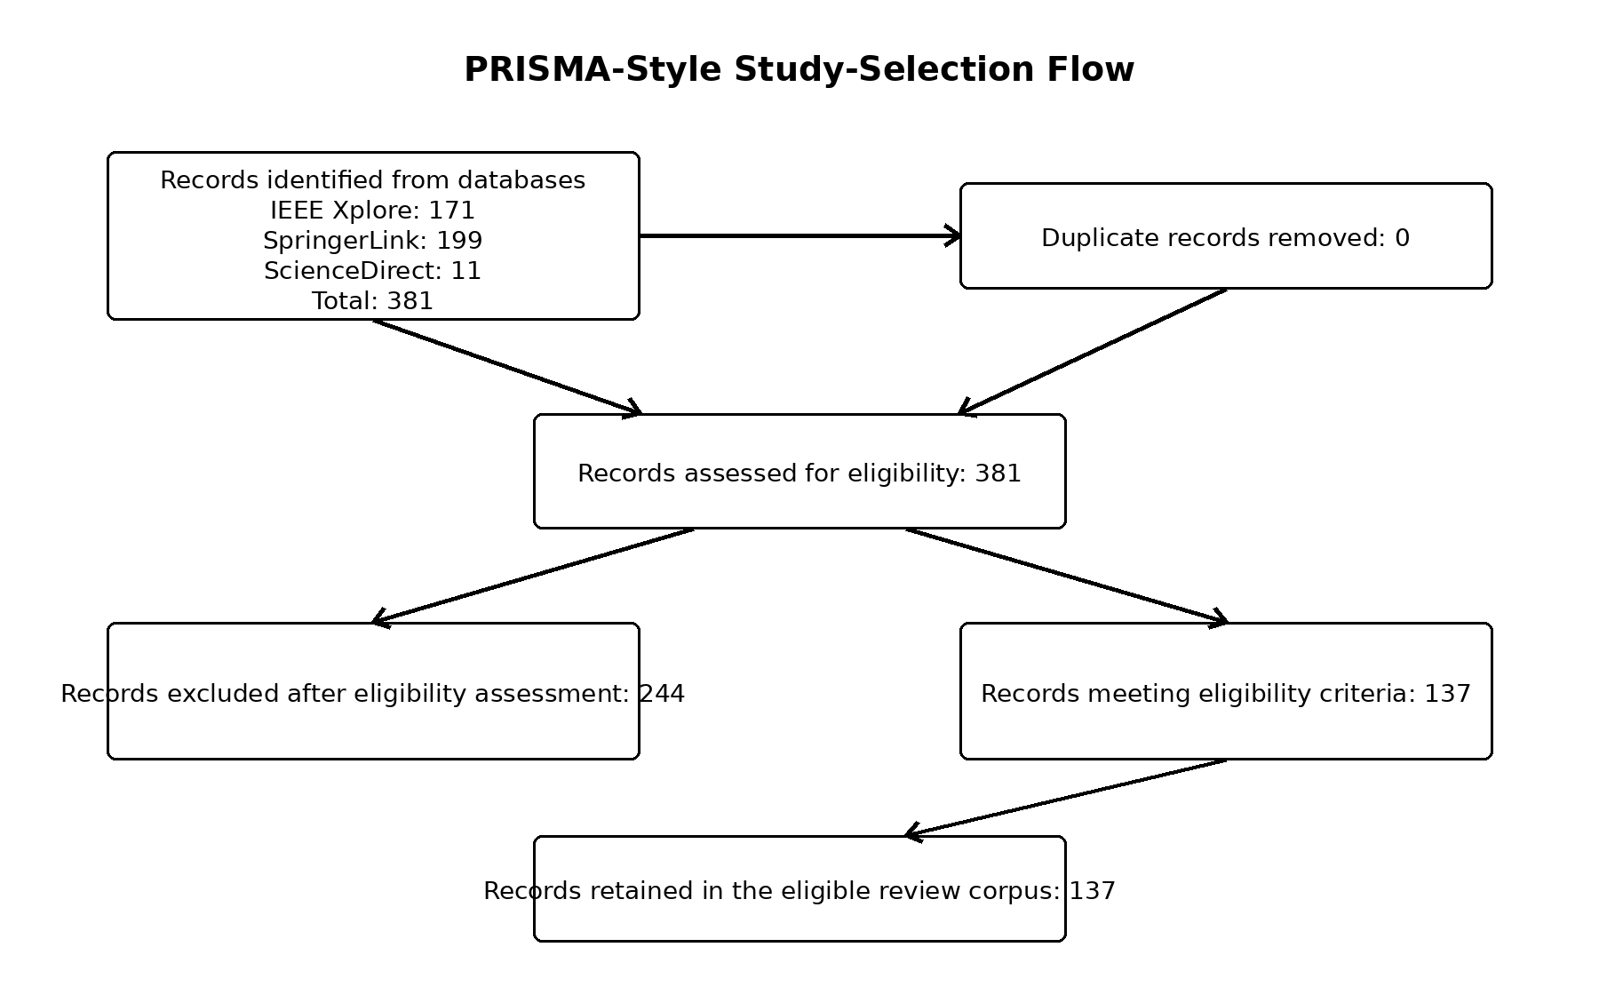
Figure 4. PRISMA-style study-selection flow for the database records used in this review.

3.8 Data Extraction
A standardized data-extraction form was developed to systematically record relevant information from each study satisfying the eligibility criteria.
The review framework recorded or evaluated the following variables where the information was available:
Table 3. Data-extraction variables.
Category | Variables
Publication | Year, authors, title, venue, DOI
Agricultural context | Crop, country, agricultural environment
Pest | Species, pest type, number of pest classes
Computer-vision task | Classification, detection, recognition, counting, segmentation
Dataset | Dataset name, number of images, source
Image acquisition | Camera, smartphone, UAV/drone, trap, fixed camera
Image environment | Laboratory, controlled environment, field, natural field
Annotation | Image-level labels, bounding boxes, segmentation masks
Model | CNN, YOLO, Faster R-CNN, Transformer, SVM, etc.
Training strategy | Transfer learning, augmentation, fine-tuning, optimization
Evaluation | Accuracy, precision, recall, F1-score, mAP, IoU
Validation | Train/test split, cross-validation, external validation, cross-location validation
Deployment | FPS, latency, model size, hardware
Reproducibility | Code, dataset, pretrained model availability
Limitations | Dataset, environmental, methodological, and generalization limitations

3.9 Quality Assessment
Methodological quality was considered using predefined criteria covering dataset quality, experimental design, validation procedures, and reporting practices.
The assessment will consider:
- clarity of dataset description;
- definition of pest classes;
- dataset size and composition;
- transparency of training, validation, and test splits;
- appropriateness of evaluation metrics;
- field-based validation;
- external or cross-location validation;
- availability of code or implementation details;
- availability of datasets; and
- reporting of computational and deployment requirements.
For future formal scoring or replication of the review, each criterion can be scored using the following scale:
- 0 = not reported or inadequate;
- 1 = partially reported;
- 2 = clearly reported or adequate.

3.10 Data Synthesis
Because the included studies are expected to vary substantially in terms of crops, pest species, datasets, image environments, computer-vision tasks, model architectures, and evaluation metrics, a direct numerical ranking of all models would not be appropriate.
Therefore, the evidence was synthesized using a structured qualitative approach.
Studies were organized, where reported information permitted, according to:
- computer-vision task;
- crop;
- pest species;
- geographic location;
- dataset characteristics;
- image acquisition method;
- image environment;
- model architecture;
- training strategy;
- evaluation metrics;
- validation strategy;
- deployment objective; and
- reproducibility.
Particular attention will be given to differences between controlled/laboratory image datasets and naturally captured field images, since performance obtained under controlled conditions may not translate directly to real-world agricultural environments.
The synthesis also examined the development of computer-vision-based pest detection methods between 2018 and 2025, including conventional image-processing approaches, machine-learning methods, CNN-based models, object-detection architectures such as YOLO and Faster R-CNN, lightweight models designed for edge devices, and Transformer-based approaches.
Where studies used sufficiently comparable datasets, tasks, and evaluation metrics, their findings were discussed comparatively. Results from fundamentally different experimental settings were not directly ranked.
The synthesis identified research gaps relevant to insect pest detection in major crops of Nepal, particularly regarding Nepal-specific datasets, pest diversity, field-based image acquisition, model generalization, validation across locations, and deployment in resource-constrained agricultural environments.

4. Major Crop and Pest Context in Nepal
Nepal’s agricultural system includes a broad range of cereal crops, vegetables, fruits, and other commodities. Official agricultural statistics provide crop-production information that can be used to define the scope of crops considered in this review [1,14].
For this review, the crop context focuses on rice, maize, wheat, potato, tomato, cucurbits, and other crops for which reliable evidence of economically important insect-pest problems was available.
Crop selection was guided by criteria such as:
- agricultural importance,
- production volume,
- documented pest pressure,
- availability of pest information,
- relevance to computer-vision research.
This prevents the phrase “major crops” from becoming subjective.

4.1 Rice
Rice is a major crop in Nepal and is affected by diverse insect populations. Field research in Lamahi, Dang, for example, documented multiple insect groups in lowland rice fields, with grasshoppers and brown planthoppers among the more abundant groups observed in that study [3].
Potential computer-vision research opportunities include:
- pest classification,
- pest detection on leaves,
- detection of multiple insects,
- field-based pest monitoring.
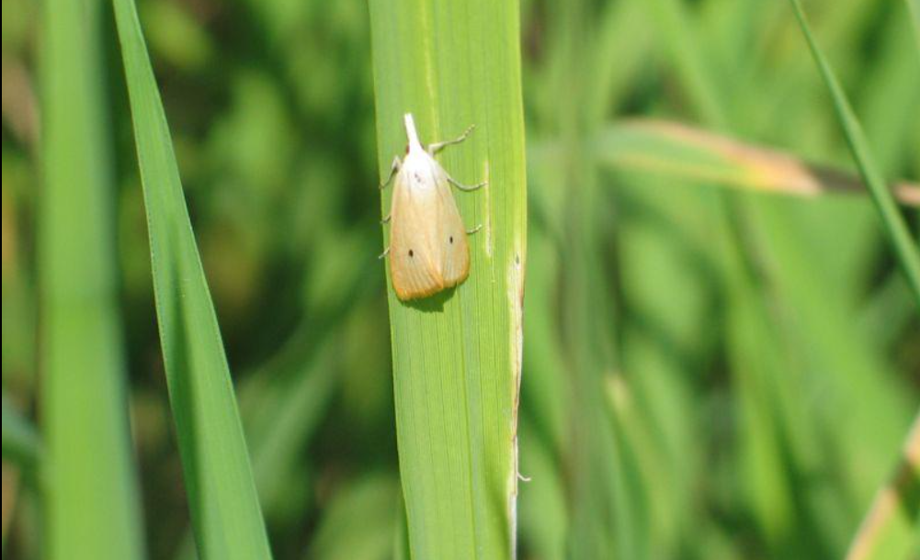
Figure 5. Representative rice pest image: yellow stem borer (Scirpophaga incertulas) on rice.
- Common name: Yellow stem borer
- Scientific name: Scirpophaga incertulas
- Crop: Rice (Oryza sativa)
- Importance: A major rice pest; larvae bore into rice stems and can cause “dead heart” in young plants and “white ear” symptoms at the reproductive stage.
- Nepal: It has been documented as a rice pest in Nepal.

4.2 Maize
Maize is another major crop relevant to Nepalese agriculture. In particular, fall armyworm (Spodoptera frugiperda) has become an important pest following its detection in Nepal in 2019 and subsequent spread across different regions [15].
This pest represents a particularly interesting computer-vision target because different developmental stages and field conditions may produce substantial visual variation.
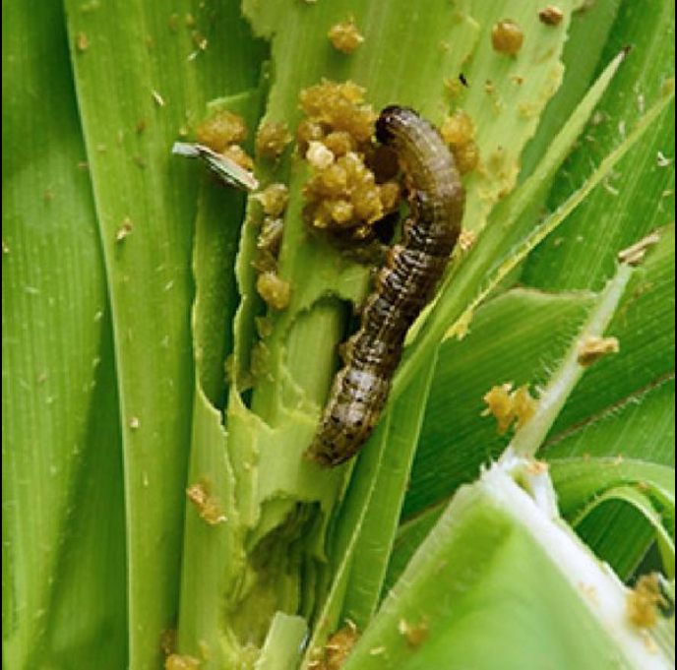
Figure 6. Representative maize image showing fall armyworm damage and larva.

4.3 Wheat
Wheat is an important cereal crop in Nepal and can be affected by several insect pests.
For computer-vision research, wheat provides opportunities for investigating pest identification under field conditions and distinguishing pest damage from other causes of visual variation.
Because the available evidence for wheat was less specific than for some other crops, the review treats aphids as a representative wheat-pest group and avoids assuming that pest rankings from other countries apply unchanged to Nepal.
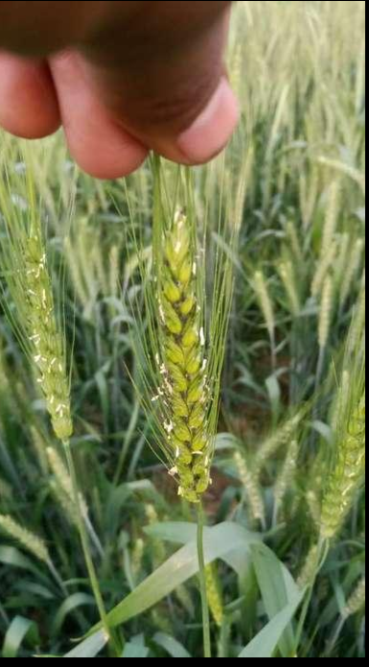
Figure 7. Representative wheat image showing aphid infestation.

4.4 Potato
Potato production is also important in Nepal and has documented pest-management requirements. NARC’s agricultural library contains technical material specifically addressing potato cultivation and pest management, demonstrating the relevance of pest management to this crop [16].
Potential computer-vision research could involve:
- insect detection,
- leaf-damage detection,
- pest classification,
- integrated crop-health assessment.
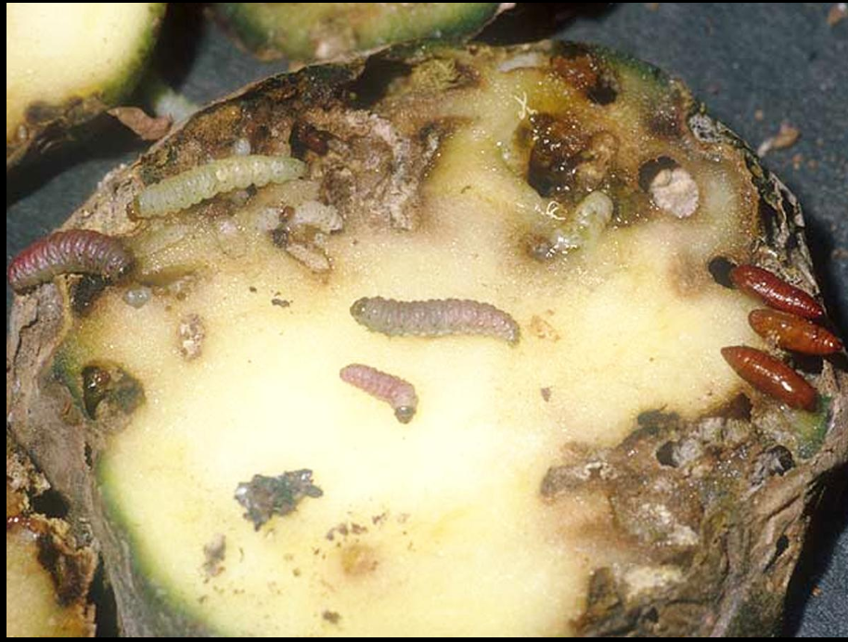
Figure 8. Representative potato image showing potato tuber moth (Phthorimaea operculella) larvae and tuber damage.

4.5 Tomato
Tomato is an important vegetable crop and has received attention in Nepalese pest-management research. Recent Nepalese research has investigated the tomato leaf miner Tuta absoluta in western Nepal, identifying it as a major tomato pest and examining monitoring and management approaches [4].
This provides an especially relevant candidate for future image-based detection because visible pest damage and insect presence can potentially be captured through field photographs.
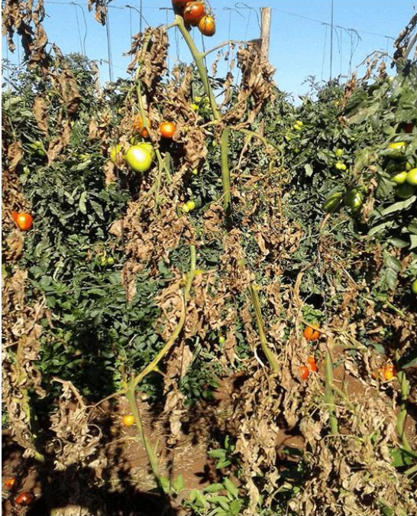
Figure 9. Representative tomato plant image showing pest-related damage associated with Tuta absoluta.

4.6 Cucurbits and Other Vegetables
Insect pests are also important in cucurbit production. A study conducted in Arghakhanchi reported red pumpkin beetle as an important pest during seedling and vegetative stages and fruit flies as important during the fruiting stage [5].
Such findings demonstrate that pest importance varies according to crop and crop-development stage.
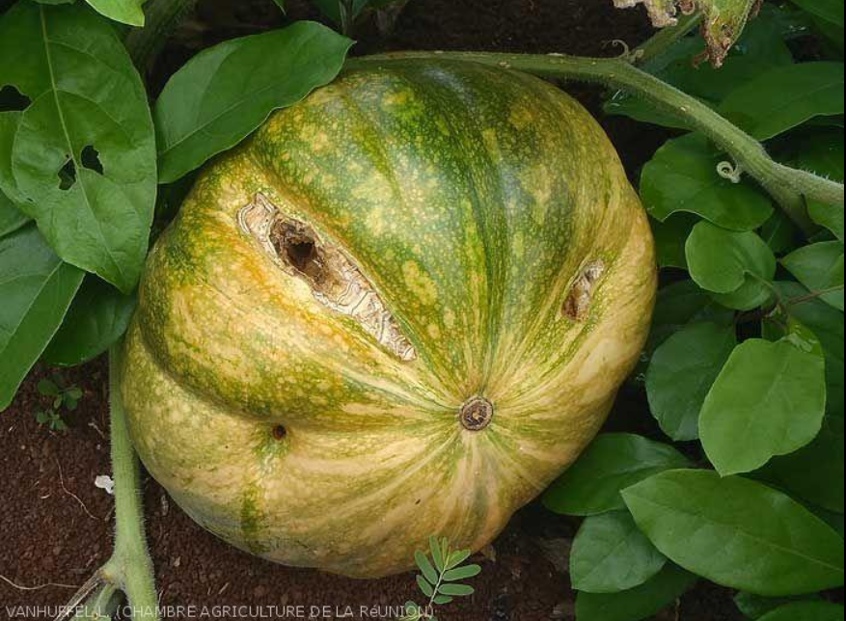
Figure 10. Representative cucurbit fruit image showing pest-related damage associated with cucurbit fruit fly.

4.7 Proposed Crop-Pest Mapping Framework
Table 4. Crop-pest mapping and Nepal-specific computer-vision evidence gaps.
Crop | Representative important pest(s) | Damage type | Existing CV evidence | Nepal-specific CV evidence / gap
Rice | Yellow stem borer (Scirpophaga incertulas) | Stem/tiller damage, dead hearts and whiteheads | International CV evidence exists for automated rice-pest identification/detection, including deep-learning approaches. However, pest-specific evidence for yellow stem borer should be confirmed during systematic screening. | No Nepal-specific CV study was identified in the targeted search. Nepal-specific research on yellow stem borer focuses mainly on occurrence, biology, damage and management rather than computer vision. Potential gap: Nepal field-image datasets and CV models specifically targeting yellow stem borer damage.
Maize | Fall armyworm (Spodoptera frugiperda) and other insect pests | Leaf/whorl damage | Strong international evidence exists, including CNN/deep-learning and YOLO-based pest/damage detection. | A Nepal-specific study published after the 2018–2025 review window collected 1,395 insect-damaged corn-leaf images in Pokhara, Nepal, covering fall armyworm and grasshopper damage, and evaluated YOLOv10 architectures [17]. It is treated here as contextual evidence rather than as part of the screened 2018–2025 corpus. Broader multi-pest, multi-location, and field-generalization evidence remains limited.
Wheat | Aphids | Leaf/stem/grain damage | International CV evidence exists for agricultural pest detection, including deep-learning/object-detection approaches, but wheat-aphid-specific CV evidence appears less developed than major applications such as tomato Tuta absoluta or maize pests. | No Nepal-specific CV study was identified in the targeted search. Nepal has agricultural research concerning wheat aphids, but this does not constitute CV evidence. Potential gap: Nepal-specific image datasets and CV systems for wheat aphid detection and damage assessment.
Potato | Potato tuber moth (Phthorimaea operculella) | Leaf/tuber damage | CV evidence for agricultural/potato pest detection exists, but direct computer-vision research specifically targeting potato tuber moth appears limited compared with other pest-crop combinations. | No Nepal-specific CV study was identified in the targeted search. Nepal has documented potato tuber moth and other potato pests, but dedicated Nepal field-image CV detection/segmentation evidence was not identified. Potential gap: Nepal-specific potato pest datasets and models, particularly for tuber moth damage.
Tomato | Tuta absoluta | Leaf/fruit damage | Strong international CV evidence exists. CNN-based classification, object detection and image segmentation approaches have been investigated for Tuta absoluta infestation and damage. | No Nepal-specific CV study was identified in the targeted search. Nepal has documented Tuta absoluta as an important tomato pest, but the identified Nepal literature concerns pest occurrence/management rather than Nepal-specific CV. Potential gap: Nepal-field-image datasets and validated CV models for Tuta absoluta detection and damage quantification.
Cucurbits | Cucurbit fruit flies (Bactrocera/Zeugodacus spp.) | Mainly fruit damage; associated feeding/infestation symptoms | CV evidence appears limited for this specific pest-crop combination. General deep-learning/object-detection methods for agricultural insect pests demonstrate technical feasibility, but dedicated cucurbit-fruit-fly CV studies appear much less common. | No Nepal-specific CV study was identified in the targeted search. Nepal has conventional agricultural research on cucurbit fruit flies, but dedicated CV-based detection or damage quantification using Nepal field images was not identified. Potential gap: Nepal-specific datasets and CV models for cucurbit fruit-fly infestation and damage.

5. Review of Computer-Vision Methods

5.1 Methodological Classification
Existing studies can be organized into four broad categories:
- Image classification
- Object detection
- Semantic segmentation
- Instance segmentation
The appropriate approach depends on the intended application.
Table 5. Computer-vision tasks and agricultural applications.
Task | Output | Agricultural application
Classification | Class label | Identify pest species
Object detection | Class + bounding box | Locate and count pests
Semantic segmentation | Pixel-level classes | Estimate affected areas
Instance segmentation | Individual object masks | Separate overlapping pests

5.2 Classification-Based Approaches
Classification models are appropriate when each image is primarily associated with one pest class.
Common architectures include:
- CNN
- ResNet
- DenseNet
- EfficientNet
- MobileNet
Their main advantages include relatively simple annotation requirements and mature transfer-learning techniques.
However, classification becomes less suitable when an image contains multiple insects or when precise pest localization is required.

5.3 Object-Detection Approaches
Object detection is particularly attractive for real-world pest monitoring because a single field image may contain multiple insects.
Representative approaches include:
- Faster R-CNN
- SSD
- YOLO-family models
YOLO’s original formulation treated object detection as a unified regression problem and emphasized real-time inference [6]. Later versions introduced architectural and training improvements aimed at balancing speed and accuracy [7].
For a future Nepal-specific system, object detection may provide a useful compromise between information content and annotation complexity.

5.4 Segmentation Approaches
Segmentation provides more detailed spatial information but requires more expensive annotations.
Segmentation can be particularly useful when the research objective is not simply pest identification but also:
- measuring pest size,
- estimating damaged leaf area,
- separating overlapping insects,
- quantifying disease or pest severity.
However, the increased annotation burden may be a major limitation when constructing a Nepal-specific dataset.

5.5 CNN-Based Models
CNN architectures remain important because they can learn hierarchical visual representations directly from images.
ResNet provides a strong general-purpose architecture [10], while EfficientNet explicitly considers computational efficiency during model scaling [11].
These characteristics make CNNs useful baseline candidates for future experimental research.

5.6 Transformer-Based Models
Vision Transformers provide an alternative to convolution-based architectures by processing images as sequences of patches [12].
The growing use of transformer architectures suggests that future pest-detection research may increasingly investigate attention-based models.
However, their suitability for Nepalese field deployment should be assessed empirically, particularly when hardware and training-data constraints are significant.

6. Dataset Analysis
Dataset quality is one of the most important factors affecting the reliability of computer-vision-based insect-pest recognition. Among the datasets identified in the reviewed literature, IP102 is particularly relevant because of its scale, hierarchical organization, class imbalance, field-oriented image characteristics, and support for both classification and object-detection research [8].
IP102 contains 75,222 images representing 102 insect-pest classes. The dataset follows a natural long-tailed distribution rather than an artificially balanced class distribution. This characteristic makes IP102 useful for evaluating pest-recognition methods under conditions that more closely resemble real-world pest occurrence, where some pest species are substantially more common than others [8].
For the Nepalese agricultural context considered in this review, the most directly relevant IP102 crop groups are rice, corn/maize, and wheat. These three crops are major agricultural crops in Nepal and together correspond to 36 pest classes and 25,850 images in IP102. These subsets therefore provide useful international benchmark evidence for understanding the technical challenges likely to arise in computer-vision-based pest recognition for Nepal. However, they should not be interpreted as Nepal-specific datasets because the IP102 images were not collected specifically from Nepal.

6.1 Dataset Size and Structure
The complete IP102 classification dataset contains:
- Total images: 75,222
- Pest classes: 102
- Training images: 45,095
- Validation images: 7,508
- Testing images: 22,619
- Average images per class: approximately 737
- Detection images with bounding-box annotations: 18,983
The classification dataset uses an approximately 6:1:3 training-validation-testing split. Based on the exact image counts, the proportions are approximately:
Training proportion:
45,095 / 75,222 × 100 = 59.95%
Validation proportion:
7,508 / 75,222 × 100 = 9.98%
Testing proportion:
22,619 / 75,222 × 100 = 30.07%
Thus, approximately 60% of the images are used for training, 10% for validation, and 30% for testing.
For object detection, IP102 contains 18,983 images with bounding-box annotations. The original benchmark reports 15,178 training images and approximately 3,800 testing images for the detection task [8].
Table 6. IP102 classification dataset distribution.
Dataset/Subset | Pest Classes | Training | Validation | Testing | Total Images | Imbalance Ratio
Rice | 14 | 5,043 | 843 | 2,531 | 8,417 | 6.4
Corn/Maize | 13 | 8,404 | 1,399 | 4,212 | 14,015 | 27.9
Wheat | 9 | 2,048 | 340 | 1,030 | 3,418 | 5.2
Beet | 8 | 2,649 | 441 | 1,330 | 4,420 | 15.4
Alfalfa | 13 | 6,230 | 1,037 | 3,123 | 10,390 | 10.7
Vitis | 16 | 10,525 | 1,752 | 5,274 | 17,551 | 74.8
Citrus | 19 | 4,356 | 725 | 2,192 | 7,273 | 17.6
Mango | 10 | 5,840 | 971 | 2,927 | 9,738 | 61.7
Complete IP102 | 102 | 45,095 | 7,508 | 22,619 | 75,222 | 80.8
For the three crop groups most directly relevant to staple-crop agriculture in Nepal:
Rice + Corn/Maize + Wheat = 8,417 + 14,015 + 3,418 = 25,850 images
Number of pest classes = 14 + 13 + 9 = 36 pest classes
These three groups therefore account for:
25,850 / 75,222 × 100 ≈ 34.36% of the complete IP102 dataset.
This is a substantial subset, although it remains an international benchmark rather than a Nepal-specific dataset.

6.2 Class Imbalance
Class imbalance is a major characteristic of IP102. The complete dataset has an imbalance ratio of approximately 80.8, indicating a substantial difference between highly represented and poorly represented pest classes [8]. The smallest individual category contains only 71 samples.
The imbalance also varies considerably among crop groups. Rice has an imbalance ratio of 6.4 and wheat 5.2, whereas corn/maize has a considerably higher imbalance ratio of 27.9. At the broader level, some economic-crop groups are even more imbalanced; Vitis, for example, has an imbalance ratio of 74.8.
This has direct implications for evaluation. Overall accuracy alone may overrepresent performance on majority classes. Consequently, precision, recall, F1-score, G-mean, and class-specific performance are more informative when evaluating models on IP102.
The original IP102 experiments demonstrate this effect clearly. The best baseline ResNet model obtained 49.4% overall classification accuracy but only 31.5% G-mean [8]. The 17.9 percentage-point difference indicates that overall accuracy hides weaker performance across underrepresented classes.
Therefore, studies using naturally imbalanced pest datasets should not report accuracy as the sole evaluation metric.

6.3 Image Acquisition Environment
Another important characteristic of IP102 is its visual diversity. Unlike datasets constructed entirely from laboratory images with uniform backgrounds, IP102 was designed to contain realistic and visually complex pest images.
Images may contain:
- complex backgrounds,
- variable illumination,
- different pest orientations,
- small pest objects,
- background clutter,
- different developmental stages,
- variation in object scale,
- partial visibility, and
- considerable intra-class appearance variation.
IP102 also retains different developmental forms of pests, including eggs, larvae, pupae, and adults [8]. Consequently, images assigned to the same pest class can differ substantially in shape, size, color, and texture.
This property is particularly important for agricultural computer vision because a system deployed in Nepalese fields would similarly encounter uncontrolled image-acquisition conditions.
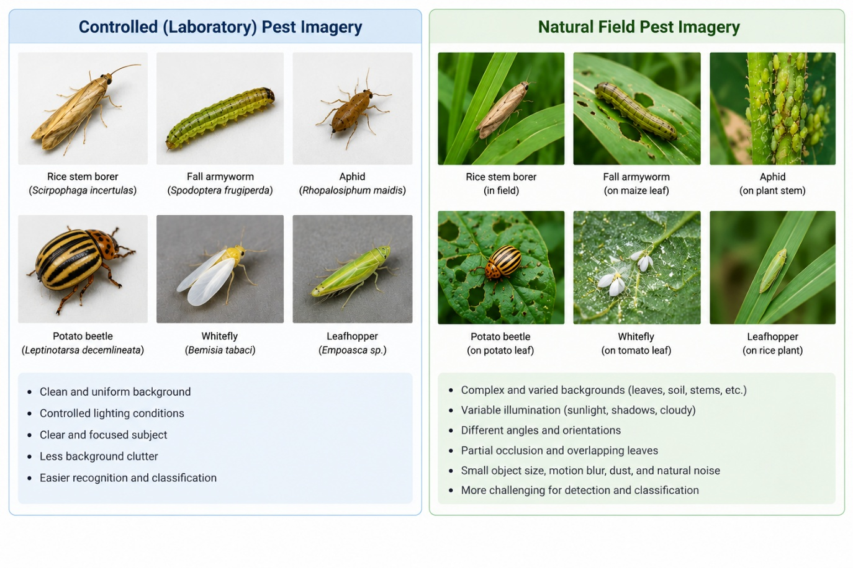
Figure 11. Representative comparison between relatively controlled pest imagery and complex natural-field pest imagery.

6.4 Annotation Type
IP102 supports two principal computer-vision tasks.
For classification, each image is associated with an insect-pest class label. The complete classification dataset contains 75,222 images covering 102 classes.
For object detection, approximately 19,000 images were additionally annotated using bounding boxes following the Pascal VOC annotation format [8]. The published dataset contains 18,983 detection images.
The distinction is important because classification answers:
“Which pest species is present in this image?”
whereas object detection additionally answers:
“Where is the pest located in the image?”
Detection is consequently more useful when pests occupy only a small portion of a complex agricultural image.
IP102 does not provide a complete segmentation-mask benchmark comparable to its classification and bounding-box annotations. Therefore, semantic or instance segmentation experiments would require additional pixel-level annotation.

6.5 Geographic Diversity and Relevance to Nepal
Although IP102 provides valuable benchmark data, it should not be treated as direct evidence of model performance in Nepal.
The dataset was constructed primarily from images collected through internet search engines, agricultural websites, insect-science sources, and extracted video frames, followed by expert verification [8]. It was not constructed specifically from Nepalese agricultural fields.
Consequently, a model performing well on IP102 may still encounter domain shift when applied in Nepal because of differences in:
- crop varieties,
- pest populations,
- altitude,
- climate,
- field background,
- agricultural practices,
- camera devices,
- lighting conditions, and
- pest developmental characteristics.
IP102 is therefore most appropriately regarded as an international benchmark and potential pre-training dataset, rather than a replacement for a Nepal-specific pest dataset.

6.6 Dataset Comparison and Nepal-Relevant IP102 Subsets
Table 7. IP102 subsets most relevant to the present review.
Crop | Pest Classes | Images | Train | Validation | Test | Task | Annotation | Direct Nepal-Specific Data
Rice | 14 | 8,417 | 5,043 | 843 | 2,531 | Classification/Detection | Labels/boxes | No
Corn/Maize | 13 | 14,015 | 8,404 | 1,399 | 4,212 | Classification/Detection | Labels/boxes | No
Wheat | 9 | 3,418 | 2,048 | 340 | 1,030 | Classification/Detection | Labels/boxes | No
IP102 Complete | 102 | 75,222 | 45,095 | 7,508 | 22,619 | Classification/Detection | Labels/boxes | No
The table demonstrates that IP102 contains substantial data relevant to rice, maize, and wheat pest recognition. Nevertheless, benchmark availability should not be confused with geographic representativeness. A major finding of this review is therefore that international datasets can support algorithm development and transfer learning, but locally collected field images remain necessary for evaluating Nepal-specific generalization.

7. Evaluation Metrics and Benchmark Performance
Evaluation metrics depend on whether the computer-vision system performs classification or object detection. Because IP102 is highly imbalanced, the original authors evaluated classification using multiple metrics rather than accuracy alone [8].

7.1 Classification Metrics

7.1.1 Accuracy
Accuracy measures the proportion of predictions that are correct:
Accuracy = (TP + TN) / (TP + TN + FP + FN)
where:
TP = True Positive
TN = True Negative
FP = False Positive
FN = False Negative
For multiclass classification, accuracy can equivalently be expressed as:
Accuracy = Number of correctly classified images / Total number of evaluated images
Accuracy is easy to interpret but may be misleading for imbalanced datasets.

7.1.2 Precision
Precision measures the proportion of predicted positive instances that are actually positive:
Precision = TP / (TP + FP)
High precision means that relatively few instances are incorrectly assigned to the class.

7.1.3 Recall
Recall measures the proportion of actual positive instances successfully identified:
Recall = TP / (TP + FN)
High recall indicates that the model misses relatively few examples of the target pest.

7.1.4 F1-Score
The F1-score is the harmonic mean of precision and recall:
F1 = 2 × (Precision × Recall) / (Precision + Recall)
F1-score is particularly useful when both false positives and false negatives are important.

7.1.5 G-Mean
For imbalanced classification, geometric mean provides information about balanced class-wise sensitivity. The IP102 benchmark includes G-mean specifically because overall accuracy may hide poor recognition of minority classes.

7.1.6 MAUC
Multi-class Area Under the Curve (MAUC) summarizes the ability of a classifier to distinguish classes across decision thresholds. The IP102 benchmark also reports MAUC to provide a broader evaluation of performance under class imbalance.

7.2 Published Classification Performance on IP102
The original IP102 study evaluated several convolutional neural networks. Models pre-trained on ImageNet and subsequently fine-tuned on IP102 substantially outperformed models trained from scratch.
Table 8. Published deep-learning classification baselines on IP102.
Model | F1-score (%) | G-mean (%) | Accuracy (%) | F1 from Scratch (%) | G-mean from Scratch (%) | Accuracy from Scratch (%)
AlexNet | 34.1 | 27.0 | 41.8 | 29.1 | 22.2 | 35.3
GoogLeNet | 32.7 | 21.3 | 43.5 | 27.0 | 11.3 | 40.2
VGGNet | 38.7 | 30.9 | 48.2 | 33.3 | 25.5 | 41.4
ResNet | 40.1 | 31.5 | 49.4 | 29.6 | 22.2 | 35.7
Among these baseline CNN models, the fine-tuned ResNet achieved the highest reported accuracy of 49.4%, F1-score of 40.1%, and G-mean of 31.5%.
The result is significant for two reasons. First, an accuracy below 50% despite the use of a strong CNN demonstrates the difficulty of the 102-class pest-recognition problem. Second, the difference between accuracy (49.4%) and G-mean (31.5%) demonstrates the effect of the long-tailed class distribution.
Pre-training was also important. ResNet accuracy decreased from 49.4% with ImageNet pre-training to 35.7% when trained from scratch, corresponding to a decrease of:
49.4 − 35.7 = 13.7 percentage points.
For VGGNet, the corresponding reduction was:
48.2 − 41.4 = 6.8 percentage points.
These results provide evidence supporting transfer learning when pest datasets contain many classes with relatively few examples.

7.3 Performance on Nepal-Relevant Crop Groups
The original IP102 study additionally evaluated ResNet separately within the eight crop-based groups. The rice, corn/maize, and wheat results are particularly relevant to this review.
Table 9. ResNet performance on rice, corn/maize, and wheat IP102 subsets.
Crop | Classes | Precision (%) | Recall (%) | F1 (%) | G-mean (%) | MAUC (%) | Accuracy (%)
Rice | 14 | 31.5 | 30.0 | 30.4 | 28.3 | 32.3 | 32.1
Corn/Maize | 13 | 55.1 | 54.4 | 54.6 | 50.3 | 61.9 | 62.2
Wheat | 9 | 37.5 | 34.5 | 35.5 | 29.3 | 52.1 | 53.0
The results reveal substantial differences among crop groups.
Corn/maize produced the strongest classification performance, with 62.2% accuracy and 54.6% F1-score. Wheat achieved 53.0% accuracy and 35.5% F1-score. Rice was substantially more difficult, with only 32.1% accuracy and 30.4% F1-score.
The difference between corn/maize and rice accuracy is:
62.2 − 32.1 = 30.1 percentage points.
The difference between wheat and rice is:
53.0 − 32.1 = 20.9 percentage points.
These results demonstrate that performance on one crop group should not automatically be generalized to another.
The rice result is particularly important to the Nepalese context. The IP102 authors attribute the difficulty of rice-pest recognition to factors including similarity between pest and background colors, high intra-class variation across developmental stages, and visual similarity among different rice-pest species [8].
Thus, the existence of a large dataset alone does not guarantee high recognition accuracy.

7.4 Object-Detection Metrics
Classification metrics alone are insufficient when the objective is to locate pests within field images.

7.4.1 Intersection over Union
Intersection over Union measures the spatial overlap between a predicted bounding box and the ground-truth bounding box:
IoU = Area of Intersection / Area of Union
An IoU value of 1 represents perfect overlap, while an IoU value of 0 represents no overlap.

7.4.2 Average Precision
Average Precision summarizes the precision-recall relationship for an object class.

7.4.3 Mean Average Precision
For multiple classes:
mAP = (1/N) Σ APᵢ
where N represents the number of evaluated classes and APᵢ represents the Average Precision for class i.
Modern object-detection evaluations commonly report AP averaged across multiple IoU thresholds as well as AP at specific thresholds.
The IP102 benchmark uses:
AP: IoU = 0.50:0.05:0.95
AP50: IoU = 0.50
AP75: IoU = 0.75
A higher IoU threshold requires more accurate localization.

7.5 Published Object-Detection Performance on IP102
Table 10. Object-detection benchmark results on IP102.
Detector | Backbone | AP (%) | AP50 (%) | AP75 (%)
Faster R-CNN | VGG-16 | 21.05 | 47.87 | 15.23
FPN | ResNet-50 | 28.10 | 54.93 | 23.30
SSD300 | VGG-16 | 21.49 | 47.21 | 16.57
RefineDet | VGG-16 | 22.84 | 49.01 | 16.82
YOLOv3 | DarkNet-53 | 25.67 | 50.64 | 21.79
FPN with ResNet-50 achieved the strongest detection result among the evaluated methods, with AP = 28.10%, AP50 = 54.93%, and AP75 = 23.30%.
YOLOv3 achieved the strongest performance among the evaluated one-stage detectors, with AP = 25.67%.
The difference between FPN and YOLOv3 was:
28.10 − 25.67 = 2.43 percentage points in AP.
At IoU = 0.50:
54.93 − 50.64 = 4.29 percentage points.
The relatively low AP values across all detectors demonstrate that localization and classification of insects in realistic images remains considerably more difficult than simply recognizing large, visually distinctive objects.
The large differences between AP50 and AP75 further demonstrate the difficulty of accurate localization. For FPN:
54.93 − 23.30 = 31.63 percentage points.
Thus, many detections that satisfy the relatively lenient IoU = 0.50 criterion fail when more accurate localization is required.

7.6 Computational Metrics
Predictive performance alone is insufficient for evaluating models intended for practical agricultural deployment.
Future Nepal-specific experimental studies should additionally report:
- inference time per image,
- frames per second (FPS),
- parameter count,
- model size,
- CPU/GPU requirements,
- peak memory consumption, and
- energy requirements where possible.
If average inference time per image is represented by t seconds, approximate throughput can be calculated as:
FPS = 1 / t
For example, a model requiring 0.05 seconds per image would theoretically process approximately:
1 / 0.05 = 20 FPS.
Computational metrics should be measured on explicitly reported hardware because FPS measured on a high-end GPU cannot be directly compared with FPS measured on a low-cost smartphone or CPU.

7.7 Interpretation of Cross-Study Performance
Numerical results reported by different computer-vision studies should not be ranked without considering differences in experimental design.
For example, 95% classification accuracy and 70% mAP do not imply that the classifier is superior to the detector because the metrics evaluate different tasks.
Cross-study comparisons may be affected by:
- dataset size,
- number of pest classes,
- class imbalance,
- image acquisition conditions,
- train-validation-test split,
- data augmentation,
- annotation quality,
- model pre-training,
- evaluation thresholds,
- hardware, and
- geographic distribution.
Consequently, this review interprets numerical results primarily as methodological evidence rather than constructing a simplistic ranking of reported percentages.

8. Nepal-Specific Research Gaps
The analysis of IP102 and the wider literature demonstrates that the principal research problem for Nepal is not simply identifying a higher-performing neural-network architecture. The more fundamental issue is whether models trained on international datasets can generalize reliably to Nepalese agricultural environments.

8.1 Dataset Gap
IP102 demonstrates what is possible with a large pest-recognition dataset: 75,222 images, 102 pest classes, expert-verified labels, a standardized train-validation-test split, and approximately 19,000 detection images.
However, an equivalent large-scale, publicly accessible dataset representing Nepalese insect pests and Nepalese field conditions was not identified in the reviewed evidence.
This represents an important research gap.
A Nepal-specific dataset should report:
- total number of images,
- images per pest class,
- crop associated with each pest,
- geographic collection location,
- developmental stage,
- field or laboratory acquisition,
- annotation type,
- train-validation-test split, and
- public availability.
International datasets such as IP102 can support transfer learning, but they cannot independently establish Nepal-specific model reliability.

8.2 Geographic Generalization Gap
Models trained on international datasets may encounter distribution shift when deployed in Nepal.
Potential sources include:
- climate,
- altitude,
- crop varieties,
- regional pest populations,
- farming practices,
- seasonal variation,
- background vegetation, and
- image-acquisition devices.
A particularly important future experiment would therefore be:
Train on IP102 → Test on independently collected Nepalese field images.
The performance difference between the IP102 test set and Nepalese test set would provide direct evidence of geographic domain shift.

8.3 Environmental Gap
Field environments contain uncontrolled visual conditions such as shadows, direct sunlight, cluttered vegetation, soil, damaged leaves, overlapping insects, partial occlusion, and small pest objects.
The relatively low IP102 detection AP values demonstrate that this remains a substantial technical problem. Even FPN, the strongest detector in the original IP102 benchmark, achieved only 28.10% AP.
Therefore, future Nepal-specific evaluation should contain deliberately difficult field images rather than relying exclusively on clean images.

8.4 Species and Life-Stage Gap
IP102 demonstrates that the same pest class may include eggs, larvae, pupae, and adults.
Such variation increases intra-class diversity.
At the same time, closely related pest species may have similar visual characteristics, increasing inter-class confusion.
This combination creates a fine-grained classification problem:
large variation within a class + small differences between classes.
Future Nepalese datasets should therefore record developmental stage where biologically appropriate.

8.5 Annotation Gap
Classification requires image-level labels, whereas detection requires bounding boxes and segmentation requires pixel-level masks.
Annotation effort consequently increases approximately as:
Image label < Bounding box < Segmentation mask
A practical Nepalese dataset project should therefore determine the intended computer-vision task before annotation begins.
A reasonable strategy would be to label a large classification dataset first and then create bounding-box annotations for a carefully selected subset.

8.6 Class-Imbalance Gap
IP102 provides direct evidence that pest datasets naturally become imbalanced. Its complete imbalance ratio reaches 80.8.
Future research should investigate:
- class-weighted loss,
- focal loss,
- oversampling,
- targeted minority-class collection,
- balanced batch sampling,
- data augmentation, and
- macro-averaged evaluation metrics.
Importantly, augmentation cannot completely replace collection of genuine minority-class field images because synthetic variation does not necessarily reproduce real geographic and biological diversity.

8.7 Reproducibility Gap
Future Nepalese pest-recognition studies should report sufficient information to reproduce their experiments.
At minimum, studies should provide:
- dataset composition,
- class distribution,
- preprocessing,
- augmentation,
- train-validation-test split,
- random seed,
- architecture,
- pre-trained weights,
- optimizer,
- learning rate,
- batch size,
- number of epochs,
- evaluation metrics,
- hardware configuration, and
- source code where possible.

8.8 Deployment Gap
A model can achieve high predictive performance while remaining unsuitable for agricultural deployment.
A Nepalese application may need to operate using:
- low-cost Android devices,
- limited mobile data,
- intermittent internet connectivity,
- CPU-only inference, and
- limited memory and battery capacity.
Therefore, model selection should consider both predictive and computational performance.
A small reduction in accuracy may be acceptable if it produces a substantial improvement in inference speed and device compatibility, provided that pest-identification reliability remains sufficient for the intended decision-support task.

9. Future Research Agenda
The evidence synthesized in this review suggests a staged research agenda for computer-vision-based insect-pest recognition in Nepal.

9.1 Nepal-Specific Dataset Development
The first priority should be the development of a geographically representative Nepalese field dataset.
Initial data collection should prioritize economically important crops and pest species for which reliable expert identification is available.
Where IP102 contains matching pest categories, its rice, corn/maize, and wheat subsets can provide useful pre-training or comparative benchmark data.
The Nepal-specific dataset should include variation in:
- geographic location,
- altitude,
- season,
- crop variety,
- pest developmental stage,
- illumination,
- camera device,
- object scale,
- background complexity, and
- crop-growth stage.
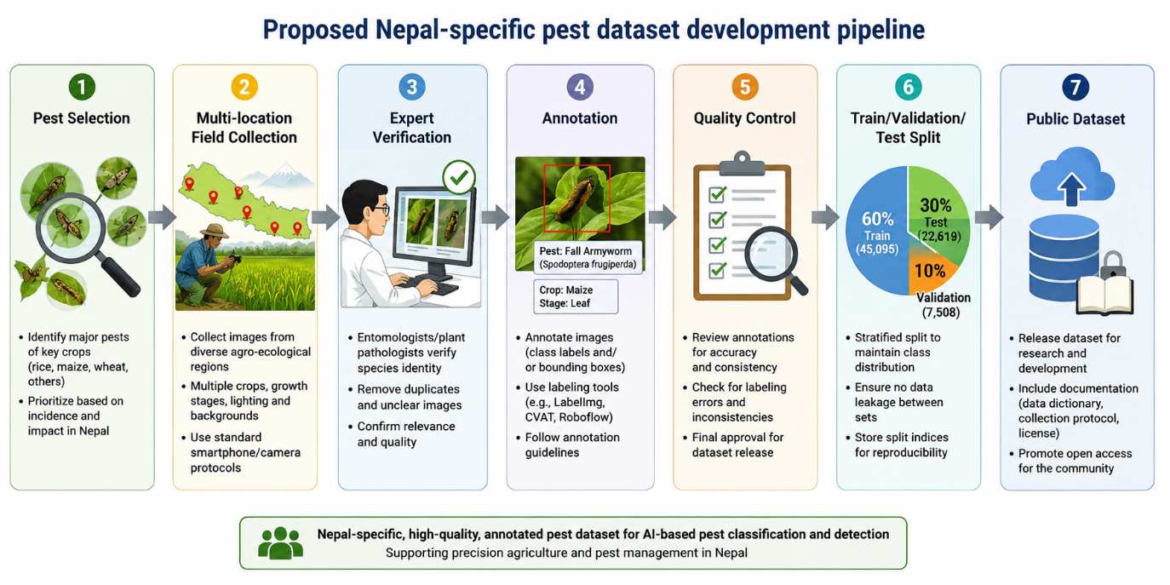
Figure 12. Proposed Nepal-specific pest dataset development pipeline.

9.2 Expert Annotation
Agricultural experts should verify pest identities.
Each image should ideally contain metadata including:
- pest species,
- crop,
- developmental stage where identifiable,
- geographic region,
- acquisition environment, and
- image source.
Detection subsets should additionally contain bounding boxes.
Annotation agreement should be measured or verified through an established quality-control protocol.

9.3 Baseline Model Development
The experimental stage should begin with a small number of representative architectures rather than testing every available model.
For classification, suitable baselines include:
- ResNet-50,
- EfficientNet,
- MobileNet, and
- a transformer-based architecture where computational resources permit.
For object detection, appropriate candidates include:
- YOLO-family detectors,
- Faster R-CNN/FPN, and
- lightweight mobile-oriented detectors.
The IP102 benchmark demonstrates that ImageNet pre-training can substantially improve performance compared with training CNNs from scratch. Transfer learning should therefore form a major component of the experimental methodology.

9.4 Cross-Dataset and Geographic Evaluation
A particularly valuable experimental design would compare:
Experiment A: IP102 → IP102
with
Experiment B: IP102 → Nepal
and
Experiment C: IP102 pre-training → Nepal fine-tuning → Nepal test set
This would directly answer whether international pest datasets transfer effectively to Nepalese agricultural environments.
The experiment would provide stronger evidence than simply training and testing using a random split of the same dataset.

9.5 Robustness Evaluation
Models should be evaluated under:
- different lighting conditions,
- different camera devices,
- partial occlusion,
- complex backgrounds,
- small pest sizes,
- different developmental stages,
- class imbalance, and
- previously unseen collection locations.
Performance deterioration under each condition should be reported.

9.6 Model Evaluation
Classification experiments should report:
- accuracy,
- macro precision,
- macro recall,
- macro F1-score,
- per-class F1-score,
- confusion matrix,
- G-mean where appropriate, and
- ROC-AUC/MAUC where appropriate.
Detection experiments should report:
- precision,
- recall,
- AP,
- AP50,
- AP75,
- mAP/AP50:95, and
- IoU-based evaluation.
Deployment evaluation should report:
- inference time,
- FPS,
- parameter count,
- model size,
- memory consumption, and
- hardware platform.

9.7 Deployment
After establishing adequate generalization, the model could be incorporated into an end-to-end decision-support system:
Mobile/Web Interface
↓
Image Capture/Upload
↓
Image Preprocessing
↓
Computer-Vision Model
↓
Pest Classification/Detection
↓
Pest Class + Confidence + Bounding Box
↓
Decision-Support Information
Technologies such as FastAPI, React, Docker, cloud infrastructure, or edge inference could be considered depending on deployment requirements.
However, deployment should remain subordinate to model reliability. A sophisticated application interface cannot compensate for a poorly validated pest-recognition model.

10. Discussion
The reviewed evidence demonstrates that computer vision has substantial potential for automated insect-pest recognition but also reveals a considerable gap between benchmark development and reliable agricultural deployment.
IP102 provides particularly strong evidence of this problem. Despite containing 75,222 images and 102 pest classes, the original fine-tuned ResNet baseline achieved only 49.4% overall accuracy and 40.1% F1-score. Detection was similarly challenging, with the strongest evaluated detector, FPN with ResNet-50, achieving 28.10% AP.
These results demonstrate that increasing dataset size does not automatically solve insect-pest recognition.
The crop-specific results are particularly informative for Nepal. ResNet achieved 62.2% accuracy for corn/maize pests and 53.0% for wheat pests, but only 32.1% for rice pests. The 30.1 percentage-point difference between corn/maize and rice demonstrates that model performance varies substantially according to the visual characteristics of the pest group.
Rice-pest recognition appears particularly challenging because of background similarity, intra-class variation across life stages, and inter-class similarity among related pest species.
A second major issue is class imbalance. The complete IP102 dataset has an imbalance ratio of 80.8. The fine-tuned ResNet obtained 49.4% accuracy but only 31.5% G-mean. Therefore, reporting only accuracy would provide an incomplete picture of model performance.
A third issue is geographic generalization. IP102 is valuable as an international benchmark, but its performance results cannot be assumed to represent performance in Nepal. Nepal contains substantial variation in altitude, climate, cropping systems, field backgrounds, crop varieties, and agricultural practices. These factors may create domain shift between benchmark images and locally acquired field images.
Consequently, a major future research question should be:
How much performance is lost when a pest-recognition model trained using international benchmark data is evaluated on independently collected Nepalese field images?
This question is arguably more relevant to practical Nepalese agriculture than determining whether one modern architecture produces a marginally higher benchmark score than another.
The literature also demonstrates an important distinction between predictive performance and deployment readiness.
A useful agricultural computer-vision system should optimize a combination of:
Classification/Detection Performance + Generalization + Robustness + Computational Efficiency + Practical Usability
rather than maximizing a single benchmark metric.
Finally, pest recognition should not be interpreted as equivalent to pest-management recommendation. Correctly identifying a pest does not independently determine whether pesticide application is necessary.
Management decisions may additionally depend on:
- pest population density,
- crop-development stage,
- economic injury thresholds,
- weather,
- geographic conditions, and
- integrated pest-management practices.
Computer vision should therefore initially function as a decision-support component rather than an autonomous pesticide recommendation system.

11. Limitations of the Review
This review has several limitations.
First, literature coverage depends on the databases and search strategy used. Relevant work may exist in regional journals, conference proceedings, theses, institutional reports, or other sources that are not indexed by the selected databases.
Second, terminology is inconsistent across the literature. Related studies may describe their tasks as pest recognition, pest identification, pest classification, pest detection, insect recognition, or agricultural image analysis. Although multiple search terms were considered, some relevant publications may therefore have been missed.
Third, computer-vision studies differ substantially in dataset size, number of classes, annotation type, train-test split, preprocessing, augmentation, model architecture, and evaluation protocol. Direct numerical ranking across studies is consequently inappropriate.
Fourth, IP102 provides a useful large-scale benchmark but is not a Nepal-specific dataset. Results obtained from IP102 therefore demonstrate the capabilities and limitations of existing computer-vision approaches rather than establishing their effectiveness under Nepalese agricultural conditions.
Fifth, the crop categories available in IP102 do not completely correspond to the major crops considered in the Nepalese context. Rice, corn/maize, and wheat have directly relevant IP102 groups, whereas equivalent IP102 superclasses are not available for several other Nepal-relevant crops. Consequently, the IP102 analysis should be interpreted as representative benchmark evidence rather than complete coverage of Nepalese crop-pest systems.
Sixth, the numerical IP102 model-performance values presented in this review are published benchmark results from the original IP102 experimental study rather than results from newly trained models in the present review. Dataset-derived quantities such as image totals, proportions, subset sizes, and differences between reported performance values were calculated from the published IP102 statistics.
Finally, this study does not experimentally train or evaluate a new computer-vision model. Its objective is to systematically synthesize existing evidence, analyze relevant benchmark datasets, identify Nepal-specific research gaps, and establish an experimentally testable research agenda.

12. Conclusion
Computer vision provides a promising approach for automated insect-pest recognition in agriculture, but the evidence reviewed in this study demonstrates that practical performance depends on considerably more than selecting a sophisticated neural-network architecture.
The IP102 benchmark illustrates both the progress and remaining difficulty of the problem. The dataset contains 75,222 images representing 102 pest classes, including 45,095 training, 7,508 validation, and 22,619 testing images. Approximately 19,000 images additionally contain bounding-box annotations for object detection.
Among the crop groups particularly relevant to Nepalese staple agriculture, IP102 provides 8,417 rice-pest images across 14 classes, 14,015 corn/maize-pest images across 13 classes, and 3,418 wheat-pest images across nine classes. Together these groups contain 25,850 images and 36 pest classes.
However, benchmark results demonstrate that pest recognition remains difficult. The original fine-tuned ResNet baseline achieved 49.4% overall accuracy and 40.1% F1-score across the complete IP102 dataset. Crop-specific accuracy varied considerably, from 32.1% for rice to 53.0% for wheat and 62.2% for corn/maize. For object detection, FPN with ResNet-50 achieved the strongest performance among the original evaluated detectors, with 28.10% AP and 54.93% AP50.
These results demonstrate that large datasets and modern CNN architectures do not automatically produce reliable pest recognition. Class imbalance, complex backgrounds, small pest objects, inter-class similarity, intra-class variation, developmental stages, and geographic domain shift remain substantial challenges.
For Nepal, the most important gap identified by this review is the absence of evidence demonstrating that models trained on international pest datasets generalize reliably to Nepalese agricultural environments. IP102 should therefore be regarded as a valuable benchmark and potential pre-training resource rather than a substitute for locally collected data.
Future experimental research should develop a representative Nepal-specific field dataset and evaluate models through cross-dataset and cross-location experiments. A particularly valuable design would compare performance on the original IP102 test data against independently collected Nepalese field data, followed by transfer learning or domain adaptation using locally collected images.
Evaluation should extend beyond overall accuracy. Classification studies should report precision, recall, F1-score, class-specific performance, and imbalance-sensitive metrics, while detection studies should report AP, AP50, AP75, IoU-based metrics, and mAP. Computational measurements such as inference time, FPS, model size, memory requirements, and hardware requirements should also be considered when deployment is intended.
Ultimately, the most valuable computer-vision system for Nepalese agriculture may not be the model that achieves the highest score on an international benchmark. It will be the model that maintains sufficiently reliable pest recognition across Nepalese field conditions while remaining computationally efficient, affordable, interpretable, and practical for agricultural decision support.

References
[1] Government of Nepal, Ministry of Agriculture and Livestock Development, Statistical Information on Nepalese Agriculture, Government of Nepal. The ministry maintains annual agricultural statistics covering crop production and related agricultural information.
[2] G. P. Joshi, K. P. Bhatta, and B. Thakurathi, “Farmers Survey to Assess of Yield Loss due to Insect Pests in Maize and their Management Strategies Adopted by Farmers of Baitadi District of Nepal,” Journal of Agriculture and Resource Management.
[3] A. Gyawali, B. Regmi, R. Pudasaini, and N. Acharya, “Diversity and abundance of insect pest of low land rice field in Lamahi, Dang district of Nepal,” Journal of Agriculture and Natural Resources, vol. 2, no. 1, pp. 238–243, 2019.
[4] K. Lamsal, P. Poudel Chhetri, R. Sapkota, and D. Khanal, “Monitoring and Bio rationale Management of Tuta absoluta [Lepidoptera: Gelechiidae] in Tomato in Western Nepal,” Nepalese Horticulture, vol. 19, no. 1, 2025.
[5] N. Parajuli, K. Khanal, A. Nepal, and B. Bastakoti, “Farmers’ perception about major insect pests of cucurbits and their management in Arghakhanchi, Nepal,” Journal of Agriculture and Natural Resources, vol. 6, no. 1, pp. 32–43, 2023.
[6] J. Redmon, S. Divvala, R. Girshick, and A. Farhadi, “You Only Look Once: Unified, Real-Time Object Detection,” Proceedings of the IEEE Conference on Computer Vision and Pattern Recognition, 2016.
[7] A. Bochkovskiy, C.-Y. Wang, and H.-Y. M. Liao, “YOLOv4: Optimal Speed and Accuracy of Object Detection,” 2020.
[8] W. Wu et al., “IP102: A Large-Scale Benchmark Dataset for Insect Pest Recognition,” Proceedings of the IEEE/CVF Conference on Computer Vision and Pattern Recognition, 2019. The dataset contains more than 75,000 images covering 102 insect-pest species and supports classification and detection research.
[9] M. J. Page et al., “The PRISMA 2020 statement: an updated guideline for reporting systematic reviews,” BMJ, vol. 372, p. n71, 2021.
[10] K. He, X. Zhang, S. Ren, and J. Sun, “Deep Residual Learning for Image Recognition,” Proceedings of the IEEE Conference on Computer Vision and Pattern Recognition, 2016.
[11] M. Tan and Q. V. Le, “EfficientNet: Rethinking Model Scaling for Convolutional Neural Networks,” Proceedings of the 36th International Conference on Machine Learning, vol. 97, pp. 6105–6114, 2019.
[12] A. Dosovitskiy et al., “An Image Is Worth 16x16 Words: Transformers for Image Recognition at Scale,” International Conference on Learning Representations, 2021.
[13] A. G. Howard et al., “MobileNets: Efficient Convolutional Neural Networks for Mobile Vision Applications,” 2017.
[14] Government of Nepal, Ministry of Agriculture and Livestock Development, Statistical Information on Nepalese Agriculture 2078/79 (2021/22).
[15] S. Nyaupane, R. P. Mainali, S. Kafle, and A. S. R. Bajracharya, “Fall Armyworm: Current Status in Nepal, its Management and Way Forward,” Nepal Journal of Science and Technology, vol. 21, no. 1, 2022.
[16] Y. P. Giri, S. Aryal, and N. Dangi, Alu Kheti tatha Shatru Jib Byabasthapan [Potato Cultivation and Pest Management], Entomology Division, Nepal Agricultural Research Council, Kathmandu.
[17] S. Timilsina, S. Sharma, B. Pokhrel, P. Aryal, K. Sato, Y. Okada, S. Watanabe, and S. Kondo, “Insect damage detection in corn leaf using YOLOv10 models: a transfer learning approach,” Materials, Methods & Technologies, vol. 19, no. 1, pp. 119–128, 2026, doi: 10.62991/MMT1997508579.

