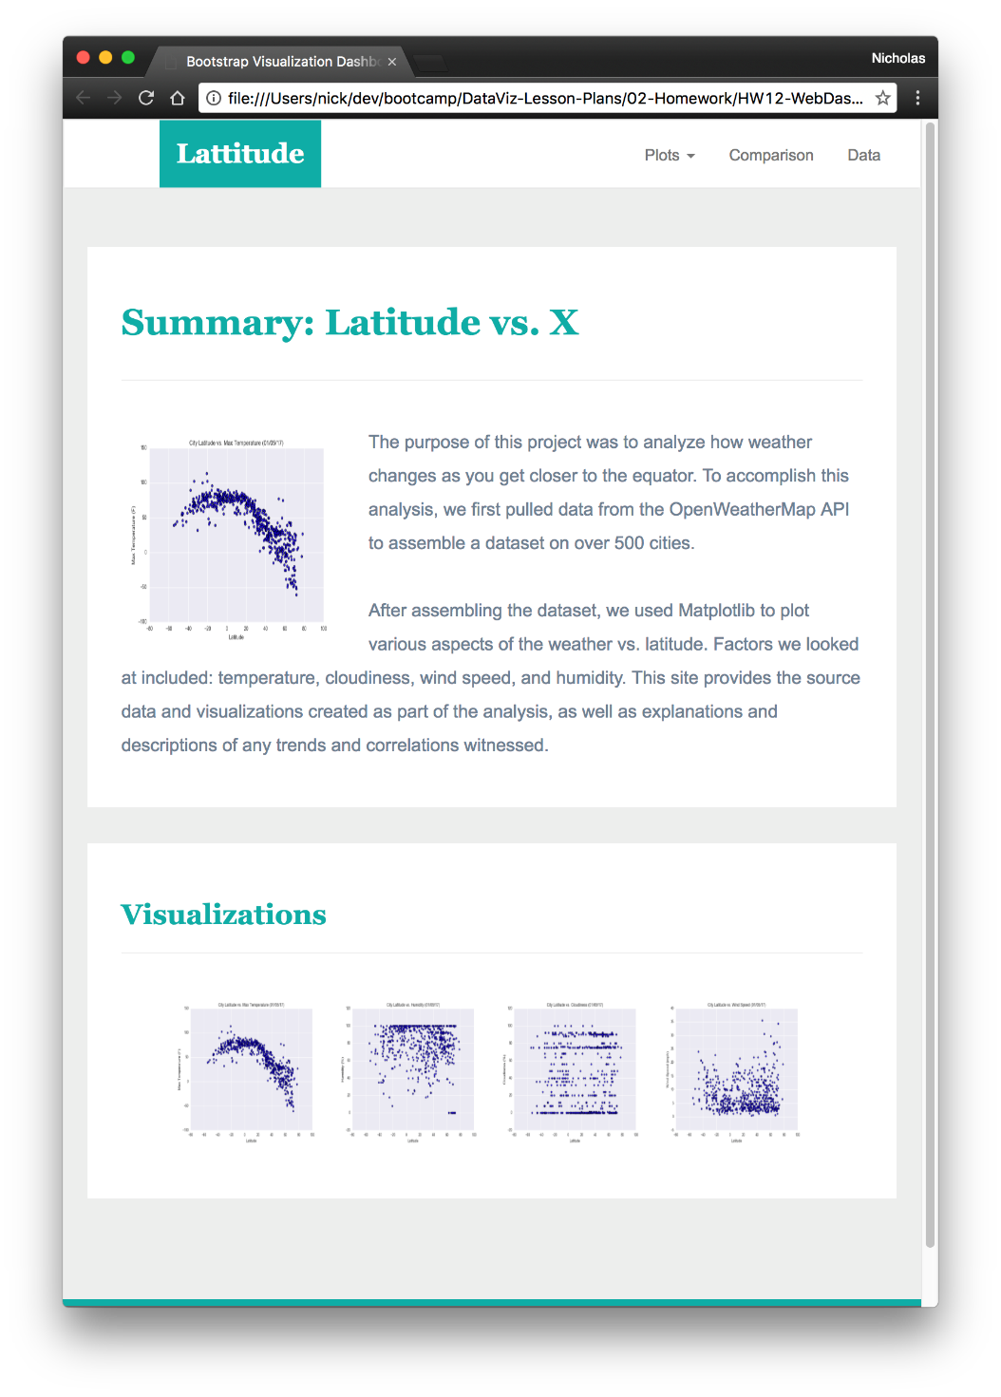

The purpose of this project was to analyze how the weather changes as you get closer to the equator. To accomplish this analysis, we first pulled the data from the OpenWeatherMap API to assemble a dataset for over 500 cities. After assembling the dataset, we used Matplotlib to plot various aspects of the weather patterns vs. Latitude. We looked at different factors, which included Temperature, Humidity, Cloudiness and Wind speed. This site provides the source data and visualization created as part of the analysis, as well as the explanations and descriptions of the trends and correlations observed during the analysis.