**##TASK 1###**

from OpenGL.GL import *

from OpenGL.GLUT import *

from OpenGL.GLU import *

import random

def draw_points(x, y):

glPointSize(5) #pixel size. by default 1 thake

glBegin(GL_POINTS)

glVertex2f(x,y) #jekhane show korbe pixel

glEnd()

def iterate():

glViewport(0, 0, 500, 500)

glMatrixMode(GL_PROJECTION)

glLoadIdentity()

glOrtho(0.0, 500, 0.0, 500, 0.0, 1.0)

glMatrixMode (GL_MODELVIEW)

glLoadIdentity()

def showScreen():

glClear(GL_COLOR_BUFFER_BIT | GL_DEPTH_BUFFER_BIT)

glLoadIdentity()

iterate()

glColor3f(1.0, 1.0, 0.0) #konokichur color set (RGB)

#call the draw methods here

for i in range(50):

draw_points(random.randint(1,500),random.randint(1,500))

#draw_points(250, 250)

glutSwapBuffers()

glutInit()

glutInitDisplayMode(GLUT_RGBA)

glutInitWindowSize(500, 500) #window size

glutInitWindowPosition(0, 0)

wind = glutCreateWindow(b"Task 1 Solution") #window name

glutDisplayFunc(showScreen)

glutMainLoop()

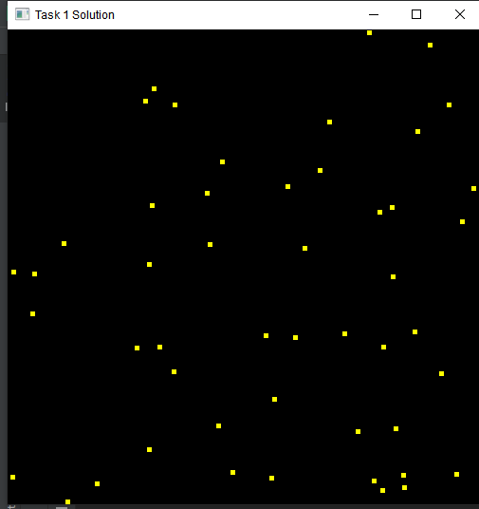

**###TASK 2###**

from OpenGL.GL import *

from OpenGL.GLUT import *

from OpenGL.GLU import *

import random #for import the random values:

def draw_points(x, y):

glPointSize(5) #pixel size. by default 1 thake

glBegin(GL_POINTS)

glVertex2f(x,y) #jekhane show korbe pixel

glEnd()

def draw_tirangle(a,b,c,d,e,f):

glPointSize(5) #pixel size. by default 1 thake

glBegin(GL_TRIANGLES)

glVertex2f(a,b) #jekhane show korbe pixel

glVertex2f(c, d)

glVertex2f(e, f)

glEnd()

def draw_lines(x, y,z,w):

glPointSize(5) #pixel size. by default 1 thake

glLineWidth(2)

glBegin(GL_LINES)

glVertex2f(x,y) #jekhane show korbe pixel

glVertex2f(z, w)

glEnd()

def iterate():

glViewport(0, 0, 500, 500)

glMatrixMode(GL_PROJECTION)

glLoadIdentity()

glOrtho(0.0, 500, 0.0, 500, 0.0, 1.0)

glMatrixMode (GL_MODELVIEW)

glLoadIdentity()

def showScreen():

glClear(GL_COLOR_BUFFER_BIT | GL_DEPTH_BUFFER_BIT)

glLoadIdentity()

iterate()

glColor3f(1.0, 1.0, 1.0) #konokichur color set (RGB)

#call the draw methods here

draw_points(260, 95)

draw_tirangle(100,350,400,350,250,495)

draw_lines(100,350,100,50)

draw_lines(400, 350, 400, 50)

draw_lines(100, 50, 400, 50)

draw_tirangle(150,250,200,250,200,300)

draw_tirangle(200, 300, 150, 300, 150, 250)

draw_tirangle(300, 250, 350, 250, 350, 300)

draw_tirangle(350, 300, 300, 300, 300, 250)

draw_lines(220, 50, 220, 150)

draw_lines(220, 150, 270, 150)

draw_lines(270, 50, 270, 150)

glutSwapBuffers()

glutInit()

glutInitDisplayMode(GLUT_RGBA)

glutInitWindowSize(500, 500) #window size

glutInitWindowPosition(0, 0)

wind = glutCreateWindow(b"Task 2 Solution") #window name

glutDisplayFunc(showScreen)

glutMainLoop()

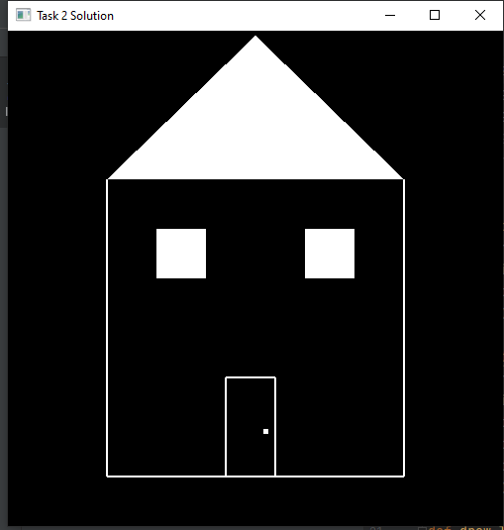

**##TASK 3###**

from OpenGL.GL import *

from OpenGL.GLUT import *

from OpenGL.GLU import *

def draw_lines(x, y,z,w):

glPointSize(5) #pixel size. by default 1 thake

glLineWidth(2)

glBegin(GL_LINES)

glVertex2f(x,y) #jekhane show korbe pixel

glVertex2f(z, w)

glEnd()

def draw_numbers(x, y,a):

if a == 0:

glColor3f(1.0, 0.0, 0.0)

draw_lines(x,y,x+55,y)

draw_lines(x+55, y, x + 55, y+55)

draw_lines(x+55, y+55, x + 55, y+110)

draw_lines(x, y+110, x + 55, y+110)

draw_lines(x, y+55, x, y+110)

#draw_lines(x, y+55, x + 55, y+55)

draw_lines(x, y, x, y+55)

elif a == 1:

glColor3f(0.0, 1.0, 0.0)

#draw_lines(x,y,x+55,y)

draw_lines(x+55, y, x + 55, y+55)

draw_lines(x+55, y+55, x + 55, y+110)

#draw_lines(x, y+110, x + 55, y+110)

#draw_lines(x, y+55, x, y+110)

#draw_lines(x, y+55, x + 55, y+55)

#draw_lines(x, y, x, y+55)

elif a == 2:

glColor3f(0.0, 0.0, 1.0)

draw_lines(x,y,x+55,y)

#draw_lines(x+55, y, x + 55, y+55)

draw_lines(x+55, y+55, x + 55, y+110)

draw_lines(x, y+110, x + 55, y+110)

#draw_lines(x, y+55, x, y+110)

draw_lines(x, y+55, x + 55, y+55)

draw_lines(x, y, x, y+55)

elif a == 3:

glColor3f(1.0, 1.0, 0.0)

draw_lines(x,y,x+55,y)

draw_lines(x+55, y, x + 55, y+55)

draw_lines(x+55, y+55, x + 55, y+110)

draw_lines(x, y+110, x + 55, y+110)

#draw_lines(x, y+55, x, y+110)

draw_lines(x, y+55, x + 55, y+55)

#draw_lines(x, y, x, y+55)

elif a == 4:

glColor3f(0.0, 1.0, 1.0)

#draw_lines(x,y,x+55,y)

draw_lines(x+55, y, x + 55, y+55)

draw_lines(x+55, y+55, x + 55, y+110)

#draw_lines(x, y+110, x + 55, y+110)

draw_lines(x, y+55, x, y+110)

draw_lines(x, y+55, x + 55, y+55)

#draw_lines(x, y, x, y+55)

elif a == 5:

glColor3f(1.0, 0.0, 1.0)

draw_lines(x,y,x+55,y)

draw_lines(x+55, y, x + 55, y+55)

#draw_lines(x+55, y+55, x + 55, y+110)

draw_lines(x, y+110, x + 55, y+110)

draw_lines(x, y+55, x, y+110)

draw_lines(x, y+55, x + 55, y+55)

#draw_lines(x, y, x, y+55)

elif a == 6:

glColor3f(1.0, 0.5, 0.8)

draw_lines(x,y,x+55,y)

draw_lines(x+55, y, x + 55, y+55)

#draw_lines(x+55, y+55, x + 55, y+110)

draw_lines(x, y+110, x + 55, y+110)

draw_lines(x, y+55, x, y+110)

draw_lines(x, y+55, x + 55, y+55)

draw_lines(x, y, x, y+55)

elif a == 7:

glColor3f(1.0, 1.0, 1.0)

#draw_lines(x,y,x+55,y)

draw_lines(x+55, y, x + 55, y+55)

draw_lines(x+55, y+55, x + 55, y+110)

draw_lines(x, y+110, x + 55, y+110)

#draw_lines(x, y+55, x, y+110)

#draw_lines(x, y+55, x + 55, y+55)

#draw_lines(x, y, x, y+55)

elif a == 8:

glColor3f(0.35, 0.05, 0.6)

draw_lines(x,y,x+55,y)

draw_lines(x+55, y, x + 55, y+55)

draw_lines(x+55, y+55, x + 55, y+110)

draw_lines(x, y+110, x + 55, y+110)

draw_lines(x, y+55, x, y+110)

draw_lines(x, y+55, x + 55, y+55)

draw_lines(x, y, x, y+55)

elif a == 9:

glColor3f(0.4, 0.55, 0.05)

draw_lines(x,y,x+55,y)

draw_lines(x+55, y, x + 55, y+55)

draw_lines(x+55, y+55, x + 55, y+110)

draw_lines(x, y+110, x + 55, y+110)

draw_lines(x, y+55, x, y+110)

draw_lines(x, y+55, x + 55, y+55)

#draw_lines(x, y, x, y+55)

def iterate():

glViewport(0, 0, 500, 500)

glMatrixMode(GL_PROJECTION)

glLoadIdentity()

glOrtho(0.0, 500, 0.0, 500, 0.0, 1.0)

glMatrixMode (GL_MODELVIEW)

glLoadIdentity()

def showScreen():

glClear(GL_COLOR_BUFFER_BIT | GL_DEPTH_BUFFER_BIT)

glLoadIdentity()

iterate()

glColor3f(1.0, 1.0, 0.0) #konokichur color set (RGB)

id = '21201785'

x = 3

for i in id:

draw_numbers(x,200,int(i))

x += 63

glutSwapBuffers()

glutInit()

glutInitDisplayMode(GLUT_RGBA)

glutInitWindowSize(500, 500) #window size

glutInitWindowPosition(0, 0)

wind = glutCreateWindow(b"Task 3 Solution ") #window name

glutDisplayFunc(showScreen)

glutMainLoop()

