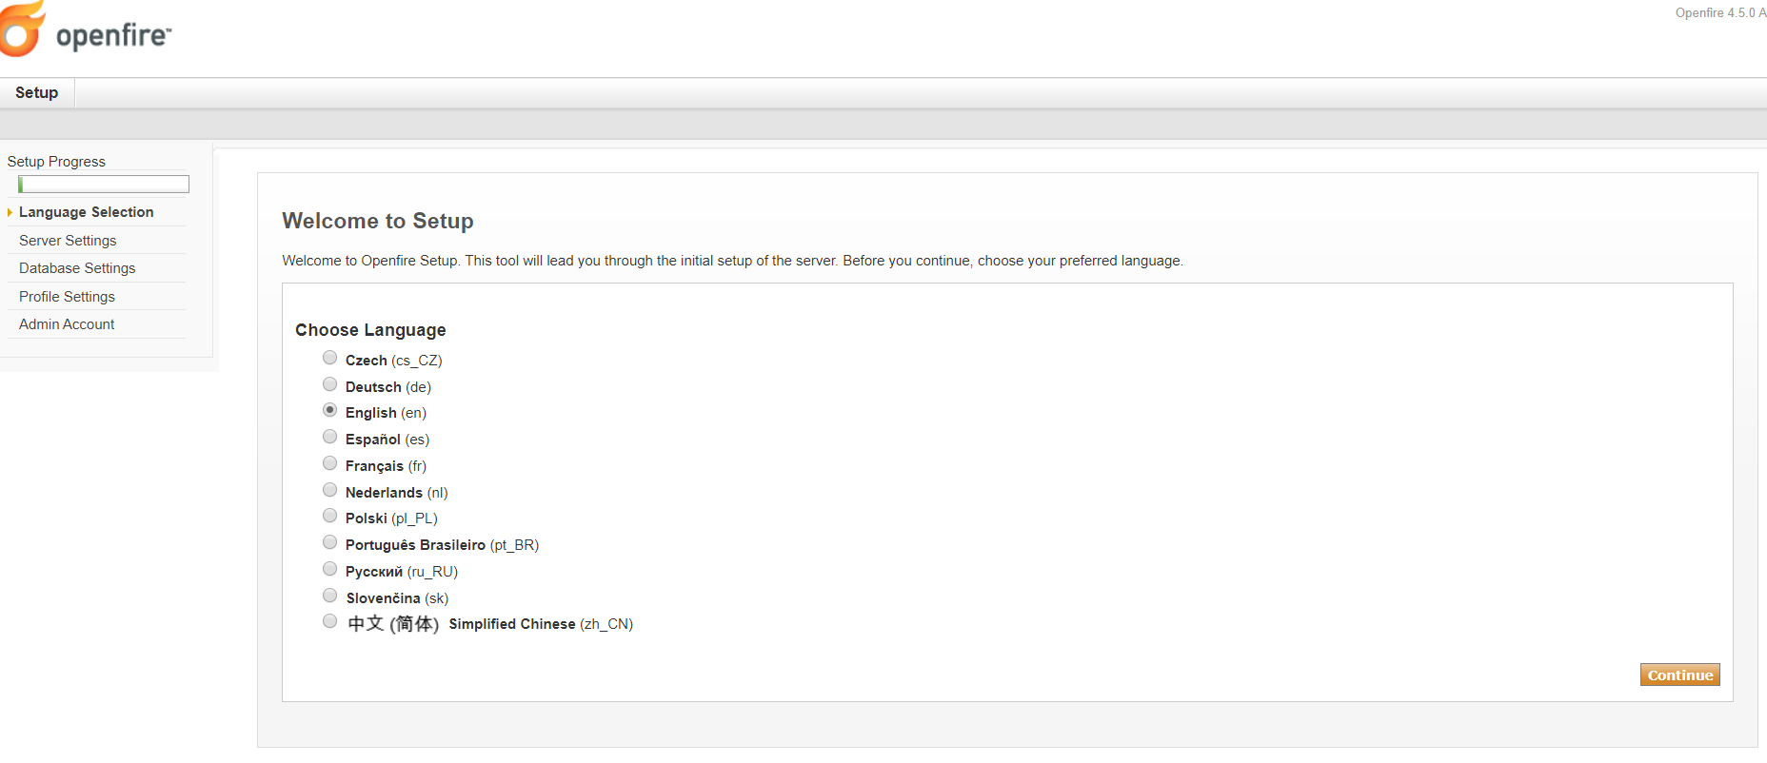
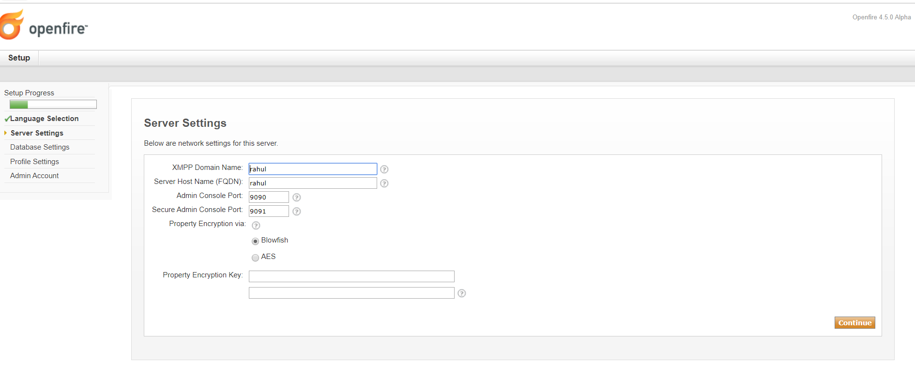
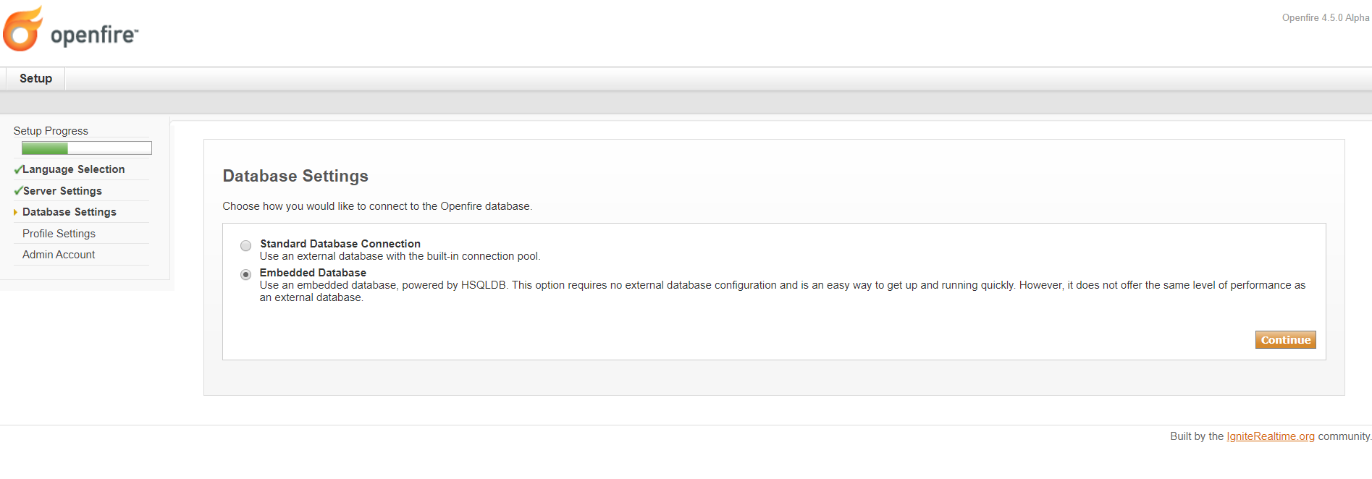
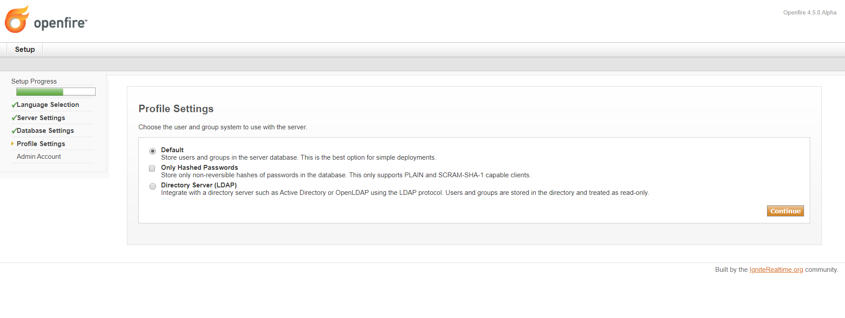
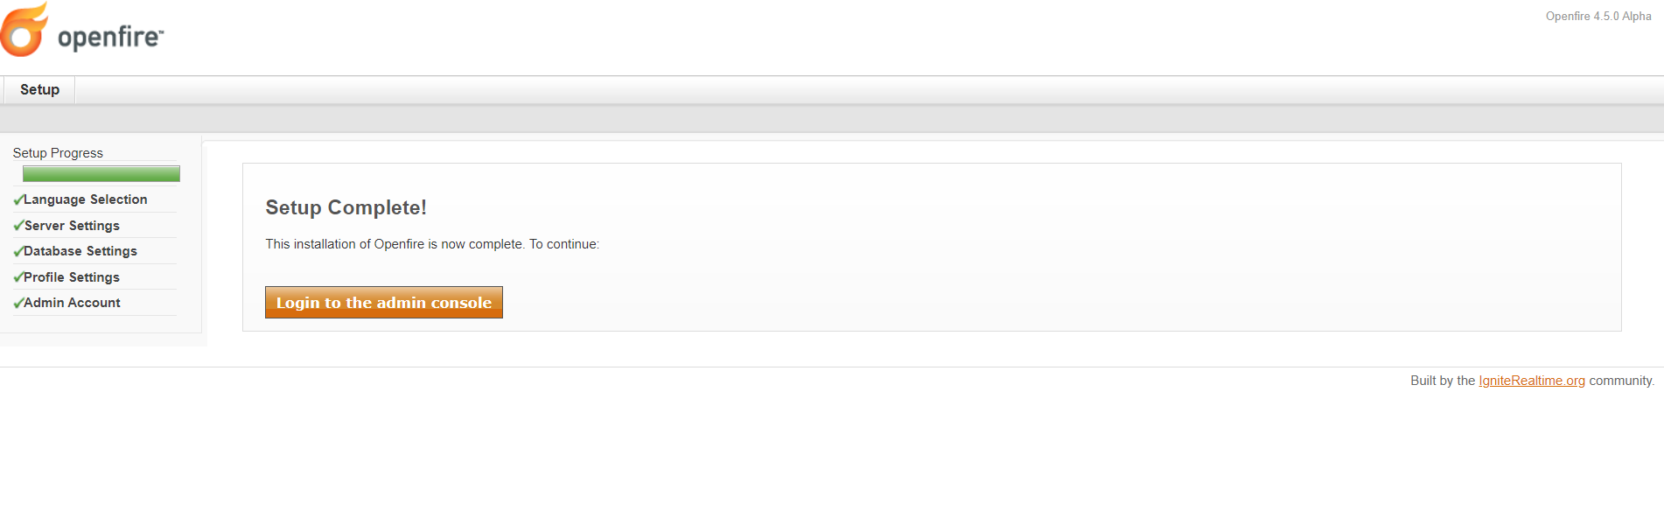
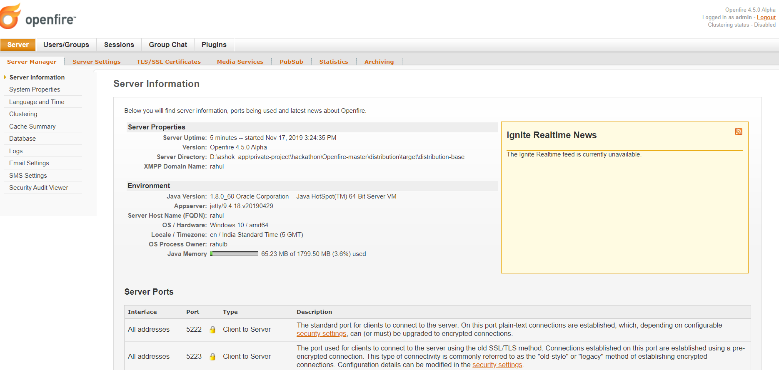

We have used Monitoring Plugin for store messaging history in open-fire data base
(https://www.igniterealtime.org/projects/openfire/plugins.jsp ).
refer flowing link for setup
https://www.igniterealtime.org/projects/openfire/plugins/1.8.1/monitoring/readme.html

