MOVIE TICKET BOOKING OUTPUT

* Login

>> If user enters incorrect details,then user have to re-enter the credentials.

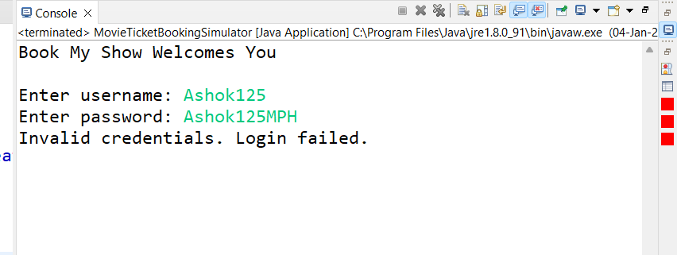

>> User enters valid credentials, then succesfull login and it display menu.

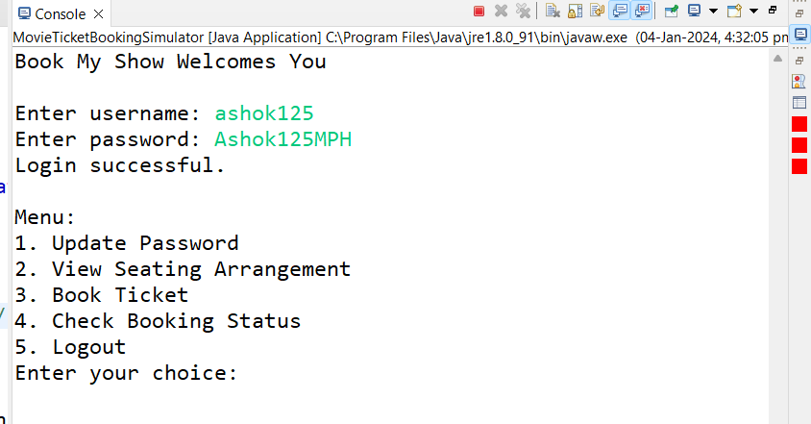

**1.Update Password.**

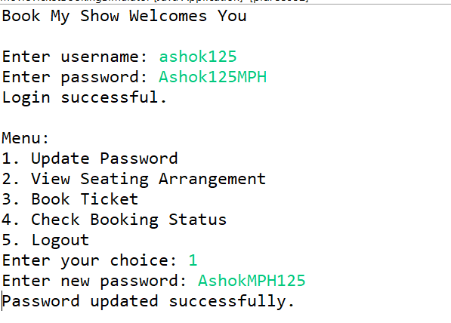

**2.View Seating Availability**

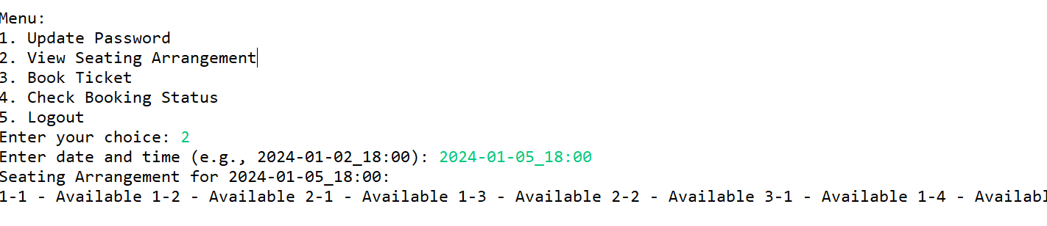

**3.Book Ticket**

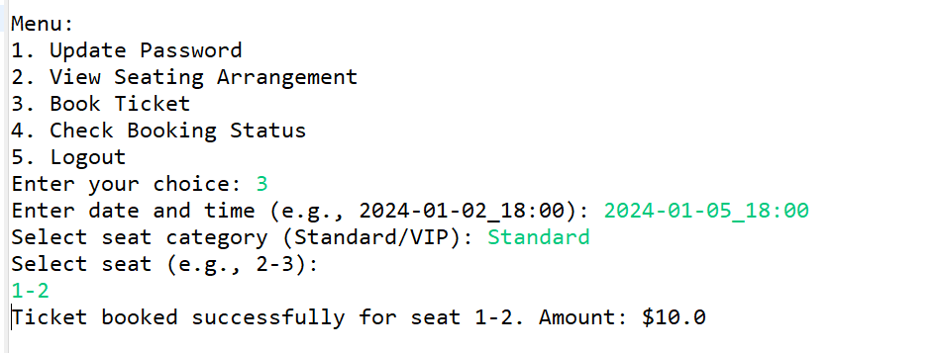

4.Check Booking Status

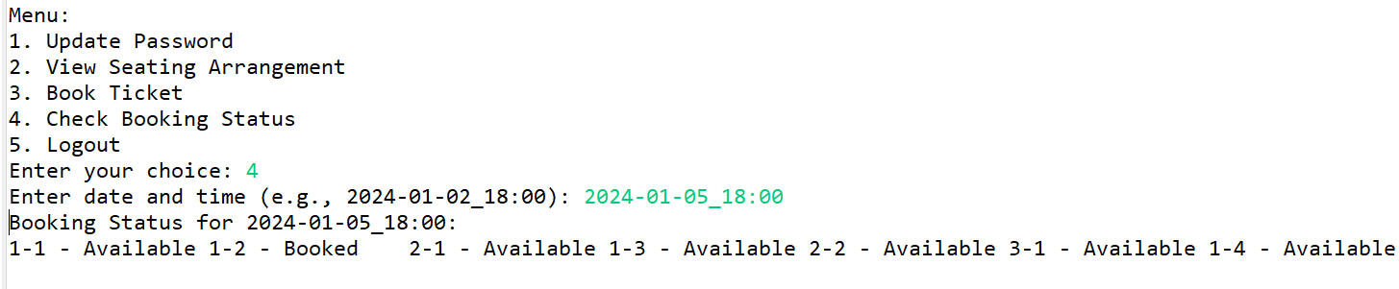



5.Logout

