Web Crawler Design document

Author Name | Ashok Chelimilla
Created Date | 15/07/2015
Modified By | 27/07/2015
Version | NA

Project:
simple crawler to crawl and download all mails for specified year from url :http://mail-archives.apache.org/mod_mbox/maven-users/.

Description:
The project must have a build system and the build system should create a jar with a defined application entry point (java -jar crawler.jar [opts] should work, assuming crawler.jar was the jar created by the build system)

Class Diagram of Crawler:

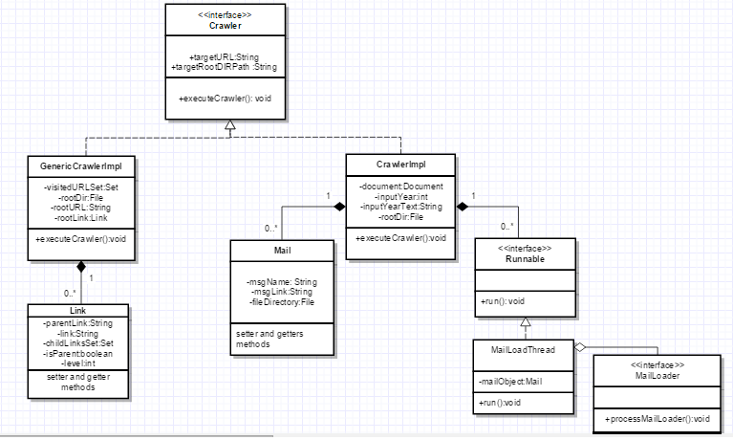

Flow chart for specified URL crawler implementation:

Start

enter year

Is year valid
End
End

NO

yes
1)Create root directory 2)Load All the mail links based on months.

Load mails and save in respective directory using thread pooling.

Flow chart for Generic crawler implementations:

Start

Enter URL

isValidURL
NO
End

Yes

Create a rootLink object.
Load rooturl(Document)
Create root directory

NO

isMail(Doc)?

Save doc

Does it has links ?

End

Load all links and insert into “childLinksSet” of rootlink object.
Use sets to avoid duplicate URLS at every level.

Load one by one link. Check isMail.

Tools Details:

- Maven
- JDK
- Jsoup
- JUnit
- Eclipsese IDE

