KYC Remediation: Vector Mathematics in Practice
Starter Package Brief - Days 5 and 6 (Thu 29-Oct and Fri 30-Oct-2026)
Your mission: You have been handed a half-finished, partly wrong KYC helper. Run it, observe what is off, list every inconsistency, write the missing pieces with Claude Code, fix the problems, prove it works end to end, push it to GitLab and walk your trainer through it. All data is synthetic.

1. The business problem
A bank's onboarding and remediation team is sitting on a backlog of KYC (know your customer) records. Analysts leave free-text notes such as 'residence bill expired last year, new one missing' or 'passport spelling differs from the form'. Today a person reads every note, decides what kind of remediation it needs, and tries to notice by eye when the same customer was entered twice.
2. The challenge
Build a small helper that does two jobs, using nothing but the mathematics from Days 5 and 6 (dot product, cosine similarity, Euclidean distance):
- Job A, classify: sort each analyst note into one of five remediation categories (proof of address, ID mismatch, source of funds, high-risk review, periodic refresh) by finding the category whose vector is closest to the note's vector.
- Job B, detect duplicates: find customer profiles that are probably the same person written twice, and send every pair to a human. Nothing is ever merged automatically.
3. Pain points the helper should relieve
Pain point | What it looks like
Backlog volume | Hundreds of records per analyst; reading each note is slow
Inconsistent wording | 'EMI missing', 'bill lapsed', 'proof outdated': different words, same problem, so keyword rules miss them
Duplicate customers | The same person entered twice inflates work and creates risk of conflicting records
Uneven triage | Two analysts triage the same note differently; high-risk items wait in the queue
Sensitive data | Identity numbers must not appear in clear in any queue or report
Audit pressure | Every decision needs a reason, a score and a human sign-off where it matters

4. The maths in plain words
Every text becomes a list of numbers (a vector). Two texts about the same thing get vectors that point the same way. Cosine similarity measures the angle between two vectors (1 means the same direction, 0 means nothing in common). Euclidean distance measures how far apart the end points are. They answer different questions, and part of your job is to see when that matters.
dot(a, b) = a1*b1 + a2*b2 + ... norm(a) = square root of (a1^2 + a2^2 + ...)
cosine(a, b) = dot(a, b) / (norm(a) * norm(b)) distance(a, b) = square root of ((a1-b1)^2 + (a2-b2)^2 + ...)
Example not in your worksheet: a = (2, 1) and b = (1, 2). dot = 4, both lengths are the square root of 5, so cosine = 4 / 5 = 0.8; distance = square root of 2 = 1.414.
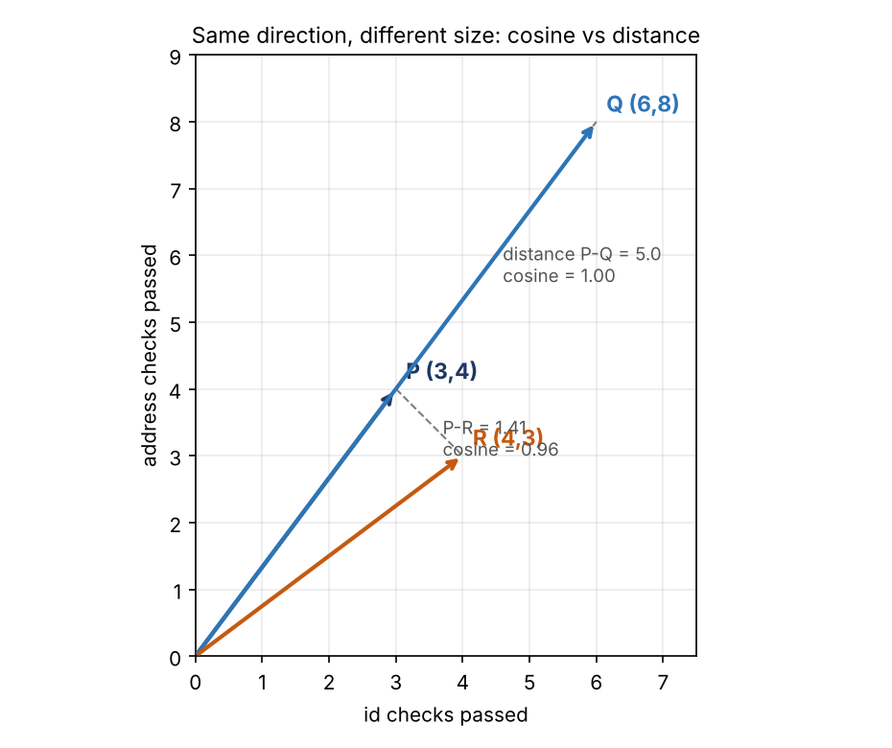
5. The target architecture
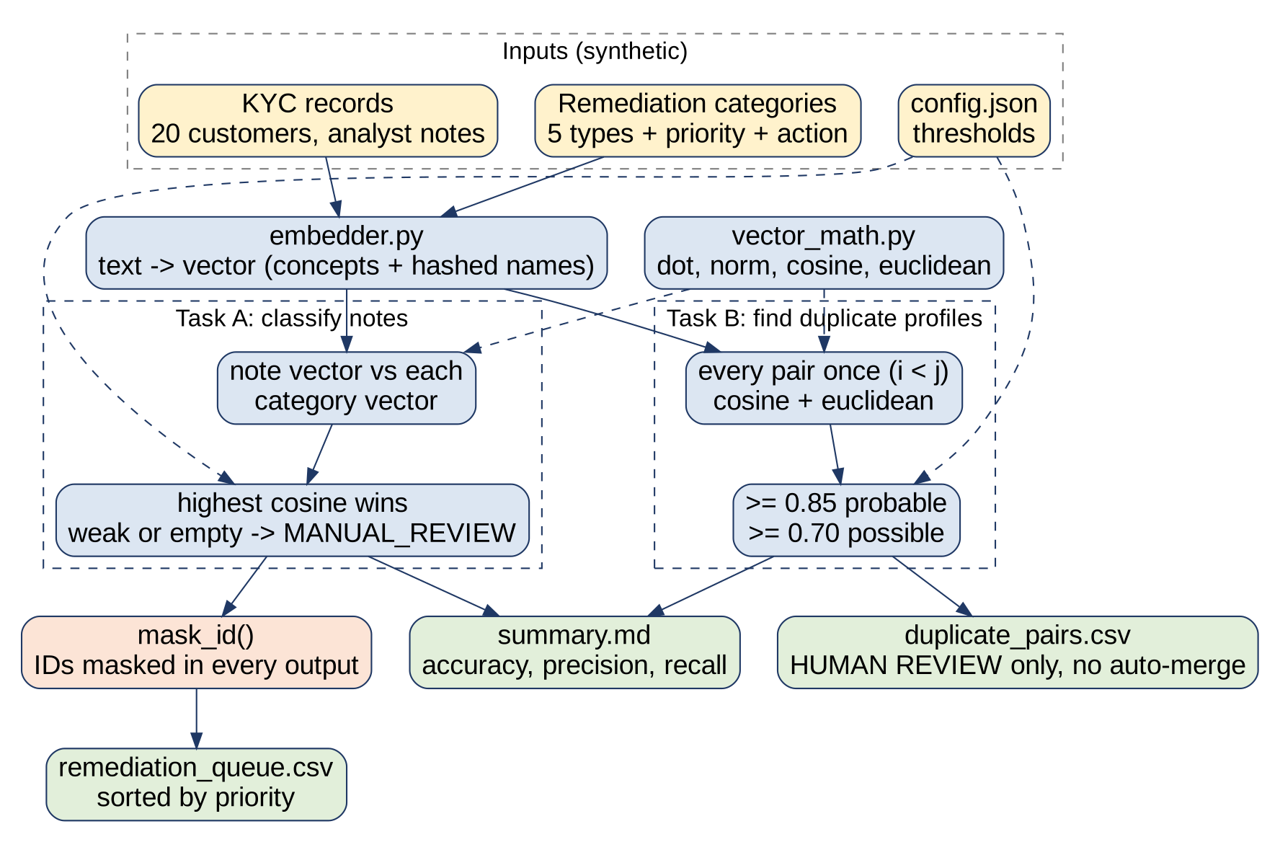
Your starter implements this design but is not finished and not fully correct. Reading the diagram, then the code, is the first way to spot where the two disagree.
6. What is in the starter package
File | Purpose
README.md | What the project claims to do and how to run it
data/ | 20 synthetic KYC records, 5 categories, a small lexicon, four tiny vectors for the worksheet, known duplicates
config.json | The thresholds the process owner decides
vector_math.py | dot, norm, normalize, cosine, distance
embedder.py | Text to vector
kyc_pipeline.py | Classify, find duplicates, mask IDs, evaluate, write CSV
run_pipeline.py | The end-to-end run (a skeleton)
by_hand/worksheet.md and check_by_hand.py | Six paper exercises and a checker
why_cosine.py | Experiments: direction vs size, short vs long note
tests/ | Some unit tests (not all present)
inconsistency_log.md, MISSING_PIECES.md | Your working sheets

7. How you work
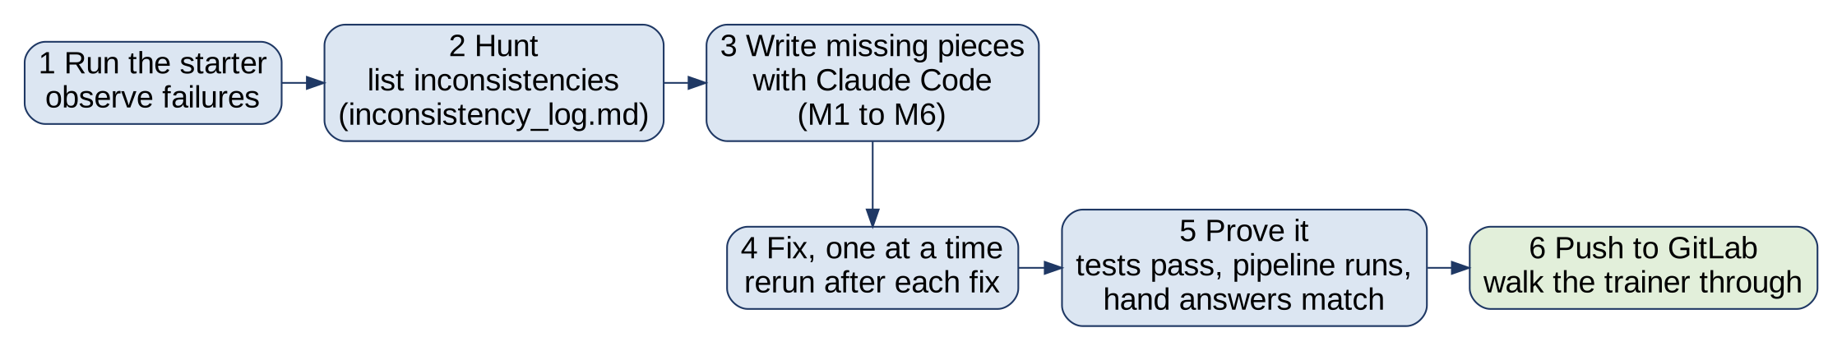
8. What you must observe
Before you change anything, run these and write down what you see. For each, ask: is this what the README and the maths say should happen?
# | Do | Observe and ask
1 | python -m unittest discover -s tests | Which tests fail or error? Do the failing tests blame the code, or could a test be wrong?
2 | Do worksheet.md on paper, fill by_hand/my_answers.json, run python check_by_hand.py | Do your paper answers match the code? If not, who is wrong: you, the code, or the data?
3 | python why_cosine.py | Do the numbers agree with what the comments claim?
4 | python run_pipeline.py | What does it say today? After you write the missing pieces, does the output look believable?
5 | Read README.md, config.json and the docstrings | Does every claim agree with the code and data?
6 | Open data/kyc_records.json | Are the records consistent with each other (ids, dates, status values)?

9. Inconsistency hunt
An inconsistency is two things that should agree but do not. There are more than ten hidden in this package, across these kinds:
- Maths: a function does not compute what its name and docstring say
- Code versus documentation: README or comments promise something the code does not do
- Data versus data: records that disagree with each other in format or identity
- Tests versus maths: a test whose expected value is itself wrong
- Configuration: settings that contradict each other or the documentation
- Privacy and safety: a rule that is stated but not enforced
Record each in inconsistency_log.md with: where, what you observed, what it should be, how you found it, fixed or not. Fix one thing at a time and rerun everything after each fix: some problems hide others.
10. Missing pieces to write with Claude Code
Id | What
M1 | vector_math.py: dot()
M2 | vector_math.py: normalize() (zero vector must raise ValueError)
M3 | kyc_pipeline.py: mask_id() (keep prefix and last 3 characters; short numbers fully masked)
M4 | kyc_pipeline.py: write_csv()
M5 | run_pipeline.py: main() (classify, find duplicates, evaluate, print two tables, write three output files)
M6 | tests/test_pipeline.py: tests for mask_id, classify, duplicates, end-to-end quality, data hygiene

Use Claude Code to write them, but you must be able to explain every line. The tests and the checker are the judges, not Claude Code.
11. Done means
- python -m unittest discover -s tests passes, including the tests you wrote
- python check_by_hand.py says every answer matches
- python run_pipeline.py runs end to end and writes the three files in output/
- IDs are masked in every output; no raw ID appears in a CSV or on screen
- inconsistency_log.md lists everything you found, each marked fixed or explained
- A short README note: what you changed and one limitation of the toy embedder
12. Push to GitLab and walk the trainer through
Create a branch named your-name-days5-6, then: git add . ; git status (confirm no .env and no output/ folder) ; git commit -m 'Days 5-6 KYC vector maths' ; git push origin your-name-days5-6 ; open a merge request and add the trainer as reviewer. At the next session, share your screen (about 8 minutes): the problem in two sentences; the architecture in one minute; two inconsistencies you found and how; run the tests and the pipeline live; one limitation.
Rules
- Synthetic data only. No real customer or bank data in files, prompts or screenshots.
- No .env, keys or secrets in the repository (none are needed).
- Your own work. You may ask your assigned peer to review, not to write.
- Thresholds are a decision for the process owner; document any you change and why.

