

**IoT Bluetooth & Wi-Fi and EC2 Cloud Projects**

**Wi-Fi Analysis**

**Project**

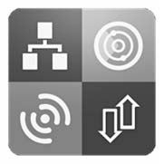

**Wi-Fi Analysis Project**

* **Wi-Fi Network Analyzer**
  + Provide Wi-Fi connection information
    - IP address of Default gateway, DNS server, device IP (internal and external),

Subnet Mask, MAC address

* + - Connected AP’s SSID, PHY channel used, Signal strength, Link speed, etc.

**Network Analyzer**

Available at Play Store and App Store

Android: <http://play.google.com/store/apps/details?id>

=net.techet.netanalyzerlite.an

iPhone: https://itunes.apple.com/us/app/network- analyzer-lite/id562315041?mt=8

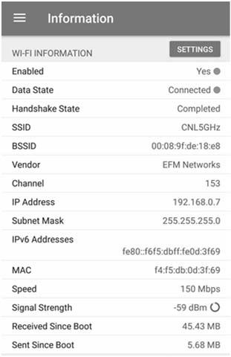

**Wi-Fi Analysis Project**

* **Wi-Fi Network Analyzer**
  + Wi-Fi information

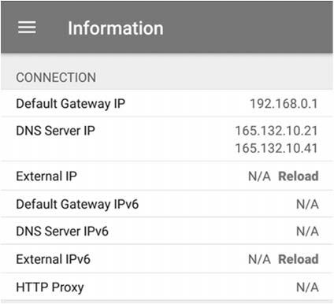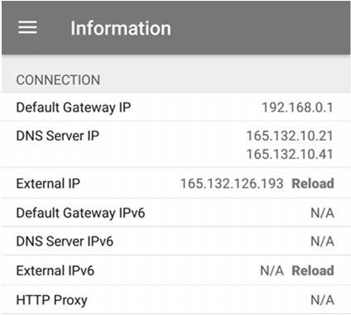

**Wi-Fi Analysis Project**

* **Wi-Fi Network Analyzer**
  + Network connection
    - Check network IPs and device’s IP

|  |  |  |
| --- | --- | --- |
| **Key** | **Value** | **Description** |
| SSID | CNL 5GHz | Wi-Fi ID (Name) |
| Channel | 153 | PHY channel using on |
| IP Address | 192.168.0.7 | Internal Address |
| Speed | 150 Mbps | Link datarate |
| Signal Strength | -59 dBm | RSSI |

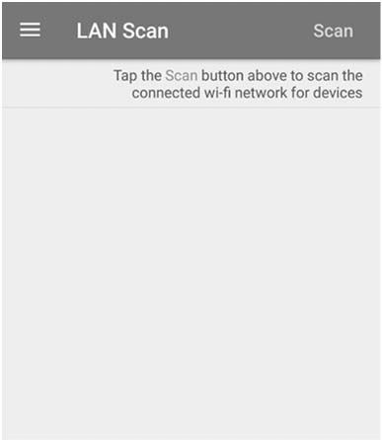

**Wi-Fi Analysis Project**

* **Wi-Fi Network Analyzer**
  + LAN Scan

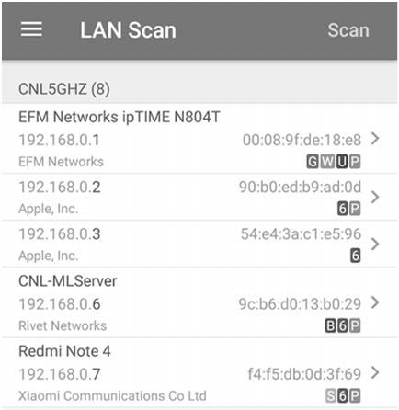

**Wi-Fi Analysis Project**

* **Wi-Fi Network Analyzer**
  + LAN Scan
    - G: Gateway
    - W: Web interface available (port 80 or 443 open)
    - U: If the device provides UPnP/DLNA services
      * UPnP: Universal Plug-and-Play
      * DLNA: Digital Living Network

Alliance

* + - * Use to share multimedia



**Wi-Fi Analysis Project**

* **Wi-Fi Network Analyzer**
  + LAN Scan
    - P: Pingable
      * Device responds to ICMP ping requests
    - 6: IPv6 address exists
    - B: Device provides Bonjour service
      * Bonjour was developed by Apple
      * Used to find printers and file-sharing servers
    - S: Scanning device (your device)

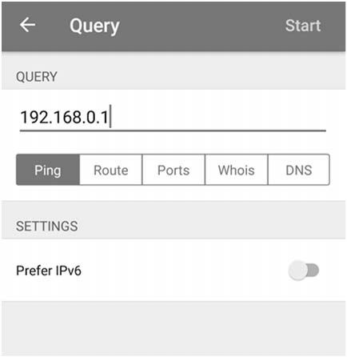

**Wi-Fi Analysis Project**

* **Wi-Fi Network Analyzer**
  + Send Ping to the Gateway

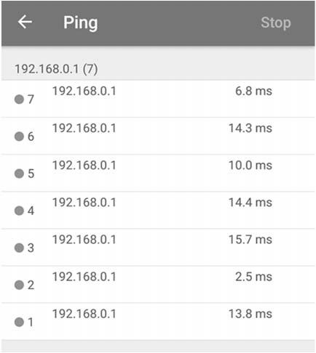

**Wi-Fi Analysis Project**

* **Wi-Fi Network Analyzer**
  + Send Ping to the Gateway

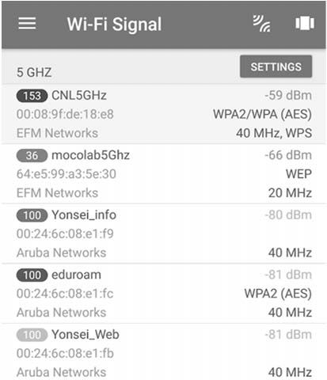

**Wi-Fi Analysis Project**

* **Wi-Fi Network Analyzer**
  + Wi-Fi Signal Scan

**1**

**2**

**3**

**4**

**1**

**2**

**3**

**4**

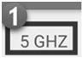

**Wi-Fi Analysis Project**

* **Wi-Fi Network Analyzer**
  + Wi-Fi Signal Scan

**2 4**

▪

**1**

**3**

: Frequency band

(5 GHz/2.4 GHz)

switch by pressing

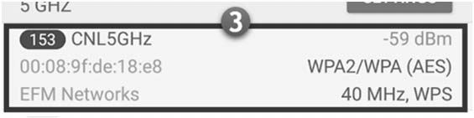

**Wi-Fi Analysis Project**

* **Wi-Fi Network Analyzer**
  + Wi-Fi signal scan

**2 4**

**1**

**3**

* + - Shows RSSI, SSID, MAC address of AP, Bandwidth and PHY channel used, Encryption scheme, etc.
      * RSSI: -59 dBm
      * SSID: CNL5GHz
      * Encryption: WPA2/WPA (AES)
      * Bandwidth: 40 MHz
      * PHY Channel:153rd channel

**1**

**2**

**3**

**4**

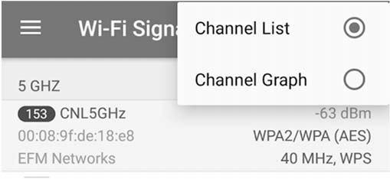

**Wi-Fi Analysis Project**

* **Wi-Fi Network Analyzer**
  + Wi-Fi signal scan

**2 4**

▪

: Channel List/Graph switcher

**1**

**3**

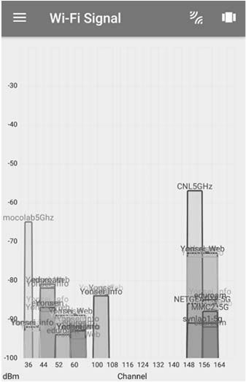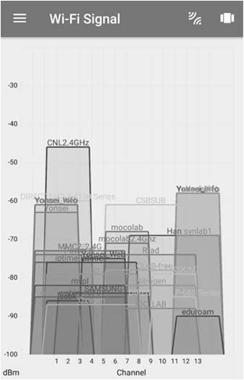

**Wi-Fi Analysis Project**

* **Wi-Fi Network Analyzer**
  + Channel graph

**5 GHz**

**2.4 GHz**



**IoT Bluetooth & Wi-Fi and EC2 Cloud Projects**

**References**



**References**

* “Network Analyzer,” Jiri Techet, [Online] Available from: https://play.google.com/store/apps/details?id=net.techet.netanalyzerlite.an [Accessed Feb. 27, 2018]
* “Network Analyzer Lite,” Techet, [Online] Available from: https://itunes.apple.com/us/app/network- analyzer-lite/id562315041?mt=8 [Accessed Feb. 27, 2018]
* “BLE Scanner,” Bluepixel Technologies LLP, [Online] Available from: https://play.google.com/store/apps/details?id=com.macdom.ble.blescanner [Accessed Feb. 27, 2018]
* “Bluetooth 4.0 Scanner,” John Abraham, [Online] Available from: https://play.google.com/store/apps/details?id=com.bluemotionlabs.bluescan [Accessed Feb. 27, 2018]
* “BLE Discovery,” Heap & Stack, [Online] Available from: https://itunes.apple.com/us/app/ble- discovery/id821826273?mt=8 [Accessed Feb. 27, 2018]
* https://aws.amazon.com